**Plant Disease Detection**

**Importance of Plant Disease detection**

Plant disease detection is of paramount importance in ensuring the health and productivity of agricultural crops. Plant diseases can have devastating effects on crop yields, leading to substantial economic losses and food insecurity. Timely and accurate detection of plant diseases is crucial for implementing effective disease management strategies. Early detection enables farmers to take proactive measures, such as targeted pesticide applications, crop rotation, or the use of resistant varieties, to prevent the spread and minimize the impact of diseases. It helps in reducing the reliance on broad-spectrum pesticides, thereby promoting sustainable and environmentally friendly agricultural practices.

Moreover, the early identification of plant diseases allows for the containment and eradication of infected plants or areas, preventing further spread to neighboring crops or regions. This is particularly important for highly contagious diseases that can rapidly devastate large areas of cultivation. Furthermore, plant disease detection facilitates research and development efforts by providing valuable data on disease prevalence, distribution, and dynamics. This information is crucial for scientists and policymakers to develop improved disease-resistant crop varieties and formulate targeted disease management strategies. Plant disease detection plays a pivotal role in safeguarding agricultural productivity, reducing economic losses, and ensuring food security. By enabling early intervention and informed decision-making, it empowers farmers and researchers to mitigate the impact of diseases and promote sustainable agriculture.

**Problem Statement**

Develop a plant disease recognition system for accurate identification of diseases in various plant species. Analyse plant images to determine if they are healthy or infected with a specific disease.

**Work Flow**

Detecting and managing plant diseases is crucial for ensuring agricultural productivity and minimizing crop losses. This concept outlines a workflow for plant disease detection, encompassing various stages from exploring the data to deriving meaningful insights.

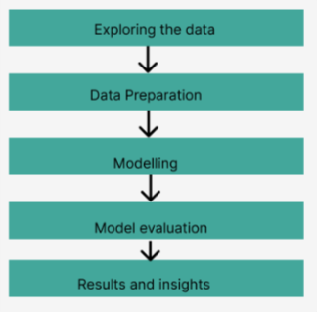

**Tools**

To effectively perform plant disease detection, several tools and technologies can greatly aid in the process. Here are the key tools that are commonly used in plant disease detection

1. **Programming Language: Python**

Python is a versatile and widely adopted programming language known for its simplicity and rich ecosystem of libraries. Its extensive collection of scientific computing libraries and machine learning frameworks make it an ideal choice for plant disease detection tasks.

1. **Data Manipulation and Analysis: NumPy, Pandas**

NumPy is a fundamental library for numerical computations in Python, offering powerful tools for array manipulation and mathematical operations. Pandas provide high-performance data structures and data analysis tools, making it easier to manipulate, clean, and preprocess the plant disease datasets.

**3. Data Visualization: Matplotlib, Seaborn**

Matplotlib is a popular plotting library that allows for creating a wide range of visualizations, including line plots, scatter plots, and histograms. Seaborn, built on top of Matplotlib, provides a higher-level interface and offers attractive statistical visualizations for effectively presenting data insights.

**4. Image Preprocessing: OpenCV**

OpenCV (Open-Source Computer Vision Library) is a powerful tool for image processing and analysis. It provides functions and algorithms for tasks like image resizing, filtering, and feature extraction, making it suitable for preprocessing plant disease images before feeding them into the detection models.

**5. Model Training and Evaluation: Py Torch, Scikit-learn**

Py Torch is a popular deep learning framework that enables building and training neural networks efficiently. It provides a dynamic computational graph and supports GPU acceleration, making it well-suited for training complex models for plant disease detection. Scikit-learn offers a range of machine learning algorithms and tools for model evaluation, including metrics and cross-validation techniques.

**6. Development Environment: Anaconda, Kaggle Notebook’s**

Kaggle Notebook is an interactive development environment that allows for creating and sharing documents containing live code, visualizations, and explanatory text. It facilitates the iterative development and experimentation process in plant disease detection. Anaconda is a popular distribution of Python that comes pre-packaged with numerous scientific computing libraries and simplifies package management. And we can use also use Powerful GPU processor they provide.

**7. Cloud Deployment: AWS (Amazon Web Services) or other cloud platforms**

For future deployment and scalability, cloud platforms like AWS offer convenient services for hosting and deploying plant disease detection models. These platforms provide computing resources, storage, and scalability options, allowing for efficient utilization of resources and easy access to the deployed model from various devices.

8. **Deep Learning Framework: PyTorch**

As mentioned earlier, PyTorch is a powerful deep learning framework that provides a flexible and intuitive interface for building and training neural networks. Its extensive collection of pre-trained models and state-of-the-art architectures can be leveraged for advanced plant disease detection tasks involving deep learning.

**Exploring the Data**

Kaggle dataset

link - ‘https://www.kaggle.com/datasets/vipoooool/ne w-plant-diseases-dataset’

* Image dataset containing different healthy and unhealthy crop leaves.
* This dataset consists of about 87K rgb images of healthy and diseased crop leaves
* Images are categorized into 38 different classes.
* The total dataset is divided into 80/20 ratio of training and validation set preserving the directory structure.
* A new directory containing 33 test images is created later for prediction purpose

**Modeling**

* Utilizing Convolutional Neural Networks (CNNs) for plant disease detection.
* Employing the ResNet (Residual Network) model, known for its effectiveness in deep learning tasks.
* The ResNet architecture consists of residual blocks stacked together to form a deep neural network.
* Highlighting the ability of ResNet to address the vanishing gradient problem and facilitate the training of deeper networks.
* Leveraging transfer learning to adapt the ResNet model for plant disease detection, benefiting from its learned features.

Here is a general overview of the ResNet architecture:

1.Initial Convolutional Layer: The input image is passed through an initial convolutional layer, which performs a set of convolutions to extract basic features from the input.

2. Stacked Residual Blocks: The network consists of several stacked residual blocks. Each residual block contains two or more convolutional layers, typically followed by batch normalization and activation functions like Relu.

3.Skip Connections: Skip connections, also known as shortcut connections, are introduced to allow the gradient to flow directly from earlier layers to later layers. These skip connections skip one or more convolutional layers and add the input from the previous layer to the output of the block. This helps in alleviating the vanishing gradient problem and enables the network to learn more effectively. 4.Down sampling: To reduce the spatial dimensions of the feature maps and increase the receptive field, ResNet uses down sampling layers. Down sampling can be achieved through convolutional layers with a stride of 2 or by using pooling operations like max pooling.

5. Global Average Pooling: Instead of using fully connected layers at the end of the network, ResNet typically applies global average pooling. This operation computes the average value of each feature map over its spatial dimensions, resulting in a fixed-length vector. This reduces the number of parameters and enables the network to be more robust to input variations.

6.Fully Connected Layer and SoftMax: The global average pooled features are then fed into a fully connected layer, followed by a SoftMax activation function to produce the final class probabilities for classification tasks. For other tasks like object detection or image segmentation, additional layers may be added to the architecture.  
  
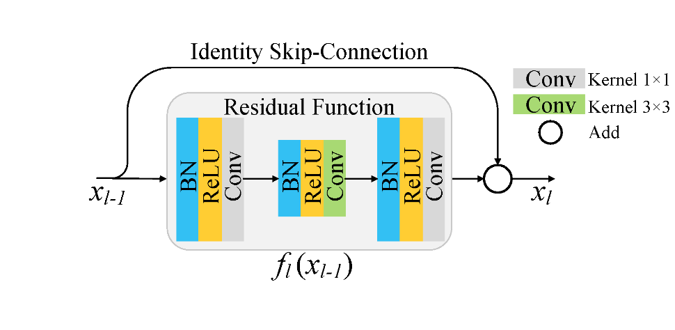

**Model Evaluation**

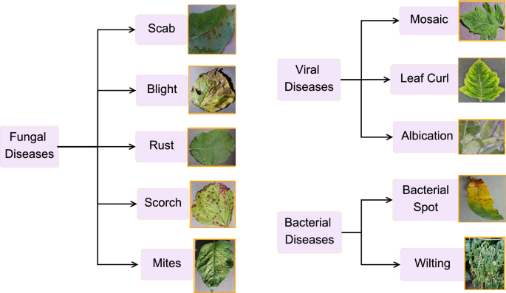

* Accuracy: mentioning the Final accuracy that we get after fine tuning the model.
* Plotting the accuracy and epochs.
* Showcase a few sample predictions made by your model on unseen images from the testing/validation set.

**Results and insights**

* Successful application of CNNs and ResNet model for plant disease detection.
* Utilized Kaggle dataset with 87,000 RGB images of healthy and unhealthy crop leaves.
* Leveraged ResNet and transfer learning for improved accuracy.
* Trying to achieve commendable accuracy through rigorous evaluation.
* Strong foundation for future advancements in plant disease detection.
* Planning to deploy the model to AWS or cloud for easy application.