Faculty of Engineering and Technology
Ramaiah University of Applied Sciences
Department of Electronics and Communincation Engineering

Programme | B.Tech in ECE
Semester/Batch | 6th sem/2023
Course Code | ECC314A
Course Title | Embedded System and IoT
Course Leader | Dr.L.S.Praveen
Assignment | Assignment-01
Group Members | Dheeraj K,Mohana,Vasudev

Report

- Development of force and angle of fingers using Flex and display results in LCD
B1.1 Introduction to Problem Statement
- Design and develop a real-time motion control system that uses a flex sensor to control the rotational angle of a servo motor, while simultaneously displaying sensor readings and servo position information on an LCD panel. The system should accurately detect the bending of the flex sensor, convert the sensor data into corresponding angular movement of the servo motor, and provide continuous visual feedback through the LCD display. The project aims to demonstrate the integration of sensors, actuators, and display modules in an embedded system for applications such as robotic arm control, prosthetic devices, and human-machine interaction systems..
B1.2 Functional Block diagram
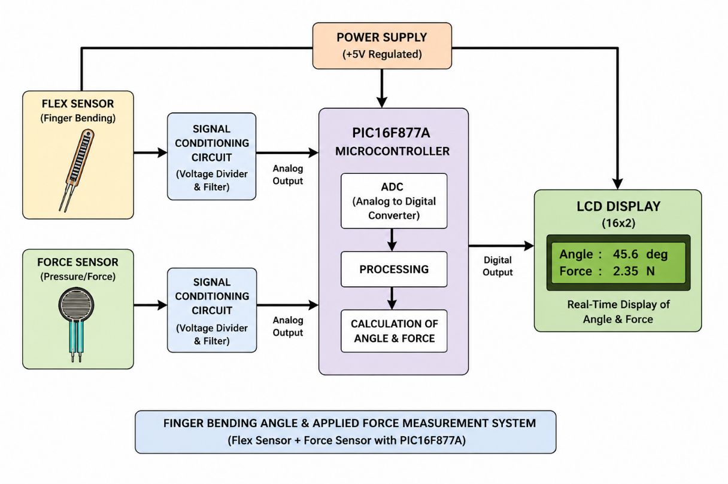
- The functional block diagram represents the overall operation of the finger bending angle and force measurement system using a flex sensor, force sensor, and PIC16F877A microcontroller. It illustrates the flow of signals from the sensors to the microcontroller for processing and the real-time display of angle and force values on the LCD
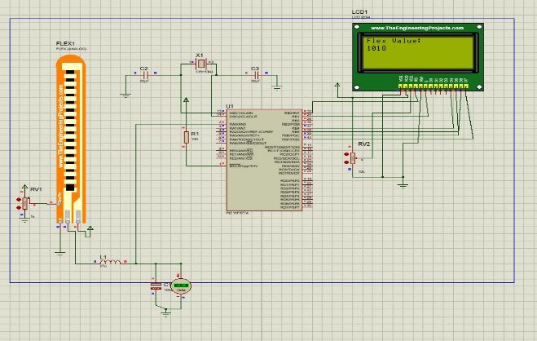
B1.3 Implementation of Problem Statement in Software
    - List components used in simulation:
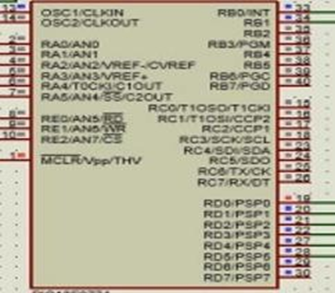
- PIC16F877A Microcontroller

  - Main processing unit of the system
  - Reads flex sensor values using ADC
  - Sends output to LCD display
  - Connections:
    - RA0/AN0 → Flex sensor output
    - PORTB/PORTD → LCD pins
    - OSC1 & OSC2 → Crystal oscillator
    - MCLR → Reset circuit
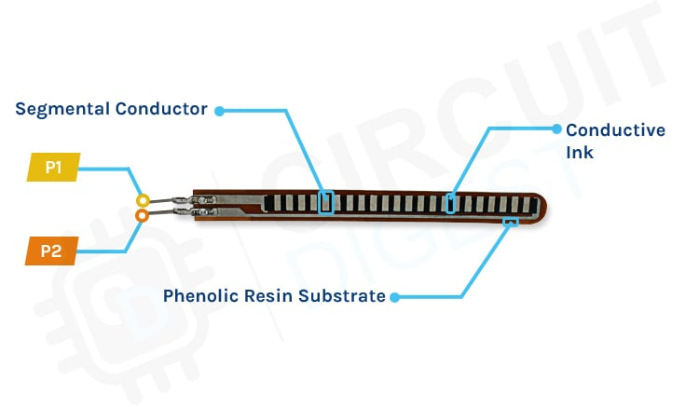
- Flex Sensor

  - Measures finger bending angle
  - Resistance changes when finger bends
  - Connections:
    - One side → VCC
    - Other side → RA0/AN0 through voltage divider
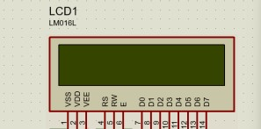
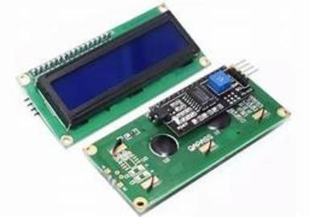
- 16x2 LCD Display

  - Displays flex/force values
  - Shows output in real time
  - Connections:
    - Data pins → PIC ports
    - VSS → GND
    - VDD → +5V
    - VEE → Contrast potentiometer
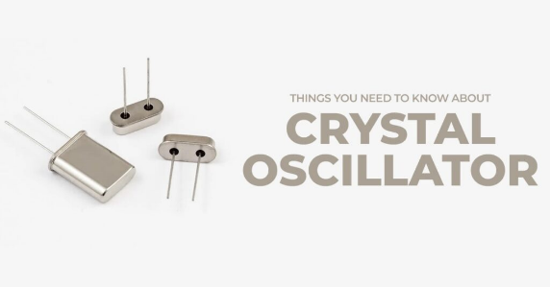
- Crystal Oscillator

  - Generates clock pulses for PIC operation
  - Connections:
    - Connected between OSC1 and OSC2 pins
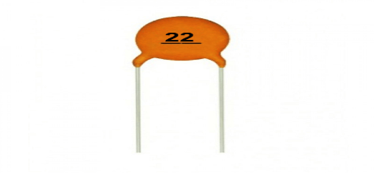
- 22pF Capacitors

  - Stabilize crystal oscillator frequency
  - Connections:
    - Connected from crystal terminals to GND

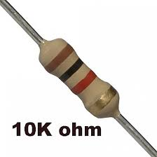
- 10kΩ Resistor

  - Maintains proper reset condition
  - Connections:
    - Connected between MCLR pin and VCC
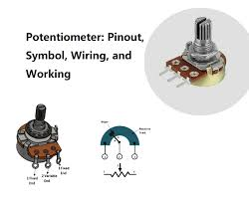
- Potentiometer RV1

  - Adjusts sensor sensitivity/calibration
  - Connections:
    - Connected with flex sensor circuit

- Potentiometer RV2
  - Controls LCD brightness/contrast
  - Connections:
    - Middle pin → LCD VEE
    - Other pins → VCC and GND
- 5V Power Supply
  - Provides power to entire circuit
  - Connections:
    - Connected to PIC, LCD, and sensors
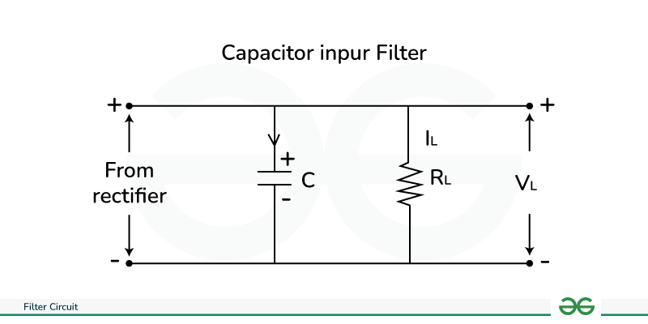
10.Filter Circuit
- Reduces electrical noise in circuit
- Connections:
  - Connected in power/sensor line
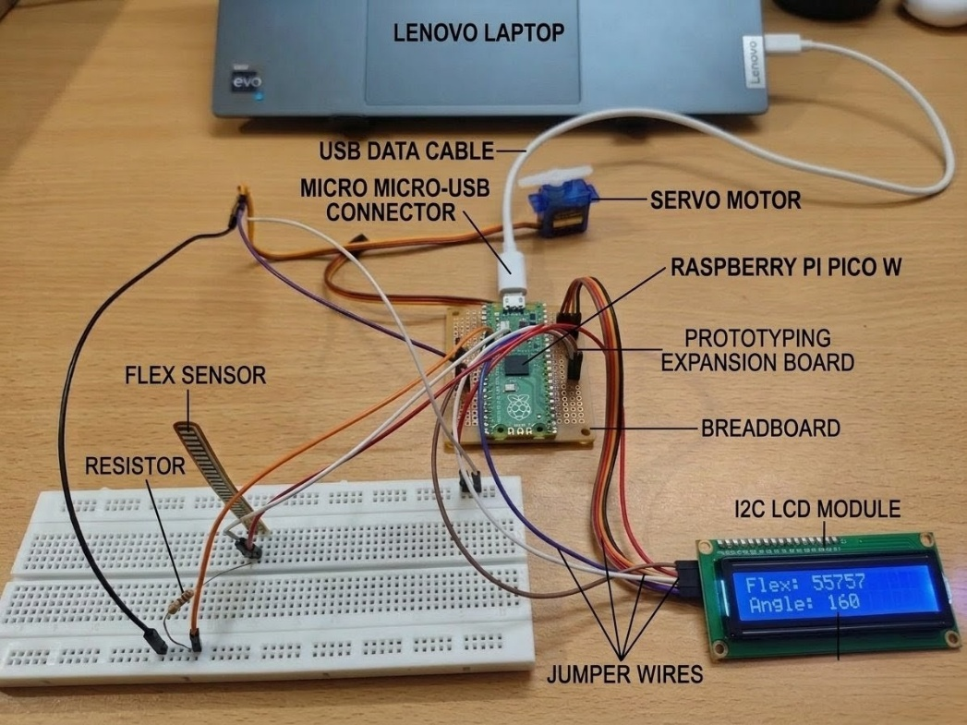
B1.4 Implementation of Problem Statement in Hardware
- Components Required
Raspberry Pi Pico W – Main microcontroller used to read sensor data and control the system.
Flex Sensor – Detects the bending of the finger by changing its resistance.
Resistor – Forms a voltage divider circuit with the flex sensor for accurate readings.
Servo Motor – Rotates according to the finger bending angle.
I2C LCD Module – Displays the flex sensor value and calculated bending angle.
Breadboard – Used for temporary circuit connections without soldering.
Jumper Wires – Connect all electronic components together.
Prototyping Expansion Board – Helps in easy interfacing of the Raspberry Pi Pico W with external components.
USB Data Cable – Provides power and programming connection between laptop and Pico W.
Laptop – Used to program and monitor the Raspberry Pi Pico W system.

Working Principle (Step by Step)
- Power Supply ON
  - The laptop supplies power to the Raspberry Pi Pico W through the USB cable.
  - LCD, flex sensor, and servo motor receive power from the controller circuit.
- Flex Sensor Operation
  - The Flex Sensor is attached to the finger.
  - When the finger bends, the resistance of the flex sensor changes.
- Voltage Divider Circuit
  - The resistor and flex sensor form a voltage divider circuit.
  - Due to resistance variation, output voltage changes according to finger bending angle.
- Analog Signal Reading
  - The analog voltage from the flex sensor is sent to the ADC pin of the Raspberry Pi Pico W.
  - The controller converts the analog signal into digital values.
- Angle Calculation
  - The microcontroller processes ADC values.
  - Using programmed calibration values, it calculates the finger bending angle.
- LCD Display Output
  - The calculated flex value and angle are displayed on the I2C LCD Module in real time.
- Servo Motor Control
  - Based on finger movement, the Servo Motor rotates to a corresponding angle. This demonstrates robotic finger or hand movement control.
- Continuous Monitoring
  - The process repeats continuously for real-time finger motion tracking and display.

Flow chart for working:
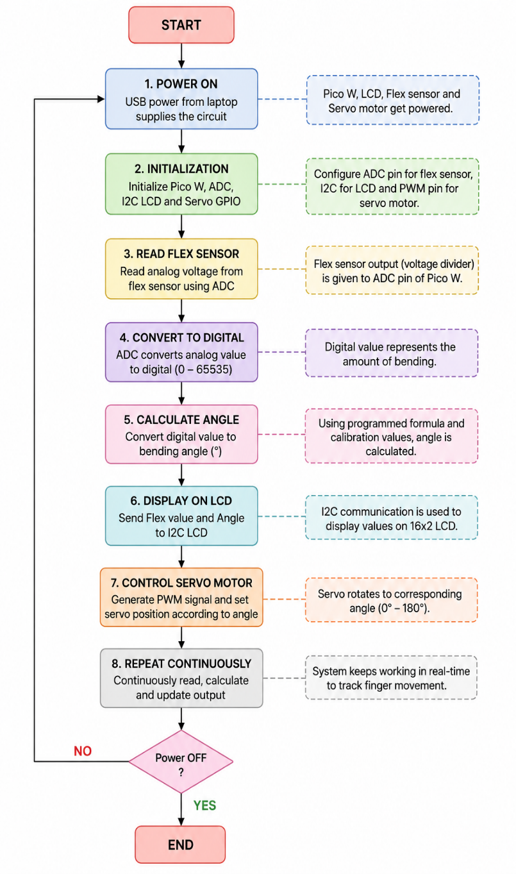

Flow chart for Code:
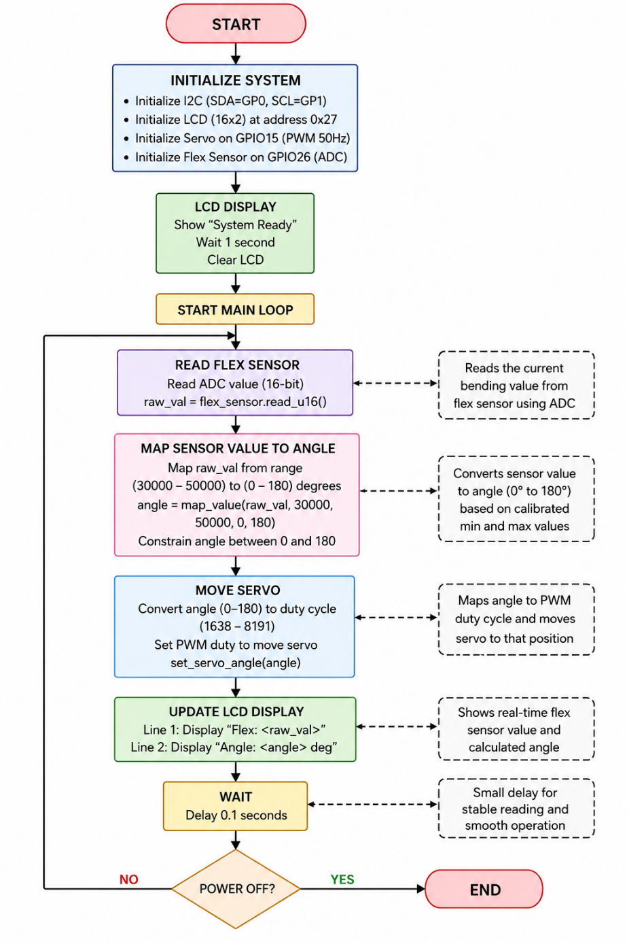

Code:
import machine
import utime
from machine import Pin, ADC, PWM, I2C
from lcd_api import LcdApi
from i2c_lcd import I2cLcd

# 1. Setup LCD (I2C)
I2C_ADDR = 0x27
totalRows = 2
totalColumns = 16
i2c = I2C(0, sda=Pin(0), scl=Pin(1), freq=400000)
lcd = I2cLcd(i2c, I2C_ADDR, totalRows, totalColumns)

# 2. Setup Servo (PWM)
servo = PWM(Pin(15))
servo.freq(50) # Standard 50Hz for servos

# 3. Setup Flex Sensor (ADC)
flex_sensor = ADC(Pin(26))

def map_value(x, in_min, in_max, out_min, out_max):
# Standard mapping function to convert sensor range to servo range
return int((x - in_min) * (out_max - out_min) / (in_max - in_min) + out_min)

def set_servo_angle(angle):
# Convert angle (0-180) to duty cycle (approx 1000 to 9000 for Pico)
# Most SG90s: 0 deg ~= 1638, 180 deg ~= 8191
duty = map_value(angle, 0, 180, 1638, 8191)
servo.duty_u16(duty)

lcd.putstr("System Ready")
utime.sleep(1)
lcd.clear()

while True:
# Read sensor (Pico ADC is 16-bit: 0-65535)
raw_val = flex_sensor.read_u16()

# ADJUST THESE LIMITS: Test your sensor flat vs bent to find actual min/max
# Assuming 30000 is flat and 50000 is fully bent
angle = map_value(raw_val, 30000, 50000, 0, 180)

# Constrain angle
angle = max(0, min(180, angle))

# Move Servo
set_servo_angle(angle)

# Update LCD
lcd.move_to(0, 0)
lcd.putstr("Flex: {}".format(raw_val))
lcd.move_to(0, 1)
lcd.putstr("Angle: {} deg ".format(angle))

utime.sleep(0.1)

Conclusion
The project successfully demonstrates the implementation of a flex sensor-based servo motor control system with real-time LCD monitoring. By detecting the bending variation of the flex sensor, the system accurately controls the rotation angle of the servo motor and displays the corresponding values on the LCD panel. This project highlights the effective integration of sensors, microcontrollers, actuators, and display interfaces in embedded systems. It also provides a practical understanding of analog signal processing, motor control, and human-machine interaction. The developed system can be further extended for applications such as robotic hands, automation systems, prosthetic control, and gesture-based devices.

