Module- 4
SENSORS AND CORROSION SCIENCE
Lecture-1
A Sensor is a device that detects and measures physical input like light, heat, moisture, pressure or any other environmental phenomena. The output produced by a sensor is generally a signal that is transmitted electronically over a network for reading or further processing.
A chemical sensor is a device that is capable of giving real time analytical information about the test sample. It interacts with the analyte, detects it and produces measurable signal that is proportional to the analyte concentration or quantity.
Main components of sensor
- Receptor
- Transducer
c) Actuator
Receptor: The receptor is the component of the chemical sensor that comes into direct contact with the analyte. It produces signal corresponding to interaction in the form of change in potential, conductivity, current, heat, pH and colour etc.
Transducer: It is used to convert a non-electrical signal into an electrical signal. These are used to convert the signal created by the receptor-analyte interaction into a measurable value. In most chemical sensor the sensing element and transducer are packaged together in the same unit.
Actuator: Actuator would receive inputs from any system in the form of electrical signals and then generate an output for its environment. Here electrical signal is converted into mechanical work. It converts electrical energy into mechanical energy.
Electrical signal and display: The electronic system analyzes the signal given by the transducer, helps in signal amplification and converts the signal from analog to digital form these amplified signals are then displayed. Signal can be displayed in various forms such as numeric value, graph, image etc. .
Conductometric sensor
In a conductometric sensor, the concentration of an analyte is determined by measuring the change in the electrolytic conductivity of the solution.
Conductance of the solution is based on
- Concentrations (number) of ions in the solutions
- Mobility of each type of ions in solution. Mobility of ions depends on its size. Smaller the size higher is the mobility and hence higher is the conductance.
When the concentration of ions (H⁺, OH⁻, salts, gases dissolved in liquids) changes, the electrical conductivity also changes.
This change in conductivity is measured and related to the property being sensed (like concentration of a chemical or presence of a gas).
Working
In a conductometric sensor, the electrode system is called a conductivity cell, which is usually made of two platinum electrodes having unit cross-sectional area and placed at a unit distance apart. The volume between the electrodes is 1 cm³. The conductance of this unit volume of solution is known as specific conductance. The specific conductance changes when the number or type of ions in the solution changes, and this variation is measured using the conductivity cell. The sensor works by immersing the two electrodes in the test medium . When a small AC voltage is applied, the ions present conduct current between the electrodes. The conductance (C) or its inverse, resistance (R = 1/C), is measured, and any change in conductance directly indicates the concentration of ions or analyte in the medium.

.
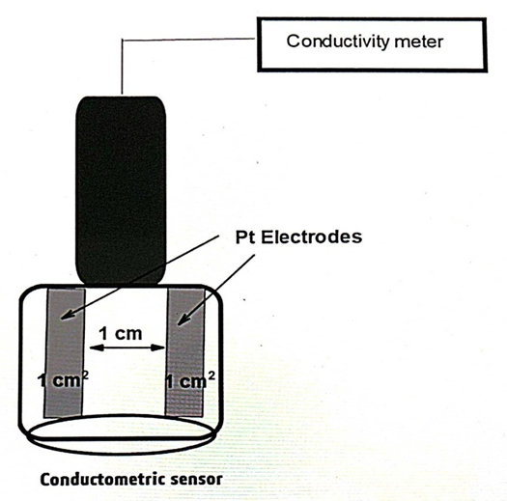
Application in the estimation of acid mixture-Titration of acid mixture with strong base:
In the mixture of strong acid and weak acid, strong acid dissociates completely and consumed first by the base. After the neutralization of strong acid, the weak acid is neutralized. During neutralization of the strong acid (Ex: HCl) conductance first falls since highly mobile H⁺ ions are replaced by Na⁺ of base. Later, during the neutralization of weak acid (Ex: acetic acid), the poorly conducting acid is converted into a salt ( Ex. CH₃COONa). The salt undergoes complete dissociation, an therefore, the conductance increases gradually. After the complete neutralization, further addition of base NaOH introduces more and more Na⁺ and OH⁻ ions into the solution, conductance again increases rapidly. When conductance of the solution is plotted against volume of base added, three straight lines will be obtained. First point of intersection corresponds to the volume of base required to neutralize strong acid and second point of intersection is for total acid.
H⁺ + Cl⁻ + Na⁺ + OH⁻ → Na⁺ + Cl⁻ + H2O

CH₃COOH + NaOH → CH₃COONa + H₂O

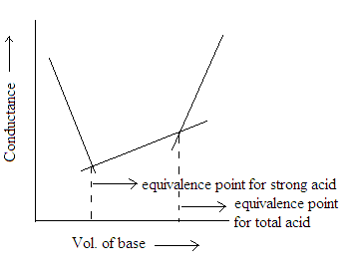
Application of conductometric sensors
- It is used to estimate acids, bases and their mixtures in a sample.
- Used to check the amount of ionic impurities in waste samples.
- Measure the acidity or alkalinity of sea water and fresh water.
- In environment monitoring, bio technology and agriculture related applications.

Review Questions
- What are sensors?
- What is Conductometric sensor?
- Which cell is used to determine Conductance of given solution?
- Give One application of conductometric sensor.
Lecture-2
Working, principle and applications of Optical sensors (colorimetry )
A sensor which measures the physical quantity of light rays and convert into electrical signal which can be easily readable by instrument or device is called optical sensors.
Principle
- Optical sensors are used to determine concentration of coloured species in the solution.
- Colorimetric optical sensors work on the principle of absorption of light by a solution or sample.
- According to Beer–Lambert’s law, the absorbance of light is directly proportional to the concentration of the analyte in the solution.
- Different analytes absorb light at specific wavelengths, producing measurable color changes
Working
- A light source (usually LED or lamp) emits light of a specific wavelength.
- The light passes through the sample solution.
- A photodetector measures the intensity of transmitted light.
- The difference between the incident light (I₀) and transmitted light (I) is calculated as absorbance.
- The absorbance value is then correlated to the concentration of the analyte using Beer–Lambert’s law.
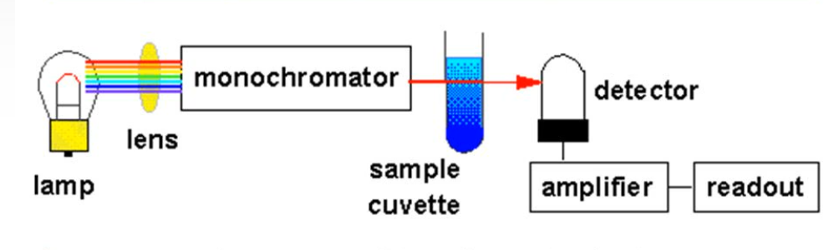
Colorimetric sensor in the estimation of copper in PCB
When Cu²⁺ ions are treated with ammonia solution, a deep blue colored cuprammonium complex is obtained. The absorbance is measured at 620nm (λmax) since the complex shows maximum absorbance at this wavelength. When absorbance of known solutions is plotted against concentration, a straight line is obtained. From this, copper in unknown solution(PCB) concentration can be obtained by measuring the absorbance of that solution.
PROCEDURE:
5, 10, 15, 20 and 25ml of standard Copper sulphate solution is taken in separate standard flasks. 5ml of ammonia is added to each of these flasks and made up to the mark using distilled water. The flasks are stoppered and shaken well for uniform concentration. To the given test solution, 5ml of ammonia is added and made up to the mark with distilled water, stoppered and shaken well. A blank solution is also prepared taking 5ml of ammonia, making up to the mark using distilled water and shaken well. The absorbance of solutions against blank is measured at 620nm using colorimeter. A calibration curve is drawn by plotting concentration of Cu (mg/cm³) against absorbance. From this, concentration of Cu in PCB solution can be determined.
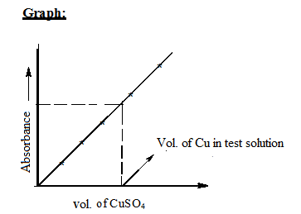
Applications of Optical Sensors
- Optical Fibre based biosensors are used in detection of explosive.
- These are used in smar twatches to measure the heartbeat of the person.
- Water and Liquid levels in industries.
- Adjusting screen brightness in smart phones.

Review Questions
1. What are Optical Sensors?
2. State Beer-Lambert’s law.
3. Name the complex formed when copper ions react with ammonia.
4. Give one Application of Optical sensor.
Lecture-3
Electrochemical Gas Sensors:
Electrochemical gas sensors are devices that detect specific gases by chemically reacting with the target gas and converting this reaction into an electrical signal. They are widely used in environmental monitoring, industrial safety, and automotive emission testing.
Electrochemical Gas Sensors for NO_{X} and SO_{X} detection
Electrochemical sensors are used to measure the concentration of pollutant gases like NO₂, NO and SO₂. A filter is used to prevent unwanted contaminants.
An electrochemical gas sensor generally consists of a sensing electrode, counter and reference electrode along with a gas- permeable membrane. The gas-permeable membrane allows only the gas not liquid.
Working Principle
- When the target gas enters through the membrane, it reaches the sensing electrode.
- Depending on the gas, either an oxidation or reduction reaction takes place.
- In oxidation, electrons flow from the working electrode to the counter electrode, while in reduction, electrons flow in the opposite direction.
- The resulting electrical current is directly proportional to the gas concentration.
- The signal is then amplified and displayed as gas concentration, usually in parts per million (ppm) or percentage volumes.

Electrochemical sensors are used to measure the concentration of pollutant gases like NO₂ and NO and SO₂. A filter is used to prevent unwanted contaminants. An electrochemical gas sensor generally consists of a sensing electrode, counter and reference electrode along with a gas-permeable membrane. During sensing operations, it is submerged in an electrolytic liquid(electrolyte). Combined, these components allow it to perform its function. The gas-permeable membrane allows only the gas not liquid. An electrochemical reaction either oxidation or reduction, depending on the type of gas occurs when the gas reaches the working electrode or sensing electrode. An oxidation reaction moves electrons from the working electrode to the counter electrode, while a reduction reaction causes electrons to move from the counter electrode to the working electrode. In either case, the electrical current generated is proportional to the concentration of the target gas. The current is then amplified and processed to give the user a reading in either parts per million (PPM) or percentage volume.

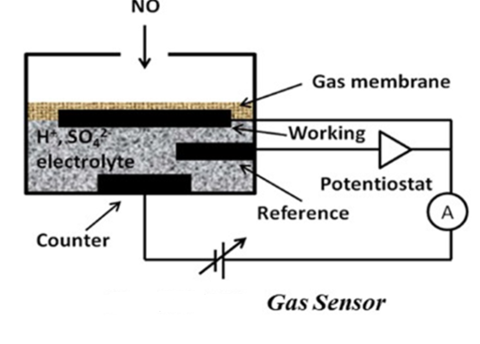
1. Detection of NO₂
The reduction reaction takes place on the surface of the sensing electrode.
Sensing Electrode is Au, Pt /Nafion with 10 M H₂SO₄ as an electrolyte.
NO₂+2H⁺+2e⁻ → NO+H₂O
2. Detection of NO
The oxidation reaction takes place on the surface of the sensing electrode. Sensing Electrode and electrolyte is Au/NASICON -NaNO₂.
NO+2H₂O → NO₃²⁻+4H⁺+3e⁻

- Detection of SO₂
The oxidation reaction takes place on the surface of sensing electrode. Sensing electrode is Au/nafion with 0.5 M H₂SO₄ as an electrolyte.
SO₂+2H₂O → SO₄²⁻+4H⁺+2e-
Review Questions
1. Name any one gas that can be detected using an electrochemical gas sensor.
2. What type of chemical reaction occurs at the electrodes of an electrochemical gas sensor?
3. What is the function of the electrolyte in an electrochemical gas sensor?
4. Mention one advantage of using electrochemical gas sensors over other types of gas sensors.
Lecture-4
Biosensors
Biosensors are devices that are used to detect and measure bioanalyte. They are used in qualitative and quantitative analysis of biomolecules, biological structures, microorganisms etc. large number of biosensors is used in healthcare, food, industrial and environmental fields to detect various bio-analytes like glucose, cholesterol, ethanol, creatinine etc. They play an important role in the detection of diseases, monitoring of human health, quality of food, water and air.
Principle, construction and working mechanism for detection of glucose in bio fluids
Definition:
It is a biochemical device that measures glucose concentration in bio fluids (blood, saliva, sweat) by using glucose oxidase enzyme converting a biochemical reaction into an electrical signal, current generated is proportional to glucose concentration.
Principle
The biosensor works on the principle of enzymatic reaction +electrochemical detection.
Glucose oxidase enzyme specifically reacts with glucose. During this reaction, hydrogen peroxide (H₂O₂) is produced as a by-product. This H₂O₂ is then oxidized at an electrode surface, releasing electrons. The flow of electrons (current) is measured, which is proportional to the amount of glucose present in the sample.
Construction:
A glucose biosensor consists of the following main components:
Bio receptor (enzyme layer): Contains the enzyme glucose oxidase, which specifically recognizes glucose molecules.
Transducer (electrode system): Converts the biochemical reaction (oxidation of H₂O₂) into an electrical signal (current).Usually made of platinum or carbon electrodes.
Immobilization Matrix: Holds the enzyme (glucose oxidase) in place on the electrode surface. Materials like polymer films, gels, or membranes are used for immobilization.
Electronics / Signal Processor: Amplifies and processes the electrical signal generated.
Display Unit: Shows the glucose concentration value
Working Mechanism
Glucose recognition: Glucose present in the biofluid (blood, saliva, sweat) diffuses to the enzyme layer.
Enzymatic reaction: glucose reacts with oxidase enzyme and produces gluconic acid and hydrogen peroxide.
Glucose + O₂ → Gluconic acid + H₂O₂ (catalysed by glucose oxidase).
Signal generation: The produced hydrogen peroxide is oxidized at the electrode surface:
H₂O₂ → 2H⁺ + O₂ + 2e⁻
Electrons released create a measurable current.
Signal conversion: The electrode current is directly proportional to glucose concentration.
Signal processing and display: The electronics amplify the current and convert it into readable alues. The final glucose concentration is displayed digitally (like in glucometer).

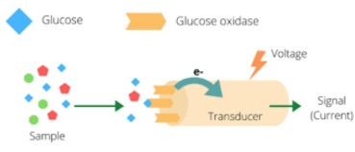
Review Questions
1. What is a biosensor?
2. Name any one biological element used in a biosensor.
3. What is the main function of the transducer in a biosensor?
4. Give one example of a commonly used biosensor.
Lecture-5
CORROSION
Corrosion is defined as “the destruction of metals or alloys by the surrounding environment through chemical or electrochemical changes.”
The process of corrosion is the transformation of pure metal into its undesired metallic compounds. The life of a metal object gets shortened by the corrosion process.
The familiar examples of corrosion are
- Rusting of iron – a reddish brown scale formation on iron and steel objects. It is due to the formation of hydrated ferric oxide.
- Green scales formed on copper vessels. It is due to the formation of basic cupric carbonate [CuCO₃ + Cu(OH)₂]
Illefects of Corrosion
- Loss of efficiency.
- Contamination of product.
- Damage of metallic equipment’s.
- Inability to use metallic materials.
- Appearance as when corroded material is unpleasing to the eye.
- Loss of valuable materials such as blockage of pipes, mechanical damage of underground water pipes.
- Accidents due to mechanical loss of metallic bridges, cars, aircrafts etc.
- Safety, for example, sudden failure can cause fire, explosion, release of toxic product, and construction collapse.
- Depletion of Natural Resources.
- India Losses 5.7 % GDP due to corrosion.
Chemical corrosion (Dry corrosion)
Chemical corrosion occurs due to the direct chemical reaction between the metal and the gases present in the corrosive environment. This type of corrosion is generally observed in the absence of moisture or conducting electrolyte medium. Therefore, it is also known as dry corrosion.
Eg: Oxidation of metals or alloys on exposure to oxygen in air. Reaction of corrosive gases such as HCl, H₂S, SO₂, Cl_{2,} F₂, NH₃ etc. with metal and alloy surfaces.
Electrochemical corrosion (Wet corrosion)
Electrochemical corrosion involves reactions in aqueous medium. The conducting surface of the metal undergoes an electrochemical reaction with the moisture and oxygen present in the atmosphere. This process can be explained on the basis of electrochemical theory of corrosion.
Electrochemical theory of corrosion
Electrochemical theory of corrosion can be explained taking iron as an example.
When a metal like iron is exposed to the corrosive environment according to electrochemical theory, corrosion of metal takes place due to the formation of anodic and cathodic regions on the same metal surface or when the two metals are in contact with each other. The electrons released at the anodic area are taken up by the cathodic area.
Following are the changes occurring.
- Formation of galvanic cells. Anodic and cathodic areas are formed resulting in minute galvanic cells.
- At anode oxidation takes place so that metal is converted into metal ions with the liberation of electrons and move towards cathode.
iii) Oxygen of the atmosphere is reduced to OH¯ ions in the presence of water (moisture) at the cathodic area.
Anodic reaction:
At the anodic area, oxidation takes place resulting in the corrosion of iron.
Fe Fe⁺² + 2e⁻
Cathodic reactions:
Electrons flow from the anodic to cathodic area and cause reduction depending on the nature of the corrosive environment. Since the metal cannot be reduced further, metal atoms at cathodic region are unaffected by the cathodic reaction. Some constituents of the corrosion medium take part in the cathodic reaction.
Most common types of cathodic reactions are either liberation of hydrogen or absorption of oxygen.
- Liberation of hydrogen takes place in the absence of oxygen
- In acidic medium and in the absence of oxygen, hydrogen liberation takes place.
2H⁺ + 2e⁻H₂↑
- In neutral or alkaline medium and in the absence of oxygen, hydroxide ions are formed with liberation of hydrogen.
2H₂O + 2e⁻ 2OH¯ + H₂↑
- Absorption of oxygen takes place in the presence of oxygen.
- In acidic medium and in the presence of oxygen.
4H⁺ + O₂ + 4e⁻ 2H₂O
(ii) In neutral or alkaline medium & in the presence of oxygen, hydroxide ions are formed
2H₂O + O₂ + 4e⁻4OH¯
The metal ions formed at the anode combine with the OH¯ ions and form the insoluble Fe(OH)₂. In an oxidizing environment, it is oxidized to ferric oxide and the yellow rust is hydrated ferric oxide.
2Fe⁺² + 4OH¯2Fe(OH)₂
4Fe(OH)₂ + O₂ + 2H₂O2[Fe₂O₃·3H₂O]
Yellow Rust
In the presence of limited oxygen, ferrous hydroxide is converted into magnetic oxide of iron (Fe₃O₄) and is known as black rust.
3Fe(OH)₂ + ½ O₂ Fe₃O₄·3H₂O

Review Questions
- What is corrosion?
- Give the name of rust of iron.
- Which gas is liberated at cathode during reduction in absence of oxygen?
- What is oxidation?
Lecture-6
Types of Corrosion
Differential Metal Corrosion (Galvanic Corrosion)
Differential metal corrosion occurs when two dissimilar metals are in contact with each other in a corrosive conducting medium. The two metals differ in their tendencies to undergo oxidation, the one with lower electrode potential or the more active metal acts as anode and the one with higher electrode potential acts as cathode. The potential difference between the two metals is the driving force for corrosion. The anodic metal undergoes corrosion and the cathodic metal is generally unattacked.
The following reactions occur during differential metal corrosion.
At the anode : M M^{+n} + ne⁻
At the cathode : Depending on the nature of the corrosion environment the cathode reaction is either hydrogen evolution or oxygen absorption.
(i) 2H⁺ + 2e⁻ H₂ ₍g₎
(ii) O₂ + 2H₂O + 4e⁻ 4OH¯
For example, if a piece of iron combined with copper is exposed to corrosive atmosphere. Iron acts as anode in the presence of copper (iron is placed above copper in the electrochemical series). In such case, iron undergoes corrosion and copper is unaffected.
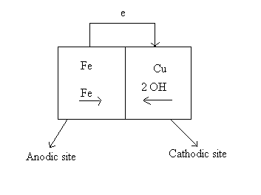

Differential Aeration Corrosion
Differential aeration corrosion occurs when a metal surface is exposed to differential air concentrations or oxygen concentrations, the part of the metal exposed to higher oxygen concentration acts as cathodic region and the part of the metal exposed to lower oxygen concentration acts as anodic region. As a result the part of the metal exposed to lower oxygen concentration undergoes corrosion.
At the anode (less O₂ concentration)
M M^{+n} + ne⁻ (oxidation)
At the cathode (more O₂ concentration)
O₂ + 2H₂O + 4e⁻ 4OH¯ (reduction)
“Corrosion of metals is due to the formation of an oxygen concentration cell because of the uneven supply of air on the metal surface is known as differential aeration corrosion.”
Examples
- Part of the nail inside the wall which is exposed to lower oxygen concentration than the exposed part, undergoes corrosion.
ii. Window rods inside the frame suffer corrosion but not the exposed parts.
iii. Metal under dirt, dust, scale or water undergoes corrosion.
iv. Paper pins inside the paper gets corroded, and the exposed part is free from corrosion.
Water line corrosion and pitting corrosion are the two cases of differential aeration corrosion.
Water Line Corrosion
Water line corrosion is observed in steel water tanks, ocean going ships etc.
The water line corrosion takes place due to the formation of differential oxygen concentration cells. The part of the metal below the water line is exposed only to dissolved oxygen while the part of the metal above the water is exposed to higher oxygen concentration of the atmosphere. Thus part of the metal below water acts as anode and undergoes corrosion and the part above the water line is free from corrosion.
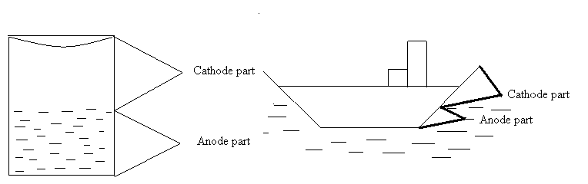

Pitting corrosion
Pitting corrosion results when small particles of dust get deposited on a steel surface. The metal below the deposit is exposed to lower oxygen concentration, acts as anode and undergoes corrosion. The metal surrounding the deposit acts as cathode because it is exposed to higher concentration of oxygen. In the presence of electrolytes and moisture, corrosion starts beneath the dust resulting in a pit. Once a pit is formed the rate of corrosion increases. This is because of the formation of small anodic area (pit) compared to a large cathodic area. The cathodic area induces the small anodic area to corrode faster by accepting electrons from the anodic area thus resulting in the enlargement of the pit.

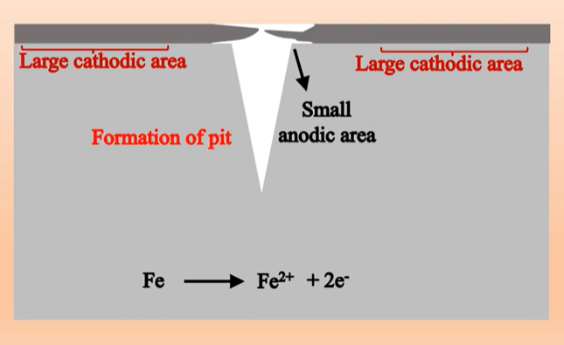

CORROSION CONTROL:
Corrosion can be controlled by preventing the formation of galvanic cell. There are various ways by which corrosion can be controlled. They are,
Protective coatings
The protective coating protects the metal from corrosion by acting as a barrier between the metal and the corrosion environment. The principal types of coatings applied on the metal surface are i. Inorganic coating
ii. Metal coating
iii. Organic coating
i.Metal Coating
Corrosion of metals can be controlled by depositing a protective metal over the surface of a base metal. This process is called metal coating. Metal coating can be anodic metal coating or cathodic metal coating.
Anodic Metal Coating
Anodic coatings are produced by coating a base metal with more active metals which are anodic to the base metal.
For example, iron is coated with more active metals such as zinc or magnesium. The characteristic feature of anodic coating is that, the base metal on which coating is done will not get corroded even if the coating is ruptured. The exposed surface of the metal is cathodic with respect to the coating metal and the coating metal undergoes corrosion. Therefore anodic coating is also known as sacrificial coating. Galvanization is an example of anodic metal coating.
Galvanization
Galvanization is a process of coating a base metal surface with zinc metal. Galvanization is carried out by hot dipping method. The galvanization process involves the following steps.
- The metal surface is washed with organic solvents to remove organic matter on the surface.
- Rust and other deposits are removed by washing with dilute sulfuric acid.
- Finally, the article is washed with water and dried.
- The article is then dipped in a bath of molten zinc, maintained at 425- 430ºC and covered with a flux of ammonium chloride to prevent the oxidation of molten zinc.
- The excess zinc on the surface is removed by passing through a pair of hot rollers, which wipes out excess of zinc coating and produces a thin coating.
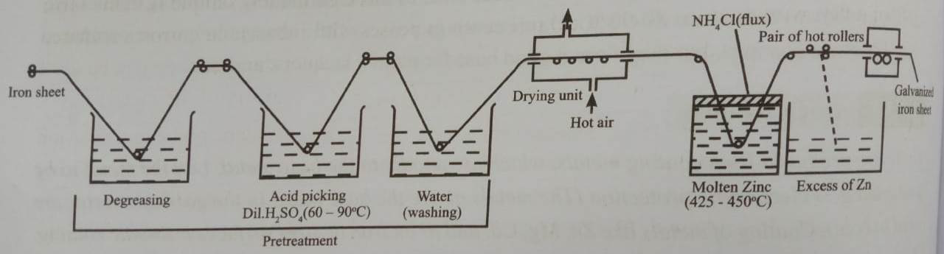

Galvanized articles are used in the form of roofing sheets, fencing wire, buckets, bolts, nuts, nails, screws, pipes tubes etc.

Review questions

1. Give one Example for waterline Corrosion.
2. What is Differential Metal Corrosion?
3. Give one Example for Pitting Corrosion.
4. What is Galvanization?

Lecture-7
ii.Inorganic coating
In this protective coating of inorganic metal oxide or metal phosphates are formed on the surface by chemical or electrochemical reaction.
This inorganic coating being protective prevents the metal from corrosion.
Anodized oxide coatings /Anodization :
    - In this base metal is made anode and made to develop protective metal oxide coating by dipping in oxidizing medium.
    - This method is used for nonferrous metals like Al, Zn , Mg.
    - It carried by making base metal anode and inert metal like lead is made cathode.
    - The electrolytic bath contains an oxidizing medium like sulphuric acid ,phosphoric acid, chromic acid, oxalic acid or boric acid.
    - Sulphuric acid, phosphoric acid, chromic acid & oxalic acid results in porous anodized coating whereas Boric acid is preferred for non- porous anodized coating.
    - On passing current the oxide film of sufficient thickness is formed on the base metal. These oxide coatings act as barrier between base metal and corrosive medium thus prevents the corrosion.
2Al+ 3H₂O Al₂O₃ + 3H₂
    - Anodising offers increased corrosion resistance and attractive finish to the surface.
    - Anodised aluminium is used in hardware, escalators, window frames etc.
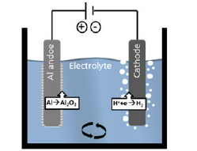
Fig 1: Anodization
Applications
Anodized articles are used as soap boxes, tiffin carriers, window frames etc.
Vapour Corrosion Inhibitors (VCIs) for Protecting Computer Circuit Boards
Definition:
Vapour Corrosion Inhibitors (VCIs) are specialized chemicals that slowly release protective vapors. These vapors condense on metal surfaces to form an invisible molecular layer that prevents corrosion. Examples: Dicyclohexylamine, Morpholine, Sodium Benzoate, Octadecylamine salts.
Working Principle:
- Sublimation (Vapor Release): VCI chemicals are stored in a carrier (like bag, paper, capsule, or coating). VCIs sublime or evaporate at room temperature.
- Vapor Transport: The vapor molecules spread out in the enclosed space (like inside a bag, box, or cabinet) and move freely and reach all exposed metal surfaces.
- Adsorption on Metal Surface: The vapour molecules adsorb onto metal surfaces such as copper, silver, and tin commonly found in PCBs.
- Protective Film Formation: Adsorption forms a microscopic protective film that blocks moisture, oxygen, and corrosive gases.
- Corrosion Prevention: When exposed to corrosive environments, this protective layer prevents oxidation, rusting, and degradation of electronic components.
Advantages for Circuit Boards:
- Non-intrusive: Does not interfere with electrical conductivity or connections.
- Provides protection for complex and delicate PCB components.
- Can be incorporated into packaging materials such as bags, boxes, or sealed enclosures.
- Ensures long-term corrosion protection during storage and transportation.

Review questions
1. What is inorganic Coating?
2. What is anodizing?
3. Name the electrolytic bath used for anodizing.

Lecture-8
Corrosion Penetration Rate (CPR)
The corrosion penetration rate (CPR) is defined as
The speed at which any metal in a specific environment deteriorates due to a chemical reaction in the metal when it is exposed to a corrosive environment.
The speed or rate of deterioration depends on the environmental conditions and the type and condition of the metal under study. Corrosion penetration rate may also be known as corrosion rate. Several pieces of data must be collected to calculate the corrosion penetration rate for any given metal:
- The weight lost (the decrease in weight of the metal during the period of reference).
- The density of the metal.
- The total surface area initially present.
- The time taken for the metal to corrode.
The CPR is calculated as follows:
CPR = (k x W) / (D x A x T)
where k = a constant
W = total weight lost
T = time taken for the loss of metal
A = the surface area of the exposed metal
D = the metal density in g/cm³
The corrosion penetration rate (CPR) is best expressed in terms of thickness loss of material per unit time. It is expressed in mpy (mils per year) or mm/year (milimeter per year).
This method involves the exposure of a weighed piece of test metal or alloy to a specific environment for a specific time. This is followed by a thorough cleaning to remove the corrosion products and then determining the weight of the lost metal due to corrosion.
- Numerical Problems.

Review Questions
1. Define CPR.
2. What is Unit of CPR?

Question Bank

1. Explain the working principle and application of conductometric sensor in the estimation of acid mixture.
2. Explain the working principle and application of of Optical sensors (colorimetry) in the estimation of copper in PCB.

5. Describe the application of Electrochemical gas sensors in sensing SOx and NOx .
6. What are Biosensors? Explain Principle, construction and working mechanism for detection of glucose in bio fluids.
7. What is corrosion? Explain the rusting of iron based on electrochemical theory.
8. Explain Differential metal corrosion and differential aeration corrosion with suitable examples.
9. Explain pitting and waterline corrosion with examples.
10. What is anodizing? Explain anodizing process.
11. Explain Galvanization with example.
12. ExplainVapour Corrosion Inhibitors (VCIs) for Protecting Computer Circuit Boards.
13.CPR Problems.

…………………………………..

