MODULE-1 FUNCTIONAL MATERIALS FOR MEMORY AND DISPLAY
Lecture-1
MEMORY DEVICES:
A memory device is a piece of hardware used to store data. They are used in a wide range of applications; including computers, smart phones, digital cameras, and many other electronic devices. Most electronic devices such as computers, mobile phones, tablets, etc all have a storage device that stores data or programs. There are several types of memory devices, each with its own unique characteristics and uses. According to the storage type of the device, electronic memory can be divided into two primary categories: volatile and non-volatile memory.
a) Volatile memory:
Volatile memory is temporary memory and requires power to maintain its data. Volatile memory loses all its data when the electricity is turned off(e.g., RAM).
b) Non-volatile memory
Non-volatile memory retains all the data even when electricity is turned off (e.g., ROM).
Organic semiconductor:
Organic semiconductors are a class of materials that exhibit electrical conductivity between that of insulators and conductors. They are characterized by their molecular structure, often featuring π-conjugated systems, which allows for the delocalization of electrons and facilitates charge transport. Unlike traditional inorganic semiconductors like silicon, organic semiconductors are derived from organic molecules or polymers, offering unique properties and potential for diverse applications.
Importance:
Organic semiconductors are important because they enable new categories of electronics, such as flexible displays and wearable devices, due to their unique properties like flexibility, low cost, and tunable properties. Their ability to be printed and processed using low-cost methods reduces manufacturing costs compared to traditional silicon-based electronics. This makes them crucial for developing energy-efficient, large-area electronics and sustainable technologies like flexible solar cells, while also offering significant potential in medical sensors and advanced lighting systems.

Advantages:
- Flexibility and Lightweight:
- They can be integrated into flexible substrates, allowing for the creation of bendable and lightweight devices like foldable phones and wearable electronics.
- Low-Cost and Scalable Manufacturing:
- Organic semiconductors can be processed at relatively low temperatures using solution-based techniques such as inkjet and roll-to-roll printing, which are less expensive than traditional silicon processing.
- Environmental Sustainability:
- Organic semiconductors can potentially be less toxic and more sustainable, with processes that require less energy and reduce environmental harm.
- Large-Area Fabrication:
- Printing methods are well-suited for large-area applications, including solar cells and displays.
Types of organic semiconductor:
1. Small-molecule semiconductors (e.g., pentacene, rubrene)
2. Polymeric semiconductors (e.g., polythiophenes, polyfluorenes)
3. Organic-inorganic hybrids (e.g., perovskite-organic blends)
Review Questions
- What are memory devices?
- What are organic Semiconductors?
- Give one advantage of organic semiconductors.
- Mention types of organic semiconductors.

Lecture-2
p-type semiconductor-pentacene and n-type semiconductor-perfluoropentacene
Acene derivatives: Pentacene & Perfluoropentacene
Pentacene is an organic semiconductor made up of five linearly fused benzene rings (a polycyclic aromatic hydrocarbon). It is commonly used in Organic Thin Film Transistors (OTFTs) and Organic Field Effect Transistors (OFETs).
- Pentacene’s have π conjugated system with holes as majority carriers and are considered as p-type semiconductor.
- There is continuous delocalisation of π electrons and lateral overlapping of π electrons between the molecules.
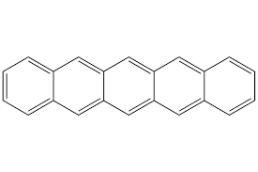
Pentacene
An Organic molecule with π conjugated system, with electron withdrawing substituent groups and possess electrons as major charge carrier is called n- type semiconductor. Ex: perfluoropentacene.
- When all the hydrogen atoms of pentacene are replaced by fluorine atoms the resulting molecule is perfluoropentacene.
- It is an organic molecule with π conjugated system with electron withdrawing substituent groups, and possess electrons as major charge carrier. is called n-type semiconductor.
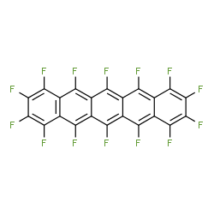
Perfluoropentacene

- Organic molecules exhibit fast switching speeds hence have high data transfer rates
- But less stable than other memory materials, not suitable for long-term storage as they may get decomposed.

Difference between organic and Inorganic memory devices:
Inorganic memory devices | Organic memory devices
Composition: Consist of non-carbon-based materials such as silicon, germanium, and gallium arsenide. | Composition: Made of carbon-based molecules,  Polymers or pi-bonded structures, often including heteroatoms like hydrogen, nitrogen, and oxygen.
Structure & Bonding: Typically have crystalline structures with strong covalent bonds, forming well-defined energy bands. | Structure & Bonding: Molecules are held together by weak van der Waals forces, forming amorphous or polycrystalline thin films rather than highly ordered crystals.
Flexibility: Generally rigid and brittle. | Flexibility: Inherently flexible and can conform to various shapes.
Mobility: Exhibit high electron mobility due to their optimal crystalline structure. | Mobility: Lower electron mobility compared to inorganic semiconductors.
Stability: More stable and durable in various environmental conditions. | Stability: More sensitive to humidity, oxygen and high temperatures.
Applications: Widely used in transistors, diodes, and integrated circuits for traditional electronics. | Applications: Used in flexible displays (OLEDs), solar cells, and sensors.

Review Questions
  - What is p-type semiconductor?
  - What is n-type semiconductor?
  - Give one example for inorganic memory devices.
  - Give one example for organic memory devices.

Lecture-3
Construction, working and advantages of pentacene semiconductor chip
A pentacene semiconductor chip is an organic electronic device using pentacene as the semiconducting layer.
Construction:
Substrate/Gate: Si (Serves as gate)
Gate Dielectric: 200-300 nm SiO₂
Semiconductor: Pentacene 30-50nm
Contacts: Au(30-50nm)
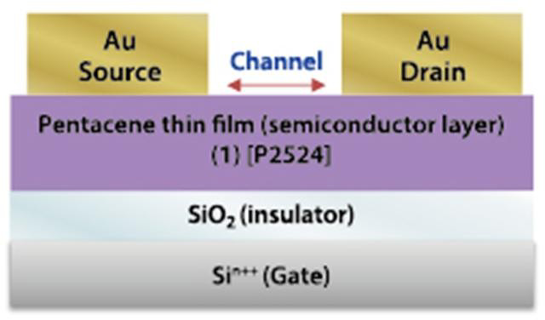
Encapsulation: Parylene- C polymer

Working Principle:
Pentacene behaves like a p-type organic semiconductor in most cases.
1. When voltage is applied to the gate electrode, an electric field is formed across
the dielectric.
2. This field induces charge carriers (holes) in the pentacene layer, forming a conductive channel between source and drain electrodes.
3. The amount of current that flows depends on the gate voltage, similar to how a MOSFET operates. Because of its π-conjugated structure, pentacene allows efficient charge delocalization, leading to relatively high mobility for an organic material (~1 cm²/V·s)
Pentacene-based semiconductor chips offer several benefits compared to traditional silicon chips:
Low-Cost Fabrication: Can be processed at low temperatures, often using solution or vacuum deposition Techniques
Lightweight: Suitable for portable and wearable electronics.
Flexibility: Can be fabricated on flexible substrates (plastic), useful in wearable electronics
and bendable displays.
Compatibility with Printing Techniques: Enables low-cost mass production compared to
silicon IC fabrication.

RESISTIVE RAM (Re RAM) MATRIALS):
Resistive RAM (ReRAM) materials are those that can change their electrical resistance in response to an applied voltage, allowing them to store data in a non-volatile manner. These materials typically consist of a metal-insulator-metal (MIM) structure where the insulator layer exhibits resistance switching behavior. Examples include TiO₂, NiO
Review Questions
1. What is Pentacene Semiconductor Chip?
2. Give one Advantage of Pentacene Semiconductor Chip.
3. What are Resistive RAM Materials?
4. Give one Example of Re RAM Materials?
Lecture-4
Synthesis of TiO₂ RAM nanomaterial by sol-gel method:
Sol-Gel process is used to prepare mono dispersed Nano particles of metal oxides at a low cost. A sol is colloidal suspension of solid particles dispersed in a liquid phase. A gel is colloidal solution made up of liquid particle dispersed in a solid phase. In general sol-gel consists of chemical transformation of sol to gel state and subsequent post treatment and transition to solid nanomaterials.
The most commonly used precursor is Titanium (IV) alkoxide like Titanium tetraisopropoxide [Ti{OCH(CH₃)₂}₄]
TiO₂ nanoparticles are widely used in applications like photo catalysis solar cell etc.
a. Preparation of sol:
In this process Titanium alkoxide (Ti(OR)₄), R an alkyl group is used as precursor (starting material) to synthesize nanoparticles. First sol is prepared by dispersing precursors in solvent (alcohol), and then hydrolysed with acidic or basic catalyst. Here alkoxide ligand is replaced by hydroxyl ligand.
Ti(OR)₄+ 4H₂O → Ti(OH)₄+ 4ROH (hydrolysis)
b. Conversion of a sol to gel:
The Hydroxyl groups undergo condensation, forming Ti-O-Ti bonds and releasing water
Ti(OH)₄→TiO₂ + 2H₂O

c. Aging of a gel (Syneresis):
The condensation process continues, results in the formation of an interconnected oxide network with Ti-O-Ti linkages.
d. Removal of Solvent:
The solvent is removed from gel by evaporative drying. Here fundamental changes in the structure of gel are seen. A solid formed by dehydration of gel is xerogel. If the solvent is extracted under critical conditions, Aerogel is obtained. Aerogel is a synthetic porous ultralight material derived from a gel, in which the liquid component of the gel has been replaced with a gas.
e. Heat Treatment:
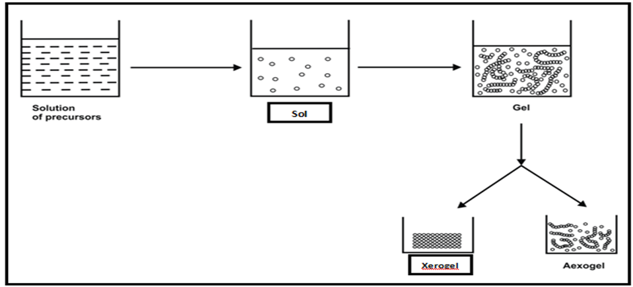
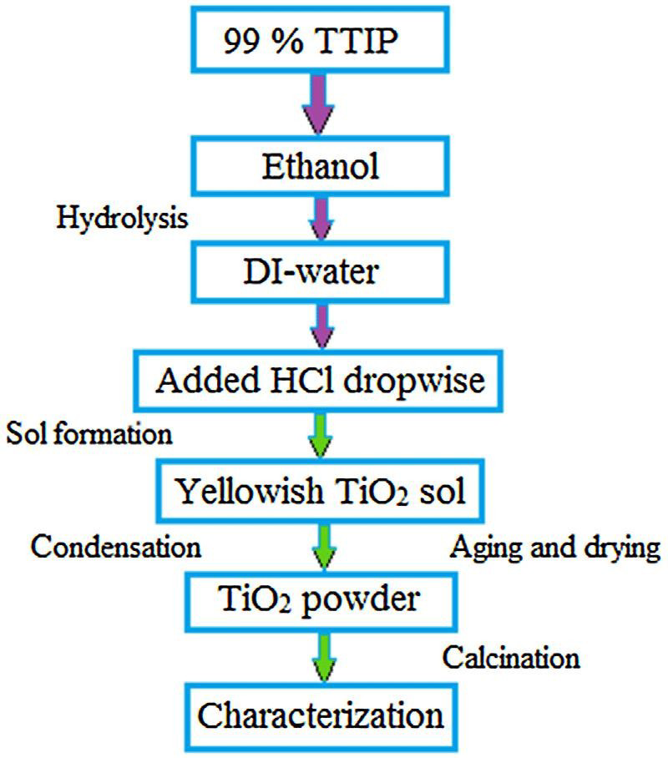
The gel is heat treated at high temperatures to collapse the pores in the gel network and to drive out remaining organic contaminants.
Properties:
- Controlled Size and Morphology:
The sol-gel method allows for precise control over particle size and morphology, producing highly uniform nanoparticles.
- High Purity and Homogeneity:
It enables the incorporation of dopants at the molecular level, resulting in high chemical purity and homogeneous materials.

- High Surface Area:
The technique can produce materials with very high surface areas, which are beneficial for catalytic and adsorption applications.
- Versatile Forms:
TiO₂ can be synthesized in various forms, including powders, thin films, and aerogels, suitable for diverse applications.
Applications:
- Photocatalysis:
TiO2 nanomaterials are excellent photocatalysts, used to degrade organic pollutants (e.g., dyes) and for water treatment.
- Solar Cells:
They serve as electron transport layers in solar cells and are used to deposit thin films for photovoltaic applications.
- Sensors:
Due to their unique surface properties, TiO₂ nanoparticles are employed in gas and chemical sensors.
- Coatings:
They find applications in self-cleaning surfaces, anti-fogging coatings, and protective layers for various materials.
- Catalysis:
TiO₂ acts as a catalyst in many chemical oxidation and reduction reactions.
DISPLAY SYSTEM:
A display system presents visual information from electronic sources, typically consisting of a screen and a graphics card, to provide users with an output of text, graphics, and video. The core function of any display technology is to simplify the sharing of visual information. Modern display systems use various technologies, including Liquid Crystal Displays (LCDs), Organic Light-Emitting Diodes (OLEDs) and Light-Emitting Diodes (LEDs) to show images and data for diverse applications, from personal computers and smartphones to industrial process documentation.
Review Questions
- What is Sol-Gel Process?
- Mention the Precursor used in the synthesis of TiO₂ RAM nanomaterial?
- Give one application of TiO₂ nanomaterials?
- What are display systems?
Lecture-5
Liquid crystals (LC’s):
Liquid Crystal is a unique state of matter in which the degree of molecular ordering lies intermediate between crystalline solid state and completely disordered liquid state. The liquid crystal state is also referred to a mesophase or mesogens. These are the state of matter which flow like liquid but have some degree of ordering in arrangement.
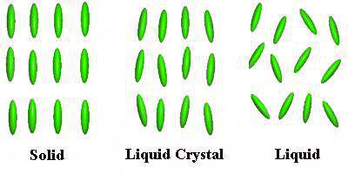
Classification
Liquid crystals are classified into two main categories, namely
(i) Thermotropic Liquid Crystals: The class of compounds that exhibit liquid crystalline behaviour on variation of temperature. E.g., Cholesteryl benzoate exhibits liquid crystal behaviour in between 145.5 ºC- 178.5 ºC. These are further classified into Nematic, Chiral Nematic and Smectic Liquid crystals.
(a) Nematic Liquid Crystals: These are formed by compounds which are optically inactive. The molecules are elongated shape with thread like structure and are approximately parallel to each other. In this phase molecules maintain a preferred orientational direction but position order is absent. Eg. Para-azoxyanisole (PAA) which exhibits liquid crystal behaviour in the temperature range 118ºC-135ºC.
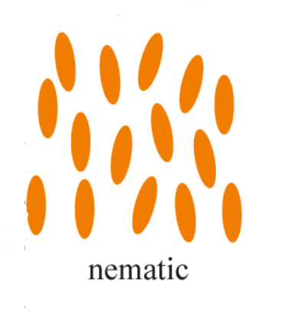
(b)Chiral Nematic or Cholesteric: These are formed by compounds which are optically active and have chiral centers. The molecules arrange themselves in layers as to form helical structure and don’t have positional order or orientation order. They change colour when exposed to different temperature. E.g., Cholesteryl formate.
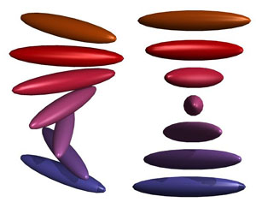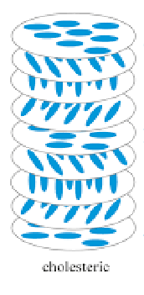

(c)Smectic Mesophase: These are soap like molecules. There is small amount of positional order and orientational order. The molecules are arranged in regularly spaced layers, Within the layers they tend to point along the director.Example: p, p'-dinonyl azobenzene

(d)Discotic Liquid Crystal: These molecules have disk like or plate like structure. Disc-shaped molecules have a tendency to lie on top of one another forming either discotic nematic phases (with discs oriented similarly) or columnar phases (which, obviously, have column-like structure).
Eg: hexa hexyl thio triphenylene
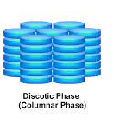
(ii) Lyotropic liquid crystals: The compounds which transforms into liquid crystal phase when mixed with solvent. They have both polar lyophilic and nonpolar lyophobic end. They are obtained from mixing a compound in a solvent and increasing the concentration of compound till liquid crystal phase is obtained. Such compounds are known as lyotropic liquid crystals. E.g., Soap- water mixture.
Properties of Liquid Crystals
- The intermolecular forces are rather weak and can be perturbed by an applied electric field.
- The molecules are polar, they interact with an electric field, which causes them to change their orientation slightly.
- Liquid Crystal can flow like a liquid, due to loss of positional order.
- Liquid crystal is optically birefringent, due to its orientation order.
- It exhibits thermal expansion.

Applications of liquid crystals
- Liquid Crystal Displays (LCDs): The liquid crystal layer in LCDs allows for the display of images and text through the use of electrical currents that control the orientation of the crystals.
- Sensors: Liquid crystal sensors are used in various applications such as temperature sensing, humidity sensing, and chemical sensing.
- Optical Devices: Liquid crystals are used in various optical devices such as variable optical attenuators, phase shifters, and tuneable filters. These devices are used in optical communication systems, spectroscopy, and imaging.
- Medicine: Liquid crystals have been used in drug delivery systems, where the drug is encapsulated in the liquid crystal matrix and delivered to specific target cells.
Review Questions
1. What are Liquid Crystals?
2. Mention the classification of Liquid Crystal.
3. Give one Property of Liquid Crystals.
4. Mention one Application of Liquid Crystals.
Lecture-6
Light-emitting diode (LED)
.A light-emitting diode (LED) is a semiconductor device that emits light when an electric current passes through it. It's essentially a p-n junction diode that produces light through a process called electroluminescence. When forward biased, electrons and holes recombine at the junction, releasing energy in the form of photons (light)

Construction:
The construction of LED is very simple because it is designed through the deposition of three semiconductor material layers over a substrate. These three layers are arranged one by one where the top region is a P-type region, the middle region is active and finally, the bottom region is N-type. The three regions of semiconductor material can be observed in the construction. In the construction, the P-type region includes the holes; the N-type region includes elections whereas the active region includes both holes and electrons.
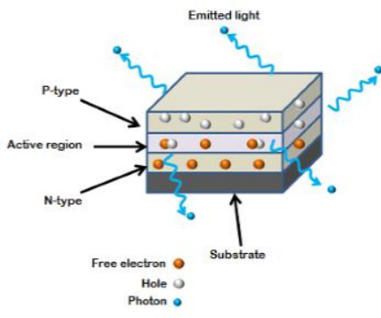
Working:
When the voltage is not applied to the LED, then there is no flow of electrons and holes so they are stable. Once the voltage is applied then the LED will forward biased, so the electrons in the N-region and holes from P-region will move to the active region. This region is also known as the depletion region. Because the charge carriers like holes include a positive charge whereas electrons have a negative charge so the light can be generated through the recombination of polarity charges.
Applications:
- LED is used as a bulb in the homes and industries
- The light-emitting diodes are used in motorcycles and cars
- These are used in mobile phones to display the message
- At the traffic light signals LED are used.
Review Questions
  - What is LCD?
  - What is LED?
  - What is Active Region?
  - Mention one application of LED.
Lecture-7
Organic light emitting diodes (OLED's)
OLEDs are thin film devices consisting of a stack of organic layers sandwiched between two electrodes. OLEDs operate by converting electrical current into light via an organic emitter.
Construction:
- Cathode: The cathode injects electrons into emissive layer
- Emissive layer: This layer is made of polyfluorene that transport electrons from cathode.This is where light is made.
- Conducting layer: This layer is made of polyaniline that transport “holes” from anode.
- Anode: It is kept transparent. Usually made up of Indium tin Oxide that removes electrons.

Working Principle
- Photoactive and electroactive materials absorb or emit light in UV or Visible region. The OLED display system consists of these materials.
- When an external electric field is applied electrons migrate from the light emitting layer to the anode, leaving behind the holes in the light emitting layer. From the anode these electrons then move towards the cathode through the external circuit and then back to the light emitting layer through the conducting layer.
- The light-emitting layer is excited by the recombination energy of electrons and holes and then the light-emitting layer emits light as the electrons return back to their ground state during recombination.
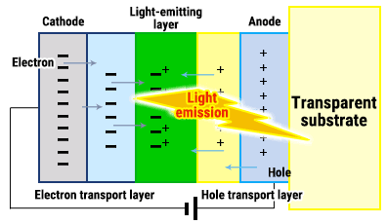
- One of the electrodes consists of transparent material in order to extract light from the light emitting layer.

Applications
- Televisions and displays: OLED displays are used in televisions, monitors, smartphones, and other electronic devices.
- Lighting: OLEDs can also be used as a source of lighting in various applications, including automotive lighting, street lighting, and architectural lighting.
- Wearable devices: The thin and flexible nature of OLEDs makes them suitable for use in wearable devices, such as smartwatches and fitness trackers.
- Automotive: OLEDs can be used in automotive applications, such as dashboard displays, interior lighting, and taillights.
- Medical: OLEDs can be used in medical applications, such as in surgical lighting and medical imaging. They offer bright and highly accurate lighting options that can help improve medical procedures and diagnosis.

Construction and working of active matrix organic light emitting diodes (AMOLEDs)
AMOLED is a type of OLED technology commonly used in large and advanced display systems. The term "active matrix" refers to the arrangement of light-emitting pixels, each controlled by its own dedicated thin-film transistor (TFT) and storage capacitor. This design ensures that each pixel is "actively" managed, resulting in high-quality displays with a long lifespan.
Construction:
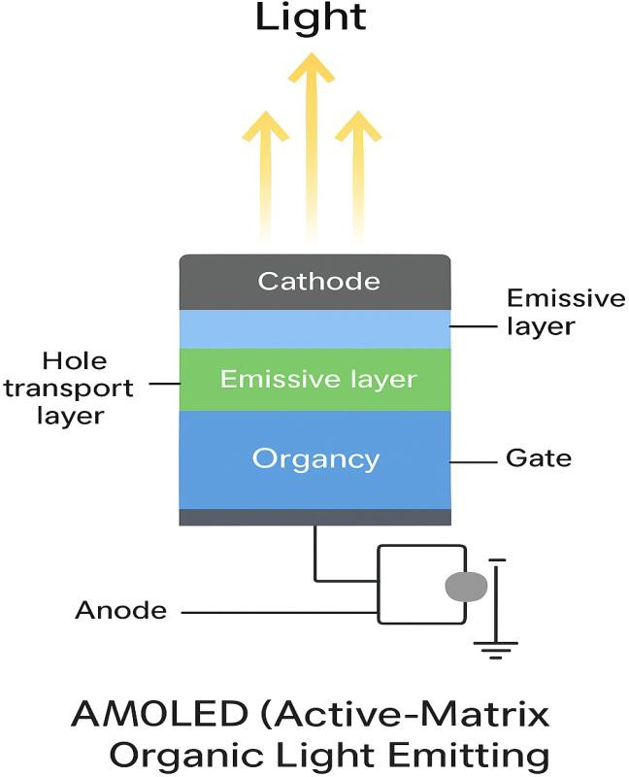
The key components of a AMOLED are:
- Emissive OLED Layer
- Electrodes
- Substrates
- Thin-film Transistor (TFT)
- Storage Capacitor

The individual AMOLED pixels have a basic structure consisting of an offset thin-film transistor connected to a transparent anode with a slight overlap. The organic emissive layer is coated on top of the anode, followed by a common cathode applied over the emissive layer. Additional material layers may be added to enhance connectivity and efficiency. As a larger system of multiple light-emitting pixels there are more electrodes to ensure connectivity. Signal and control electrodes are used to indicate which pixels should be emitting light at a given time. The transistor allows for precise control over the state of each pixel.
Working:
AMOLEDs consist of a grid of OLED pixels, each controlled by dedicated circuitry that includes transistors and capacitors. Each OLED pixel is paired with at least one thin-fim transistor and a corresponding capacitor, which precisely manage its on/off state and brightness. When a voltage is applied to the transistor, it charges the capacitor, maintaining the pixel's state until the next refresh cycle.
When a voltage is applied across the AMOLED device, the control and signal electrodes determine which pixels light up, their brightness and timing. Only selected pixels receive voltage at any given moment to produce the desired image or light output. Within each pixel, the organic light-emitting diode (OLED) component is composed of specific materials that emit light at the required wavelength. Materials used in the OLED layer of AMOLED devices include polymers and small molecules, each serving specific roles, such as efficiently harnessing electric charge and converting it into light.
Applications of AMOLED Displays:
- Smartphones: AMOLED screens are popular for their vibrant colors and power efficiency in smartphones.
- Tablets: The high contrast and fast response times of AMOLEDs make them suitable for tablets.
- Smart watches: Their thin and flexible nature allows for curved and wearable designs in smart watches.
- VR Headsets: AMOLEDs are widely used in virtual reality headsets due to their high refresh rates and immersive visuals.
- Televisions: Large-screen AMOLED TVs offer excellent picture quality and deep blacks.
Review Questions
- What is OLED?
- Give one Advantage of OLED.
- What is AMOLED?
- Give one Advantage of AMOLED over OLED.

Lecture-8
Quantum light emitting diodes (QLED’S)
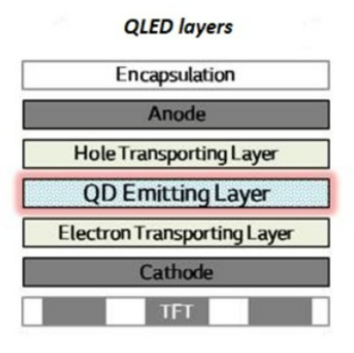
Quantum light emitting diodes are a form of light emitting technology used for creating large area displays. In QLED the light emitting is from the quantum dots such as cadmium selenide nano crystals. They emit light under applied electric field.

Construction:
- Substrate: The base layer of the QLED, providing structural support.
- Transparent Conductive Electrode (e.g., ITO): Allows for the injection of electrical current into the device.
- Hole Transport Layer (HTL): Transports holes (positive charge carriers) towards the quantum dots.
- Quantum Dot (QD) Layer: The core component, containing quantum dots that emit light when excited.
- Electron Transport Layer (ETL): Transports electrons (negative charge carriers) towards the quantum dots.
- Cathode: Completes the electrical circuit, allowing for the flow of current.
Working Principle:
- Charge Injection:
- When a voltage is applied, electrons are injected from the cathode into the ETL, and holes are injected from the anode into the HTL.
- Charge Transport:
- The ETL and HTL facilitate the movement of electrons and holes towards the QD layer.
- Recombination and Light Emission:
- When electrons and holes meet within the quantum dots, they recombine, releasing energy in the form of light. The color of the emitted light is determined by the size of the quantum dots.
- Color Tuning:
- Different sizes of quantum dots can be used to produce different colors. By combining quantum dots that emit red, green, and blue light, a full-color display can be created.
- Light Modulation:
- The liquid crystal layers then modulate the light from the quantum dots to create the desired image.
Applications of QLED
Televisions and displays: QLED displays are commonly used in televisions, monitors, smartphones, and other electronic devices. They offer superior image quality and color accuracy compared to traditional LCD displays.
Lighting: QLEDs can also be used as a source of lighting in various applications, including automotive lighting, street lighting, and architectural lighting.
Medical imaging: QLEDs can be used in medical imaging applications, such as in MRI machines, to produce high-resolution and accurate images.
Virtual and augmented reality: QLED displays are suitable for use in virtual and augmented reality applications due to their ability to produce vibrant and accurate colors, which can enhance the immersive experience.
Advertising displays: QLED displays can be used in advertising displays, such as digital billboards to produce high-quality and eye-catching visuals.
Review Questions

1. What is QLED?
2. Mention one Property of QLED.
3. Give one Advantage of QLED in Medical Field.
4. Give one Advantage of QLED over AMOLED.

Question Bank
- What are memory devices? Explain the types of organic memory materials (devices) by taking p type and n-type semiconductor materials.
- Discuss the Differences between organic and Inorganic memory devices:
- Explain Advantages of organic semiconductors.
- Explain the construction and working of organic pentacene semiconductor chip.
- What are resistive ram (Re RAM) materials? Explain the synthesis of TiO2 RAM nanomaterial by sol-gel method
- What are liquid crystals? Explain the classification of liquid crystals with suitable examples.
- Mention any four properties and applications of Liquid crystals in display systems
- Explain construction, working and applications of LED.
- Explain construction,working and applications of OLED.
- Explain construction, working and applications of AMOLED.
- Explain construction, working and applications of QLED.

-------------------------

