MODULE-3
SUSTAINABLE ENERGY SYSTEMS
Lecture 1
ENERGY SYSTEMS:
Energy systems are defined as well-engineered systems designed to supply energy services, including power generation, heating, cooling, and domestic hot water, to end users. They encompass primary energy sources, energy conversion management, and distribution to various sectors such as residential, commercial, industrial, and agricultural.
Nernst equation:
Nernst derived quanitative relationship between potential and concentration of metal ions involved.
The Nernst Equation is given by,
Where,
- E = Electrode potential of an electrode
- E⁰ = Electrode potential under standard conditions
- R = universal gas constant
- T = temperature
- n = number of electrons transferred in the redox reaction
- F = Faraday constant
- M^{n+} = Molar concentration of a metal ion in an aqueous solution

Concentration Cells
Galvanic cells in which both the anode and the cathode are made up of the same element (metal or non-metal) in contact with the solutions of the same electrolyte, but emf arises due to difference in concentrations of electrolyte are referred to as concentration cells.
Eg: Concentration cell consisting of two half cells. Both the electrodes are made up of copper metal but dipped in copper sulphate solutions of different concentrations. It is represented as
Cu|Cu⁺²(C₁)||Cu⁺²(C₂)|Cu
Where C₁and C₂ are the molar concentrations of the Cu⁺² ions in the two half cells.
By convention left hand electrode is the anode and the right-hand electrode is the cathode.

The half-cell reactions are
Cu Cu⁺²(C₁) + 2e⁻ (Anode reaction)
Cu⁺²(C₂) + 2e⁻Cu (Cathode reaction)
Adding the two half-cell reactions, the net cell reaction is
Cu⁺²(C₂) Cu⁺²(C₁)
The potential of the cell is Ecell = E_{R} -E_{L}
Where E◦ is the standard reduction potential of the species in the concentration cell. On simplifying
E_{cell} is positive if C₂>C₁
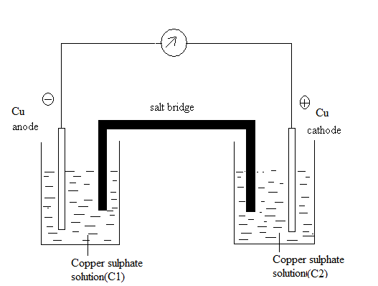
Review Questions
1. What is energy System?
2. What are concentration cells?
3. What is Nernst Equation?
4. What is an electrochemical cell?
5. What is half-cell?
Lecture 2
Numerical Problems on Concentration Cell
Lecture 3
Batteries:
Battery is a device consisting of two or more galvanic cells connected in series or parallel or both, that store chemical energy in the form of active materials and on demand convert it into electrical energy through electrochemical redox reaction.
Classification of batteries
i) Primary battery or primary cells: In primary the cell reaction is not reversible. These are not rechargeable and once discharged have no further electrical use and battery becomes dead. Eg. Dry Cell.
ii) Secondary batteries: Secondary batteries are rechargeable. The cell reactions are reversible and these are also known as reversible batteries. After discharge secondary batteries can be recharged electrically to their original condition by passing current through them in the direction opposite to that discharge current. Eg: Lead acid battery, Ni-MH battery
iii) Reserve batteries: In these batteries, a key component is separated from the rest of the battery prior to activation. Usually, the electrolyte is the component that is isolated. The activation involves adding electrolyte and hence the battery has long term storage capacity. In this condition, chemical deterioration or self- discharge is essentially eliminated. Eg: Li-V₂O₅.
Li- ion Battery
Anode - Lithium intercalated in graphite as anode (Li/C)
Cathode – Lithium Cobalt Oxide or LiMnO₂ or (LiMO₂)
Electrolyte – Lithium salt such as LiPF₆ in organic electrolyte mixture such as ethylene carbonate – dimethyl carbonate.
The Separator –Polypropylene.
Electrode reactions
While discharging, lithium atoms present in the graphite layer are oxidized, liberating electrons and lithium ions. Electrons flow through external circuit to the cathode and lithium ion moves through the electrolyte towards cathode. At cathode lithium ions are reduced to lithium atoms and are inserted into the layered structure of metal oxide. Here lithium ions become embedded in the porous electrode material in a process known as intercalation.

When the cell is charging, the reverse occurs. Lithium present in the layered metal oxide oxidizes, liberating electrons and lithium ions. Electrons flow through external circuit and lithium ion moves through the electrolyte towards anode.

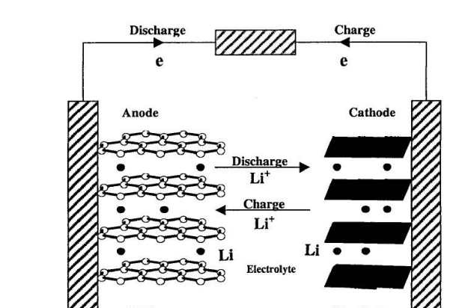

Applications
- These are used in cell phones, laptops, electrical vehicles and aerospace applications.
NEXT-GENERATION ENERGY SYSTEMS:
Na- ion Battery
Anode – Hard carbon/ Na
Cathode –Sodium inserted layered metal oxide, (NaMO₂)
Electrolyte – NaPF₆ dissolved in binary organic solvent mixture such as ethylene carbonate-dimethyl carbonate
The Separator –Polypropylene.
Aluminum is used as current collector.
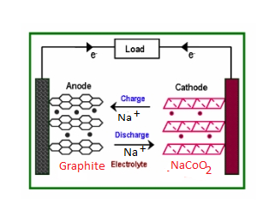
Electrode reactions
During discharging
At anode,
C-Na Na⁺ + C + e⁻
Electrons flow from anode to cathode through external circuit. Sodium ions move through the electrolyte and separator to reach cathode.
At cathode,
Sodium ions are reduced to sodium atom and are inserted into the layered structure of metal oxide.
Na⁺ + e⁻ + MO₂ Na-MO₂
Reactions are reverse during charging of the battery.
Applications
- Mobile phones, camera and Laptops.
- Large scale grid storage application.
Review Questions
1. Give an example for primary battery.
2. Give the application for reserve battery.
3. What is the application of Sodium-ion battery.
4. Give the application of Li-ion battery.
Lecture 4
ULTRA-SMALL ASYMMETRIC SUPER CAPACITORS:
Super capacitor
A supercapacitor is an energy storage device that bridges the gap between high-energy batteries and high-power conventional capacitors.
Construction of an Ultra-small Asymmetric Supercapacitor (ASC):
Cathode (positive electrode) is a battery-type material such as MnO₂. These transition metal oxides/hydroxides store charge through Faradaic (redox) reactions:
Anode (negative electrode) is a carbon-based material such as Graphene/ Activated carbon/ Carbon nanotubes. These materials store charge electrostatically through electric double layer (EDL)
Electrolyte: polymer gel electrolyte such as PVA/H₂SO₄, provides H⁺ ions for ionic conduction.
Separator: Ultra-thin porous membrane, allows ion movement but prevents electrical short.
Current Collectors: Flexible materials such as PET, cellulose paper, or metal foils.
Working
During Charging Process:
When a voltage is applied across the supercapacitor
At Anode: H⁺ ions from the electrolyte are attracted onto the surface of carbon electrode. They accumulate at the surface, forming the electric double-layer. (There is no Faradaic reaction, only physical charge storage)
C + e⁻ + H⁺ ↔ C⁻ H⁺
At Cathode: Mn (III) is oxidized to Mn(IV). H⁺ ions are released into the electrolyte. Electrons flow from cathode to anode through the external circuit during charging
HMnO₂​ ↔ MnO₂ ​+ H⁺ + e⁻
​During Discharging Process:
When the supercapacitor is connected to a load (like an LED), the stored energy is released.
At Anode: An electric double-layer present at anode disintegrates releasing electrons, Electrons move through the external circuit from anode to cathode. This flow of electrons through the external circuit constitutes the electric current that powers the device. H⁺ ions move back toward the cathode.
C⁻H⁺ → C + e⁻ + H⁺
At Cathode: Mn(IV) is reduced back to Mn(III). H⁺ ion from the electrolyte is intercalated into the MnO₂ layer.
MnO₂ ​+ e⁻ + H⁺→ HMnO₂​
The combination of Faradaic reactions (positive electrode) and EDL (negative electrode) allows the ASC to deliver high energy, high power and stability.

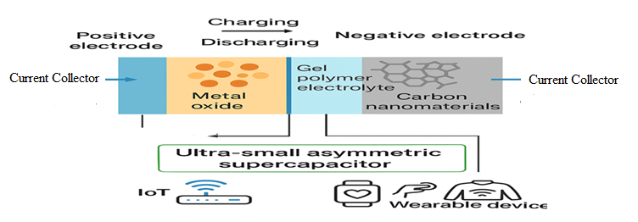

Applications in IoT/Wearables:
- Power source for low-energy IoT sensors and wireless nodes.
- Integrated into flexible and stretchable wearables such as smart textiles, fitness trackers, and health monitoring devices.
- Suitable for intermittent energy harvesting systems (solar cells, piezoelectric harvesters).
- Lightweight, eco-friendly, and mechanically robust, ideal for bendable and portable electronics.
- Long cycle life ensures reliable operation in implantable medical devices and compact communication modules.
Review Questions
- What are Ultra-small asymmetric super capacitors?
- Give one application of Ultra-small asymmetric super capacitors?
- Mention the electrode Matrial used in Ultra-small asymmetric super capacitors?
- Give one example for non-faradaic material.
Lecture 5
Sustainable Energy Devices:
Introduction: Sustainable energy devices use renewable energy sources such as solar, wind, hydro, biomass, geothermal, and fuel cells to generate electricity or heat while minimizing environmental impact. These devices support the transition to a low-carbon economy by mitigating carbon emissions and promoting energy security and affordability.

Fuel cells
Definition: A fuel cell is galvanic cell in which the chemical energy contained in a readily available fuel oxidant system is converted directly into electrical energy by means of electrochemical processes in which the fuel is oxidized at the anode.
Like other electrochemical cell, the fuel cell has two electrodes and an electrolyte. However the fuel and the oxidizing agents are continuously and separately supplied to the two electrodes of the cell, at which they undergo reactions. These cells are capable of supplying current as long as they are supplied with the reactants.
A fuel cell consists of following arrangement
Fuel | electrode | electrolyte | electrode | Oxidant
At the anode, fuel undergoes oxidation
Fuel Oxidation product + ne⁻
At the cathode, the oxidant gets reduced.
Oxidant + ne⁻Reduction product
The electrons liberated from the oxidation process at the anode can perform useful work when they pass through the external circuit to the cathode.
Difference between fuel cell and Battery
Aspect | Fuel Cell | Battery
Energy Role | Generates electricity continuously from fuel supply | Stores chemical energy and releases it until depleted
Fuel Source | Requires constant external supply of fuel (e.g., hydrogen) and oxygen | Contains internal reactants, no external supply needed during use
Operation Time | Operates as long as fuel is supplied | Operates until internal chemicals are exhausted
Refuel/Recharging Time | Refueling takes minutes (like fueling a car) | Recharging can take hours
Energy Density | Generally higher energy density, suitable for larger vehicles | Lower energy density, suitable for smaller, lighter applications
Emissions | Water and heat only (if hydrogen used) | No emissions during use, but production impacts environment
Cost | Typically, more expensive | Generally, less expensive
Efficiency | Higher efficiency | Lower efficiency
Review Questions
1. What are sustainable energy devices?
2. What are fuel cells?
3. What are the difference between fuel cell and battery?
4. What are the reactins taking place at anode and cathode in fuel cell?
Lecture 6
Solid Oxide fuel cell:
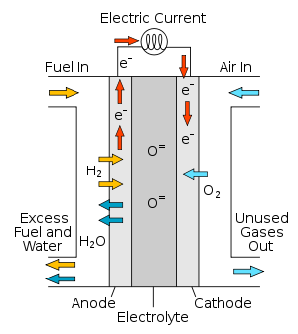
In SOFC anode is Ni on ZrO₂, The cathode is porous strontium doped LaMnO₃ (Lanthanum manganate). The electrolyte is solid ZrO₂- Y₂O₃ (Yettria stabilized Zirconia). It is oxygen ion (O²⁻) conductor. The advantage of solid electrolyte is that it is less corrosive. Hydrogen is used as the fuel and Oxygen as the oxidant. During its operation SOFC produces large amount of heat, which can be used for space heating, water heating etc. The cell operates at temperature above 1000◦C.
.
Oxygen supplied at the cathode reacts with incoming electrons from the external circuit to form oxygen ions, which migrate to the anode through the oxygen ion conducting electrolyte. At the anode, oxygen ions combine with hydrogen to form water, liberating electrons. Electrons flowfrom anode through the external circuit to cathode.
Electrode reactions:
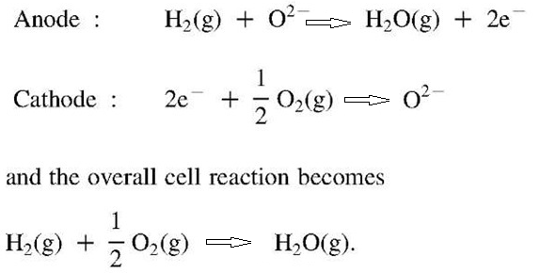

Advantages: High efficiency, reliability, fuel adaptability, and very low levels of NO_{x} and SO_{x} emissions.
Applications
- Solid Oxide fuel cells are used in locomotives. The heat produced by the cell is used for space heating, water heating etc.
- Used in power plants and for industrial applications.
Review questions
1. Name the anode material in SOFC.
2. Name the cathode material in SOFC.
3. Which is the electrolyte used in SOFC.
4. What are applications of SOFC.
Lecture 7
Photovoltaic cells
Definition: Photovoltaic cells or solar cells are semiconductor devices they convert sunlight falling on them into direct electricity.

Construction and Working of a Photovoltaic cells
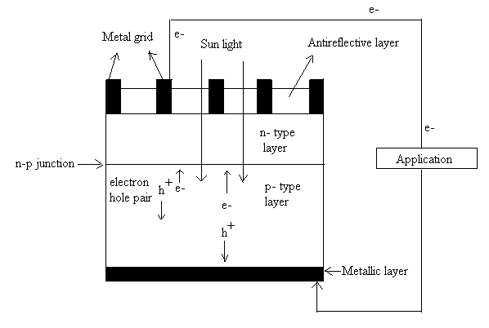
Solar cells consist of p-n junction formed from a semiconductor diode obtained when n - type and p- type semiconductor is brought together to form a metallurgical junction. The diode has two electrical contacts one of which is in the form of a metallic grid and other is a layer of noble metal on the back of the solar cell. The metallic grid allows light to fall on the semiconductor between the grid lines. An anti-reflective layer between the grid lines increases the amount of light transmitted to the semiconductor.When light radiation falls on the p-n junction diode, electron hole pairs are generated by the absorption of the radiation. The electrons are drifted to and collected at the n- type end and holes are drifted to and collected at the p-type end. When these two ends are electrically connected through a conductor, there is a flow of current between two ends through the external circuit. Thus, photoelectric current is produced and available for use.
Advantages of photovoltaic cells
- Energy source is unlimited
- No emissions and does not cause environmental pollution.
- Low operating costs
- No moving parts and no wear and tear
- Operates at ambient temperature
- Quick installation
Disadvantages of photovoltaic cells
- High installation costs
- Energy can be produced only during day time / Weather dependent
- Large space needed
- Less efficient
Review Questions
    - What is photovoltaic cell?
    - Mention the application of photovoltaic cell.
    - What are the advantages of photovoltaic cell?
    - What are disadvantages of photovoltaic cell?
Lecture 8
Hydrogen Production by Photocatalytic Water Splitting:
In this method water is Split into hydrogen and oxygen by using a photocatalyst and co-catalyst using solar energy.
In this method powdered photocatalyst made up of semiconductor material along with co-catalyst made up of nanoparticles is suspended in water.
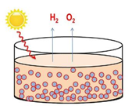
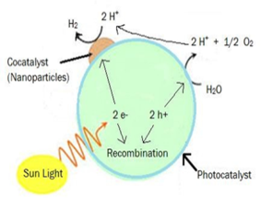

When solar light falls on these photocatalyst(TiO₂) electron and hole pairs are generated , which are separated and transferred to the surface due to the presence of co-catalyst(Pt).
The holes (h⁺) will oxidise water molecules to liberate oxygen gas and H⁺ ions
H₂O (l) + 2h⁺ 2H⁺ (aq) + ½ O₂ (g)
The H⁺ ions combine with electrons to produce hydrogen at the surface of the cocatalyst.

2 H⁺ + 2 e⁻ H₂ (g)
The produced hydrogen can be used as the fuel in hydrogen fuel cell.

Review Questions
1. What is green fuel?
2. Why hydrogen is called green fuel?
3. Name the co-catalyst used in hydrogen production by photocatalytic water splitting.
4. Name the catalyst used in hydrogen production by photocatalytic water splitting.

Question Bank
- Describe the hydrogen production by photo catalytic water splitting method.
- Explain the construction and working of photovoltaic cells.
- Describe the construction and working of Solid oxide fuel cell.
- What are fuel cells? Differentiate fuel cell and Battery.
- Derive Nernst equation for concentration cell.
- Describe the construction, working and applications of Na-ion batteries and mention any four applications.
- Describe the construction, working and applications of Li-ion batteries and mention any four applications.
- Describe the construction, working and applications Solid oxide fuel cell.

