CASE STUDY: AI ADOPTION & PRODUCTIVITY INTELLIGENCE
Table of Contents
1. Project Overview 3
2. Business Context 4
3. Business Problem 4
4. Project Objectives 5
5. Dataset Overview 5
6. Data Preparation 6
7. Analytical Methodology 7
8. Dashboard Architecture 8
8.1 Executive AI Intelligence Overview 8
8.2 AI Usage Behaviour 9
8.3 AI Performance Insights 10
8.4 AI User Segmentation 11
9. Key Findings 12
10. Business Interpretation 13
11. Recommendations 14
12. Technical Implementation 14
13. Project Limitations 15
14. Business Value 16
15. Conclusion 16
16. Skills Demonstrated 17

AI Adoption & Productivity Intelligence
A Power BI Business Intelligence Case Study
Tools: Power BI | DAX | Data Cleaning | Data Visualisation | Business Intelligence
Dataset: 288 users
Project Type: AI Adoption & Productivity Analytics

1. Project Overview
The AI Adoption & Productivity Intelligence project analyses user-level data to examine patterns in artificial intelligence adoption, usage behaviour, productivity, satisfaction and time savings. The dataset contains 288 users and provides information relating to AI tools, usage hours, AI purposes, user type, productivity outcomes, satisfaction levels and geographical distribution. The project uses Microsoft Power BI to transform the dataset into a four-page business intelligence solution. The dashboard combines executive KPI reporting, AI tool analysis, behavioural analysis, user-level performance analysis and custom user segmentation. The analysis moves from broad adoption patterns towards deeper performance and behavioural insights. The final segmentation framework classifies users according to their relative AI usage and productivity levels, allowing different user profiles to be examined separately. The project demonstrates how user-level data can be converted into an executive-oriented analytical solution that supports the interpretation of AI adoption and productivity patterns.
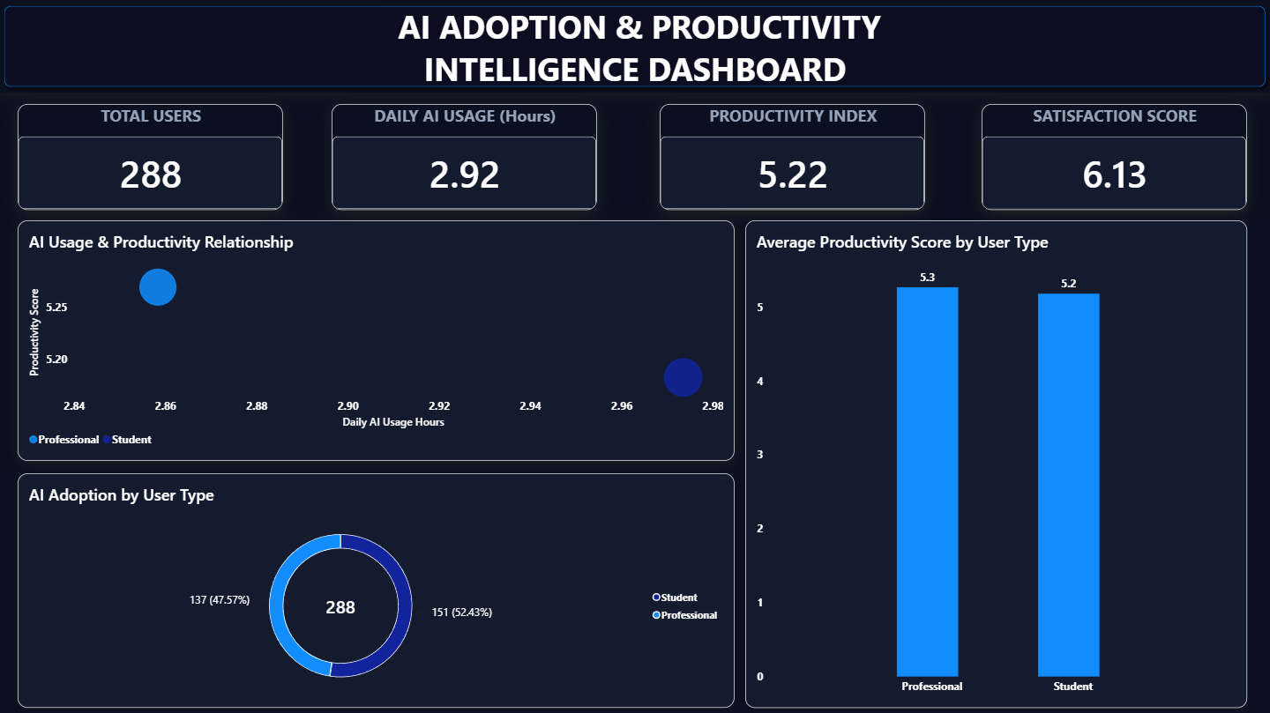
Power BI | DAX | Data Analytics | Business Intelligence

2. Business Context
Understanding AI Adoption Beyond Usage
AI adoption is increasingly measured through indicators such as tool usage, frequency of interaction and time spent using AI applications. However, usage volume alone does not provide a complete view of AI effectiveness. A user may interact with AI frequently without demonstrating a corresponding level of productivity, while another user may achieve a relatively high productivity score with lower AI usage. Similarly, AI usage may be associated with different levels of satisfaction and time savings across users. The project therefore approaches AI adoption as a multidimensional analytical problem. It considers usage, productivity, satisfaction, time savings, purpose and user behaviour together rather than treating AI adoption as a single metric.

3. Business Problem
The dataset contains multiple dimensions of AI adoption, but the underlying information does not immediately provide a consolidated view of user behaviour and performance.
The project therefore addresses several business questions:
- Which AI tools demonstrate the highest adoption?
- What are users primarily using AI for?
- How frequently do users interact with AI?
- How does AI usage relate to productivity?
- How does AI usage relate to satisfaction?
- Which users demonstrate strong AI adoption and productivity?
- Which users demonstrate lower AI adoption and productivity?
- How are users distributed geographically?
- Which behavioural segments require closer investigation?
These questions provide the analytical foundation for the Power BI dashboard.

4. Project Objectives
The project establishes the following objectives:
- Measure overall AI adoption across the available user population.
- Identify the most frequently used AI tools within the dataset.
- Analyse AI usage purposes to understand how users apply AI.
- Examine AI usage against productivity and satisfaction at the user level.
- Identify high-performing AI users using multiple performance indicators.
- Analyse geographical distribution of AI users.
- Develop a custom user segmentation framework based on AI usage and productivity.
- Present the findings through an executive Power BI dashboard suitable for decision-support and portfolio demonstration.

5. Dataset Overview
Data Structure
The dataset contains 288 user records and includes variables covering AI adoption, user characteristics, productivity, satisfaction, efficiency and geographical information.
The principal analytical fields include:
Category | Variables
User Information | User ID, User Type
AI Adoption | AI Tool, AI Usage Hours
AI Application | AI Purpose
Productivity | Productivity Score
Satisfaction | Satisfaction Score
Efficiency | Time Saved Hours
Geography | Country
Additional Measures | Work/Study Hours, Accuracy Rating, AI Recommendation

6. Data Preparation
Preparing the Dataset for Analysis
The dataset undergoes preparation before visual analysis. The process standardises categorical values, removes inconsistencies in AI tool naming and prepares the fields for consistent aggregation within Power BI. AI tool names such as Chat GPT / ChatGPT, Google Gemini / Gemini, and Microsoft Copilot / Copilot are standardised into consistent categories. Unclassified AI tool and purpose values are treated as Other rather than being presented as unfinished or inconsistent categories. The prepared dataset is then loaded into Power BI, where the fields are used to construct measures, analytical visuals and user-level segmentation. The preparation process improves the consistency of the dashboard and reduces the risk of duplicate categories affecting interpretation.
Before | Standardised
Chat GPT | ChatGPT
ChatGPT | ChatGPT
Google Gemini | Gemini
Gemini | Gemini
Microsoft Copilot | Copilot
Copilot | Copilot
Unknown | Other

7. Analytical Methodology
The analysis follows a structured business intelligence workflow.
Stage 1 — Data Preparation
The dataset is reviewed, standardised and prepared for consistent analysis.
Stage 2 — Descriptive Analysis
Core KPIs measure:
- Total users
- Average AI usage
- Average productivity
- Average satisfaction
Stage 3 — Behavioural Analysis
AI tools, AI purposes, usage frequency and geographical distribution are analysed to identify adoption patterns.
Stage 4 — Relationship Analysis
Scatter plots examine relationships between:
- AI usage and productivity
- AI usage and satisfaction
User ID is used as the analytical detail level so that individual user variation remains visible.
Stage 5 — User Segmentation
A DAX-based segmentation framework compares each user's AI usage and productivity against the overall dataset averages.
Stage 6 — Decision-Oriented Reporting
The results are presented through four Power BI pages designed to move from executive overview → behaviour → performance → segmentation.

8. Dashboard Architecture
The Power BI solution contains four analytical pages.

8.1 Executive AI Intelligence Overview
The first dashboard page provides an executive-level overview of AI adoption and user outcomes.
The page presents four core KPIs:
- 288 total users
- 2.92 average AI usage hours
- 5.22 average productivity score
- 6.13 average satisfaction score
The page also compares AI usage with productivity, presents the distribution of users by user type and compares average productivity between user groups. The purpose of the page is to establish the overall performance profile before moving into detailed behavioural analysis.

8.2 AI Usage Behaviour
The second dashboard page examines how users interact with AI.
- The Most Used AI Tools visual identifies the relative adoption of different AI platforms. ChatGPT represents the highest recorded tool adoption in the dataset, with 119 users.
- The AI Usage Purpose Analysis visual examines the activities for which users apply AI, while the AI Usage Frequency Pattern illustrates the distribution of users according to daily AI usage.
- The Global AI Adoption Distribution map adds a geographical perspective and demonstrates how AI users are distributed across countries.
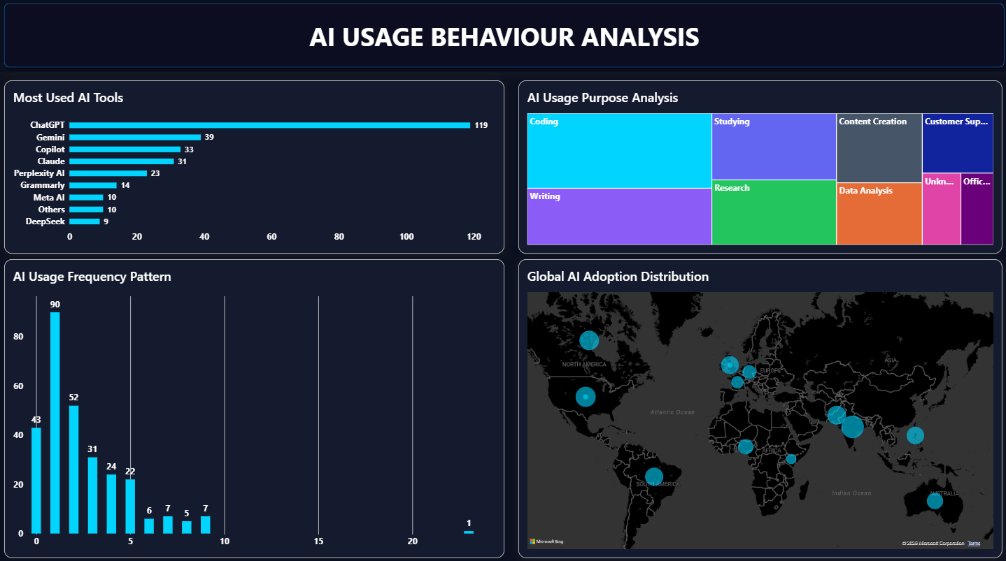

8.3 AI Performance Insights
The third dashboard page examines the relationship between AI usage and user outcomes.
- The AI Usage vs Productivity Performance scatter plot displays individual users according to AI usage and productivity, with bubble size representing time saved. User type provides additional segmentation.
- The AI Usage vs Satisfaction Impact visual applies the same user-level approach to satisfaction, allowing differences in satisfaction to be examined alongside AI usage.
- The AI Power User Ranking table provides a detailed view of users with stronger productivity profiles and compares their AI usage, time savings and satisfaction measures.
- The page therefore shifts the analysis from adoption volume towards user-level performance patterns.
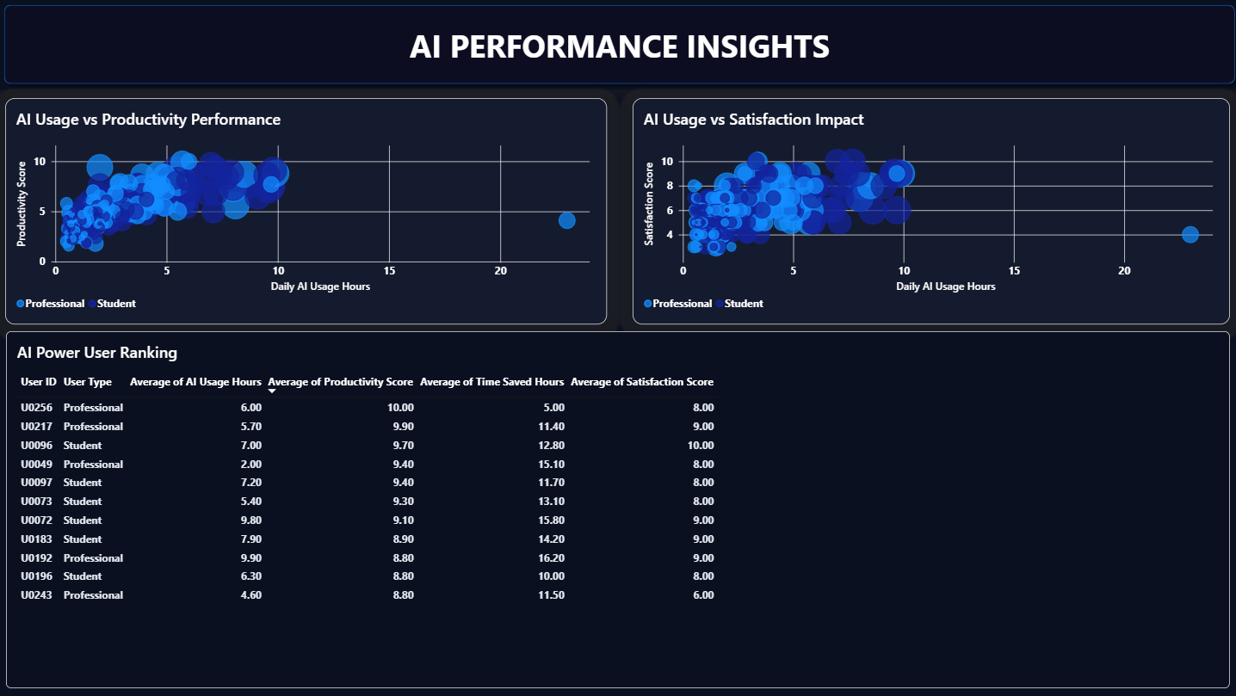

8.4 AI User Segmentation
The fourth dashboard page introduces a custom user segmentation framework.
The framework uses the dataset's overall average AI usage and productivity scores as benchmark thresholds:
- Average AI usage: 2.92 hours
- Average productivity score: 5.22
Each user is then classified according to whether their AI usage and productivity fall above or below these benchmarks.
Four segments are produced:
Segment | Users | Share
AI Champions | 84 | 29.17%
High Adoption / Lower Productivity | 19 | 6.60%
Low Adoption / High Productivity | 36 | 12.50%
Low Adoption / Low Productivity | 149 | 51.74%
Total | 288 | 100%

The segmentation matrix provides a visual representation of these groups, while the distribution chart and KPI cards show their relative size.
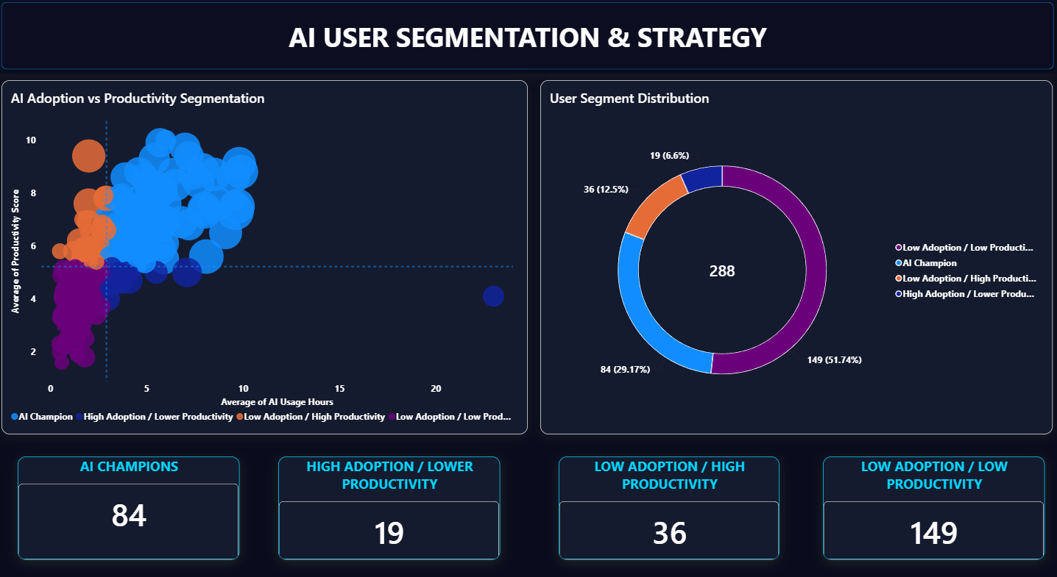

9. Key Findings
What the Analysis Shows
Finding 1- AI adoption is concentrated around established AI platforms
ChatGPT represents the highest recorded tool adoption in the dataset, indicating a strong concentration of users around established generative AI platforms.
Finding 2- AI usage varies between users
The user-level scatter analysis demonstrates substantial variation in AI usage. Users do not follow a single adoption pattern, which supports the use of behavioural segmentation.
Finding 3- AI usage should not be interpreted as a direct measure of productivity
The relationship analysis shows that AI usage and productivity should be considered together rather than treating higher usage as automatically representing higher productivity.
Finding 4- Distinct user profiles exist
The segmentation framework identifies four user profiles based on relative AI usage and productivity.
Finding 5- The largest segment is Low Adoption / Low Productivity
The segment contains 149 users, representing 51.74% of the dataset.
This group represents the largest population in the segmentation framework and therefore provides an important area for further investigation.
Finding 6- AI Champions represent a substantial user group
The AI Champion segment contains 84 users, representing 29.17% of the dataset.
These users demonstrate both relatively high AI usage and relatively high productivity according to the segmentation thresholds.

10. Business Interpretation
The segmentation results indicate that AI adoption cannot be evaluated effectively through usage volume alone.
- The AI Champion segment demonstrates relatively high AI adoption alongside relatively high productivity. This segment can therefore provide useful examples of effective AI-enabled workflows.
- The High Adoption / Lower Productivity segment demonstrates a different pattern. Higher AI usage does not correspond to a higher productivity score within the segmentation framework, suggesting that usage frequency alone may not represent effective AI application.
- The Low Adoption / High Productivity segment provides another useful comparison. These users demonstrate relatively high productivity despite lower AI usage, creating an opportunity to examine whether productivity is being supported by alternative workflows or practices.
- The Low Adoption / Low Productivity segment represents the largest group. Its size indicates that low adoption and low productivity occur together for a substantial proportion of the dataset and therefore warrant further investigation.
These interpretations represent associations within the dataset rather than evidence of causal relationships.

11. Recommendations
Data-Driven Recommendations
1. Analyse AI Champion behaviours
The practices of AI Champions can be examined to identify repeatable workflows, tools and use cases that may support effective AI adoption.
2. Investigate high usage with lower productivity
Users in the High Adoption / Lower Productivity segment can be examined to determine whether frequent AI usage is associated with inefficient workflows, unsuitable tool selection or gaps in AI capability.
3. Study low-adoption high performers
The Low Adoption / High Productivity segment can be analysed to identify productivity practices that do not depend heavily on AI usage.
4. Provide targeted support to low-adoption low-productivity users
The largest segment can be examined further to identify potential barriers to AI adoption, workflow inefficiencies or training requirements.
5. Monitor multiple performance indicators
AI adoption should be monitored alongside productivity, satisfaction and time savings rather than through usage hours alone.

12. Technical Implementation
Power BI & DAX
The project uses Microsoft Power BI as the primary business intelligence platform.
The dashboard incorporates:
- KPI cards
- Clustered column charts
- Bar charts
- Donut charts
- Treemaps
- Scatter plots
- Geographic mapping
- Analytical tables
- Conditional formatting
- Custom DAX measures
- Calculated columns
- User segmentation
A calculated DAX column creates the four user segments by comparing individual AI usage and productivity scores against dataset-level averages.
DAX measures then calculate the number of users within each segment, allowing the KPI cards to update dynamically.
POWER BI - Dashboard Development
DAX - Measures & Segmentation
DATA CLEANING - Standardisation & Preparation
DATA VISUALISATION - Analytical Storytelling
BUSINESS INTELLIGENCE - Decision Support

13. Project Limitations
The analysis identifies patterns and relationships within the available dataset but does not establish causal relationships between AI usage and productivity or satisfaction. The segmentation thresholds are based on overall dataset averages. Consequently, the four segments represent relative positions within this dataset rather than universal definitions of high or low AI adoption. The analysis also depends on the variables available in the dataset. Additional information such as job role, industry, task complexity, AI training level and organisational context could provide further explanatory value.
These limitations are considered when interpreting the findings.

14. Business Value
The project demonstrates how a relatively complex user-level dataset can be transformed into a structured business intelligence solution. The dashboard provides several layers of analysis:
Executive layer
What is happening?
Behavioural layer
How are users adopting AI?
Performance layer
How does usage relate to user outcomes?
Segmentation layer
What different user profiles exist?
This layered approach allows the dashboard to serve both high-level review and deeper analytical investigation.

15. Conclusion
The AI Adoption & Productivity Intelligence project demonstrates a structured approach to analysing AI adoption through Power BI. The analysis combines adoption metrics, behavioural patterns, productivity, satisfaction, time savings, geography and user segmentation into a single analytical solution. The custom segmentation framework adds a decision-oriented layer by distinguishing users according to relative AI usage and productivity. Overall, the project demonstrates practical capability in Power BI, DAX, data preparation, analytical visualisation, business intelligence and data storytelling, while also recognising that the observed relationships represent patterns within the dataset rather than causal effects.

16. Skills Demonstrated
Technical Skills
Power BI
- Dashboard development
- Visual design
- Data modelling
- Report formatting
DAX
- Calculated columns
- Measures
- CALCULATE
- DISTINCTCOUNT
- Conditional segmentation
- Dynamic KPI calculations
Data Analytics
- Descriptive analysis
- Relationship analysis
- User segmentation
- Behavioural analysis
- Performance analysis
Business Intelligence
- Business question development
- KPI design
- Data storytelling
- Decision-support reporting

