Automated Security Scanning for Infrastructure as Code (IaC) Using Terraform, Checkov & tfsec
Thigulla Dheeraj Goud
Email: thigulladheerajgoud@gmail.com
M Balaji Partha Sarathi
Email: balu17.marripally@gmail.com
Adutla Sathvik Reddy
Email: sathvikreddyadutla@gmail.com
Kattekola Prashanth
Email: kattekolaprashanth55@gmail.com
Department of Computer Science and Engineering
Sreyas Institute of Engineering and Technology, Hyderabad, India

Abstract
This article presents a practical DevSecOps implementation of automated security scanning for Infrastructure-as-Code (IaC) using Terraform, Checkov, and tfsec. The project aims to prevent cloud misconfigurations by integrating automated static security analysis tools into the development workflow. Through Terraform, Azure resources are defined declaratively, while Checkov and tfsec analyze the IaC before deployment to ensure compliance and security. This automation helps development teams adopt a ‘shift-left’ approach to cloud security, detecting vulnerabilities early and improving IaC reliability. The methodology, workflow, and scan results demonstrate how continuous scanning, policy-as-code, and secure configuration can be integrated effectively into modern DevOps pipelines.

1. Introduction
In modern cloud-native development, Infrastructure-as-Code (IaC) enables teams to define and manage cloud resources programmatically. While this accelerates provisioning, insecure IaC files can introduce vulnerabilities such as open storage, weak encryption, or public network access. Automated IaC security scanning integrates security directly into the DevOps lifecycle—aligning with the ‘shift-left’ principle. Tools like Checkov (by Bridgecrew/Prisma Cloud) and tfsec (by Aqua Security, now part of Trivy) statically analyze Terraform code to identify misconfigurations before resources are deployed. This article focuses on designing a workflow that embeds these scans into both local and CI/CD processes, ensuring continuous compliance, risk mitigation, and proactive remediation.

2. Background and Literature Review
Multiple studies emphasize that cloud breaches often stem from misconfigured IaC templates rather than exploited vulnerabilities. Recent research frameworks like GLITCH and CloudCustodian demonstrate policy-as-code enforcement for automated detection of security ‘smells’ in Terraform and CloudFormation templates. Industry tools such as Checkov, tfsec, KICS, and Terrascan provide static analysis across multi-cloud providers (AWS, Azure, GCP). Integrating these tools into CI/CD pipelines is a recognized DevSecOps best practice. The process typically involves initialization (policy setup), integration (linking with GitHub Actions or Jenkins), execution (running static scans), remediation (fixing findings), and validation (re-scanning). This automation reduces manual reviews, speeds up deployment, and improves infrastructure integrity.

3. Existing System
Traditional infrastructure deployment relied on post-deployment audits and manual configuration reviews. These methods are error-prone and reactive, identifying misconfigurations only after resource creation. Without automated checks, developers might inadvertently deploy insecure components—such as publicly accessible storage or disabled HTTPS. This lack of early-stage validation increases security risks, operational costs, and remediation time.

4. Proposed System
The proposed system embeds automated IaC security scanning into the DevOps workflow. Terraform serves as the IaC tool for provisioning Azure infrastructure, while Checkov and tfsec perform static scans on the Terraform files before deployment. Each code change triggers these scans locally or via CI/CD pipelines. If violations are found, detailed remediation guidance is provided. Once issues are resolved, a re-scan validates the code’s compliance with best practices and cloud provider security baselines.

5. Architecture
The architecture integrates three primary components: Terraform (for IaC management), Checkov (for policy-based scanning), and tfsec (for vulnerability detection). The workflow ensures secure cloud provisioning by automatically validating code prior to execution. The architecture diagram below illustrates this flow.

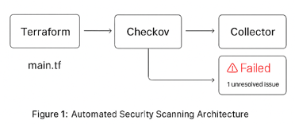
Figure 1: Automated Security Scanning Architecture

6. Methodology
1. Environment Setup: Terraform v1.13.4, Python 3.8+, Checkov (via pip), and tfsec (via shell script) were installed on Ubuntu under WSL.
2. Sample IaC: A Terraform script was written to provision an Azure Storage Account with deliberately insecure configurations (HTTP enabled, public access, outdated TLS).
3. Scanning: Both Checkov and tfsec were executed on the Terraform directory.
4. Remediation: Identified misconfigurations were corrected based on tool recommendations.
5. Validation: Scans were re-run to confirm compliance and zero failed checks.
Sample IaC Code:
resource "azurerm_storage_account" "example" {
name = "examplestorageacct"
resource_group_name = "rg-devops"
location = "eastus"
account_tier = "Standard"
account_replication_type = "LRS"
enable_https_traffic_only = false
public_network_access = "Enabled"
}

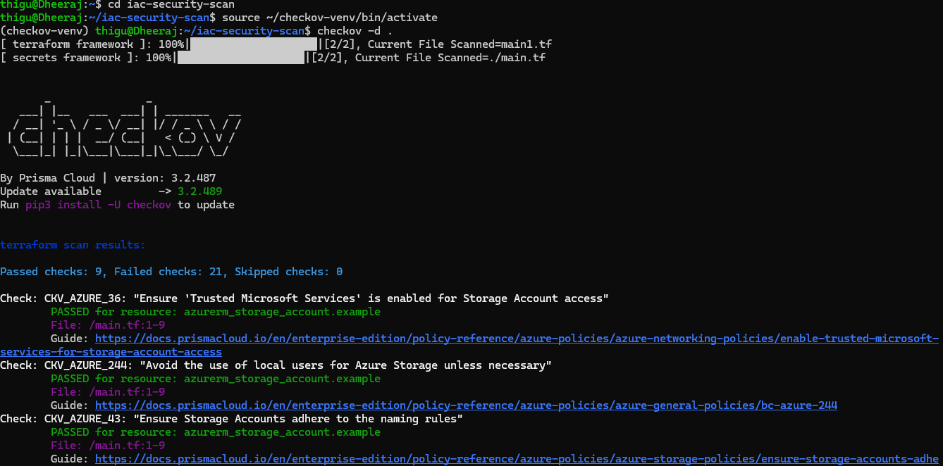
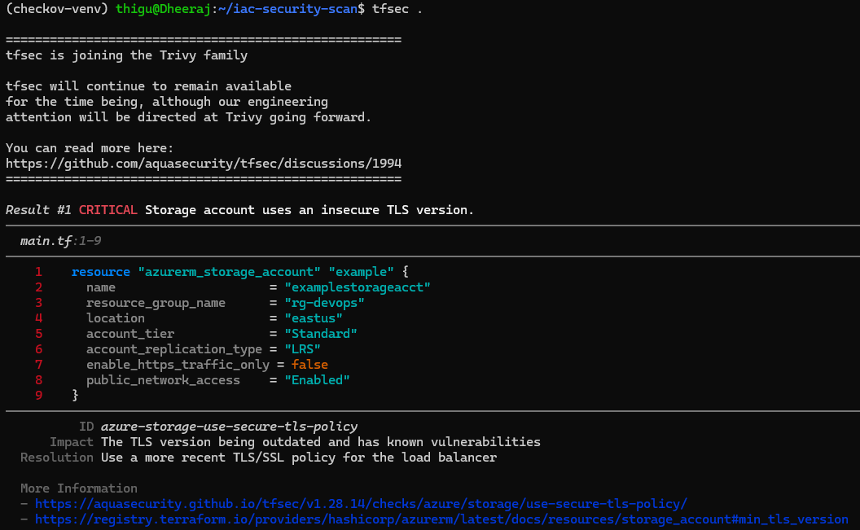
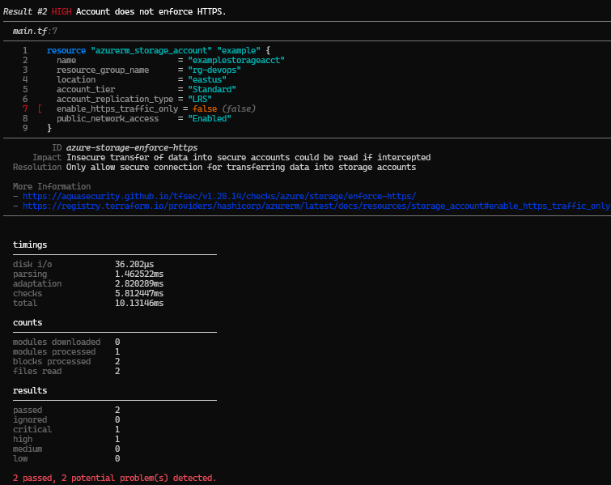
Figures 2–4: Checkov and tfsec scan outputs showing detected issues and remediation.

7. Results and Discussion
Initial scans reported multiple failed checks, including public access enabled, HTTPS not enforced, and insecure TLS. After applying remediation, both Checkov and tfsec reported full compliance. The automated scanning setup achieved early detection of IaC vulnerabilities, reducing post-deployment rework and strengthening cloud security posture. The integration of Checkov and tfsec proved effective for continuous compliance monitoring in DevSecOps workflows.

8. Benefits and Impact
• Early detection of security issues through static IaC analysis.
• Policy-as-Code enforcement ensures compliance with organizational standards.
• Integration into CI/CD pipelines supports automated security at every commit.
• Reduced risk of misconfiguration-related breaches.
• Improved DevOps efficiency through consistent, secure deployments.

9. Conclusion
This project successfully demonstrates how automated security scanning can be embedded into Infrastructure-as-Code workflows using Terraform, Checkov, and tfsec. The system validates infrastructure code pre-deployment, ensuring adherence to cloud security and compliance standards. By shifting security left, organizations can minimize vulnerabilities, enforce policies automatically, and streamline DevOps operations.

10. Future Enhancements
• Integration with CI/CD pipelines such as GitHub Actions or Jenkins for continuous scanning.
• Use of Checkov custom policies for organization-specific compliance.
• Integration with Trivy for container image and IaC joint scanning.
• Centralized dashboard for reporting and analytics of IaC compliance.

11. References
[1] Bridgecrew, 'Checkov Documentation', 2025.
[2] Aqua Security, 'tfsec Documentation', 2025.
[3] HashiCorp, 'Terraform Documentation', 2025.
[4] CrowdStrike, 'IaC Scanning Overview', 2024.
[5] Wiz.io Academy, 'Best Practices for IaC Scanning', 2024.
[6] env0.com, 'Top IaC Security Tools 2024', 2024.
[7] arXiv, 'GLITCH: Detecting Security Smells in Infrastructure as Code', 2023.

