TRAFFIC SIGN DETECTOR

*A project submitted in partial fulfillment of the*

*requirements for the award of the degree of*

Bachelor of Technology

in

INFORMATION TECHNOLOGY



Submitted by:

**Dheeraj**

**Roll No.: 11912020**

**Group No- 213**

Supervised by:

**Dr. Mukesh Mann**

Assistant Professor

Indian Institute of Information technology,

Sonepat -131201,HARYANA, INDIA

**ACKNOWLEDGEMENTS**

I humbly consider it a privilege and honor to express my heartiest and profound gratitude to Prof **(Dr) Mukesh Mann**, Assistant Professor -IT, and IIIT Sonepat, for his appropriate direction, valuable suggestion.

This guidance and support received from my entire classmates who contributed and who are contributing to this project, is vital for the success of this project. I am grateful for their constant support and help.

I also gratitude to my parents for their consistant support throughout the project.

**Dheeraj**

**SELF DECLARATION**

I hereby declare that the work contained in the project titled “**Traffic Sign Detector**” is original. I have followed the standards of project ethics to the best of my abilities. I have cited all sources of information that I have used in the project.

Name: Dheeraj

Roll No.: 11912020

Department of Information Technology,

Indian Institute of Information Technology,

Sonepat-131201, Haryana, India.

**CERTIFICATE**

This is to certify **Dheeraj** has worked on the project entitled “**Traffic Sign Detector**” under my supervision and guidance.

The contents of the project, being submitted to the **Information Technology**, **IIIT Sonepat,** for the award of the degree of **B.Tech** in **Information Technology**, are original and have been carried out by the candidate himself. This project has not been submitted in full or part for the award of any other degree or diploma to this or any other university.

Dr. Mukesh Mann

Supervisor

Department of Information Technology,

Indian Institute of Information Technology,

Sonepat-131201, Haryana, India

**ABSTRACT**

Name of the student–**Dheeraj,** Roll No: **11912020,** Degree for which submitted **B.Tech (IT).,** Department of **Information Technology**, **IIIT, Sonepat**.

Project Title: **Traffic Sign Detector**

Name of the thesis supervisor: **Dr. Mukesh Mann**

Month and year of the project submission: **April 2021**

Traffic sign detection software systems are of paramount importance for the future of automation vehicle technology and smart vehicles. In this paper, we propose a Convolutional Neural Network based approach or model for detecting and classifying traffic signs which is challenging in different different environmental conditions. In the proposed model, our approach is to consecutively (i) selectively preprocess the image to enhance the sign features (ii) classify the sign proposals extracted from the image. These tasks are carried out by implementing CNNs architecture and depth. The proposed model has been evaluated on the Traffic-Sign Recognition Dataset which was available on the Kaggle website which is good website for machine learning and deep learning datasets.

**LIST OF ABBREVIATIONS**

|  |  |
| --- | --- |
| TSD | Traffic Sign Detector |
| S/W | Software |
| AI | ARTIFICIAL INTELLIGENCE |
| ML | MACHINE LEARNING |
|  |  |
|  | |

**LIST OF FIGURES**

|  |  |  |
| --- | --- | --- |
| **Figure’s No.** | **Name of Figures** | **Page Nos.** |
| Fig 1.1 | The Sashimi Model | 04 |
| Fig 2.1 | Activity Diagram | 06 |
| Fig 2.2 | Data Flow Diagram | 07 |
| Fig 2.3 | Use Case Diagram | 07 |
| Fig 2.7 | Star Uml Logo | 08 |
| Fig 2.8 | Python Logo | 08 |
| Fig 2.9 | Jupyter Logo | 09 |
| Fig 2.10 | Github Logo | 09 |
| Fig 3.1 | Tensorflow | 11 |
| Fig 3.2 | Keras | 11 |
| Fig 3.3 | Matplotlib | 11 |
| Fig 3.4 | Numpy | 12 |
| Fig 3.5 | OpenCV | 13 |
| Fig 4.1 | Black-Box Testing | 16 |
| Fig 4.2 | White-Box Testing | 17 |

|  |  |
| --- | --- |
| Acknowledgments………………………………................................... | i |
| Self Declaration…………………………………................................... | ii |
| Certificate…………………………….................................................... | iii |
| Abstract……………………………....................................................... | iv |
| List of Abbreviations…………………………….................................. | v |
| List of Figures……………………………............................................. | v |
| List of Tables…………………………….............................................. | v |
|  |  |

|  |  |  |  |  |
| --- | --- | --- | --- | --- |
|  | **TABLE OF CONTENTS** | | | |
| **CHAPTER 1** | **INTRODUCTION** | | | **01-05** |
|  | 1.1 | Introduction……………………............................ | | 01-01 |
|  | 1.2 | Problem Outline……………………….................. | | 01-01 |
|  | 1.3 | Purpose of Project………………………………... | | 02-02 |
|  | 1.4 | Project Description………………………………. | | 02-02 |
|  | 1.5 | Project Objectives…............................................... | | 02-03 |
|  | 1.6 | Project Methodology ………................................. | | 03-04 |
|  | 1.7 | Organization of project…………….…................. | | 05-05 |
|  | 1.8 | Summary…………………….………………....... | | 05-05 |
|  |  |  | |  |
| **CHAPTER** **2** | **DESIGN** | | 06-10 | | |
|  | 2.1 | Introduction | | 06-06 |
|  | 2.2 | Diagrams | |  |
|  |  | 2.2.1 Activity Diagram | | 06-06 |
|  |  | 2.2.2 Data Flow Diagram | | 06-07 |
|  |  | 2.2.3 Use Case Diagram | | 07-07 |

|  |  |  |  |  |
| --- | --- | --- | --- | --- |
|  | 2.3 | Development Platform Tools | 08-09 | |
|  | 2.4 | Summary | 10-10 | |
|  |  |  |  | |
| **CHAPTER** **3** | **IMPLEMENTATION** | | 11-18 | |
|  | 3.1 | Introduction | 11-11 | |
|  | 3.2 | List of libraries used | 11-13 | |
|  | 3.3 | The architecture of Lenet-5 | 13-13 | |
|  | 3.4 | What is Lenet-5 | 14-14 | |
|  | 3.5 | Some Features of Traffic Sign Detector | 14-16 | |
|  | 3.6 | Some Graphs Generated | 17-18 | |
|  |  | 3.6.1 Accuracy Graph | 17-17 | |
|  |  | 3.6.2 Loss Graph | 17-17 | |
|  |  | 3.6.3 Distribution of the training Dataset | 18-18 | |
|  | 3.6 | Summary | 18-18 | |
|  |  |  |  | |
| **CHAPTER** **4** | **Testing and Validation** | | 19-23 | |
|  | 4.1 | Software Testing - Validation Testing | 19-19 | |
|  | 4.2 | Software Verification | 19-19 | |
|  | 4.3 | Manual and Automated Testing | 19-19 | |
|  | 4.4 | Testing Approaches | 20-21 | |
|  |  | 4.4.1 Black-Box Testing | 20-20 | |
|  |  | 4.4.2 White-Box Testing | 20-21 | |
|  | 4.5 | Test Summary | 21-21 | |
|  | 4.5 | Testing Technique used for TSD | 21-21 | |
|  | 4.6 | Fail Case | 21-21 | |
|  | 4.7 | Summary | 21-22 | |
| **CHAPTER** **5** | **Conclusion and Future Scope** | | | 23-23 |
|  | 5.1 | Limitation | 23-23 | |
|  | 5.2 | Scope of project | 23-23 | |
|  | 5.3 | Future goals | 23-23 | |
|  |  |  |  | |
|  | **REFERENCES** | | 24-24 | |
|  | **Appendix** | | 24-24 | |

**CHAPTER 1**

**INTRODUCTION**

**1.1 INTRODUCTION –**

Nowadays, there is a lot of attention being given to the ability of the car to drive itself or you can say self driving car or the car with various automation features. One of the many important aspects of a self-driving car is the ability to detect traffic signs to provide safety and security for the people not only inside the car but also outside of it. The traffic environment consists of different aspects whose main purpose is to regulate the flow of traffic, make sure each driver is adhering to the rules to provide a safe and secure environment and avoid accidents to all the parties concerned. We used the kaggle traffic sign dataset. The dataset consisted of different types of traffic signs and various classes of traffic signs. We also have to take care of all weather conditions, lighting conditions, camera qualities, computation power. We have to do this project with some good accuracy and cost effective manner. The main objective of our project is to design and construct a computer-based system that can automatically and live detect the traffic signs to assist the user or the machine/smart vehicle so that they can take appropriate actions. The proposed approach consists of building a model using convolutional neural networks by getting or extracting traffic signs from an image or video frame.

This report is organized as follows: Chapter 2 presents the related works in the field of Design of the Traffic Sign Detection software. In Chapter3, the overall implementation is discussed. In chapter 4 we discuss about software testing and validation results. In Chapter5, the conclusion, suggestions and future scope and hardware implementation of this project that will be made for future improvement in the field of traffic sign detection in smart vehicles.

**1.2 Problem Outline**

To solve the concerns over road safty and avoid the chances of accidents traffic sign detection (TSD) software has been introduced. An TSD software system can detect and recognize traffic signs from and within images or video frame captured by cameras happening in real time. In adverse traffic conditions, the driver may not notice traffic signs, as his/her focus is on driving which may cause accidents. In such scenarios, the TSD software comes into role to play. The main objective of the research or to develop this project on TSD is to improve the robustness and efficiency of the TSD software system. Developing an TSD software system is a difficult job given the continuous changes in the environment, lighting conditions and weather conditions. This project aims to develop an efficient TSD software system that can detect and classify traffic signs into various classes in a real-time environment or the live detection.

**1.3 PURPOSE**

Traffic-sign detection and classification is an interesting topic in computer vision and it is especially important in the context of autonomous vehicle technology. Robust and real-time traffic-sign detection algorithms have to be employed if self-driving cars are to become commonplace in the roads of the future.

Traffic sign detection software system going to play a very importance for the future of autonomous vehicle technology. The main purpose of this project is to reduce the number of accidents during driving and 100% focus on driving. During Driving Our 100% focus must be on driving not on seeing which traffic signs are around them. That why we develop a project that is Traffic sign Detector which detects traffic signs around them and tells what is the traffic sign.

**1.4 Project Description**

Nowadays, Self Driving cars are a trending topic. One of the many important aspects of a self-driving car is the ability to detect traffic signs to provide safety and security for the people not only inside the car but also outside of it.

The project is built using OpenCV, Python library to implement machine learning and deep learning principles in JupyterNotebookEditor.Keras Algorithm is used to build this deep learning model to detect the traffic-sign detector. The camera can be installed in the car after this, This model can work on real-time camera footage and detect the traffic sign and tell the driver what the traffic sign means. The model can predict up to certain accuracy about the traffic sign.

Deep learning is used to develop our traffic sign model. The architecture used for the object detection purpose is Single Shot Detector (SSD) because of its good performance accuracy and high speed**.** Alongside this, we have used basic concepts of transfer learning in neural networks to finally output the meaning of traffic signs in an image or a video stream. We aim to show that our model performs well on the test data with max% precision and recall, respectively.

**1.5 PROJECT OBJECTIVES**

1. **Live Traffic Sign Detection:** To identify the traffic sign and tell the meaning of it with the help of computer vision and deep learning.
2. **Max Accuracy:** To achieve maximum accuracy on detection, to do this data set is needed as big as possible
3. **Reduce Accident:** As this software detects the traffic sign so the driver will be able to focus 100% on driving.

**ALL THE ABOVE LISTED OBJECTIVES WILL BE ACHIEVED BY USING SASHIMI MODEL**

**1.6 PROJECT METHODOLOGY –**

All the objectives mentioned above are going to be achieved with the help of the **SASHIMI** model.

The first objective i.e.Live Traffic Sign Detection: To identify the traffic sign and tell the meaning of it with the help of computer vision and deep learning.

Our second objective is to maximize Accuracy: To achieve maximum accuracy on detection to do this we are going to take the data set as big as possible

Our second objective is to Reduce Accident: As this software detect the traffic sign so the driver will be able to focus 100% on driving. Installing the camera in the car and detecting traffic signs live using RasberiPi is the future goal of our project.

In this project, the changing of requirements is required and we are going to overlap the different S/W phases over each other. All the resources for the project are available to us and we wanted the project to get started soon, moreover, we wanted to shorten our time scale that’s why we used this model.

**3 Months 6 Months 9 Months**

**Fig 1.1 THE SASHIMI MODEL**

**Advantages of using the SASHIMI Model in this project-**

* Shortens the development time, as different S/W layers are overlapped over each other.
* A 12-month project could be done in 9 months.
* People with different skills can start working on the project without waiting for the work done for the previous phase.
* The architect can start working on the project before even the analyst or who is doing the requirements is done.

**Disadvantages of using the SASHIMI Model in this project-**

* It may result in some rework because the design phase is started before all the requirements were done.
* It means that if something is found later, during the requirement phase, the design phase is then again needed to be adjusted.

If the coding phase is already started, then that requirement change may also result in some rework.

**1.7 THE ORGANISATION OF PROJECT**

* In Chapter 1, a brief Intro, problem outline, project objectives, methodology, the scope of TSD are discussed.
* In Chapter 2, the Study Design of TSD will be discussed.
* In Chapter 3, Implementation will be discussed– a tool used in the development of this project.
* In Chapter 4, Software testing and validation will be discussed.
* In Chapter 5, the Conclusion and Future of this Project will be discussed.

**1.8 SUMMARY**

In this chapter, A brief introduction to Traffic Sign Detector is given. Nowadays, there is a lot of attention being given to the ability of the car to drive itself. One of the many important aspects of a self-driving car is the ability to detect traffic signs to provide safety and security for the people not only inside the car but also outside of it.

After that, the problem outline is discussed with the purpose of the project, its goals, and its description which tells about why we selected this project.

Project Objectives are discussed afterward which are Live TrafficSignDetection, achieving Max Accuracy, and Reducing Accidents by taking large data set as much as possible.

Project Methodologies are also discussed to achieve the above-mentioned objectives in the future. THE SASHIMI MODEL will be used in the project methodology.

Further future scopes for Traffic Sign Detector are also discussed in this chapter. The aim is to implement this software in the car to make it similar to smart vechicle.

The organization of the project is discussed at the end in which a brief intro of all the chapters have been given

**CHAPTER - 2**

**DESIGN**

**2.1Introduction –**

TSD will be used to detect Traffic Signs. In this chapter, we will be discussing general components for TSD and designing parts like Development Platform tools used, Use Case Diagrams, Data Flow Diagrams, Activity Diagrams. At last, We Give a Summary of this Design Chapter.

* 1. **Diagrams -**

**2.2.1 Activity Diagram:**

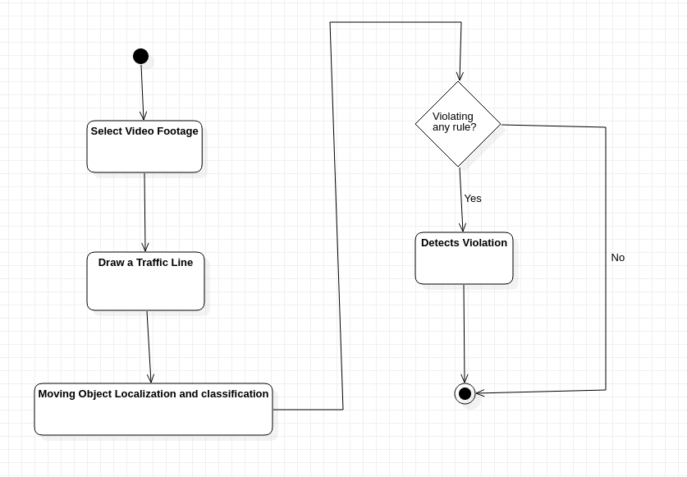

Fig 2.1 Activity Diagram

* + 1. **Data Flow Diagram :**

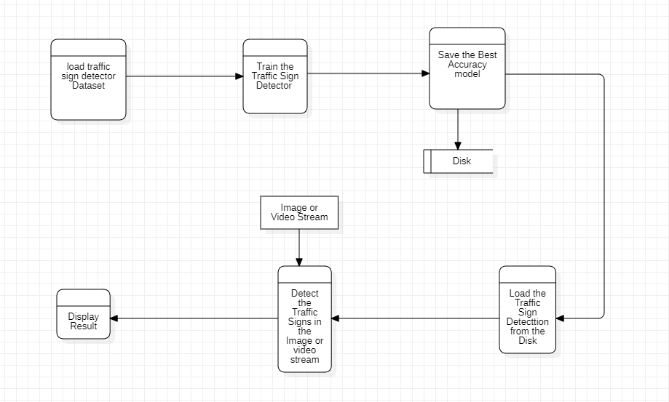

Fig 2.2 Data Flow Diagram

* + 1. **Use Case Diagram :**

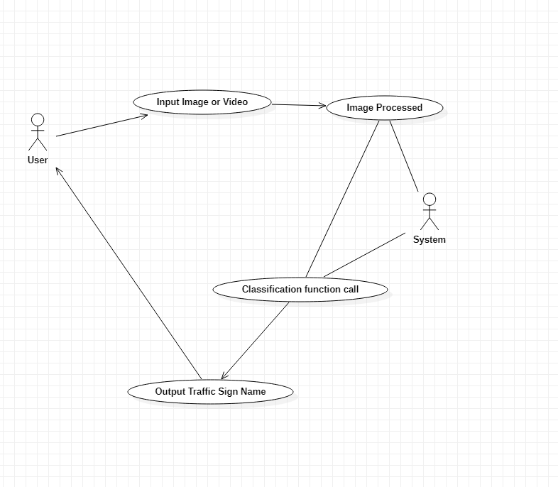

Fig 2.3 Use Case Diagram

* 1. **DEVELOPMENT PLATFORM-TOOLS –**

The following development tools are needed for the development of this project

1. Star UmlFor Developing Various Diagrams related to this project.

2. Python, as the programming language.

3. Jupyter Notebook for Coding purpose.

4. GitHub for collaboration purposes.

1) STAR UML -



**FIG 2.7 STAR UML**

StarUML is a sophisticated software modeler for agile and concise modeling. It is compatible with many UML diagrams.

2) PYTHON LANGUAGE –



**FIG 2.8 PYTHON**

Python is an interpreted, high-level, and general-purpose programming language. Its overall code written code is very less as compare to other programming languages.

3) JupyterNotebbok -



**FIG 2.9 Jupyter Notebook**

JupyterLab is a web-based interactive development environment for Jupyter notebooks, code, and data . Its provide environment of machine learning and deep learning. JupyterLab also contain various features that help developers to develop project easily

4) GITHUB –



**FIG 2.10 GITHUB**

1. GitHub, Inc. is a subsidiary of [Microsoft](https://en.wikipedia.org/wiki/Microsoft) which provides [hosting](https://en.wikipedia.org/wiki/Internet_hosting_service) for [software development](https://en.wikipedia.org/wiki/Software_development) and [version control](https://en.wikipedia.org/wiki/Version_control) using [Git](https://en.wikipedia.org/wiki/Git). It provides access control and several collaboration features such as bug tracking, feature requests and many more.
   1. **SUMMARY** –

This chapter talks about the design part of the Traffic Sign Detector. The working of TSD is also discussed in this chapter. General components of TSD.

This chapter also talks about the system Design of TSD in which a brief discussion is there for the total design of the TSD.

The total design consists of two phases: training and testing

Then a brief discussion of the Data Flow Diagram, Activity Diagram, and Use Case Diagram is also there which tells the depth working of TSD.

In the end, development tools used in TSD are discussed.

**CHAPTER 3**

**IMPLEMENTATION**

* 1. **INTRODUCTION**

Implementation i.e how TSD is implemented is discussed in this chapter.

* 1. **List of Libraries Used:**
* **Tensorflow:** TensorFlow provides a collection of workflows to develop and train models using Python or JavaScript.



**Fig 3.1**

* **Keras:** Keras is an API designed for human beings, not machines. Keras follows best practices for reducing cognitive load it offers consistent & simple APIs, it minimizes the number of user actions required for common use cases, and it provides clear & actionable error messages. It also has extensive documentation and developer guides.



**Fig 3.2**

* **Matplotlib:** Matplotlib is a comprehensive library for creating static, animated, and interactive visualizations in Python.

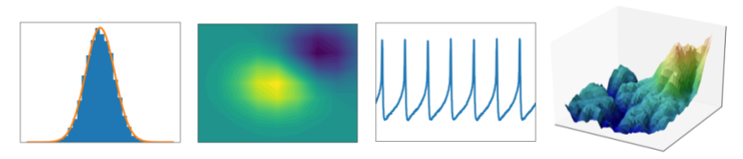

**Fig 3.3**

* **Numpy:** NumPy is a Python library used for working with arrays. It also has functions for working in the domain of linear algebra, Fourier transform, and matrices.



**Fig 3.4**

* **Open-cv:** OpenCV-Python is the Python API for OpenCV, combining the best qualities of the OpenCV C++ API and the Python language.



Fig3.5

* **Imutils:** A series of convenience functions to make basic image processing functions such as translation, rotation, resizing and many more.

**3.3 The Architecture of Lenet-5 -**

Suppose you want to learn a new subject. There are two ways to do that. One is to buy some books and start reading everything from scratch. The other way round is to go to a teacher and he will share all the knowledge and experience he has gained. Which process is faster and easier as well. The second one i.e taking the help of a teacher.

Transfer learning works similarly. Transfer learning is the method that uses a neural network trained on a large and generalized enough dataset and is being used for another problem. These neural networks are called Pre-trained networks.

## 3.4 What is Lenet5?

Lenet-5 is one of the earliest pre-trained models proposed by Yann LeCun and others in the year 1998, in the research paper [Gradient-Based Learning Applied to Document Recognition](http://yann.lecun.com/exdb/publis/pdf/lecun-01a.pdf). They used this architecture for recognizing the handwritten and machine-printed characters.

The main reason behind the popularity of this model was its simple and straightforward architecture. It is a multi-layer convolution neural network for image classification.

**3.5** **Some features of Traffic Sign Detector:-**

**Different types of sign detecions:-**

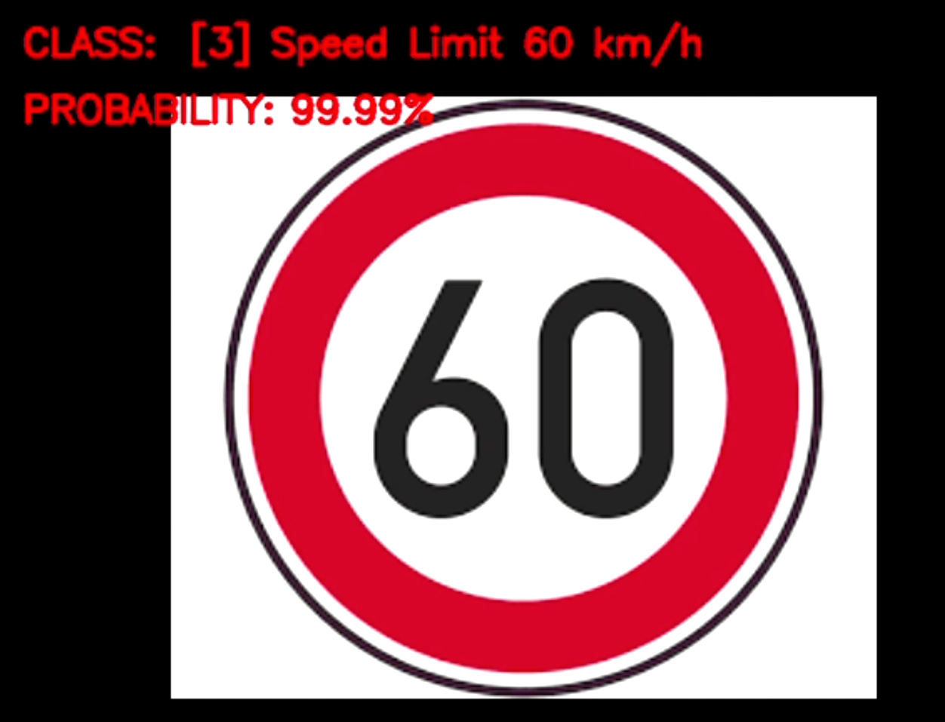

Figure 3.6 Speed Limit Sign Detection

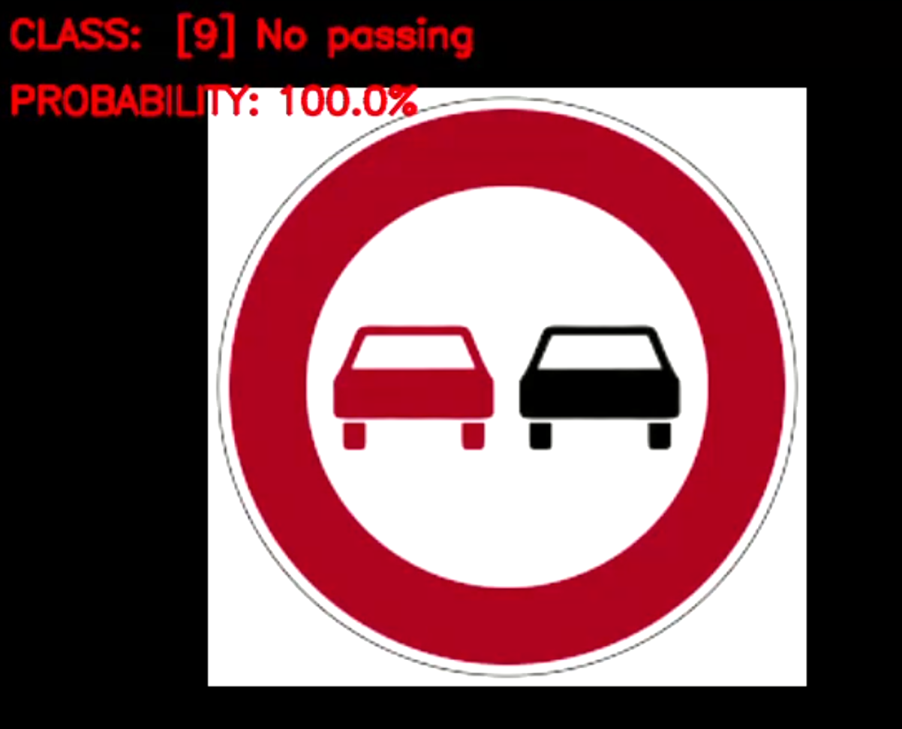

Figure 3.7 No passing Sign Detection

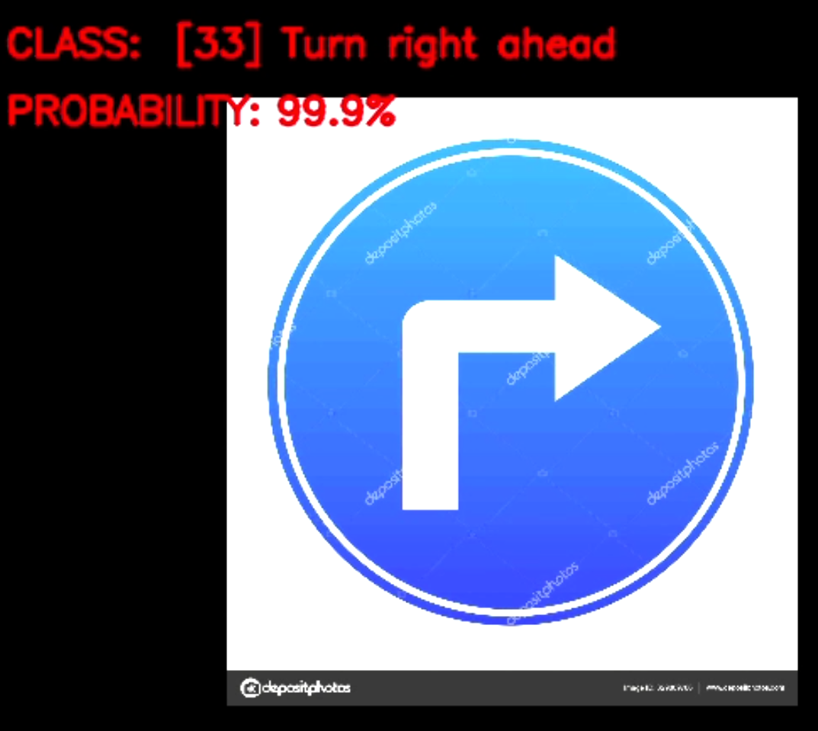

Figure 3.8 Turn Right Ahead Sign Detection

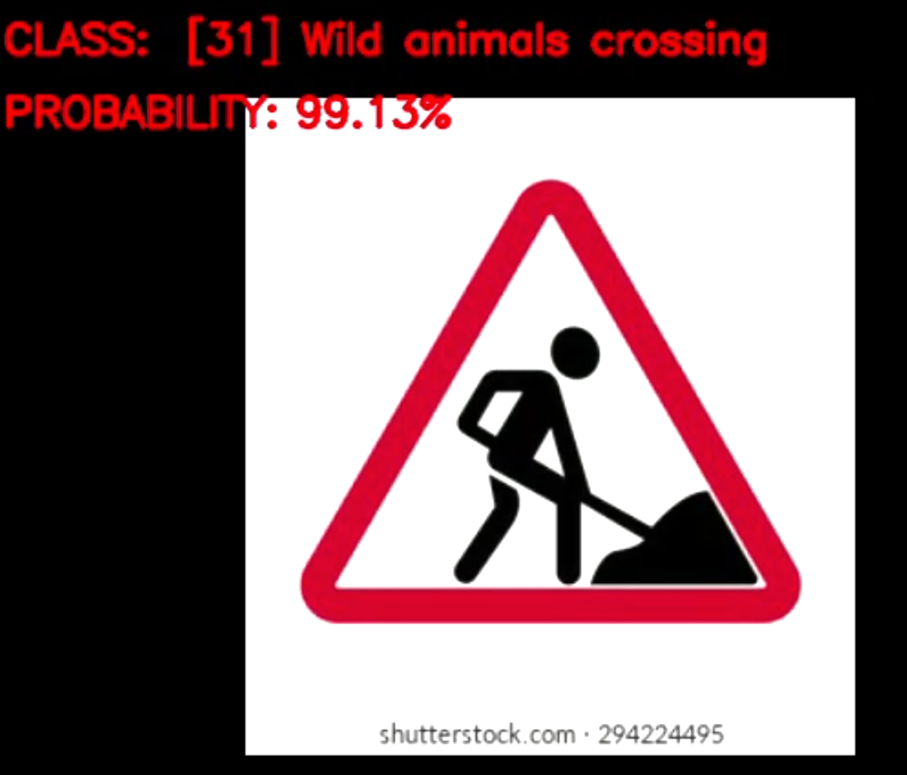

Figure 3.9 Wild Animals Crossing Sign Detection

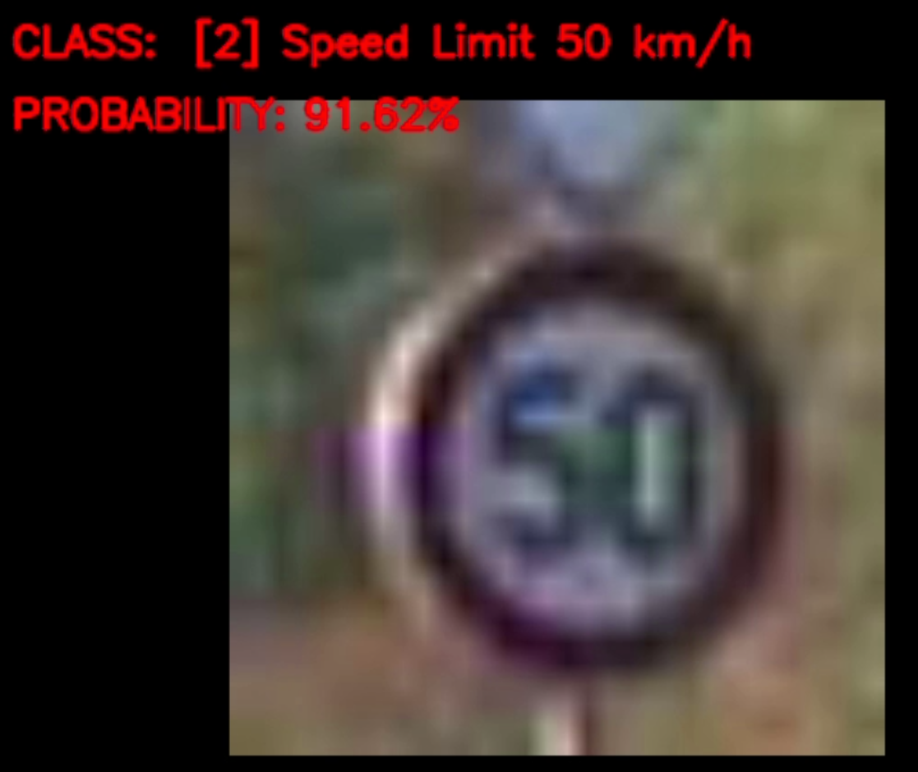

Figure 3.10 Speed limit Sign Detection (More blur image)

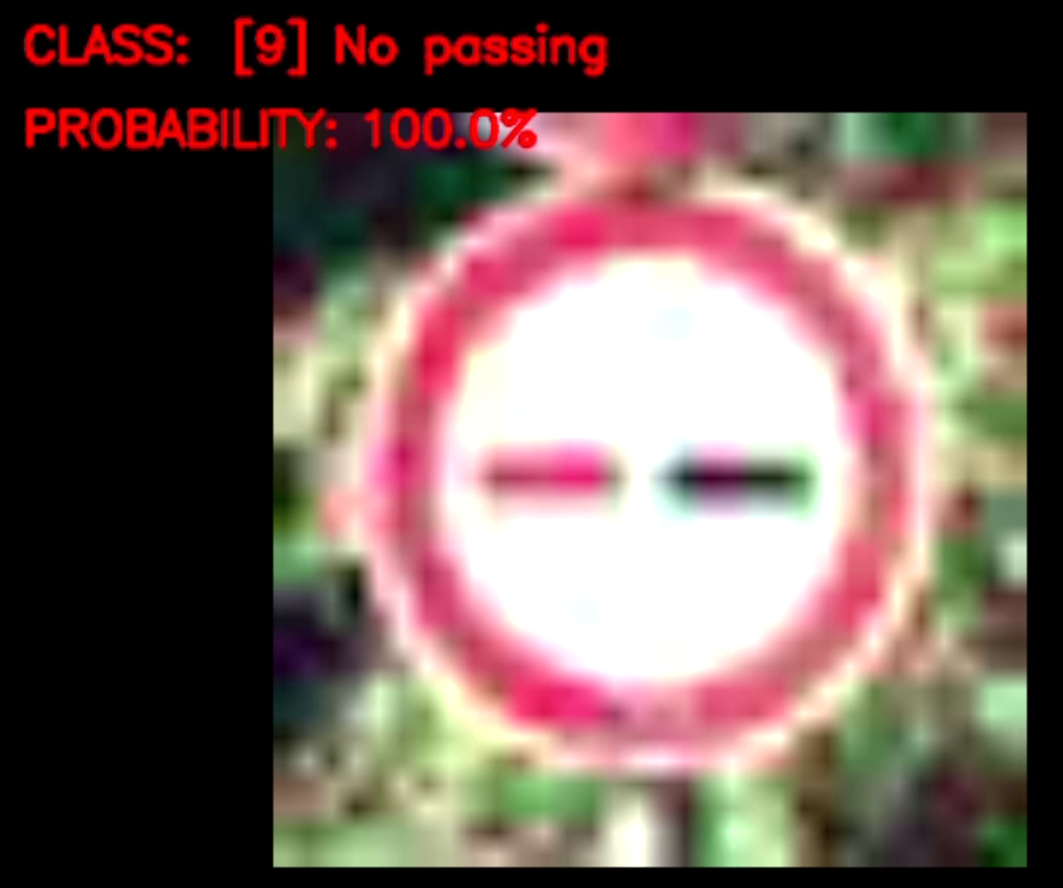

Figure 3.11 No passing Sign Detection (More Blur image)

**3.6 Some Graphs Generated**

**3.6.1 Accuracy Graph**

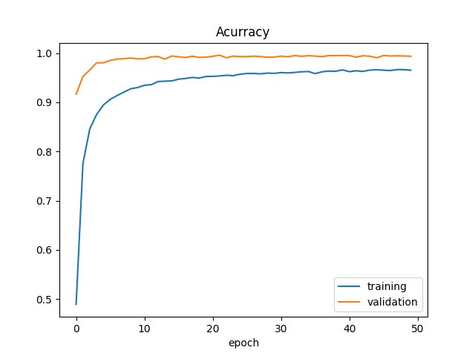

**3.6.2 Loss graph**

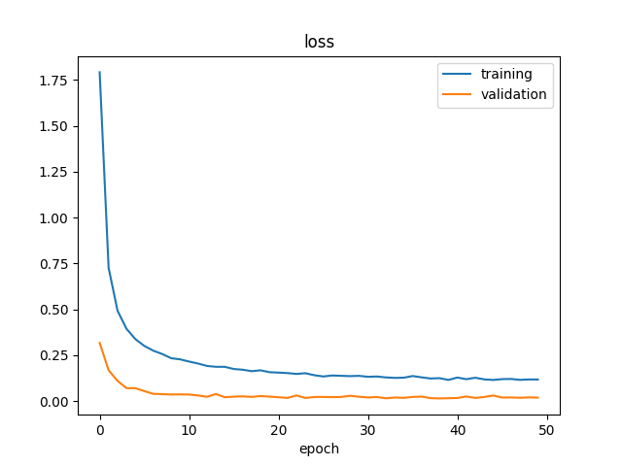

**3.6.3 Distribution of the training dataset**

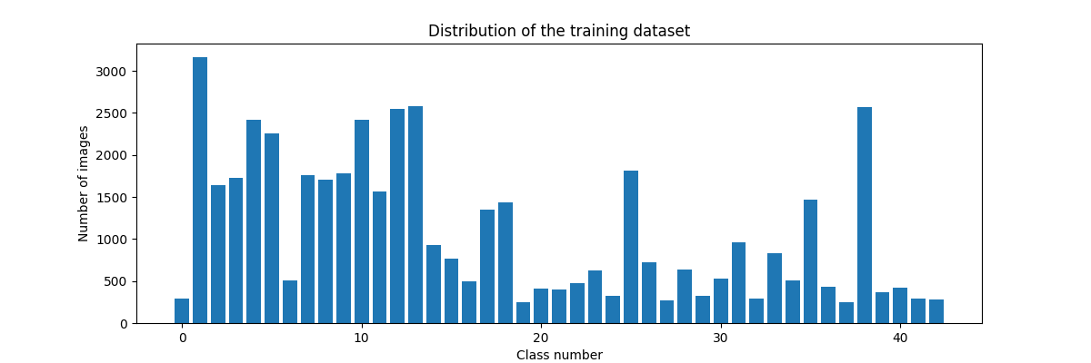

**3.7 SUMMARY –** In this chapter, the implementation of TSD is discussed. Some main features are also discussed.

**CHAPTER – 4**

**TESTING AND VALIDATION**

## Software Testing - Validation Testing -

Validation is the process of examining whether or not the software satisfies user requirements. It is carried out at the end of the SDLC. If the software matches the requirements for which it was made, it is validated.

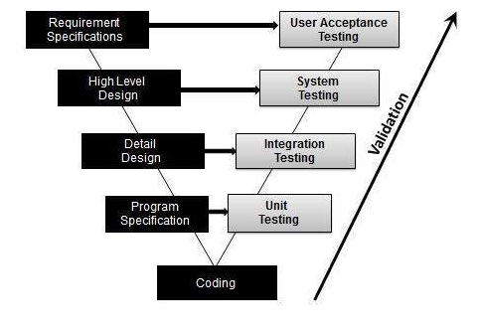

## Software Verification -

Verification is the process of confirming if the software is meeting the business requirements, and is developed adhering to the proper specifications and methodologies.

## Manual Vs Automated Testing

**4.3 Testing can either be done manually or using an automated testing tool:**

* **Manual** - This testing is performed without taking the help of automated testing tools. The software tester prepares test cases for different sections and levels of the code, executes the tests, and reports the result to the manager.
* **Automated** This testing is a testing procedure done with aid of automated testing tools. The limitations of manual testing can be overcome using automated test tools.

There are software and hardware tools that help testers in conducting load testing, stress testing, regression testing.

## 4.4 Testing Approaches -

Tests can be conducted based on two approaches –

* Functionality testing
* Implementation testing

### 4.4.1 Black-box testing -

It is carried out to test the functionality of the program. It is also called ‘Behavioral’ testing. The tester, in this case, has a set of input values and respective desired results. On providing input, if the output matches with the desired results, the program is tested ‘ok’, and problematic otherwise.

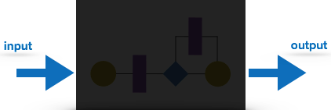

**Fig 4.1 Black-Box Testing**

### White-box testing -

It is conducted to test the program and its implementation, in order to improve code efficiency or structure. It is also known as ‘Structural’ testing.

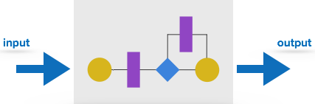

**Fig 4.2 White-Box testing**

The white box testing contains various tests, which are as follows:

* Path testing
* Loop testing
* Condition testing
* Testing based on the memory perspective
* Test performance of the program

### Before Testing

Testing starts with test case generation. Following documents are needed for reference –

* **SRS document**
* **Test Policy document**
* **Test Strategy document**
* **Traceability Matrix document**

**While Being Tested**

The following documents may be required while testing is started and is being done:

* **Test Case document**
* **Test Description**
* **Test case report**
* **Test logs**

**After Testing**

The following documents may be generated after testing :

* 1. **Test summary** - This test summary is the collective analysis of all test reports and logs. It summarizes and concludes if the software is ready to be launched.
  2. **TESTING TECHNIQUE USED FOR TRAFFIC SIGN DETECTOR**

Manual testing is done for this project as it was not possible to automate the testing for this project. Testing is done for the detection of various types of masks and different combinations

* 1. **FAIL CASE:-**

The one failure of the Traffic Sign Detector is it can not work on the very low-quality camera.

* 1. **SUMMARY –**

Various software testing techniques are described in this chapter. Manual Testing is done for this project as automation for Traffic Sign Detector was not possible.

**CHAPTER - 5**

**CONCLUSION AND FUTURE SCOPE**

**5.1 LIMITATION**

The identification of traffic-sign detector is the data set, computation power, lighting conditions. However, the development of a Traffic Sign Detector condition identification network is challenging for several reasons.

The limitation in datasets is one main challenge. The Traffic sign detector conditions datasets are generally small, and their image quality is not high enough. Furthermore, the various performances of Traffic Sign Detection with different light conditions largely increase the difficulty of identification. There are a few limitations to our study. Firstly, the traffic Sign Dataset we used for classification identification is relatively small, where it cannot cover all types of signs used.

Also, the dataset does not contain video, where the identification result on a video stream cannot be tested. Another limitation is the excessive data loading time in Jupiter Notebook while loading the dataset into it.

**5.2 SCOPE OF PROJECT**

This project can be implemented in a car. Nowadays, there is a lot of attention being given to the ability of the car to drive itself. One of the many important aspects of a self-driving car is the ability to detect traffic signs to provide safety and security for the people not only inside the car but also outside of it. The traffic environment consists of different aspects whose main purpose is to regulate the flow of traffic, make sure each driver is adhering to the rules to provide a safe and secure environment to all the parties concerned.

**5.3 FUTURE GOALS**

* Integrate with the voice system
* Collecting more dataset
* Integrate with RasberiPi using GPIOS coding
* After that coding integrates with the car system.

**REFERENCES**

1.Github ,accessed 1 October 2021, <https://en.wikipedia.org/wiki/GitHub>

2.Software Process Models, accessed 1 October 2021, <https://www.thomasalspaugh.org/pub/fnd/softwareProcess.html>

3.Keras, accessed 1 October 2021, <https://en.wikipedia.org/wiki/Keras>

# 4.Unified Modeling Language (UML) | Activity Diagrams, accessed 1 October 2021, <https://www.geeksforgeeks.org/unified-modeling-language-uml-activity-diagrams/>

5. Software Development models, accessed 1 October 2021, <https://mohamadkoteich.com/2019/01/30/software-development-models/>

6. StarUml, accessed 2 October 2021, <https://en.wikipedia.org/wiki/StarUML>

7.Python, accessed 3 October 2021, <https://en.wikipedia.org/wiki/Python_(programming_language)>

8. OpenCv, accessed 3 October 2021, <https://en.wikipedia.org/wiki/OpenCV>

9. Jupyter Notebook, accessed 4 October 2021, <https://jupyter.org/>

10.smart Vehicles & IoT, accessed 4 October 2021,

<https://www.intelligenthq.com/smart-vehicles-the-internet-of-things/>

**APPENDIX**

GITHUB LINK- <https://github.com/Dheeraj2000/Traffic-Sign-Detector.git>