

# A PBL PROJECT

On

**ONLINE FOOD ORDERING SYSTEM**

Submitted By:

|  |  |
| --- | --- |
| M. HARSHITHA  N. GUNA PRIYA  M. DHEERAJ  P. CHARAN REDDY  S. HARIKA | 218R1A1234  218R1A1242  218R1A1241  218R1A1247  218R1A1253 |

Under the Guidance of:

# Mrs. K. SUSHMA

Assistant Professor, Department of IT

# DEPARTMENTOFINFORMATIONTECHNOLOGY

CMRENGINEERINGCOLLEGE

**UGC AUTONOMOUS** (Approved by AICTE-New Delhi & J.N.T.U, Hyderabad) Kandlakoya(v), Medchal Road,Hyderabad-501 401,TelanganaState India.



# CERTIFICATE

This is to certify that the project entitled “**ONLINE FOOD ORDERING SYSTEM”** is a bonafide work carried out by:

|  |  |
| --- | --- |
| M. HARSHITHA  N. GUNA PRIYA  M. DHEERAJ  P. CHARAN REDDY  S. HARIKA | 218R1A1234  218R1A1242  218R1A1241  218R1A1247  218R1A1253 |

In the part of innovative teaching methodology **PBL (Project Based Learning)** of Software Engineering Laboratory under our guidance and supervision.

|  |  |
| --- | --- |
| Project Coordinator  **Mrs.K.Sushma**  Assistant Professor,Department of IT,  CMR Engineering College,  Hyderabad | Head of the Department  **Dr.Madhavi Pingili**  Professor & HOD,  Department of IT,  CMR Engineering College,Hyderabad |

# DECLARATION

This is to certify that the work reported in the present project entitled “**ONLINE FOOD ORDERING SYSTEM”** is a record of Bonafide work done by us in the Department of Information Technology, CMR Engineering College, Hyderabad. The reports are based on the project work done entirely by us and not copied from any other source. We submit our project for further development by any interested students who share similar interests to improve the project in the future.The results embodied in this project report have not been submitted to any other University or Institute for the award of any degree or diploma to the best of our knowledge and belief.

|  |  |
| --- | --- |
| M. HARSHITHA  N. GUNA PRIYA  M. DHEERAJ  P. CHARAN REDDY  S. HARIKA | 218R1A1234  218R1A1242  218R1A1241  218R1A1247  218R1A1253 |

# ACKNOWLEDGEMENT

We are extremely grateful to our Principal, **Dr. A. Srinivasula Reddy,** and our HOD, **Dr.Madhavi Pingili**, Department of IT, CMR Engineering College for their constant support. We are immensely thankful to **Mrs. K. Sushma**, Assistant Professor, Project Coordinator, Department of IT, for his constant guidance, encouragement,and moral support through out the project. We will be failing in duty if we do not acknowledge with gratitude thanks to the authors of the references and other literate referred to in the Project.We express our thanks to the Department of Information Technology, CMR Engineering College, and friends for all the help and co-ordination extended in bringing out this project successfully in time. Finally, we are very thankful to our parents who guided us every step.

|  |  |
| --- | --- |
| M. HARSHITHA  N. GUNA PRIYA  M. DHEERAJ  P. CHARAN REDDY  S. HARIKA | 218R1A1234  218R1A1242  218R1A1241  218R1A1247  218R1A1253 |

**TABLEOFCONTENTS**

|  |  |
| --- | --- |
| **CONTENT** | **PAGE NUMBER** |
| DECLARATION | 3 |
| ACKNOWLEDGEMENT | 4 |
| ABSTRACT | 6 |
| INTRODUCTION | 7 |
| HARDWARE AND SOFTWARE REQUIREMENTS | 8 |
| FLOWCHART | 9 |
| SOFTWARE REQUIREMENT ANALYSIS | 10 |
| SYSTEM DESIGNING | 11 |
|  |  |
| TESTING | 12 |
| SOURCE CODE | 13-14 |
| OUTPUT | 15 |
| TEST CASES | 16-17 |
| USE CASE DIAGRAM | 18 |
| CLASS DIAGRAM | 19 |
| INFORMATION | 20 |
| CONCLUSION | 21 |
| REFERENCES | 22 |

# ABSTRACT

An Online Food Ordering System is proposed here which simplifies the food ordering process. The proposed system shows an user interface and update the menu with all available options so that it eases the customer work. Customer can choose more than one item to make an order and can view order details before logging off. The order confirmation is sent to the customer. The order is placed in the queue and updated in the database and returned in real time. This system assists the staff to go through the orders in real time and process it efficiently with minimal errors.Customers will appreciate it because it allows them to place orders quickly and easily anytime they want.They can also rest assured that when they place their orders, there will be no misunderstandings. An online food ordering solution for restaurants can do wonders for you.When the customer wants to order over the phone, customer is unable to see the physical copy of the menu available in the restaurant, this also lacks the verification that the order was placed for the appropriate menu items.

# INTRODUCTION

The labour rates are increasing steadily year on year thus making it difficult to find employees. The food industry is highly labour intensive and the biggest expense in the food industry is the cost of employing the right kind of people to do the work. One of the ways to reduce this expense is to use modern technology to replace some of the jobs done by human beings and make machines do the work. Here we propose an “Online Food Ordering System” that has been designed for Fast Food restaurant, Take-Out or College Cafeterias. The system can also be used in any food delivery industry. This simplifies the process of food ordering for both the customer and the restaurant, as the entire process of taking orders is automated.

An online food ordering system typically consists of a user-friendly website or mobile application that connects customers with a network of restaurants and food establishments. These platforms provide a virtual marketplace where customers can explore different cuisines, view restaurant profiles, browse menus, and make informed decisions based on reviews and ratings. By eliminating the need for physical menus and phone calls, online food ordering systems simplify the ordering process and save valuable time for both customers and businesses.

One of the key advantages of online food ordering systems is the level of customization they offer. Customers can easily personalize their orders by selecting specific dishes, choosing portion sizes, adding or removing ingredients, and providing special instructions. This flexibility caters to individual preferences and dietary restrictions, enhancing the overall dining experience and ensuring customer satisfaction.

# FUNCTIONALREQUIREMENTS

## HARDWAREREQUIREMENTS:

* Processor -Intel Core i3 64 bit
* RAM - 1 GB
* Hard Disk -160GBHDD

## SOFTWAREREQUIREMENTS:

* Operating System -Windows10
* Language - JAVA
* Software - JAVA Debugger(PDB)

# FLOWCHART

Figure-1:

FLOWCHART FOR ONLINE FOOD ORDERING SYSTEM

**SOFTWARE REQUIREMENT ANALYSIS**

The Software Requirements Specification is produced at the culmination of the analysis task. The function and performance allocated to software as part of system engineering are refined by establishing a complete information description, a detailed functional and behavioral description, an indication of performance requirements and design constraints, appropriate validation criteria, and other data pertinent to requirements

The proposed system has the following requirements:

**∙** System needs store information about new entry of Food Item.

**∙** System needs to help the internal staff to keep information of Category.

**∙** System need to maintain quantity record.

**∙** System need to keep the record of Customer

**∙** System need to update and delete the record.

**∙** System also needs a search area.

**∙** It also needs a security system to prevent data.

**SYSTEM DESIGNING**

In this phase, a logical system is built which fulfils the given requirements. Design phase of software development deals with transforming the clients requirements into a logically working system Normally, design is performed in the following in the following two steps:

**1. Primary Design Phase:**

In this phase, the system is designed at block level. The blocks are created on the basis of analysis done in the problem identification phase. Different blocks are created for different functions emphasis is put on minimizing the information flow between blocks Thus, all activities which require more interaction are kept in one block.

**2. Secondary Design Phase**:

In the secondary phase the detailed design of every block is performed.

**The general tasks involved in the design process are the following:**

1. Design various blocks for overall system processes.

2. Design smaller, compact and workable modules in each block

3. Design various database structures.

4. Specify details of programs to achieve desired functionality.

5. Design the form of inputs, and outputs of the system.

6. Perform documentation of the design.

7. System reviews.

**TESTING**

The software testing, investigation conducted to provide stakeholders with information about the quality of the product or service under test. We have 2 specialists for the duration of 60 days, the following phases will cover Testing Plan: The IEEE stander and other tools follow to perform this plan that builds the testing phase styrene. Test Designing: test design is the act of creating and writing test suites for testing software We have several recommended testing tools to perform this phase by the test specialist Unit testing: we shall create the individual units of source code that is, the sets of one or more computer program modules together with associated control data Component Testing till now we have designed and developed model, therefore the model level testing that will find the bugs in the model and will verify the functions of the model System Testing’s the final and important testing will be dealt by system testing that integrated system to evaluate the system's compliance with its specified requirements. Documentation & Provide Feedback to Programmers: finally, the document will be shines all the tested resins and defects.

# SOURCE CODE

import java.util.ArrayList;

import java.util.List;

import java.util.Scanner;

class FoodItem {

private String name;

private double price;

public FoodItem(String name, double price) {

this.name = name;

this.price = price;

}

public String getName() {

return name;

}

public double getPrice() {

return price;

}

}

class Order {

private List<FoodItem> items;

private double total;

public Order() {

items = new ArrayList<>();

total = 0.0;

}

public void addItem(FoodItem item) {

items.add(item);

total += item.getPrice();

}

public void removeItem(FoodItem item) {

items.remove(item);

total -= item.getPrice();

}

public double getTotal() {

return total;

}

public void printOrder() {

System.out.println("Order details:");

for (FoodItem item : items) {

System.out.println("- " + item.getName() + " $" + item.getPrice());

}

System.out.println("Total: $" + total);

}

}

class OnlineFoodOrderingSystem {

private List<FoodItem> menu;

private Order currentOrder;

public OnlineFoodOrderingSystem() {

menu = new ArrayList<>();

currentOrder = new Order();

}

public void addItemToMenu(FoodItem item) {

menu.add(item);

}

public void displayMenu() {

System.out.println("Menu:");

for (int i = 0; i < menu.size(); i++) {

FoodItem item = menu.get(i);

System.out.println((i + 1) + ". " + item.getName() + " $" + item.getPrice());

}

}

public void placeOrder() {

Scanner scanner = new Scanner(System.in);

int choice;

do {

System.out.println("Enter the item number to add to the order (0 to finish):");

choice = scanner.nextInt();

if (choice > 0 && choice <= menu.size()) {

FoodItem selectedItem = menu.get(choice - 1);

currentOrder.addItem(selectedItem);

System.out.println(selectedItem.getName() + " added to the order.");

}

} while (choice != 0);

System.out.println("Order placed successfully!");

currentOrder.printOrder();

}

}

public class Main {

public static void main(String[] args) {

// Create an instance of the online food ordering system

OnlineFoodOrderingSystem system = new OnlineFoodOrderingSystem();

// Add items to the menu

system.addItemToMenu(new FoodItem("Pizza", 10.99));

system.addItemToMenu(new FoodItem("Burger", 5.99));

system.addItemToMenu(new FoodItem("Salad", 7.99));

// Display the menu

system.displayMenu();

// Place an order

system.placeOrder();

}

}

**OUTPUT**

Adding food items to list and placing order:

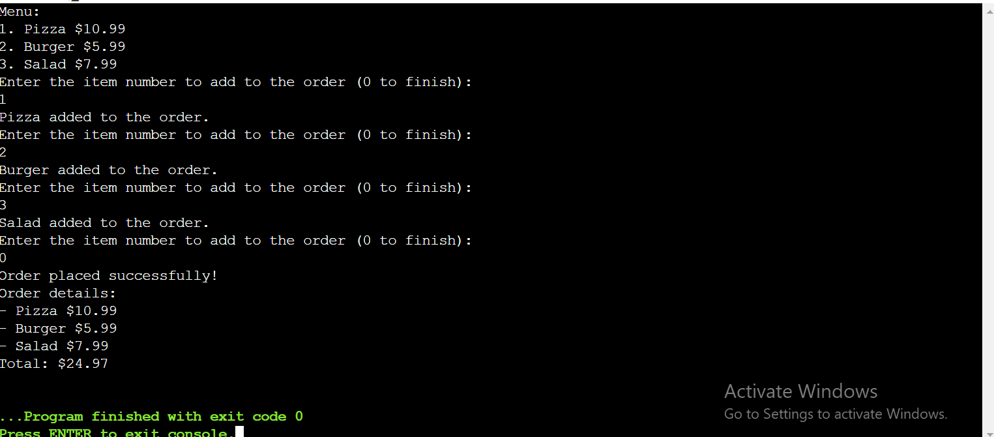

# TEST CASES

# Test cases for an online food ordering system should cover various aspects to ensure the system functions correctly and meets user expectations. Below are some test cases you can consider:

# 1. User Registration and Login:

# a. Verify that users can successfully register with valid information.

# b. Verify that users cannot register with invalid or duplicate information (e.g., email, username).

# c. Verify that users can log in using their registered credentials.

# d. Verify that login fails with incorrect credentials.

# 2. Menu and Food Items:

# a. Verify that the menu displays all available food items correctly.

# b. Verify that food items are categorized properly (appetizers, main courses, desserts, etc.).

# c. Verify that food items have correct details (name, description, price, image).

# d. Verify that food items can be added to the cart from the menu.

# e. Verify that food items cannot be added if they are out of stock.

# f. Verify that the cart reflects the correct quantity and price of selected items.

# 3. Order Placement:

# a. Verify that users can place an order with valid delivery information.

# b. Verify that users cannot place an order without adding items to the cart.

# c. Verify that users are informed if an item is out of stock before placing the order.

# d. Verify that the order confirmation page displays the correct details (order number, items, total

# price, delivery address, etc.).

# e. Verify that users receive an email confirmation after placing the order.

# 4. Payment Processing:

# a. Verify that users can choose from multiple payment options (credit/debit card, PayPal, etc.).

# b. Verify that payment information is processed securely and not stored in plain text.

# c. Verify that the correct amount is charged to the user's account for the order.

# d. Verify that payment fails gracefully if there are issues with the payment gateway.

# 5. Search Functionality:

# a. Verify that users can search for specific food items using keywords.

# b. Verify that search results are relevant and displayed correctly.

# 6. Mobile Responsiveness:

# a. Verify that the website is responsive and functions correctly on various devices (desktop,

# tablet, smartphone).

# 7. Performance and Load Testing:

# a. Verify that the system can handle multiple concurrent users without significant slowdowns.

# b. Verify that response times are within acceptable limits during peak hours.

# USE CASE DIAGRAM FOR FOOD ORDERING SYSTEM

# 

# Figure-2

# CLASS DIAGRAM FOR FOOD ORDERING SYSTEM

Figure-3:

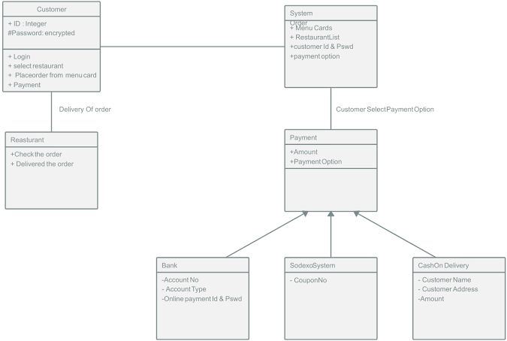

# INFORMATION

With the help of this system, people can easily order the food. It can also ensure that the people do not waste their precious time and use their time productively in the other works. In long run, this will ensure that it helps to reduce labor cost. This system proves to be more cost effective and reliable over other systems. This system is difficult to forge or cheat when compared to other systems in terms of payment for the food. It is very easy to use and has least maintenance. It does not require any human intervention and thus can be called fully automated. There aren’t any limitations as such for this system, however one needs to take care of the smaller parameters like server breakdown while this system is implemented.

An online food ordering system has become increasingly popular and widely adopted in recent years, revolutionizing the way people order and enjoy food. This system offers several advantages and has transformed the food service industry in numerous ways. Let's discuss some key aspects of online food ordering systems:

* Convenience and Accessibility
* Expanded Choice and Variety
* Customization and Personalization
* Time and Cost Efficiency
* Integration of Technology
* Data Insights and Business Growth
* Feedback and Reviews

# CONCLUSION

An online food ordering system is developed where the customers can make an order for the food and avoid the hassles of waiting for the order to be taken by the waiter. Using the application, the end users register online, read the E-menu card and select the food from the e-menu card to order food online. Once the customer selects the required food item the chef will be able to see the results on the screen and start processing the food. This application nullifies the need of a waiter or reduces the workload of the waiter. The advantage is that in a crowded restaurant there will be chances that the waiters are overloaded with orders and they are unable to meet the requirements of the customer in a satisfactory manner. Therefore, by using this application, the users can directly place the order for food to the chef online.

In conclusion an online food ordering system is proposed which is useful in small family run restaurants as well as in places like college cafeteria, etc. This project can later be expanded on a larger scale. It is developed for restaurants to simplify their routine managerial and operational task and to improve the dining experience of the clients. This also helps the restaurant owners develop healthy customer relationships by providing reasonably good services. The system also enables the restaurant to know the items available in real time and make changes to their food and beverage inventory based on the orders placed and the orders completed.

**REFERENCES**

* <https://www.geeksforgeeks.org/design-a-webpage-for-online-food-delivery-system-using-html-and-css/>
* <https://www.sourcecodester.com/python/14542/food-ordering-system-using-python-source-code.html>
* <https://www.softwareadvice.com/resources/free-online-food-ordering-software/>

**THANKYOU!**