

INDRAPRASTHA INSTITUTE *of*

INFORMATION TECHNOLOGY

DELHI

Department

of

Electronics & Communication Engineering

ECE113|Basic Electronics

Lab :5

Student Name: Dheeraj

Roll No.:2020194

Date:1-08-21

**Aim**: To draw the phasor diagram of a series RLC circuit and compare the experimental and theoretical results.

**Components**: **Resistor, Capacitor, inductor,wires, Voltage source, ground.**

Software/Tools Used :

* LT Spice

**Theoretical Calculation :**

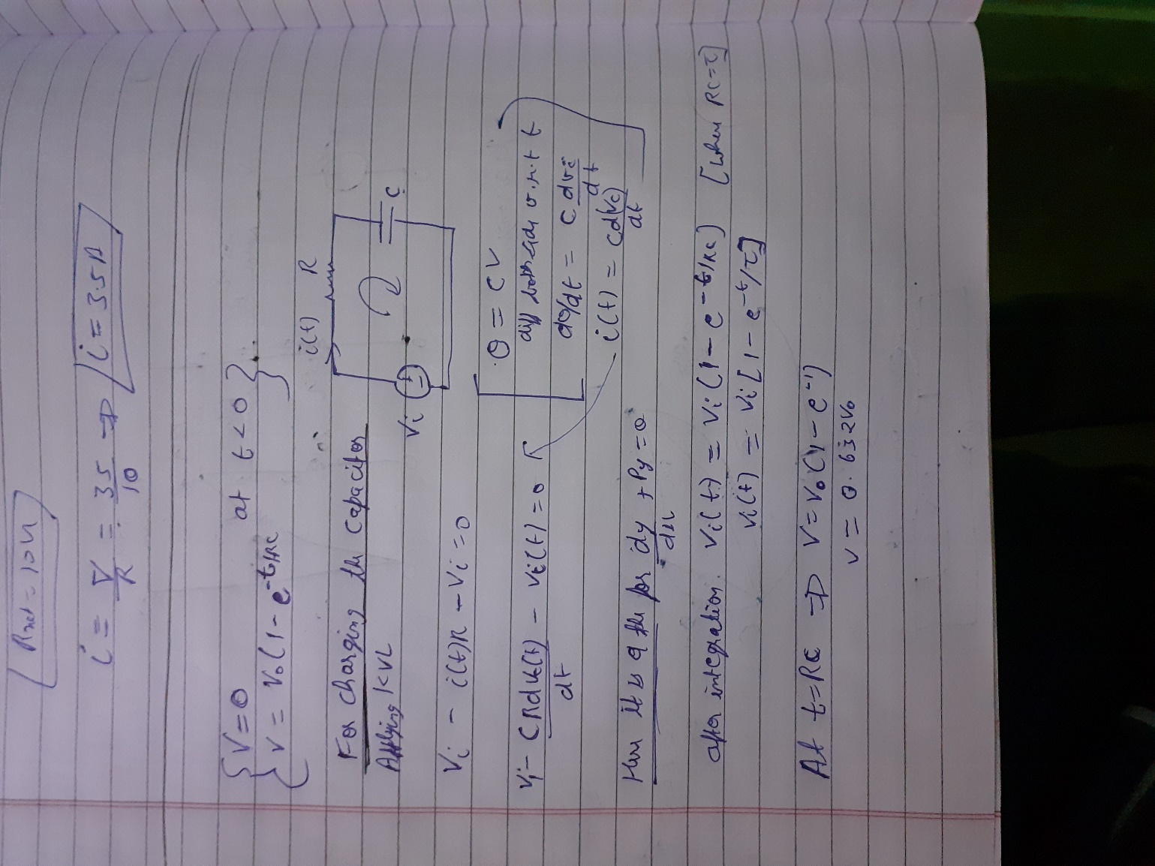

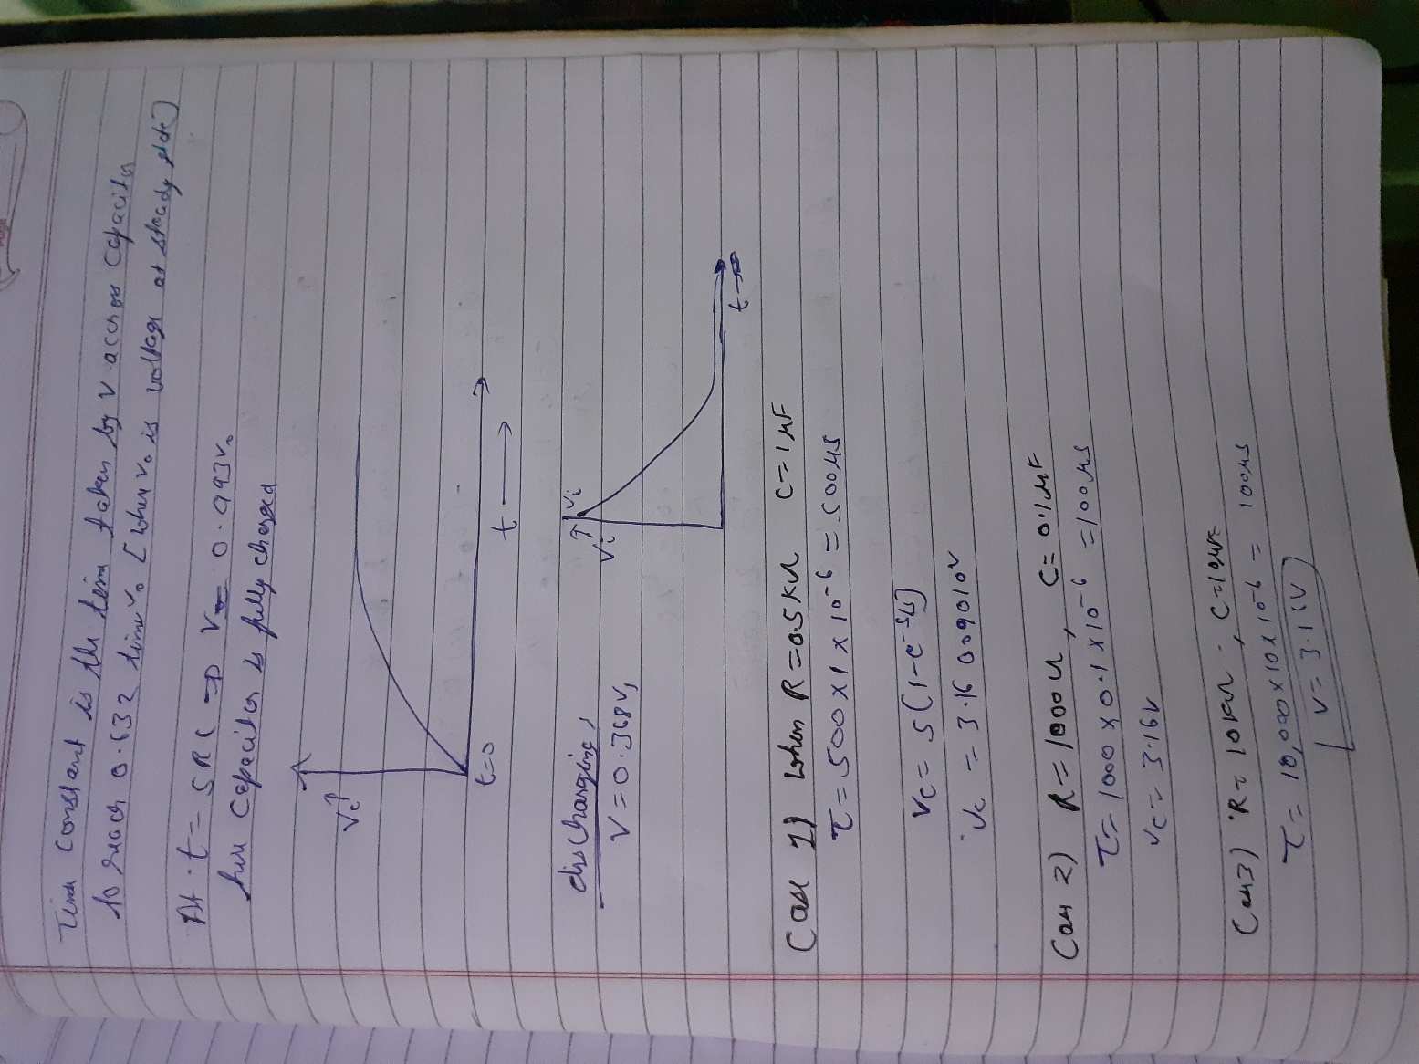

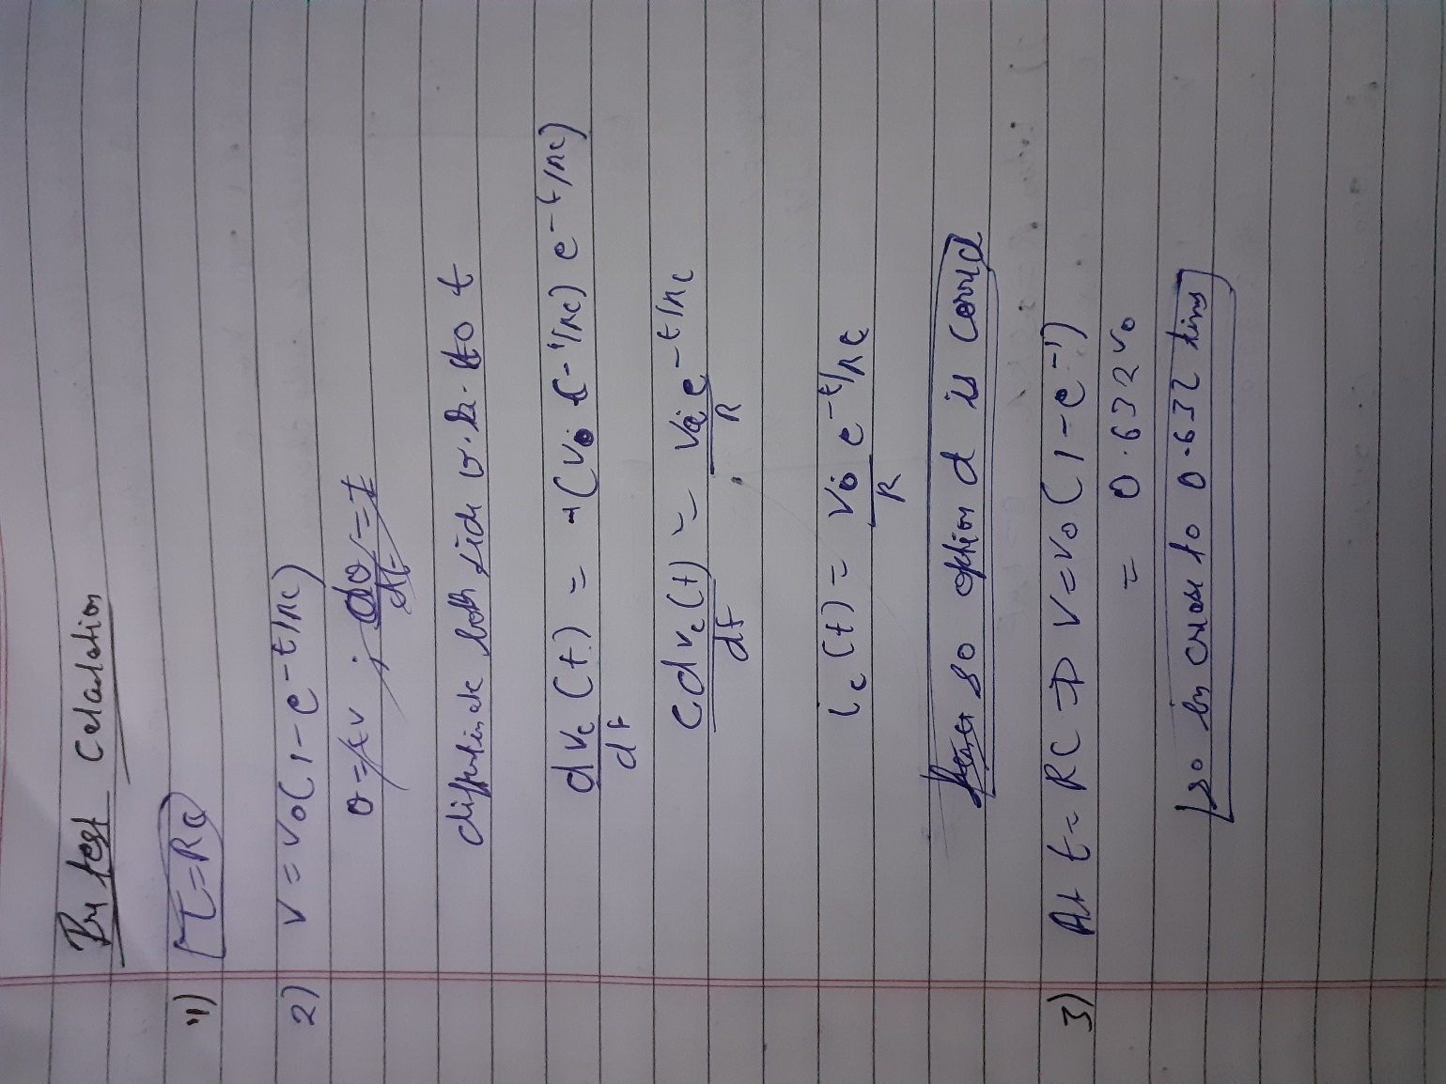

**Circuit Diagram and Link:**

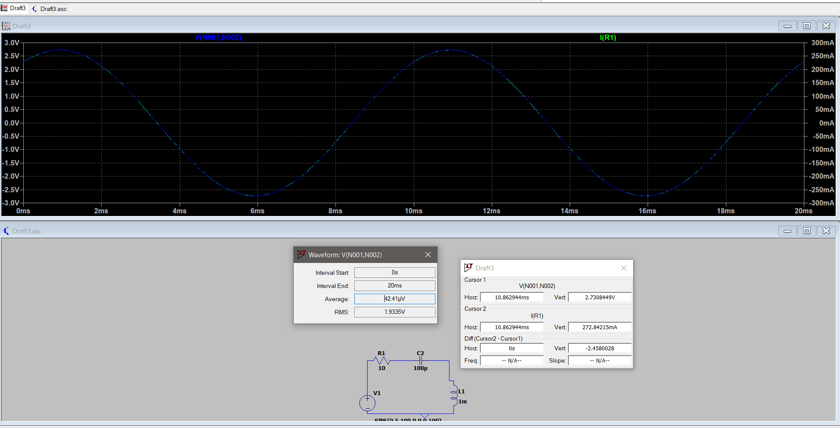

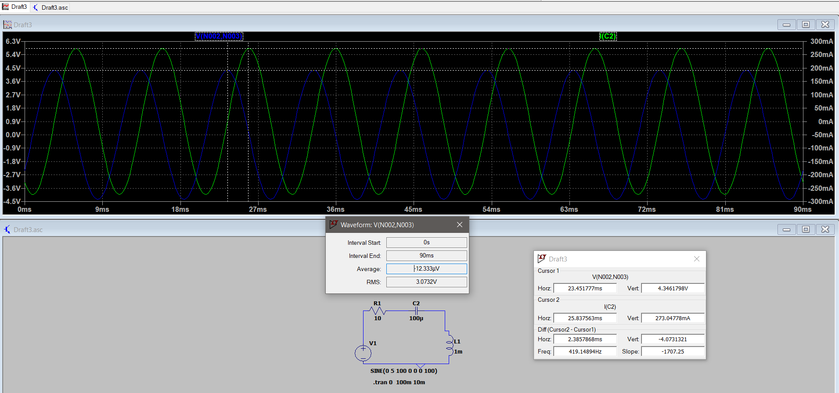

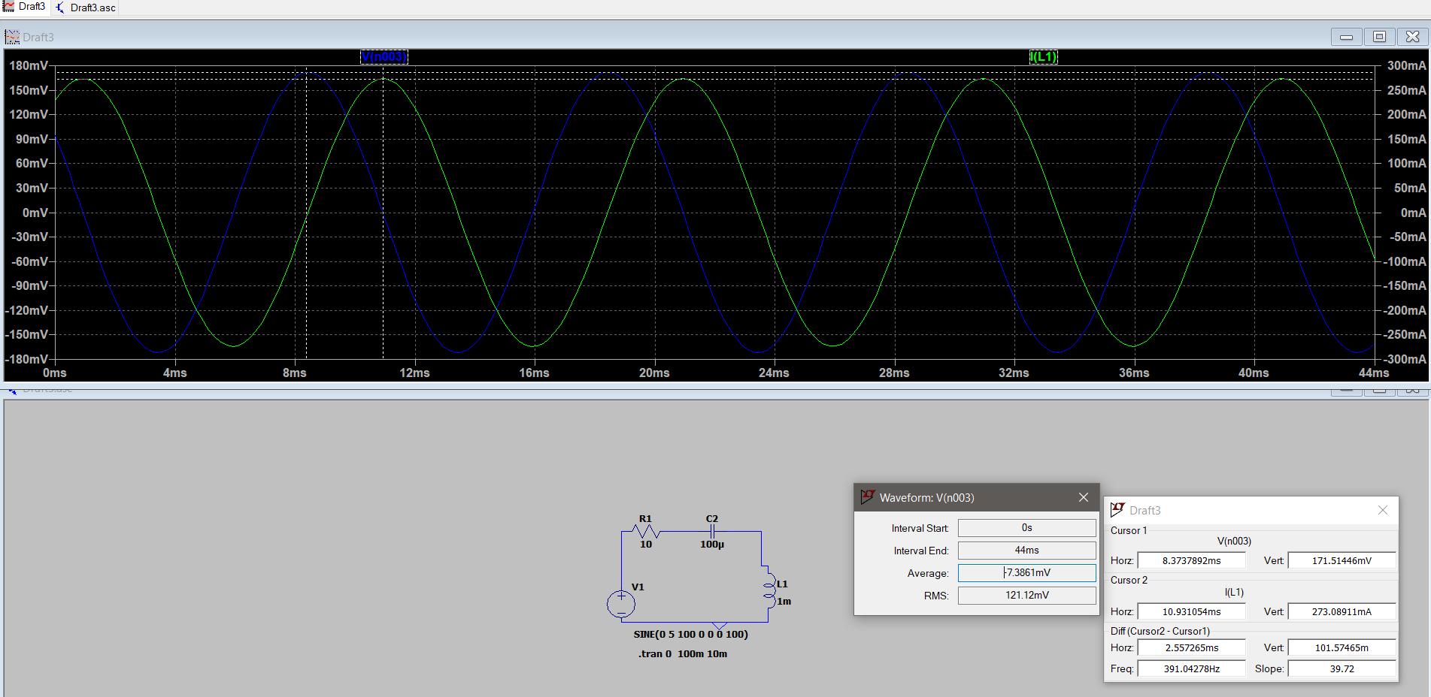

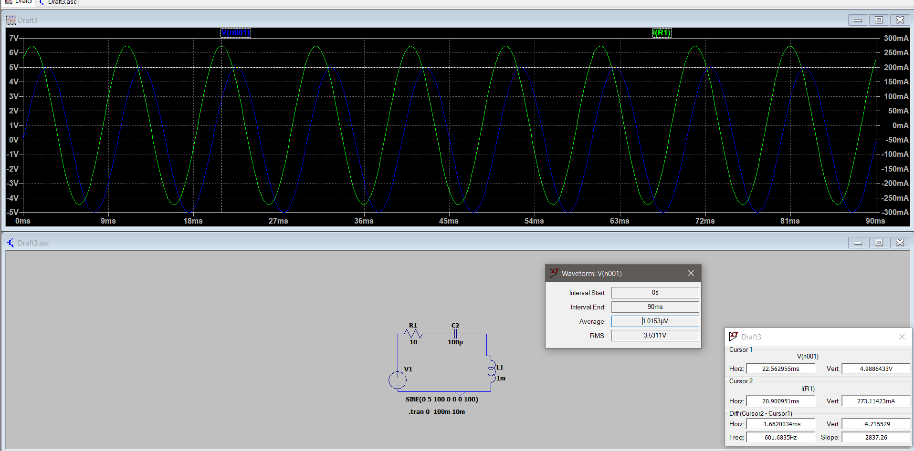

**frequency 500Hz**

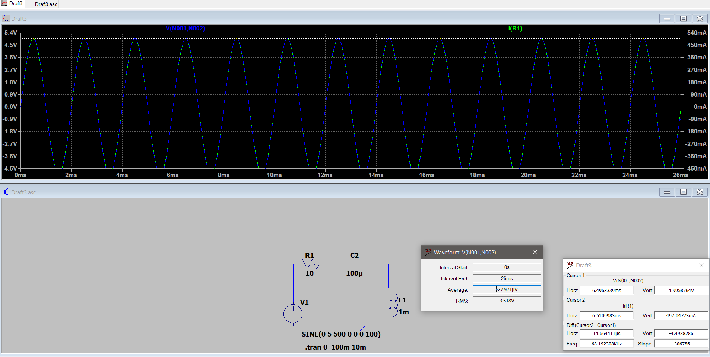

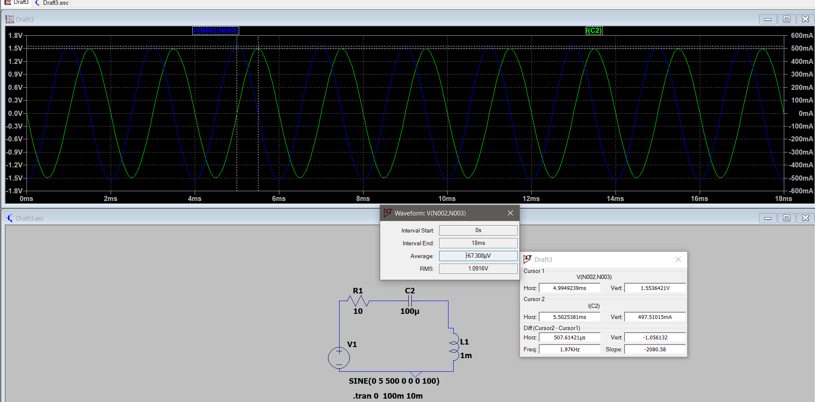

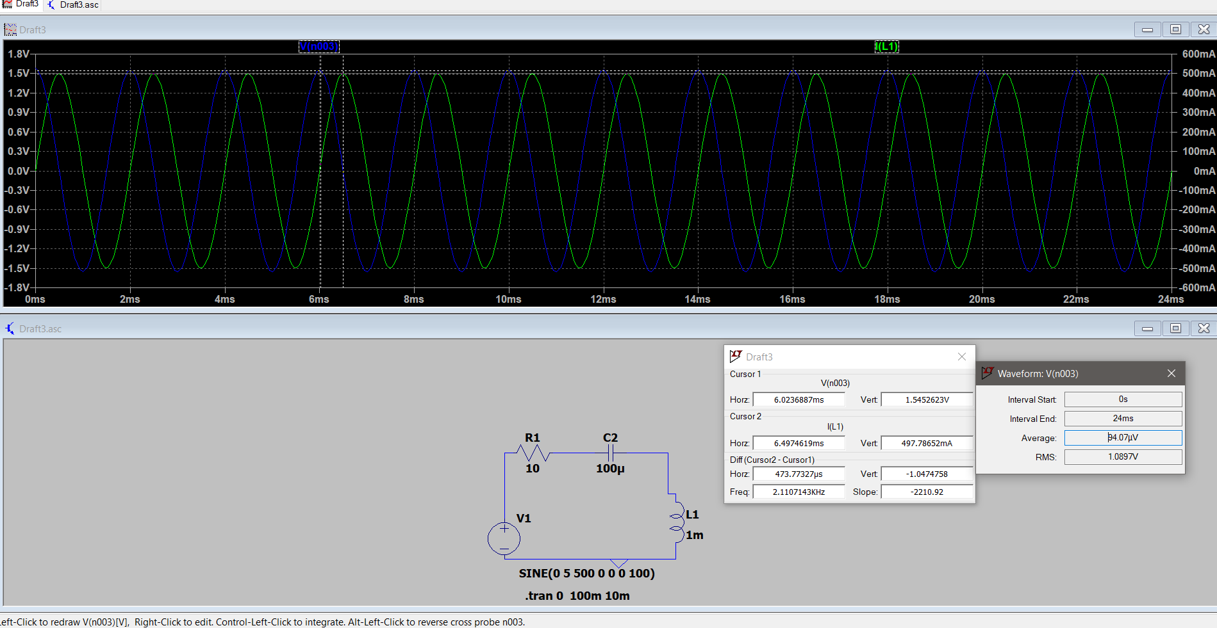

**Observations Table**

**TABLE 5.1: For Ideal Inductor**

|  |  |  |  |  |  |  |  |  |
| --- | --- | --- | --- | --- | --- | --- | --- | --- |
| **Input freq** | **VR** |  | **Vc** |  | **Vl** |  | **V** |  |
|  | practical | theoretical | practical | theoretical | practical | theoretical | practical | theoretical |
| 100 hz | 1.93 | 1.93 | 3.07(90 degree lag) | 3.07(90 degree lag) | 0.121(90 degree led) | 0.121(90 degree led) | 3.53(62.45 degree lag) | 3.53(62.45  degree lag) |
| 500hz | 3.55 | 3.55 | 1.11(90 degree lag) | 1.12(90 degree lag) | 1.10(90 degree led) | 1.10(90 degree led) | 3.53  (0 degree) | 3.53  (0 degree) |
| 700 hz | 3.51 | 3.51 | 0.742(90degree lag) | 0.785(90 degree lag) | 1.50(90 degree led) | 1.506(90degree led) | 3.53(9.81degree lead | 3.54(12degree lead |
|  |  |  |  |  |  |  |  |  |

For Practical Inductor

0

|  |  |  |  |  |  |  |  |  |
| --- | --- | --- | --- | --- | --- | --- | --- | --- |
| **Input freq** | **VR** |  | **Vc** |  | **Vl** |  | **V** |  |
|  | practical | theoretical | practical | theoretical | practical | theoretical | practical | theoretical |
| 100 hz | 1.30 | 1.31 | 2.06(90 degree lag) | 2.08(90 degree lag) | 1.62(2.03 degree led) | 1.64(2.87 degree led) | 3.53(34.2 degree lead) | 3.54(34.2 degree lead) |
| 500hz | 1.57 | 1.57 | 0.492(90 degree lag) | 0.498(90 degree lag) | 2.03(13.1 degree led) | 2.025(1.41 degree led) | 3.53(0 degree) | 3.53(0 degree) |
| 700hz | 1.57 | 1.57 | 0.355(90 degree lag) | 0.355(90 degree lag) | 2.07(17.6 degree led) | 2.07(19.37 degree led) | 3.53(8.46 degree led) | 3.53(5.4 degree led) |

**Observations/Results:**

When circuit is charging then voltage vs time graph first increase then finally reach to saturation. The current flowing through the capacitor shows exponential decay as it suddenly reaches to max value.

We observed the response of RC series circuit and determine time constant of the circuit.

**Applications**:

* Used in camera flash
* Rc circuit is used to filter signals.