Lab Assignment: DC Power Supply

# Objective

The objective of this lab assignment over the course of the semester is to learn how to

1. Design
2. Simulate
3. Connect and (d) Test a +5V, 1A DC power supply circuit with less than 10% ripple from a 230 V input AC mains supply.

# Skills Gained

1. Learn how to read a datasheet and choose appropriate components for a design
2. Learn how to draw a schematic
3. Learn how to simulate the behaviour of the circuit on LTSpice
4. Connect the various electrical and electronics components on a breadboard using connecting wires
5. Test the performance of the circuit and compare the performance with simulation results

# Software Tools

|  |  |  |  |
| --- | --- | --- | --- |
| **S.No** | **Tools** | **Link** | **Objective** |
| 1 | LTSPICE | [https://www.analog.com/en/designcenter/design-tools-andcalculators/ltspice-simulator.html](https://www.analog.com/en/design-center/design-tools-and-calculators/ltspice-simulator.html) | Simulate time domain and frequency domain behaviour of the circuit |

# Suggested Components

|  |  |  |
| --- | --- | --- |
| **Component** | **Type** | **Purpose** |
| 230V AC power cord | Three pin/2A | To connect 230V AC mains supply to the circuit |
| 15-0-15v | Transformer | Step down 230V to 15V, Current rating above 1A, 50Hz core |
| 1A-Fuse | Slow Blow | Protect circuit from surges in the supply |
| 1N4007 | Diode | Configure diodes to form rectifier (half wave / full wave / Bridge) to form pulsating DC |
| 7805 | Regulator | Regulate pulsating DC to a 5V DC output |
| Capacitor | Electrolytic | For filter and suppressing transients |
| Resistors | 1k ohm/ Quarter watt/Carbon film | 1k ohm, addition for filters |
| Breadboard | Full Size (5.5cmx17cm) | To mount the components and making the circuit |
| Multimeter | Digital (RMS) | For measuring voltage and current |
|  | Buzzer/Led |  |
| LED | 5mm Diameter | To connect across output of our design |

# Grading Policy

20 marks will be divided as follows:

* 5 simulation assignments (2 marks each) = 5 x 2 = 10 marks
* 1 measurement assignment with fabricated circuit = 5 marks
* 2 viva voce exams, one before mid-sem and one before end sem = 2.5 x 2 = 5 marks

# Design of a 5V DC power supply

A simple design of the 5V DC power supply circuit is shown below. You can use the figure below as a starting point in your design. Note that you can choose to modify the design below to get better results.

The different stages in the power supply design are:

1. Transformer
2. Rectifier
3. Filter
4. Voltage regulator

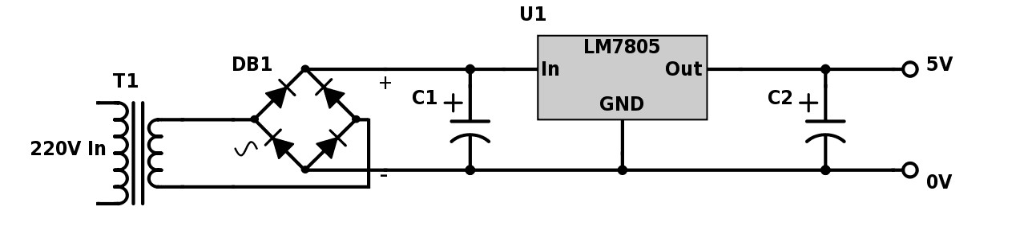

The transformer steps down the 230 V input AC supply voltage to a 15 V AC supply voltage. This output is then passed through a bridge rectifier (4 diode circuit) to obtain a rectified (one-sided) pulsating output voltage with a high ripples. The output of the rectifier is passed through a filter (a single capacitor circuit in the figure shown above) to reduce the amount of ripple and then passed through a voltage regulator. The output of the regular is a 5V DC output.

**Lab Exercise 1:**

1. **Become familiar with lab assignment objectives and lab grading policies**
2. **Become familiar with basics of LTSpice using the LTSPICE user guide - choosing components, drawing a circuit, setting up different types of source excitations, carrying out time-domain (transient and steady state), frequency domain and noise analyses.**
3. **Learn about root mean square of an AC voltage supply**
4. **Design of a transformer in LTSpice.**

*Reading Exercise*

1. Please read about RMS voltage in <https://www.electronics-tutorials.ws/accircuits/rms-voltage.html>
2. Please read about transformer basics in [https://www.electronics-tutorials.ws/transformer/transformerbasics.html](https://www.electronics-tutorials.ws/transformer/transformer-basics.html)
3. Viva questions will be asked based on the lab exercise and the reading exercise

# Root mean square of a voltage source

When we consider AC (alternating current) voltage sources, we can describe them in terms of their peak voltages or their root-mean-square voltages.

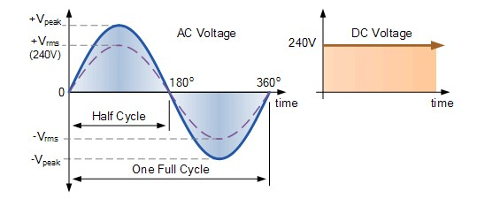

Fig.1. Peak, rms voltage of an AC voltage source (web link)

Therefore if we consider a sinusoidal voltage with a peak voltage *Vpeak*, of time period *T* which is the reciprocal of the frequency *f0*, then the rms voltage can be computed by



# Transformer

AC voltages are supplied because they can be generated at a low voltage and then stepped up to a higher voltage (at the same frequency). The high voltage is then distributed over long distances along transmission lines. The high voltages result in low transmission line currents and hence low I2R losses. The higher AC voltages can then again be stepped down to lower voltages in our homes and workplaces. The step-up and step-down operations are possible due to a static electrical device known as a transformer. An electrical transformer is a passive electromagnetic element that is used to convert AC voltages from one level to another (without changing the frequency) using the principle of mutual induction. A transformer in its simplest form will consist of a magnetic core on which two coils of different number of turns are wound. One coil, called the primary winding, is connected to the supply of electricity and the other, the secondary winding, will be connected to a load. When an AC voltage is applied to the primary windings, a magnetic flux is created that flows through the core. Based on Faraday’s principle, an induced EMF is set up in the secondary windings. Assuming, no losses,

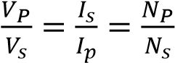= turns ratio or transformation ratio

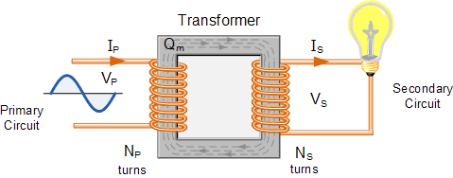

Fig.2 Single Phase Transformer

If the primary voltage is greater than the secondary voltage, then it is known as a step-down transformer (usually found at homes / workplaces). If the primary voltage is lesser than the secondary voltage, then it is known as a stepup transformer (usually found at distribution centres). The efficiency of the transformer is the ratio of the output power to the input power. In ideal transformers, the efficiency is 100%. In non-ideal transformers, part of the power of the primary is lost as heat in the transformer core. The rating of a transformer is stated in terms of the voltamperes that it can transform without overheating.

## Simulating Transformer in LTSpice

We use a pre-existing schematic of an ideal transformer in LTSpice. To import this example circuit in Spice, go to the spice example folder and import the schematic with name “IdealTransformer.asc”.

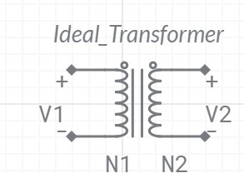

Fig.3 Ideal transformer

1. In the imported example circuit as mentioned above, make the settings of the turns ratio in order for the transformer to work as step-down as (230V to 15V), where N1 = N and N2 = 1.
2. In this example circuit, customize the given source voltage settings at the input side to sinusoidal voltage with 50Hz frequency.
3. The power supply along with the source resistance is connected to the primary while the load resistance (RLOAD [Ω]) is connected to the secondary as shown in Figure.4. We will vary the load resistance and measure the efficiency of the power supply in Table.1

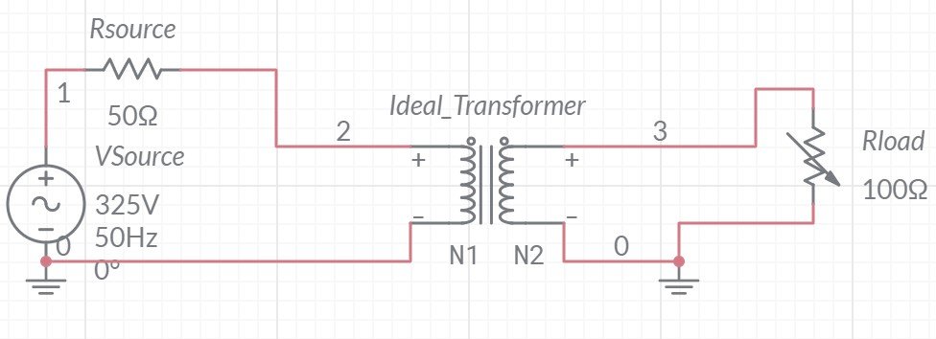

Fig.4 Simulation of the power supply with ideal transformer circuit

Lab Exercise

Assume that the AC power supply to the primary windings of the transformer consists of 230V, 50Hz. Under ideal conditions, the transformer should step down the 230V to 15V.

1. Consider two cases in the above simulation:
   * 1. The transformer is assumed to have 100% efficiency. Keep the source voltage fixed (*Vsource*), and complete the table for different values of load (*Rload*) on secondary (0 -10 MΩ). Note that *Psource* is the average power drawn from the voltage supply and *Pload* is the average power dissipated at the load. Table 1: Single-Phase Transformer Measurements and Calculations (for 100% efficient transformer) *RMS values of voltage/current are mentioned in the table.

|  |  |  |  |  |  |  |  |  |
| --- | --- | --- | --- | --- | --- | --- | --- | --- |
| S.No | Secondary  RLOAD [Ω] | Vsource [V] | Isource [A] | Psource [W] | Vload [V] | Iload [A] | Pload [W] | Efficiency  (Pload /  Psource)[%] |
| 1 | 100 | 230 | 0.010238 | 2.354 | 15.35 | 0.15357 | 2.357 | 100.1 |
| 2 | 250 | 230 | 0.00410 | 0.943 | 15.377 | 0.061508 | 0.945 | 100.2 |
| 3 | 500 | 230 | 0.00205 | 0.4715 | 15.384 | 0.030768 | 0.4733 | 100.3 |
| 4 | 700 | 230 | 0.001465 | 0.3369 | 15.386 | 0.02198 | 0.33818 |  |
| 5 |  | 230 | 0.0010258 |  | 15.387 | 0.015387 |  |  |

* + 1. Now we model a non-ideal transformer. We model the core loss with a shunt (parallel) resistance of

*Riron*, the windings losses as *Rprimary* and *Rsecondary*. Keep the source voltage fixed (*Vsource*), and complete the table for different values of load (*RLOAD*) on secondary (0 -10 MΩ).

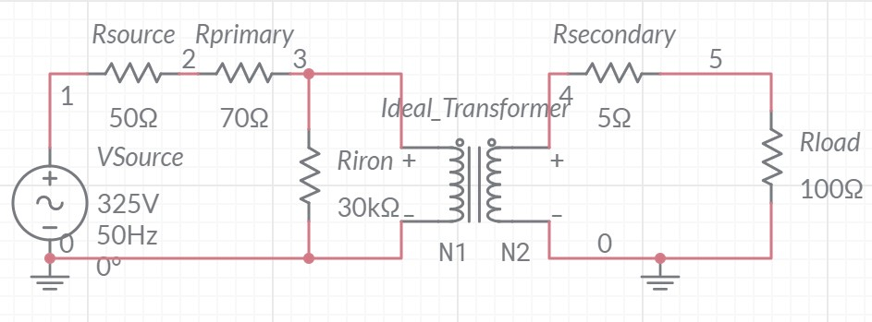



Fig 5 : Simulation of the Non-ideal transformer circuit

Table 2: Measurements for Non-ideal transformer:



*RMS values of voltage/current are mentioned in the table.

|  |  |  |  |  |  |  |  |  |  |  |  |  |
| --- | --- | --- | --- | --- | --- | --- | --- | --- | --- | --- | --- | --- |
| S.No | Secondary RLOAD [Ω] | Vsource  [V] | Isource  [A] | Psource  [W] | Vprimary | Iprimary | Pprimary | Vload [V] | Iload  [A] | Pload  [W] | Efficiency of  Transformer | Efficiency of power source  (Pload/Psource) |
|  |  |  |  |  |  |  |  |  |  |  | (Pload/Pprimary) | [%] |
| 1 | 100 | 230 | 0.1731 | 39.813 | 229.99 | 0.1731 | 39.811 | 14.526 | 0.14526 | 2.11004 | 5.3001 | 5.299 |
| 2 | 250 | 230 | 0.011648 | 2.679 | 229.8 | 0.01164 | 2.674 | 14.998 | 0.059 | 0.8848 | 33.089 | 33.027 |
| 3 | 500 | 230 | 0.00967 | 2.2241 | 230.38 | 0.00967 | 2.227 | 15.162 | 0.0303 | 0.4594 | 20.62 | 20.65 |
| 4 | 700 | 230 | 0.00910 | 2.093 | 230.4 | 0.00910 | 2.096 | 15.209 | 0.0217 | 0.3298 | 15.73 | 15.75 |
| 5 | 1000 | 230 | 0.00867 | 1.9941 | 230.4 | 0.00867 | 1.9975 | 15.245 | 0.015245 | 0.2323 | 11.629 | 11.649 |

1. Based on the above readings, draw the following plots:
   1. between the transformer efficiency and secondary load (only in the case of non-ideal transformer).
   2. between the power source efficiency and secondary load (for both ideal and non-ideal cases).

Both the plots need to be drawn on the same graph.

1. Please suggest the suitable range of loads at which the transformer should be operated so that both the efficiencies are within a maximum optimum range.
2. Prepare an electronic lab report with results.