NAME: CHALIL DHEERAJ PRADEEP KUMAR DATE: 4/ 8/ 2020
EXPERIMENT NO 1(extended.)
LINE DRAWING

Aim: To write an option based program that draws Horizontal, Vertical and Diagonal Lines based on User Inputs
Option 1 : Horizontal Line – kn owing X-coordinate range and specific Y-coordinate and plot the line.
Option 2 : Vertical Line – knowing X-coordinate and Y-coordinate range and plot the line
Option 3 : Diagonal Line - ask for inputs - for example : the input : 5, 10; should plot the line (5,5) (6,6) (7,7) (8,8) (9,9) (10,10).

Program:
import OpenGL
OpenGL.ERROR_ON_COPY = True

from OpenGL.GLUT import *
from OpenGL.GL import *
from OpenGL.GLU import *
w,h = 500,500

def init2D(r,g,b):
glClearColor(r,g,b,0.0)
glMatrixMode (GL_PROJECTION)
gluOrtho2D (-500.0, 500.0, -500.0, 500.0)

def horizontal():
glClear(GL_COLOR_BUFFER_BIT)
glPointSize(4.0)
glColor3f(0.0, 0.0, 1.0)
glBegin(GL_POINTS)
for x1 in range(x2):
glVertex2i(x1,y)
glEnd()
glFlush()

def vertical():
glClear(GL_COLOR_BUFFER_BIT)
glPointSize(4.0)
glColor3f(0.0, 1.0, 0.0)
glBegin(GL_POINTS)
for y1 in range(y2):
glVertex2i(x,y1)
glEnd()
glFlush()

def diagonal():
glClear(GL_COLOR_BUFFER_BIT)
glPointSize(4.0)
glColor3f(1.0, 0.0, 0.0)
glBegin(GL_POINTS)
for d1 in range(d2):
glVertex2i(d1,d1)
glEnd()
glFlush()

option = input('Enter 1 for horizontal line and 2 for verticle line and 3 for diagonal line : ')
if option == '1':
print('selected for horizontal line')
x1 = int(input('Enter x1 value : '))
x2 = int(input('Enter x2 value : '))
y = int(input('Enter y value : '))
glutInit(sys.argv)
glutInitDisplayMode(GLUT_SINGLE | GLUT_RGB)
glutInitWindowSize(w, h)
glutInitWindowPosition(100,100)
glutCreateWindow(b'Horizontal line')
init2D(0.0,0.0,0.0)
glutDisplayFunc(horizontal)
glutMainLoop()

if option == '2':
print('selected for verticle line')
x = int(input('Enter x value : '))
y1 = int(input('Enter y1 value : '))
y2 = int(input('Enter y2 value : '))
glutInit(sys.argv)
glutInitDisplayMode(GLUT_SINGLE | GLUT_RGB)
glutInitWindowSize(w, h)
glutInitWindowPosition(100,100)
glutCreateWindow(b'Vertical line')
init2D(0.0,0.0,0.0)
glutDisplayFunc(vertical)
glutMainLoop()

if option == '3':
print('selected for diagonal line line')
d1 = int(input('Enter value1 : '))
d2 = int(input('Enter value2 : '))
glutInit(sys.argv)
glutInitDisplayMode(GLUT_SINGLE | GLUT_RGB)
glutInitWindowSize(w, h)
glutInitWindowPosition(100,100)
glutCreateWindow(b'Diagonal line')
init2D(0.0,0.0,0.0)
glutDisplayFunc(diagonal)
glutMainLoop()

else:
print('Invalid option')

Result: Successfully executed a python program to draw horizontal, vertical and diagonal lines
Input/Output(1/3):
Enter 1 for horizontal line and 2 for vertical line and 3 for diagonal line : 1
selected for horizontal line
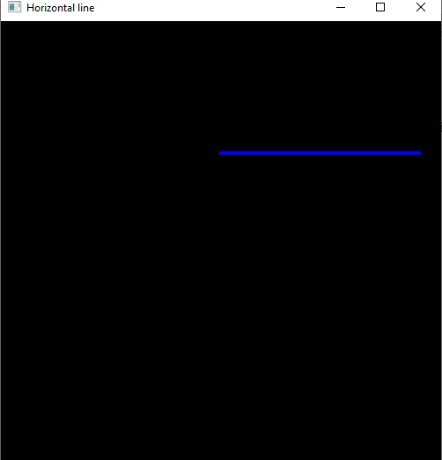
Enter x1 value : 150
Enter x2 value : 450
Enter y value : 200

Input/Output(2/3):
Enter 1 for horizontal line and 2 for vertical line and 3 for diagonal line : 2
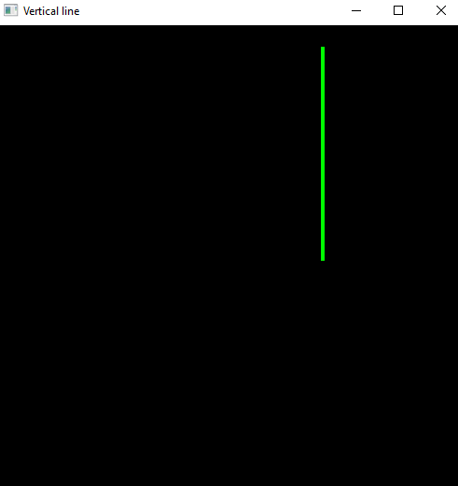
selected for vertical line
Enter x value : 200
Enter y1 value : 150
Enter y2 value : 450

Input/Output(3/3):
Enter 1 for horizontal line and 2 for vertical line and 3 for diagonal line : 3
selected for diagonal line
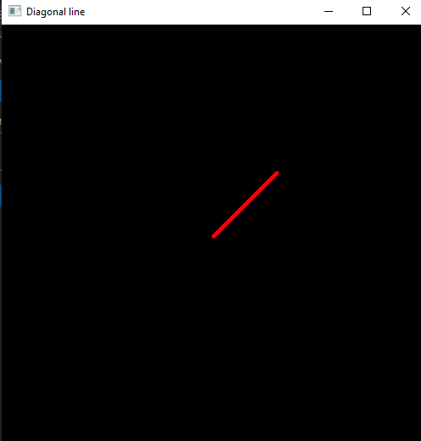
Enter for value1: -450
Enter for value1: 150

