Name: CHALIL DHEERAJ Date: 11-11-2020
Experiment no: 3
Aim
To write a menu driven program to Implement 2D transformations on an equilateral triangle
A: Translation
B: Rotation
C: Scaling
D: Reflection
Program
from OpenGL.GL import *
from OpenGL.GLU import *
from OpenGL.GLUT import *
import math

def init():
glClearColor(0.0, 0.0, 0.0, 0.0)
gluOrtho2D(-500.0, 500.0, -500.0, 500.0)

def ROUND(a):
return int(a+0.4)

def setPixel(x1,y1,x2,y2,x3,y3):
glPointSize(5.0)
glBegin(GL_TRIANGLES)
glVertex2i(x1,y1)
glVertex2i(x2,y2)
glVertex2i(x3,y3)
glEnd()
glFlush()

def userinput():
global x1,x2,y1,y2,x3,y3,option
print('Enter the co-ordinates of the trianglr: ')
x1 = int(input('Enter the x1 value: '))
y1 = int(input('Enter the y1 value: '))
x2 = int(input('Enter the x2 value: '))
y2 = int(input('Enter the y2 value: '))
x3 = int(input('Enter the x3 value: '))
y3 = int(input('Enter the y3 value: '))
option = int(input('Enter 1 for Translation, 2 for Rotation, 3 for Scaling and 4 for Reflection: '))

def translation():
print('enter the units to be transalated')
newx = int(input('enter the units of x: '))
newy = int(input('enter the units of y: '))
setPixel(x1 + newx,y1 + newy,x2 + newx,y2 + newy,x3 + newx,y3 + newy)

def rotation():
theeta = int(input('Enter the angle in degrees to be rotated w.r.t origin: '))
theeta = (theeta*math.pi)/180
newx1 = x1*math.cos(theeta) - y1*math.sin(theeta)
newy1 = x1*math.sin(theeta) + y1*math.cos(theeta)
newx2 = x2*math.cos(theeta) - y2*math.sin(theeta)
newy2 = x2*math.sin(theeta) + y2*math.cos(theeta)
newx3 = x3*math.cos(theeta) - y3*math.sin(theeta)
newy3 = x3*math.sin(theeta) + y3*math.cos(theeta)
setPixel(ROUND(newx1),ROUND(newy1),ROUND(newx2),ROUND(newy2),ROUND(newx3),ROUND(newy3))

def scaling():
print('Enter the scaling factors (scaling w.r.t point x1,y1)')
newx = int(input('Enter the X scaling factor: '))
newy = int(input('Enter the y scaling factor: '))
setPixel(x1, y1, x2 * newx, y2 * newy, x3 * newx, y3 * newy)
glColor3f(0.2,0.0,1.5)
setPixel(x1,y1,x2,y2,x3,y3)

def reflection():
ref = int(input('Select 1 for reflection about x axis and 2 for reflection about y axis'))
if ref == 1:
setPixel(x1,-y1,x2,-y2,x3,-y3)
elif ref == 2:
setPixel(-x1,y1,-x2,y2,-x3,y3)
else:
print('Invalid option')

def display():
glColor3f(0.2,0.0,1.5)
setPixel(x1,y1,x2,y2,x3,y3)
if option == 1:
glColor3f(1.0,0.0,1.0)
translation()
elif option == 2:
glColor3f(1.0,0.0,1.0)
rotation()
elif option == 3:
glColor3f(1.0,0.0,1.0)
scaling()
elif option == 4:
glColor3f(1.0,0.0,1.0)
reflection()
else:
print('Invalid option')

def main():
userinput()
glutInit()
glutInitDisplayMode(GLUT_SINGLE | GLUT_RGB)
glutInitWindowSize(500, 500)
glutInitWindowPosition(100, 100)
glutCreateWindow(b'2D transformations')
glutDisplayFunc(display)
init()
glutMainLoop()

main()

Result
Successfully executed a program to write a menu driven program to Implement 2D transformations on an equilateral triangle
A: Translation
B: Rotation
C: Scaling
D: Reflection
Input(1/4)
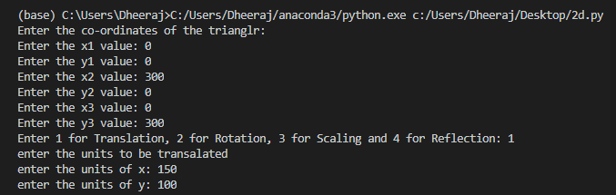
Output(1/4)
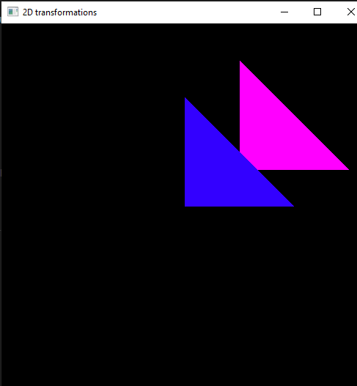

Input(2/4)
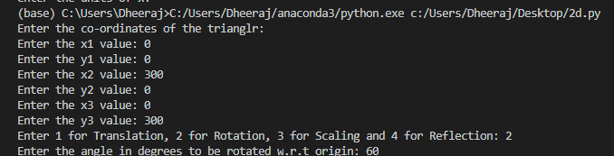
Output(2/4)
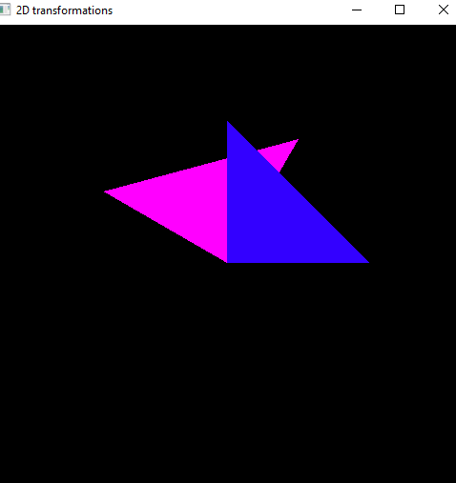

Input(3/4)
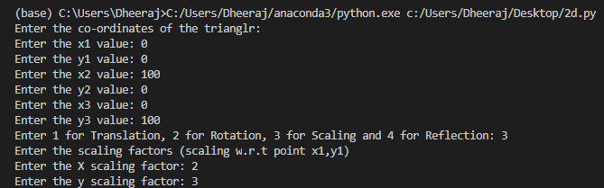
Output(3/4)
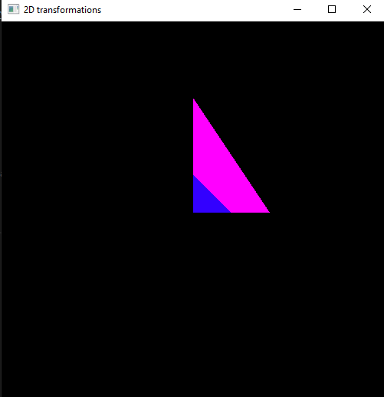

Input(4/4)
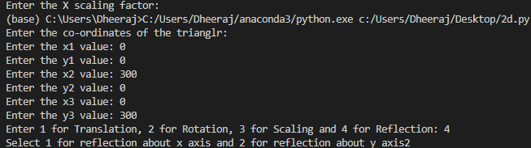
Output(4/4)
