Name: CHALIL DHEERAJ Date: 23-11-2020
Experiment no: 7
Aim
To write a program to
A) Clip a line using Cohen-Sutherland Line Clipping Algorithm
B) Clip a polygon using Sutherland Hodgeman polygon clipping algorithm.
Program
# Experiment VI: Clipping algorithms
# Write a program to
# A)clip a line using Cohen Sutherland Line Clipping algorithm.
# B)clip a polygon using Sutherland Hodgeman polygon clipping algorithm

from OpenGL.GL import *
from OpenGL.GLU import *
from OpenGL.GLUT import *

import sys
import math

def init():
# sets background color as 0
glClearColor(0.0, 0.0, 0.0, 0.0)
# sets the coordinates to be0 shown on the window
gluOrtho2D(-500.0, 500.0, -500.0, 500.0)

# function to initialize glut & create window
def glutFunct():
glutInit(sys.argv)
glutInitDisplayMode(GLUT_SINGLE | GLUT_RGB)
glutInitWindowSize(500, 500)
glutInitWindowPosition(0, 0)
glutCreateWindow(b"Clipping Algorithms")
init()

################################################################################
################################################################################
################################################################################
# functions for clipping window
def drawClippingWindow(xWin0, xWinMax, yWin0, yWinMax):
edges = [
[0, 1],
[1, 2],
[2, 3],
[3, 0]
]
points = [
[xWin0, yWin0],
[xWinMax, yWin0],
[xWinMax, yWinMax],
[xWin0, yWinMax]
]
rgb = (1.0, 1.0, 1.0)

drawLines(edges, points, rgb)

def getClippingWindowSize():
print("Enter the clipping window size : ")
xWin0 = float(input("Enter the minimum window value of x : "))
xWinMax = float(input("Enter the maximum window value of x : "))
yWin0 = float(input("Enter the minimum window value of y : "))
yWinMax = float(input("Enter the maximum window value of y : "))
return xWin0, xWinMax, yWin0, yWinMax

################################################################################
################################################################################
################################################################################
# function for drawing lines
def drawLines(edges, points, rgb):
# glClear(GL_COLOR_BUFFER_BIT)
# glPointSize(5.0)
# glBegin(GL_LINES)

glColor3f(rgb[0], rgb[1], rgb[2])
for e in edges:
for v in e:
glVertex2fv(points[v])

# glEnd()
# glFlush()

################################################################################
# get the given line points
def getLine():
x1 = float(input("Enter the initial x coordinate value : "))
x2 = float(input('Enter the final x coordinate value : '))
y1 = float(input("Enter the initial y coordinate value : "))
y2 = float(input("Enter the final y coordinate value : "))

return x1, x2, y1, y2

def drawGivenLine(x1, x2, y1, y2):
edges = [
[0, 1]
]
points = [
[x1, y1],
[x2, y2]
]
rgb = [0.0, 0.0, 1.0]

drawLines(edges, points, rgb)

################################################################################
# implementation of Cohen-Sutherland line clipping algo
INSIDE = 0
LEFT = 1
RIGHT = 2
DOWN = 4
TOP = 8

def computeCode(x, y, xWin0, xWinMax, yWin0, yWinMax):
code = INSIDE

if x < xWin0:
code |= LEFT

elif x > xWinMax:
code |= RIGHT

if y < yWin0:
code |= DOWN

elif y > yWinMax:
code |= TOP

return code

def cohenSutherland(x1, x2, y1, y2, xWin0, xWinMax, yWin0, yWinMax):
drawGivenLine(x1, x2, y1, y2)

code1 = computeCode(x1, y1, xWin0, xWinMax, yWin0, yWinMax)
code2 = computeCode(x2, y2, xWin0, xWinMax, yWin0, yWinMax)
accept = False

while True:
if code1 == 0 and code2 == 0:
accept = True
break

elif code1 & code2 != 0:
break

else:
x = float()
y = float()

if code1 != 0:
code_out = code1
else:
code_out = code2

if code_out & TOP:
y = yWinMax
x = x1 + (x2 - x1) * (y - y1) / (y2 - y1)

elif code_out & DOWN:
y = yWin0
x = x1 + (x2 - x1) * (y - y1) / (y2 - y1)

elif code_out & LEFT:
x = xWin0
y = y1 + (x - x1) * (y2 - y1) / (x2 - x1)

elif code_out & RIGHT:
x = xWinMax
y = y1 + (x - x1) * (y2 - y1) / (x2 - x1)

if code_out == code1:
x1, y1 = x, y
code1 = computeCode(x, y, xWin0, xWinMax, yWin0, yWinMax)

else:
x2, y2 = x, y
code2 = computeCode(x, y, xWin0, xWinMax, yWin0, yWinMax)

if accept:
edges = [[0, 1]]
points = [
[x1, y1],
[x2, y2]
]
rgb = [1.0, 0.0, 0.0]
drawLines(edges, points, rgb)
drawClippingWindow(xWin0, xWinMax, yWin0, yWinMax)

else:
print("The given line cannot be clipped!")

################################################################################
# for clipping lines
def clipLine(x1, x2, y1, y2, xWin0, xWinMax, yWin0, yWinMax):

glClear(GL_COLOR_BUFFER_BIT)
glPointSize(5.0)
glBegin(GL_LINES)

cohenSutherland(x1, x2, y1, y2, xWin0, xWinMax, yWin0, yWinMax)

glEnd()
glFlush()

################################################################################
################################################################################
################################################################################
# function for drawing polygons
def drawPolygons(edges, points, rgb):
glColor3f(rgb[0], rgb[1], rgb[2])
for e in edges:
for v in e:
glVertex2fv(points[v])

################################################################################
# function for getting the given polygon
def getPolygon():
n = int(input("Enter the number of edges : "))
edges = list(list())
points = list(list())

for i in range(n):
edges += [[i, (i+1) % n]]

for i in range(n):
x = float(input("Enter the x-coordinate value of point " + str(i+1) + ": "))
y = float(input("Enter the y-coordinate value of point " + str(i+1) + ": "))
points += [[x, y]]

# print(edges)
# print(points)

return edges, points

################################################################################
# to draw the given polygon
def drawGivenPolygon(edges, points):
rgb = [1.0, 0.0, 0.0]
drawPolygons(edges, points, rgb)

################################################################################
# implementation of Sutherland-Hodgeman algorithm
def SHC(points, xWin0, xWinMax, yWin0, yWinMax):
global x_new, y_new, x_newr, y_newr, x_newb, y_newb, x_newt, y_newt
x_new = []
y_new = []
x_newr = []
y_newr = []
x_newb = []
y_newb = []
x_newt = []
y_newt = []
n = len(points)
for i in range(n-1):
clipl(points[i][0], points[i][1],
points[i+1][0], points[i+1][1], xWin0)
clipl(points[n-1][0], points[n-1][1], points[0][0], points[0][1], xWin0)
# drawpolygon(x_new,y_new)

n = len(x_new)
for i in range(n-1):
clipr(x_new[i], y_new[i], x_new[i+1], y_new[i+1], xWinMax)
clipr(x_new[n-1], y_new[n-1], x_new[0], y_new[0], xWinMax)
# drawpolygon(x_newr,y_newr)

n = len(x_newr)
for i in range(n-1):
clipb(x_newr[i], y_newr[i], x_newr[i+1], y_newr[i+1], yWin0)
clipb(x_newr[n-1], y_newr[n-1], x_newr[0], y_newr[0], yWin0)
# drawpolygon(x_newb,y_newb)

n = len(x_newb)
for i in range(n-1):
clipt(x_newb[i], y_newb[i], x_newb[i+1], y_newb[i+1], yWinMax)
clipt(x_newb[n-1], y_newb[n-1], x_newb[0], y_newb[0], yWinMax)
# drawpolygon(x_newt, y_newt)

n = len(x_newt)
newEdges = list(list())
for i in range(n):
newEdges += [[i, (i+1) % n]]

newPoints = list(list())
for i in range(len(x_newt)):
newPoints += [[x_newt[i], y_newt[i]]]

rgb = [0.0, 0.0, 1.0]

drawPolygons(newEdges, newPoints, rgb)

def clipl(x1, y1, x2, y2, xWin0):

if x2 - x1 != 0:
m = (y2 - y1)/(x2 - x1)
else:
m = 4000
if x1 >= xWin0 and x2 >= xWin0:

x_new.append(x2)
y_new.append(y2)

elif x1 < xWin0 and x2 >= xWin0:

x_new.append(xWin0)
y_new.append(y1 + m*(xWin0 - x1))
x_new.append(x2)
y_new.append(y2)

elif x1 >= xWin0 and x2 < xWin0:

x_new.append(xWin0)
y_new.append(y1 + m*(xWin0 - x1))

def clipr(x1, y1, x2, y2, xWinMax):
if x2 - x1 != 0:
m = (y2 - y1)/(x2 - x1)
else:
m = 4000

if x1 <= xWinMax and x2 <= xWinMax:

x_newr.append(x2)
y_newr.append(y2)

elif x1 > xWinMax and x2 <= xWinMax:

x_newr.append(xWinMax)
y_newr.append(y1 + m*(xWinMax - x1))
x_newr.append(x2)
y_newr.append(y2)

elif x1 <= xWinMax and x2 > xWinMax:
x_newr.append(xWinMax)
y_newr.append(y1 + m*(xWinMax - x1))

def clipt(x1, y1, x2, y2, yWinMax):
if (y2-y1) != 0:
m = (x2-x1)/(y2-y1)
else:
m = 4000
if y1 <= yWinMax and y2 <= yWinMax:
x_newt.append(x2)
y_newt.append(y2)
elif y1 > yWinMax and y2 <= yWinMax:
x_newt.append(x1+m*(yWinMax-y1))
y_newt.append(yWinMax)
x_newt.append(x2)
y_newt.append(y2)

elif y1 <= yWinMax and y2 > yWinMax:
x_newt.append(x1+m*(yWinMax - y1))
y_newt.append(yWinMax)

def clipb(x1, y1, x2, y2, yWin0):
if (y2-y1) != 0:
m = (x2-x1)/(y2-y1)
else:
m = 4000
if y1 >= yWin0 and y2 >= yWin0:
x_newb.append(x2)
y_newb.append(y2)
elif y1 < yWin0 and y2 >= yWin0:
x_newb.append(x1+m*(yWin0-y1))
y_newb.append(yWin0)
x_newb.append(x2)
y_newb.append(y2)

elif y1 >= yWin0 and y2 < yWin0:
x_newb.append(x1+m*(yWin0 - y1))
y_newb.append(yWin0)

################################################################################
# for clipping polygons

def clipPolygon(edges, points, xWin0, xWinMax, yWin0, yWinMax):

glClear(GL_COLOR_BUFFER_BIT)
glPointSize(5.0)
glBegin(GL_LINES)

drawClippingWindow(xWin0, xWinMax, yWin0, yWinMax)

drawGivenPolygon(edges, points)

SHC(points, xWin0, xWinMax, yWin0, yWinMax)

glEnd()
glFlush()

################################################################################
################################################################################
################################################################################

def menu():
print("\t\tMENU")
print("1. clip a line using Cohen Sutherland Line Clipping algorithm")
print("2. clip a polygon using Sutherland Hodgeman polygon clipping algorithm")

def main():
menu()
ch = int(input("Enter your choice : "))

if ch != 1 and ch != 2:
print("Invalid choice! \nExiting...")
exit()

xWin0, xWinMax, yWin0, yWinMax = getClippingWindowSize()

if ch == 1:
x1, x2, y1, y2 = getLine()

glutFunct()
glutDisplayFunc(lambda: clipLine(
x1, x2, y1, y2, xWin0, xWinMax, yWin0, yWinMax))

if ch == 2:
edges, points = getPolygon()

glutFunct()
glutDisplayFunc(lambda: clipPolygon(
edges, points, xWin0, xWinMax, yWin0, yWinMax))

glutMainLoop()

main()

Result
Successfully executed a program to
A) Clip a line using Cohen-Sutherland Line Clipping Algorithm
B) Clip a polygon using Sutherland Hodgeman polygon clipping algorithm.
Input1
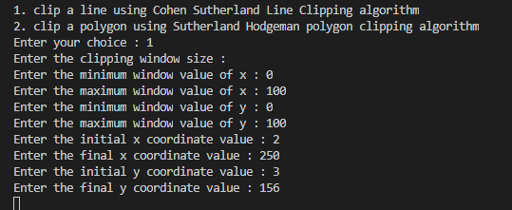
Output1
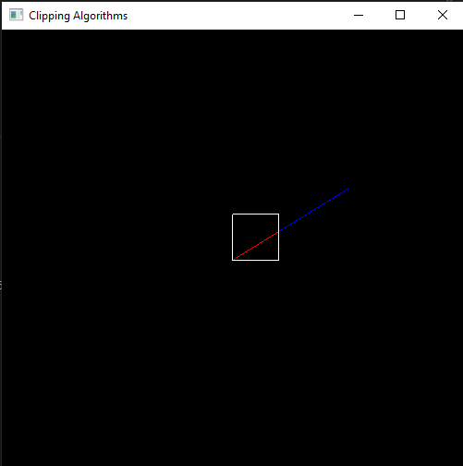

Input2
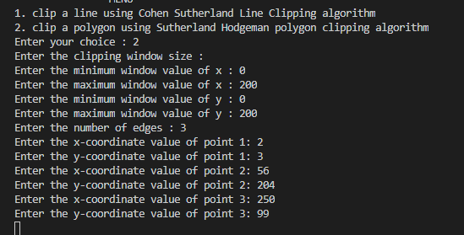

Output2
