Gray Scale Video & Image Colorization

In this project we have developed custom encoder and decoder based CNN model to colour gray images. Encoder will take colour and gray images dataset as input and then extract features to train a decoder model which will generate new colour image from gray image.

To train CNN we have used HDR high quality images and in below screen showing dataset details

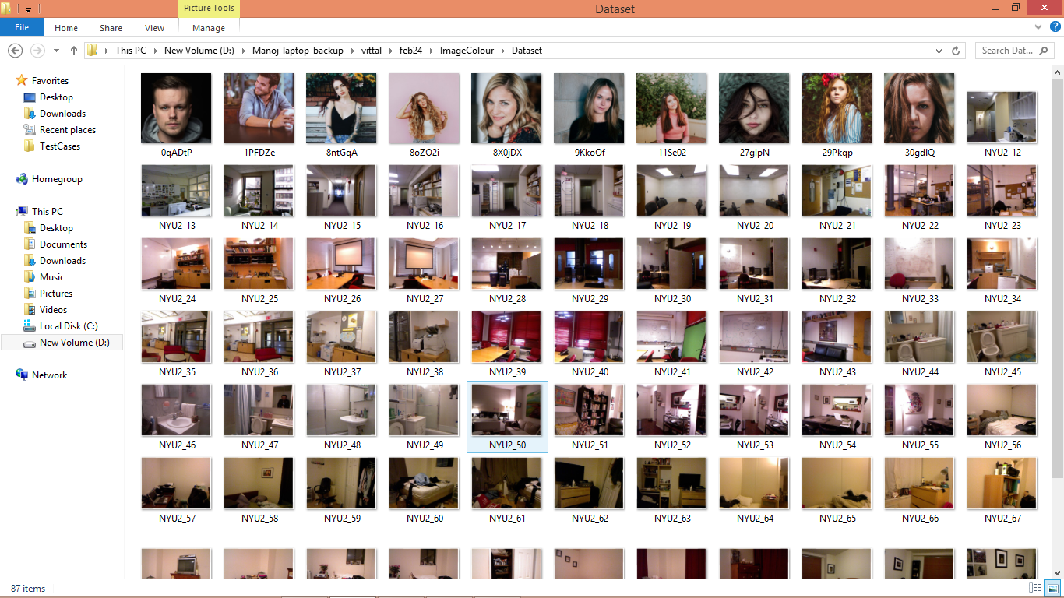

So by using above images will train a model and this model can be applied on test image or video to convert from GRAY to colour.

To implement this project we have designed following modules

1. Upload Colour Images Dataset: using this module we will upload dataset to application
2. Pre-process Dataset: this module will read all images and then extract and normalized all images features
3. Train Custom CNN Model: processed images features will be input to CNN encoder decoder algorithm to train a model
4. Colorized Test Image: trained CNN model will be applied on test image to convert to colour format
5. Colorized Video: trained CNN model will be applied on gray video to convert to colour format

SCREENSHOTS  
to run project double click on ‘run.bat’ file to get below screen

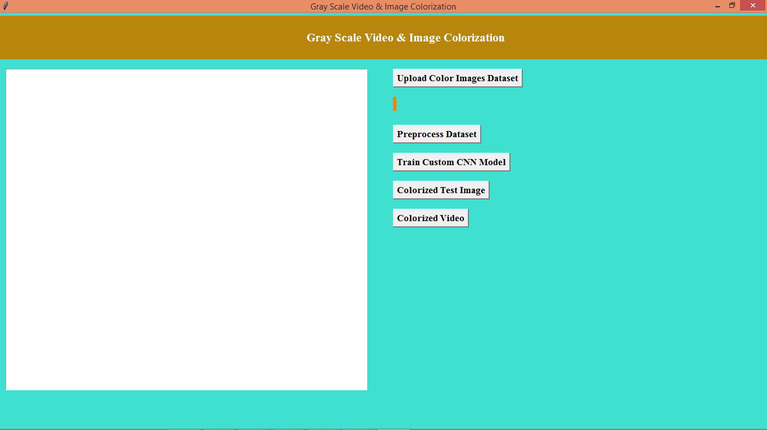

In above screen click on ‘Upload Colour Images Dataset’ button to upload dataset and get below output

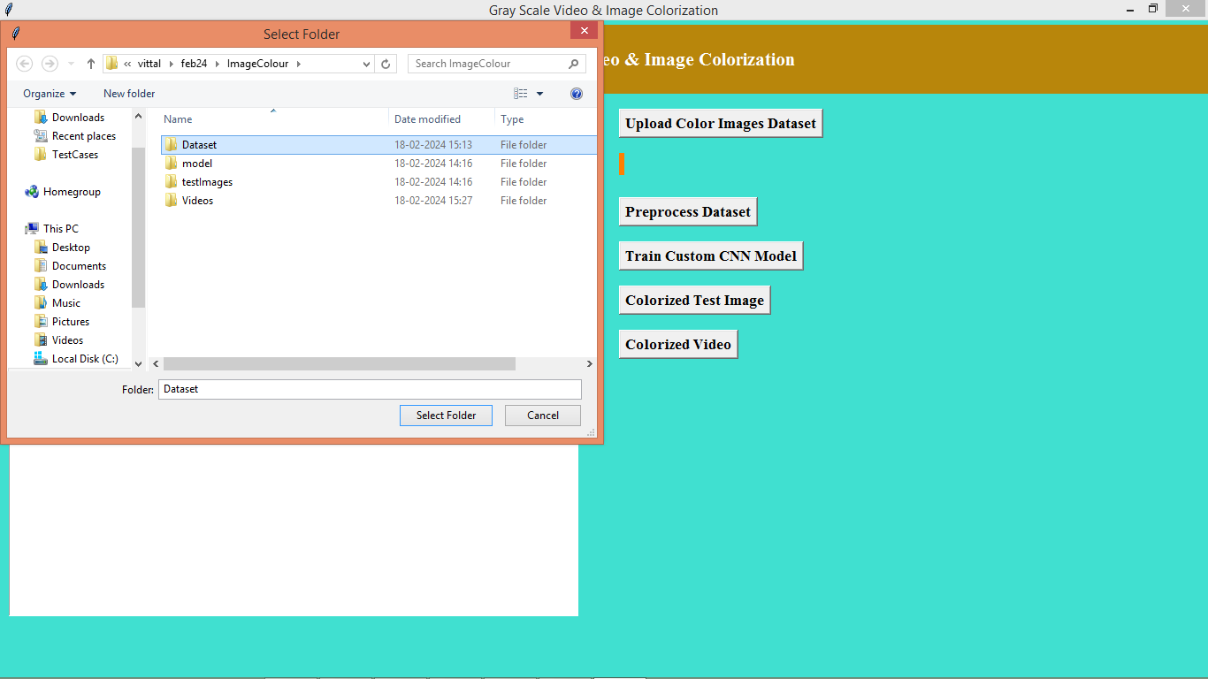

In above screen selecting and uploading ‘Dataset’ folder and then click on ‘Select Folder’ button to load dataset and get below output

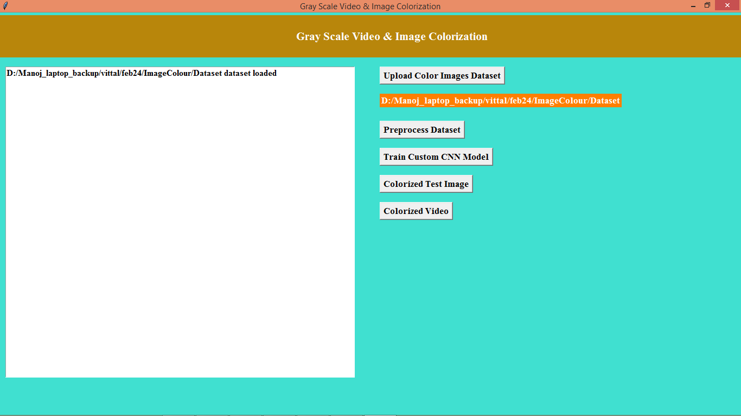

In above screen dataset loaded and now click on ‘Pre-process Dataset’ button to process images and get below output

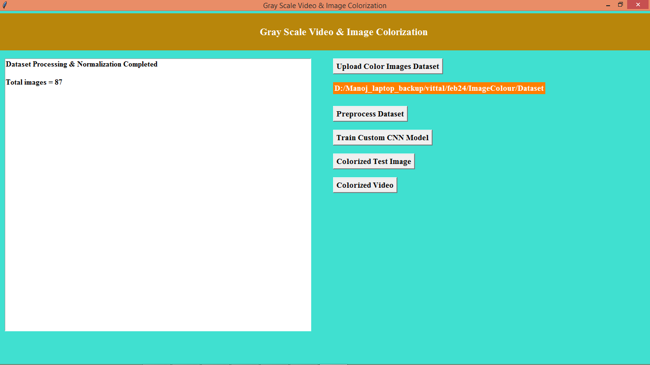

In above screen displaying total number of images processed and now clicks on ‘Train Custom CNN Model’ algorithm to train a model and get below output

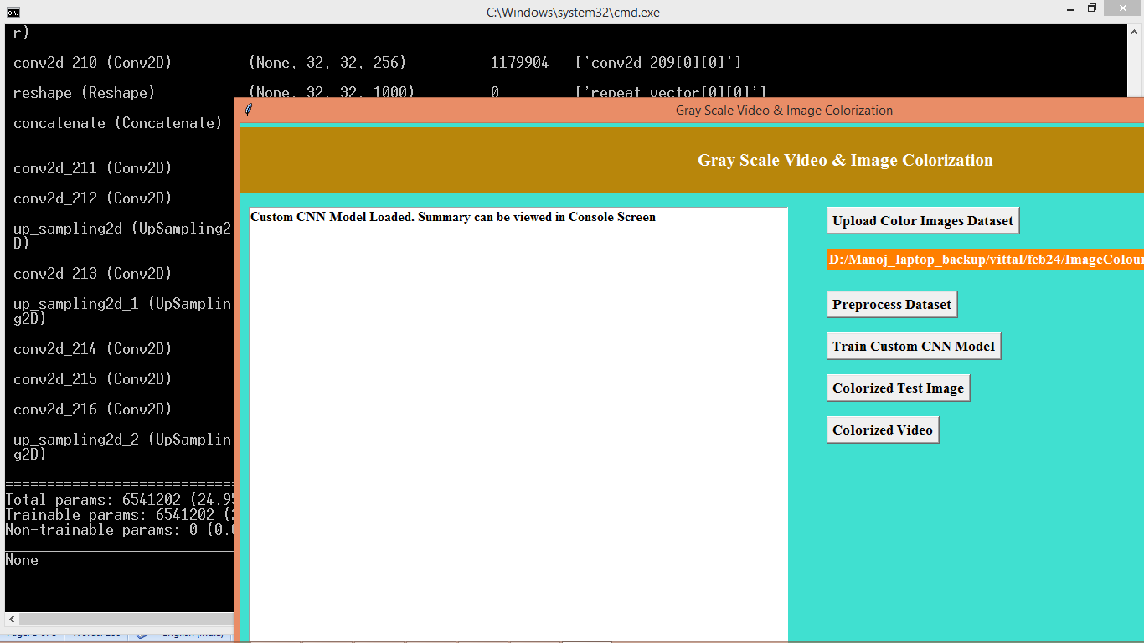

In above screen model is loaded and in black console can see all model details and now click on ‘Colorized Test Image’ button to upload gray image

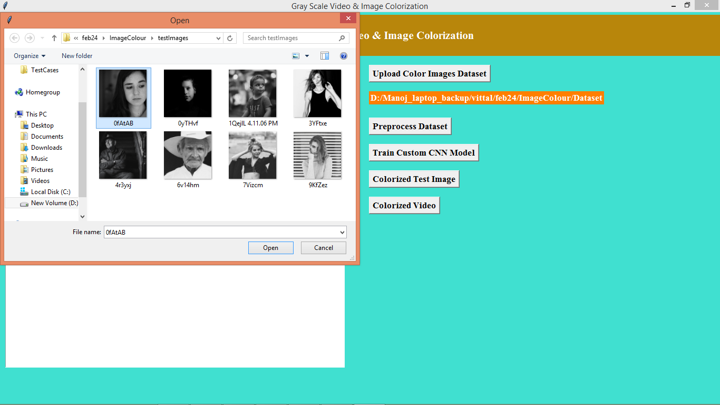

In above screen selecting and uploading gray image and then click on ‘Open’ button to get below output

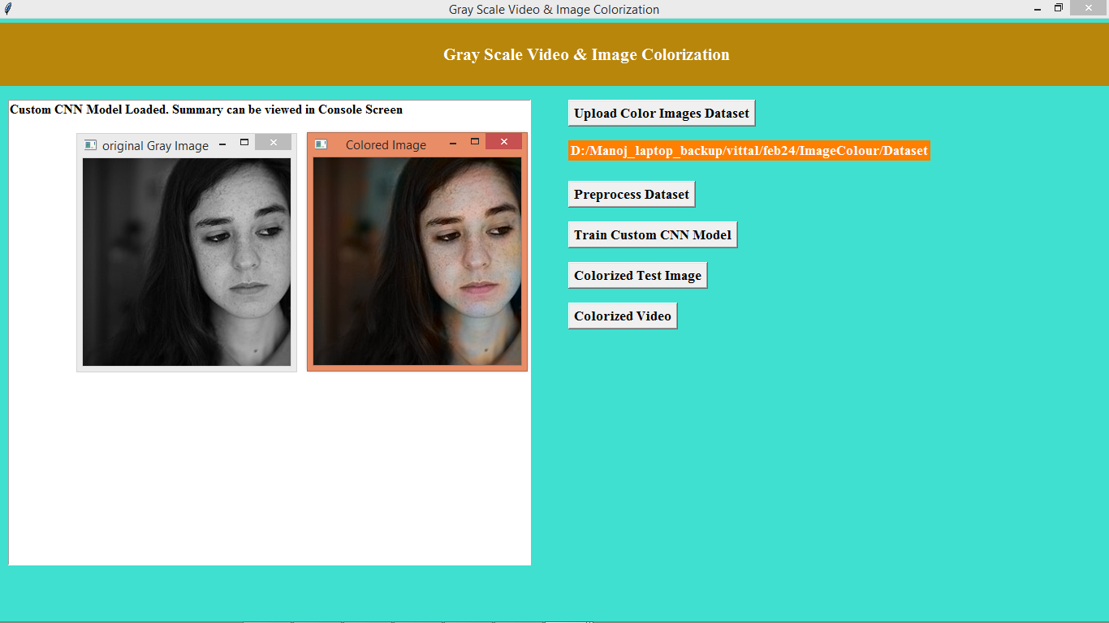

In above screen first image is the input gray image and second is the predicted coloured image and below is another output

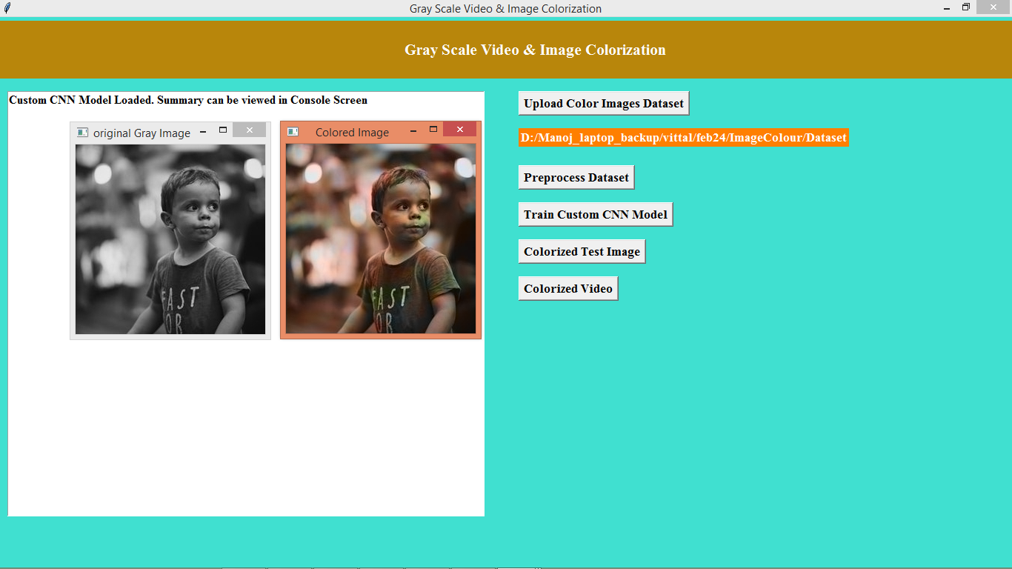

In above screen can see another output

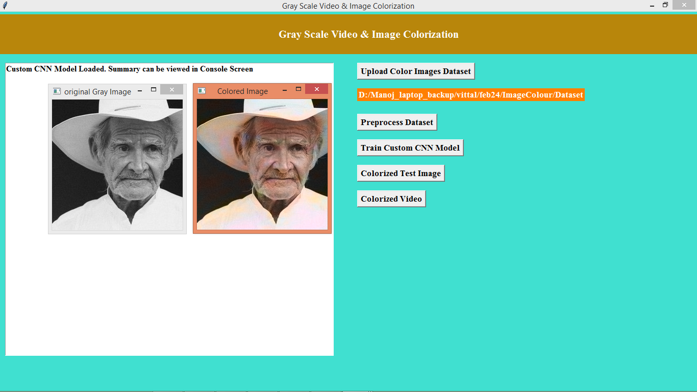

Above is another output and similarly you can upload and test other image and now click on ‘Colorized Video’ button to get below output

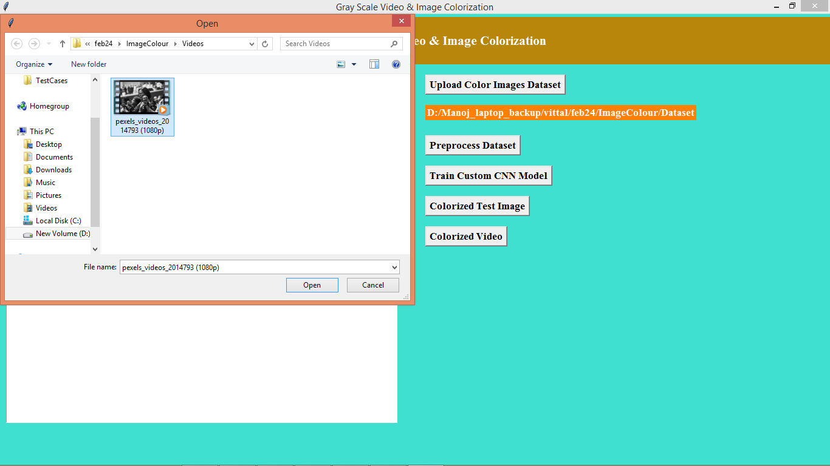

In above screen uploading Gray video and then click on ‘Open’ button to get below output

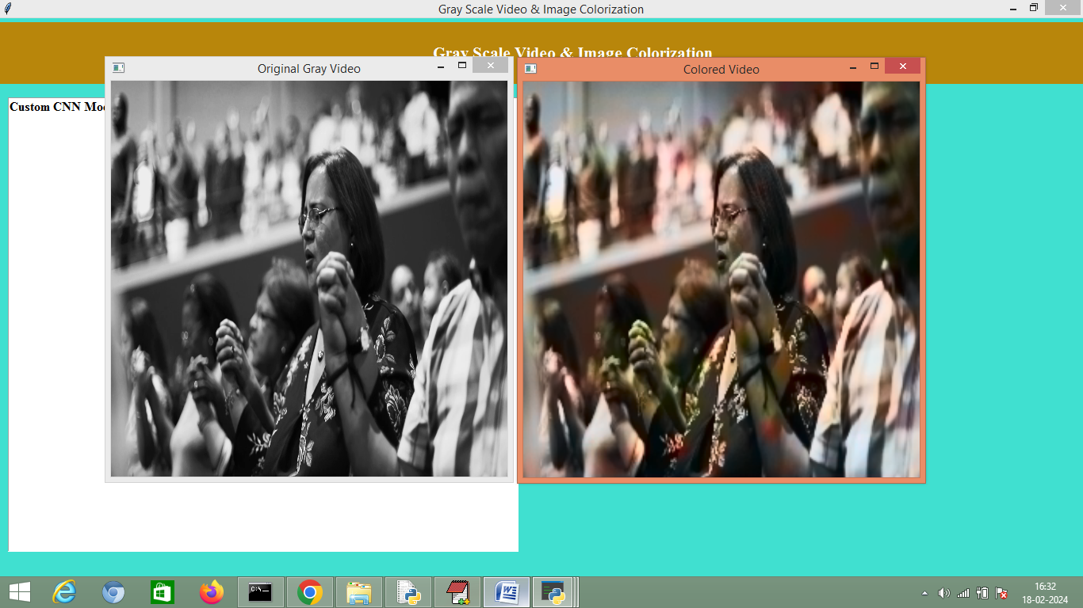

In above screen in first video can see playing of Gray video and second video is the coloured video

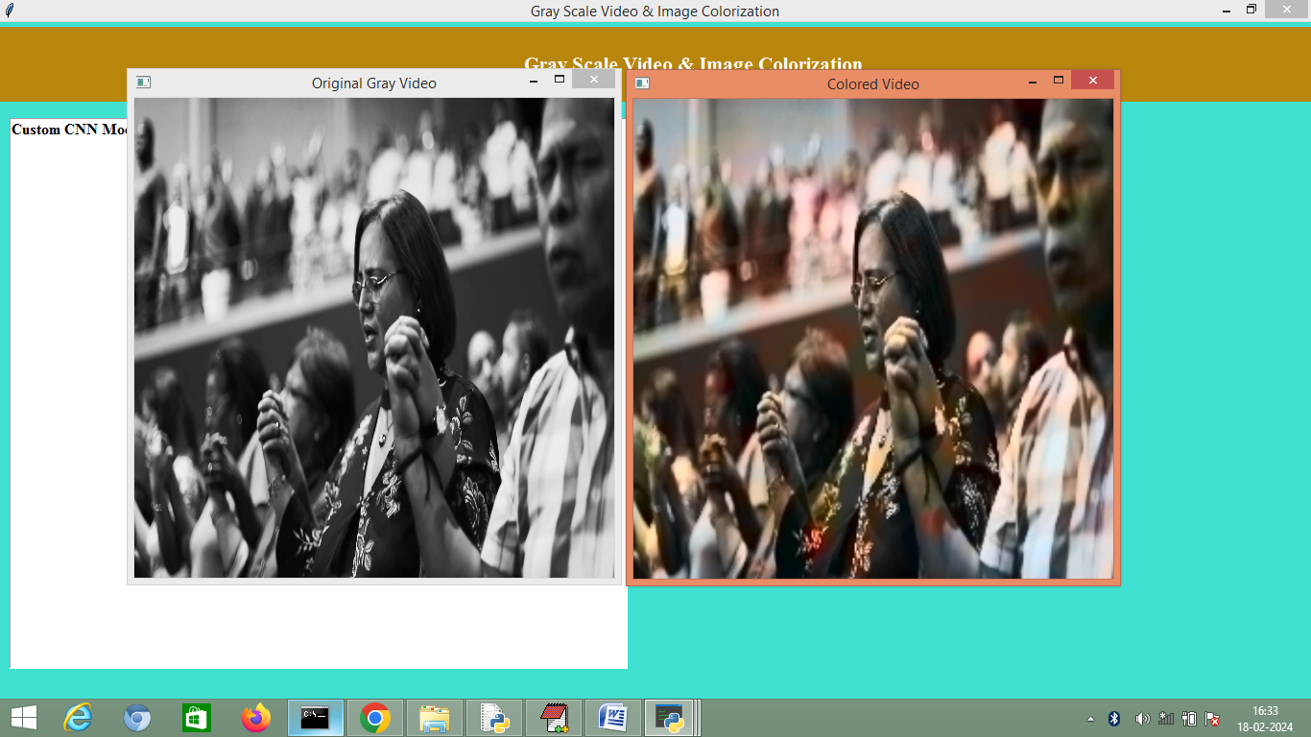

While execution you can see playing of video so by using above code u can convert gray to colour images.

Custom CNN we have trained with few images with 5000 epochs on Google colab GPU and if we increase dataset and trained for more epochs than output will be little more better but COLAB resources exhausting after 3 hours of training with 80 images so we have come up with this much colour output