**Calculations for deciding the components to be used for drone(quadcopter)**

* First, calculate the approx weight of whole quadcopter

1. Weight of frame = 300 gm
2. Weight of bettary = 600 gm
3. BLDC Motors = 4x85 gm
4. Propellers = 4x15 gm
5. Esc + R pi + FC(apm)= 200 gm
6. Camara + gimble = 300 gm
7. Buffer weight = 200 gm

TOTAL = 2000 gm

As per calculation,the total weight of drone is 2 kg about. So you need to generate **3 times** of thrust of its weight for smooth lifting the quad and hovering.

So we need to generate **6 kg** of thrust from four motors.

So each motor needs to generate **1.5 kg** of thrust.

Now according to required thrust we have to choose specified motors and propellers.

First of all, calculate the power.

Equation for power is

**Power = propller’s constant * (R.P.M.)power factor**

Now thrust is,

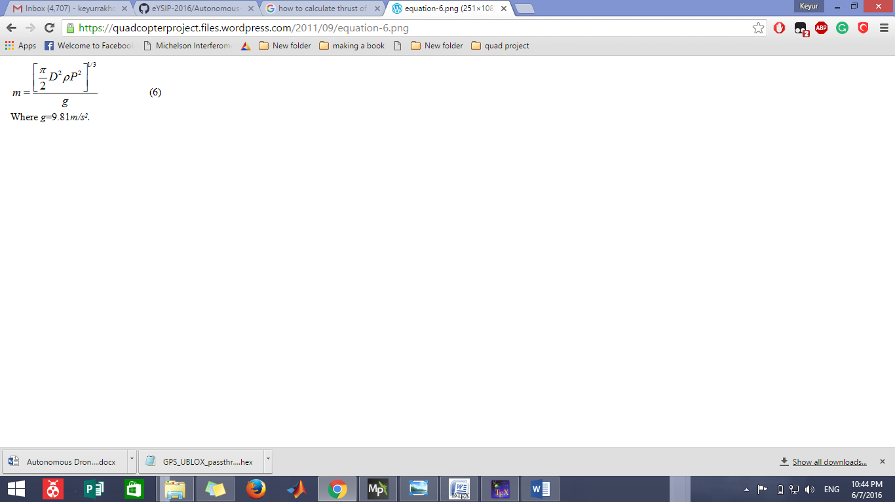

D= diameter of propeller

ρ= Air constant 1.22

P= power supplied by motor to propeller

Now calculate the power according to your propeller’s constant and put it in equation 2.

Do the propeller test and get the readings, you can also find the prop test reading from sellers.

we choose **10x4E** propeller. We got power **222W – 15 A.**

By putting the all the values in equation 2. We get 1.6 kg of thrust per motor.

**1.6*4 = 6.4kg** Which is enough to lift 2 kg of the quadcopter.