# School Management System Project

School Management system project is made in java using DBMS as backend database and provide various types of operations.

The Salient Features of the project are:

* The admin can register new employees who can use system and given the username and password to log in system.
* Then the operator can admit new student and hire new employee. Where student and employee will be provided a unique Identification number.
* After that the student fees and employee salary stated from the admission to the school.
* The operator then can add new subject to system that can taught to students in that term, and by same procedure results of students can be entered “class, session and term wise”
* After the finale exams there is the option to promote the students to the next class if they were passed the previous class.
* Then after every month operator can allocate the fees to the system against each student, same type of operation is for salary of employee.
* There is the option to generate the reports.
  + By giving the student id we generate it details in school.
  + Same for employees id to generate the details of employee
  + Then by giving student id, session (midterm-I, midterm-II, Final), class id (one, two, and three, ….), and term year.
  + The subjects report by giving the term year, to generate the list of subject that were taught in the give term.
  + In last generate the class details of class by giving the class id, term year to generate the report, in that show the details of all student that were enrolled in that class in that term year.
* In last the operator can generate the student certificate.

Technologies used

1. [Java NetBeans // To Download the NetBeans file click (ctrl+Enter) on the blue word .onstall only the NetBeans from above link to](https://drive.google.com/drive/folders/13OjYSFFDwkv9glP3cd6jVLxfr8N1pltC?usp=sharing)
2. [Xampp](https://drive.google.com/file/d/1LbpaX3XwhCFhHGF8OJL8LuWsnbwrXbMp/view?usp=sharing) // To Download the Xampp file click (ctrl+Enter) on the blue word
3. [Mysql Database](https://drive.google.com/file/d/1deJmFnyJUc3X6d416K3asmj46l9cGDeI/view?usp=sharing) // To Download the database file click (ctrl+Enter) on the blue word

Instruction to Use the project

* TO install and use the project you need to be download above mentioned software’s to use the project.

https://drive.google.com/drive/folders/13OjYSFFDwkv9glP3cd6jVLxfr8N1pltC?usp=sharing

<https://drive.google.com/file/d/1LbpaX3XwhCFhHGF8OJL8LuWsnbwrXbMp/view?usp=sharing>

https://drive.google.com/file/d/1deJmFnyJUc3X6d416K3asmj46l9cGDeI/view?usp=sharing

* After installing above mentioned software’s then you need to run the NetBeans and import the project from location where you have installed.
* To import the project here are dome instruction
  + Open NetBeans
  + Click File >Open project
  + Navigate the location of project where you have installed
  + Then click open project
  + Then clean and build the project.
* Then import the database file with extension “.sql” in myphp admin
  + Install Xampp
  + Open the Xampp and start the mysql and apache then click the mysql admin

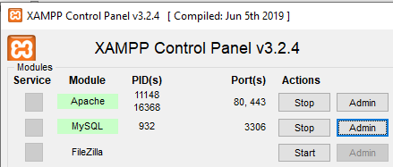

* + After that local host will open in default browser then you need click import

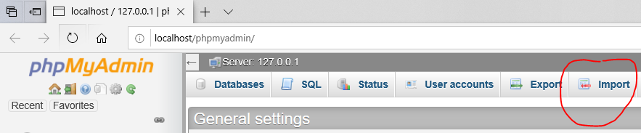

* + Then click the browse and navigate the location of “DB.sql” you have installed or you can find it in project file that you have downloaded or download from above given third link.
  + Then Click the go in the last of the page

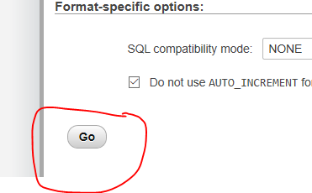

* After that in NetBeans you have to connect with Xampp

<https://youtu.be/Lq8V-pD4qCo>

By clicking above link there is the video how to connect NetBeans with Xampp by watching this you can connect with server. And enjoy the service.

Thanks.

Team members:

Name: Dheeraj Parkash Email:dheerajparkash.bcsf18@iba-suk.edu.pk

Name: Adarsh Chimnani Email:AdarshUmesh.bcsf18@iba-suk.edu.pk

Name: Laksh Kumar Email: LakshKumar.bcsf18@iba-suk.edu.pk