- Additional Files to be Added

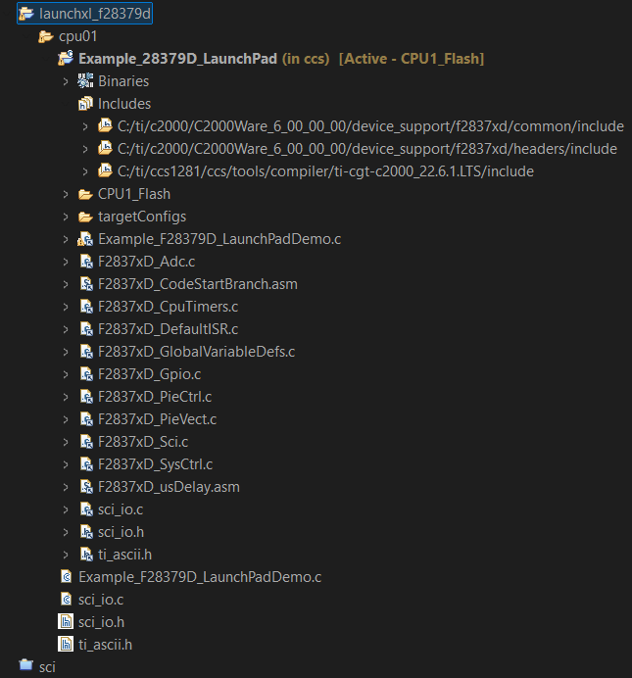

- In properties of the file

Include Options:
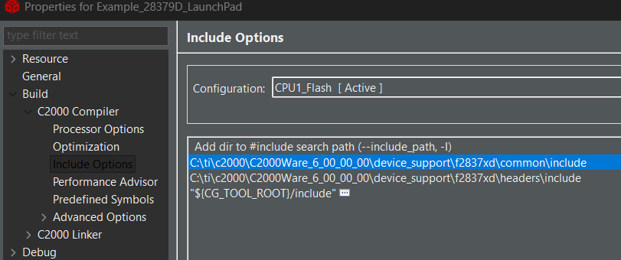
Predefined Symbols:

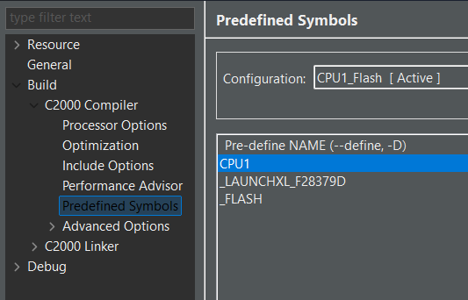

File Search Path:

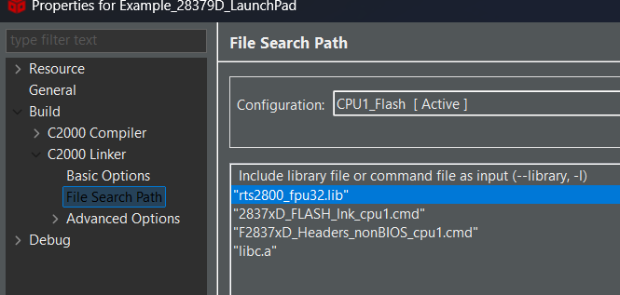

Gineral:

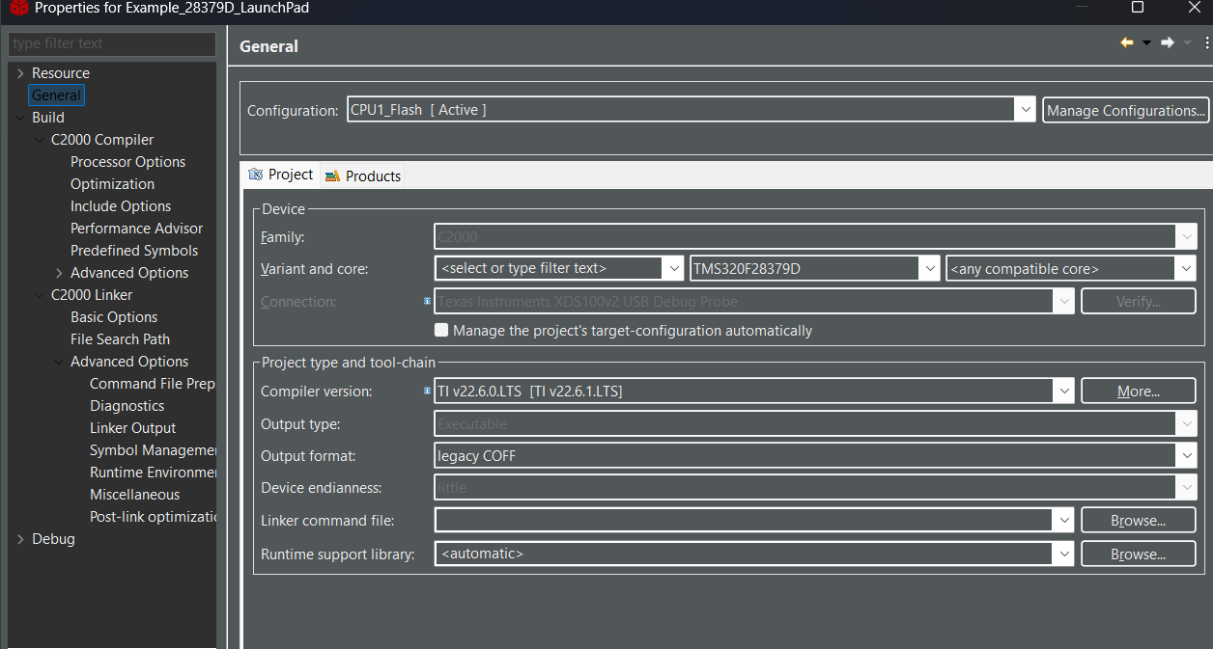
Add All these and cross check if all these options are opted in the properties
Output:
Under View check for terminal option
there give
COM(N) based on ur pc connections
Baud rate 115200
Data size:8
Parity None
stop bits: 1
And click ok to run those in terminal to view it
Instead u can run in putty and save directly in CSV and sample the the adc values

To RUN
FIRST build ur projects and then push it into the board

ADCPIN: Pin no 23
Ground: GND

Changed code with better time stamp and ADC Sample output

//###########################################################################
//
// FILE: Example_F28379D_LaunchPadDemo.c
//
// TITLE: F28379D LaunchPad Out of Box Demo
//
// DESCRIPTION:
//! \addtogroup cpu01_example_list
//! <h1>Out of Box Demo (LaunchPadDemo)</h1>
//!
//! This program is the demo program that comes pre-loaded on the F28379D
//! LaunchPad development kit. The program starts by flashing the two user
//! LEDs. After a few seconds the LEDs stop flashing and the device starts
//! sampling ADCIN14 once a second. If the sample is greater than midscale
//! the red LED on the board is lit, while if it is lower a blue LED is lit.
//! Sample data is also display in a serial terminal via the boards back
//! channel UART. You may view this data by configuring a serial terminal
//! to the correct COM port at 115200 Baud 8-N-1.
//!
//
//###########################################################################
//
//
// $Copyright:
// Copyright (C) 2013-2025 Texas Instruments Incorporated - http://www.ti.com/
//
// Redistribution and use in source and binary forms, with or without
// modification, are permitted provided that the following conditions
// are met:
//
// Redistributions of source code must retain the above copyright
// notice, this list of conditions and the following disclaimer.
//
// Redistributions in binary form must reproduce the above copyright
// notice, this list of conditions and the following disclaimer in the
// documentation and/or other materials provided with the
// distribution.
//
// Neither the name of Texas Instruments Incorporated nor the names of
// its contributors may be used to endorse or promote products derived
// from this software without specific prior written permission.
//
// THIS SOFTWARE IS PROVIDED BY THE COPYRIGHT HOLDERS AND CONTRIBUTORS
// "AS IS" AND ANY EXPRESS OR IMPLIED WARRANTIES, INCLUDING, BUT NOT
// LIMITED TO, THE IMPLIED WARRANTIES OF MERCHANTABILITY AND FITNESS FOR
// A PARTICULAR PURPOSE ARE DISCLAIMED. IN NO EVENT SHALL THE COPYRIGHT
// OWNER OR CONTRIBUTORS BE LIABLE FOR ANY DIRECT, INDIRECT, INCIDENTAL,
// SPECIAL, EXEMPLARY, OR CONSEQUENTIAL DAMAGES (INCLUDING, BUT NOT
// LIMITED TO, PROCUREMENT OF SUBSTITUTE GOODS OR SERVICES; LOSS OF USE,
// DATA, OR PROFITS; OR BUSINESS INTERRUPTION) HOWEVER CAUSED AND ON ANY
// THEORY OF LIABILITY, WHETHER IN CONTRACT, STRICT LIABILITY, OR TORT
// (INCLUDING NEGLIGENCE OR OTHERWISE) ARISING IN ANY WAY OUT OF THE USE
// OF THIS SOFTWARE, EVEN IF ADVISED OF THE POSSIBILITY OF SUCH DAMAGE.
// $
//###########################################################################

//
// Included Files
//
#include <stdint.h>
#include <stdbool.h>
#include <stdio.h>
#include <file.h>

#include "F28x_Project.h" // DSP28x Headerfile
#include "ti_ascii.h"
#include "sci_io.h"

//
// Defines
//

//
// Micro-seconds to wait for ADC conversion. Longer than necessary.
//
#define CONV_WAIT 1L

//
// Globals
//
extern void DSP28x_usDelay(Uint32 Count);

static unsigned short indexX=0;
static unsigned short indexY=0;

const unsigned char escRed[] = {0x1B, 0x5B, '3','1', 'm'};
const unsigned char escWhite[] = {0x1B, 0x5B, '3','7', 'm'};
const unsigned char escLeft[] = {0x1B, 0x5B, '3','7', 'm'};
const unsigned char pucTempString[] = "ADCIN14 Sample: ";

int16_t currentSample;

//
// sampleADC -
//
int16_t sampleADC(void)
{
int16_t sample;

//
// Force start of conversion on SOC0
//
AdcaRegs.ADCSOCFRC1.all = 0x03;

//
// Wait for end of conversion.
//
while(AdcaRegs.ADCINTFLG.bit.ADCINT1 == 0)
{
//
// Wait for ADCINT1
//
}
AdcaRegs.ADCINTFLGCLR.bit.ADCINT1 = 1; // Clear ADCINT1

//
// Get ADC sample result from SOC0
//
sample = AdcaResultRegs.ADCRESULT1;

return(sample);
}

//
// drawTILogo -
//
void drawTILogo(void)
{
unsigned char ucChar, lastChar;

putchar('\n');
while(indexY<45)
{
if(indexY<45)
{
if(indexX<77)
{
ucChar = ti_ascii[indexY][indexX++] ;

//
// We are in the TI logo make it red
//
if(ucChar != '7' && lastChar=='7')
{
putchar(escRed[0]);
putchar(escRed[1]);
putchar(escRed[2]);
putchar(escRed[3]);
putchar(escRed[4]);
}

//
// We are in the TI logo make it red
//
if(ucChar == '7' && lastChar!='7')
{
putchar(escWhite[0]);
putchar(escWhite[1]);
putchar(escWhite[2]);
putchar(escWhite[3]);
putchar(escWhite[4]);
}

putchar(ucChar);
lastChar = ucChar;
}

else
{
ucChar = 10;
putchar(ucChar);
ucChar = 13;
putchar(ucChar);
indexX=0;
indexY++;
}
}
}
}

//
// clearTextBox -
//
void clearTextBox(void)
{
putchar(0x08);

//
// Move back 24 columns
//
putchar(0x1B);
putchar('[');
putchar('2');
putchar('6');
putchar('D');

//
// Move up 3 lines
//
putchar(0x1B);
putchar('[');
putchar('3');
putchar('A');

//
// Change to Red text
//
putchar(escRed[0]);
putchar(escRed[1]);
putchar(escRed[2]);
putchar(escRed[3]);
putchar(escRed[4]);

printf((char*)pucTempString);

//
// Move down 1 lines
//
putchar(0x1B);
putchar('[');
putchar('1');
putchar('B');

//
// Move back 20 columns
//
putchar(0x1B);
putchar('[');
putchar('2');
putchar('0');
putchar('D');

//
// Save cursor position
//
putchar(0x1B);
putchar('[');
putchar('s');
}

//
// updateDisplay -
//
void updateDisplay(void)
{
//
// Restore cursor position
//
putchar(0x1B);
putchar('[');
putchar('u');

printf("%d ", currentSample);
}

//
// scia_init - SCIA 8-bit word, baud rate 0x000F, default, 1 STOP bit,
// no parity
//
void scia_init()
{
//
// Note: Clocks were turned on to the SCIA peripheral
// in the InitSysCtrl() function
//

//
// 1 stop bit, No loopback, No parity,8 char bits, async mode,
// idle-line protocol
//
SciaRegs.SCICCR.all =0x0007;

//
// enable TX, RX, internal SCICLK, Disable RX ERR, SLEEP, TXWAKE
//
SciaRegs.SCICTL1.all =0x0003;

SciaRegs.SCICTL2.bit.TXINTENA =1;
SciaRegs.SCICTL2.bit.RXBKINTENA =1;

//
// 115200 baud @LSPCLK = 50MHz (200MHz SYSCLK)
//
SciaRegs.SCIHBAUD.all =0x0000;

SciaRegs.SCILBAUD.all =53;

SciaRegs.SCICTL1.all =0x0023; // Relinquish SCI from Reset

return;
}

//
// Main
//
void main()
{
volatile int status = 0;
uint16_t i;
volatile FILE *fid;

//
// If running from flash copy RAM only functions to RAM
//
#ifdef _FLASH
memcpy(&RamfuncsRunStart, &RamfuncsLoadStart, (size_t)&RamfuncsLoadSize);
#endif

//
// Initialize System Control:
// PLL, WatchDog, enable Peripheral Clocks
// This example function is found in the F2806x_SysCtrl.c file.
//
InitSysCtrl();

//
// For this example, only init the pins for the SCI-A port.
//
EALLOW;
GpioCtrlRegs.GPBMUX1.bit.GPIO42 = 3;
GpioCtrlRegs.GPBMUX1.bit.GPIO43 = 3;
GpioCtrlRegs.GPBGMUX1.bit.GPIO42 = 3;
GpioCtrlRegs.GPBGMUX1.bit.GPIO43 = 3;
EDIS;

//
// Clear all interrupts and initialize PIE vector table:
// Disable CPU interrupts
//
DINT;

//
// Initialize PIE control registers to their default state.
// The default state is all PIE interrupts disabled and flags
// are cleared.
// This function is found in the F2837xD_PieCtrl.c file.
//
InitPieCtrl();

//
// Disable CPU interrupts and clear all CPU interrupt flags
/*
IER = 0x0000;
IFR = 0x0000;
*/
//
// Initialize the PIE vector table with pointers to the shell Interrupt
// Service Routines (ISR).
// This will populate the entire table, even if the interrupt
// is not used in this example. This is useful for debug purposes.
// The shell ISR routines are found in F2837xD_DefaultIsr.c.
// This function is found in F2837xD_PieVect.c.
//
InitPieVectTable();

//
// Initialize SCIA
//
scia_init();

//
// Initialize GPIOs for the LEDs and turn them off
//
EALLOW;
GpioCtrlRegs.GPADIR.bit.GPIO31 = 1;
GpioCtrlRegs.GPBDIR.bit.GPIO34 = 1;
GpioDataRegs.GPADAT.bit.GPIO31 = 1;
GpioDataRegs.GPBDAT.bit.GPIO34 = 1;
EDIS;

//
// Enable global Interrupts and higher priority real-time debug events:
//
EINT; // Enable Global interrupt INTM
ERTM; // Enable Global realtime interrupt DBGM

//
// Configure the ADC: Initialize the ADC
//
EALLOW;

//
// write configurations
//
AdcaRegs.ADCCTL2.bit.PRESCALE = 6; // set ADCCLK divider to /4
AdcbRegs.ADCCTL2.bit.PRESCALE = 6; // set ADCCLK divider to /4
AdcSetMode(ADC_ADCA, ADC_RESOLUTION_12BIT, ADC_SIGNALMODE_SINGLE);
AdcSetMode(ADC_ADCB, ADC_RESOLUTION_12BIT, ADC_SIGNALMODE_SINGLE);

//
// Set pulse positions to late
//
AdcaRegs.ADCCTL1.bit.INTPULSEPOS = 1;
AdcbRegs.ADCCTL1.bit.INTPULSEPOS = 1;

//
// power up the ADCs
//
AdcaRegs.ADCCTL1.bit.ADCPWDNZ = 1;
AdcbRegs.ADCCTL1.bit.ADCPWDNZ = 1;

//
// delay for 1ms to allow ADC time to power up
//
DELAY_US(1000);

//
// ADCA
//
EALLOW;
AdcaRegs.ADCSOC0CTL.bit.CHSEL = 0x0E; //SOC0 will convert pin ADCIN14

//
// sample window is acqps + 1 SYSCLK cycles
//
AdcaRegs.ADCSOC0CTL.bit.ACQPS = 25;

AdcaRegs.ADCSOC1CTL.bit.CHSEL = 0x0E; //SOC1 will convert pin ADCIN14

//
// sample window is acqps + 1 SYSCLK cycles
//
AdcaRegs.ADCSOC1CTL.bit.ACQPS = 25;

AdcaRegs.ADCINTSEL1N2.bit.INT1SEL = 1; //end of SOC1 will set INT1 flag
AdcaRegs.ADCINTSEL1N2.bit.INT1E = 1; //enable INT1 flag
AdcaRegs.ADCINTFLGCLR.bit.ADCINT1 = 1; //make sure INT1 flag is cleared

//
// Redirect STDOUT to SCI
//
status = add_device("scia", _SSA, SCI_open, SCI_close, SCI_read, SCI_write,
SCI_lseek, SCI_unlink, SCI_rename);
fid = fopen("scia","w");
freopen("scia:", "w", stdout);
setvbuf(stdout, NULL, _IONBF, 0);

//
// Print a TI Logo to STDOUT
//
drawTILogo();

//
// Twiddle LEDs
//
GpioDataRegs.GPADAT.bit.GPIO31 = 0;
GpioDataRegs.GPBDAT.bit.GPIO34 = 1;

for(i = 0; i < 50; i++)
{
GpioDataRegs.GPATOGGLE.bit.GPIO31 = 1;
GpioDataRegs.GPBTOGGLE.bit.GPIO34 = 1;
DELAY_US(50000);
}

//
// LEDs off
//
GpioDataRegs.GPADAT.bit.GPIO31 = 1;
GpioDataRegs.GPBDAT.bit.GPIO34 = 1;

//
// Clear out one of the text boxes so we can write more info to it
//
clearTextBox();

currentSample = sampleADC();

//
// Main program loop - continually sample temperature
//
for(;;)
{
currentSample = sampleADC();

static unsigned long time_us = 0;
const unsigned long Ts_us = 1;

printf("%lu, %d\n", time_us, currentSample);

time_us += Ts_us;

// LED indication (optional)
if(currentSample > 2048)
{
GpioDataRegs.GPBSET.bit.GPIO34 = 1;
GpioDataRegs.GPACLEAR.bit.GPIO31 = 1;
}
else
{
GpioDataRegs.GPBCLEAR.bit.GPIO34 = 1;
GpioDataRegs.GPASET.bit.GPIO31 = 1;
}

DELAY_US(1); // adjust this if your sample period is different
}

}

//
// End of File
//

