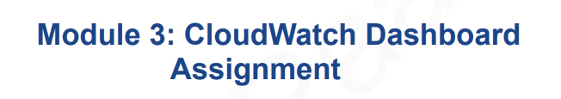

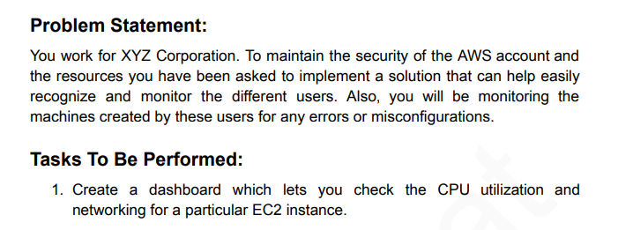

We’ll implement:

1. **CloudWatch Dashboard** → to monitor EC2 metrics (CPU, Network, etc.)
2. **CloudTrail** → to track which IAM users perform which actions

### **STEP 1: Launch an EC2 Instance**

Instance ID: i-0ed186295449fbd37  
  
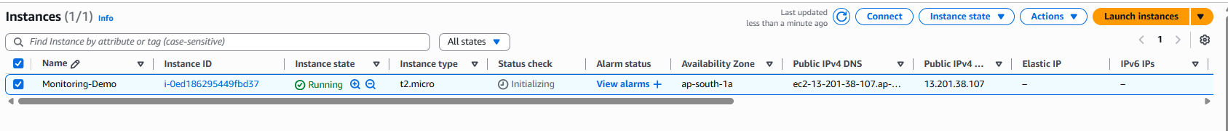

### 

### **STEP 2: Enable Detailed Monitoring (optional but better)** Select the instance → Monitoring tab → Enable Detailed Monitoring

### (This gives 1-minute metric intervals instead of 5)

### **STEP 3: Open CloudWatch**

### Go to CloudWatch from the AWS console

### On the left menu, click Dashboards

### Click Create dashboard

### Name it: EC2-Monitoring-Dashboard

### Choose Line as the first widget type

### **STEP 4: Add CPU Utilization Widget**

### In metrics selection → Choose EC2 → Per-Instance Metrics → CPUUtilization

### Select your instance ID

### Click Create widget

### 📊 You’ll now see real-time CPU graph.

### 

### **STEP 5: Add Network Widgets**

### Add another widget → Line → choose

### NetworkIn

### NetworkOut

### Select your instance ID again

### Add both to your dashboard

### 💡 Optional: You can display both metrics in one chart.

### 

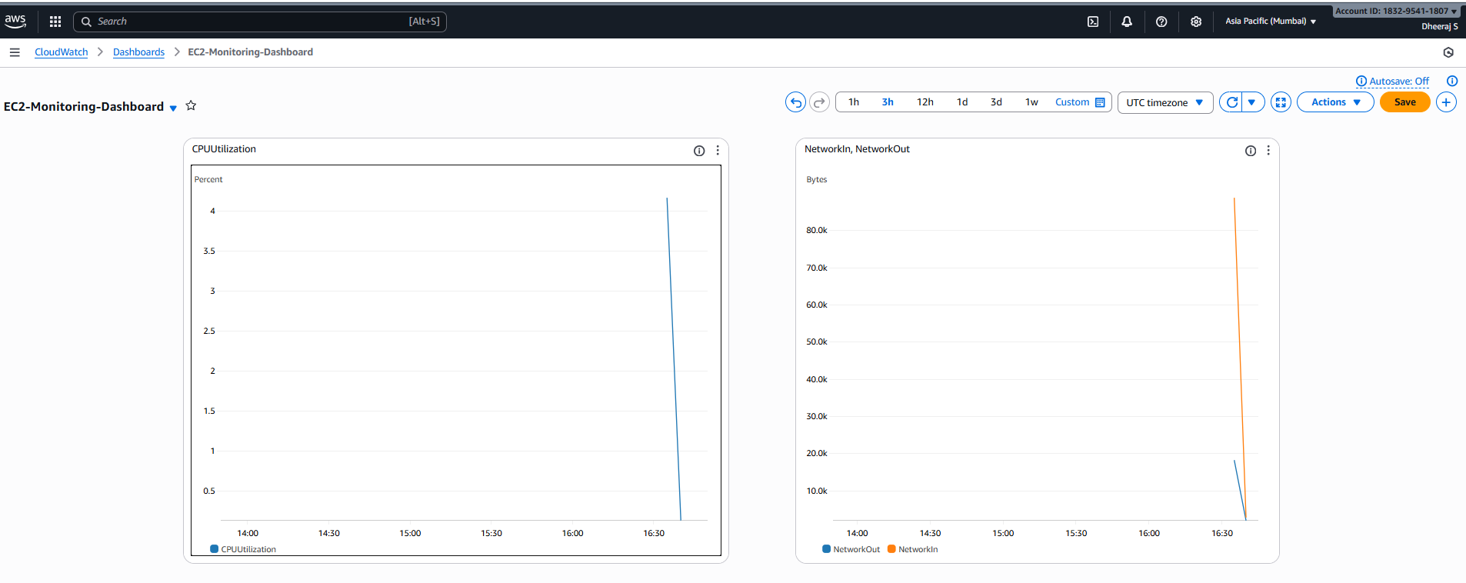

### **STEP 6: Enable CloudTrail for User Monitoring**

1. Go to **CloudTrail** → **Trails → Create trail**
2. Trail name: UserActivityTrail
3. Choose **All regions**
4. Create new S3 bucket (default name is fine)
5. Click **Create trail**

✅ CloudTrail now records every action (EC2 launch, stop, delete, etc.)

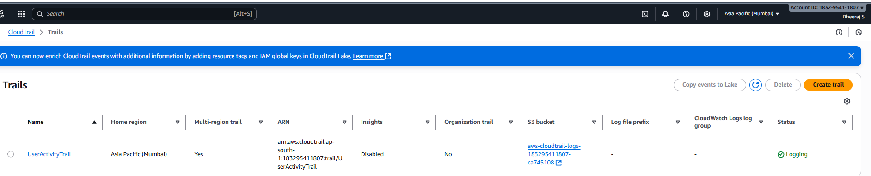

Now CloudTrail will:

* Record **every user action** (IAM, EC2, S3, etc.)
* Store logs in your S3 bucket (e.g., cloudtrail-logs-dheeraj)
* Work continuously for free (under basic free-tier limits)

### **🧾 Verify It Works**

1. Go to **CloudTrail → Event History**
2. Filter by:  
   * Event source = ec2.amazonaws.com
   * Or Event name = RunInstances, TerminateInstances, etc.
3. You’ll see **who** did the action (IAM user/email), **what** they did, and **when**.

