DevOps Capstone Project 2

You are hired as a DevOps Engineer for Analytics Pvt Ltd. This company is a product based organization which uses Docker for their containerization needs within the company. The final product received a lot of traction in the first few weeks of launch. Now with the increasing demand, the organization needs to have a platform for automating deployment, scaling and operations of application containers across clusters of hosts. As a DevOps Engineer, you need to implement a DevOps lifecycle such that all the requirements are implemented without any change in the Docker containers in the testing environment.
Up until now, this organization used to follow a monolithic architecture with just 2 developers. The product is present on: https://github.com/hshar/website.git
Following are the specifications of the lifecycle:
1. Git workflow should be implemented. Since the company follows a monolithic architecture of development, you need to take care of version control. The release should happen only on the 25th of every month.
2. CodeBuild should be triggered once the commits are made in the master branch.
3. The code should be containerized with the help of the Dockerfile. The Dockerfile should be built every time if there is a push to GitHub. Create a custom Docker image using a Dockerfile.
4. As per the requirement in the production server, you need to use the Kubernetes cluster and the containerized code from Docker Hub should be deployed with 2 replicas. Create a NodePort service and configure the same for port 30008.
5. Create a Jenkins Pipeline script to accomplish the above task.
6. For configuration management of the infrastructure, you need to deploy the configuration on the servers to install necessary software and configurations.
7. Using Terraform, accomplish the task of infrastructure creation in the AWS cloud provider.
Architectural Advice:
Softwares to be installed on the respective machines using configuration management.
Worker1: Jenkins, Java
Worker2: Docker, Kubernetes
Worker3: Java, Docker, Kubernetes
Worker4: Docker, Kubernetes
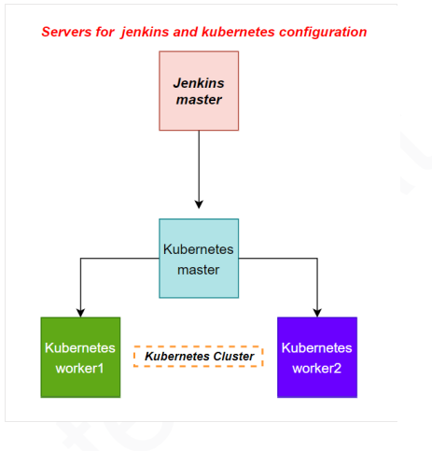

Solution

- Install terraform on the machine1 and check for the version of terraform
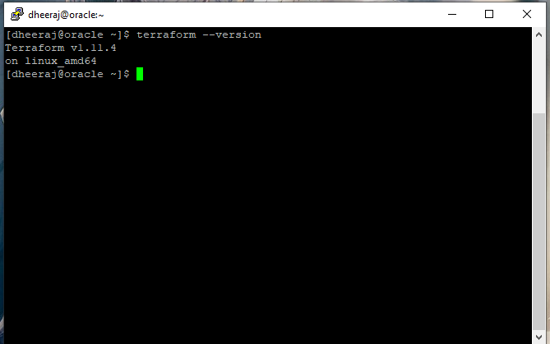

- Configure the terraform to create infrastructure using aws account
Go to .aws location
Edit config file with region where the infrastructure has to be created
Provide credential details in the credential file
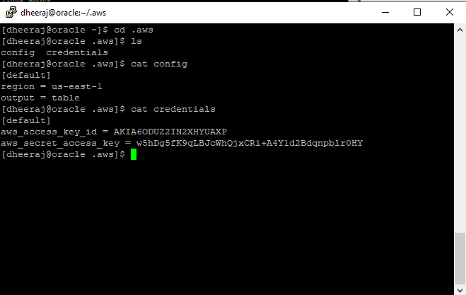

- Create a folder and write a code for terraform to create infrastructure on aws (file named as main.tf)
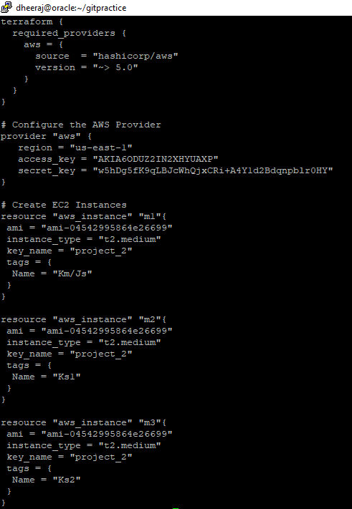

- Initiate terraform in the folder.
Command: terraform init
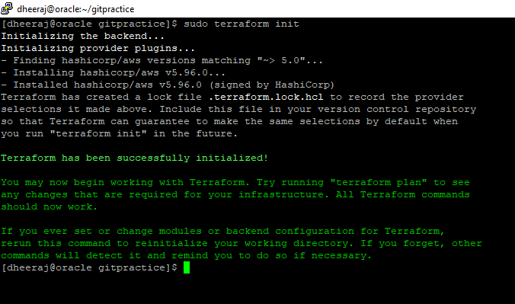
- Run terraform plan to check what changes the code will make
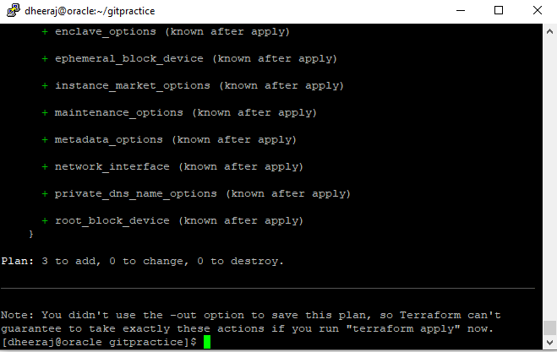

- Run terraform apply to create infrastructure and write “yes” or creating resources
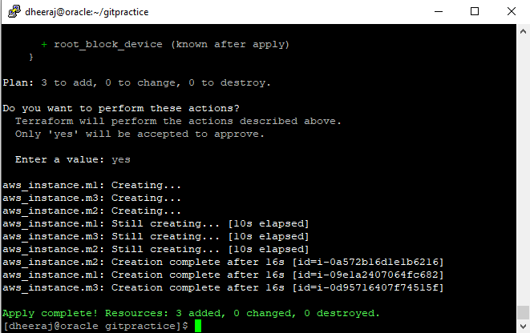

- Check on the aws console if the resources are created
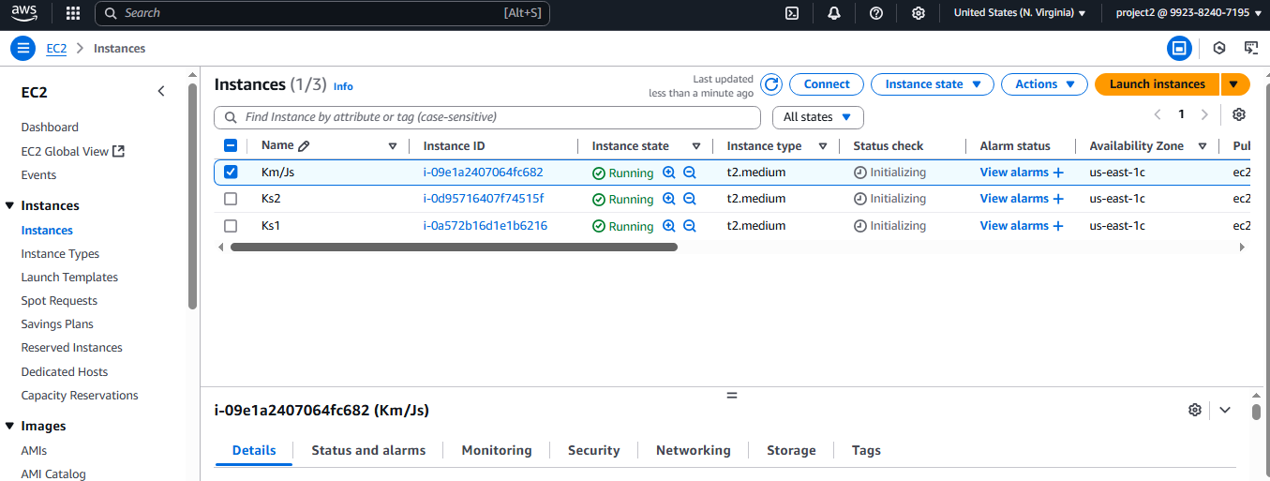

- Install ansible and conform it’s installation
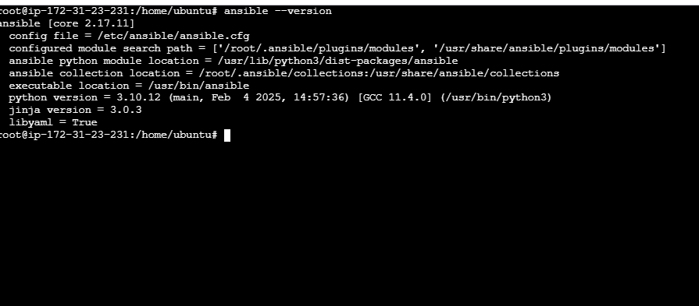

- Go to .ssh location and create ssh key
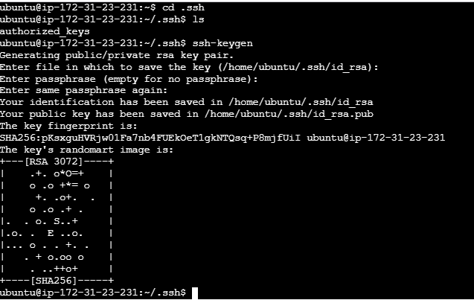
- Copy the content of the pubkey and paste it on the all the slave machines
- Go to the ansible master machine and paste all the slave machines private ip-address in the path etc/ansible ad add ip-address in hosts file
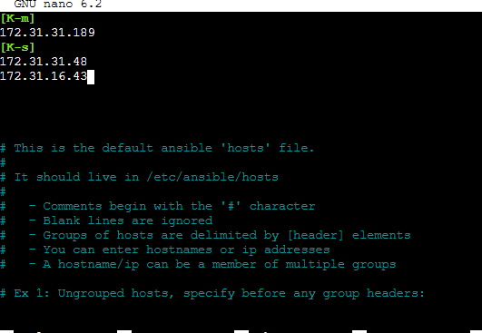

- Check connection by pinging the all the machine
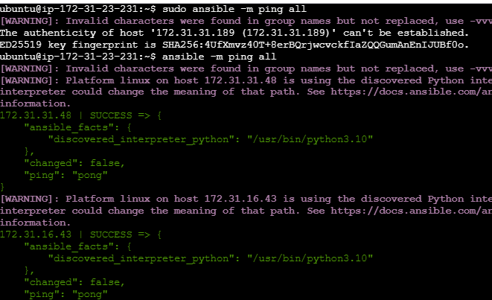

- Creating a playbook to install Jenkins in master machine( in the same machine)
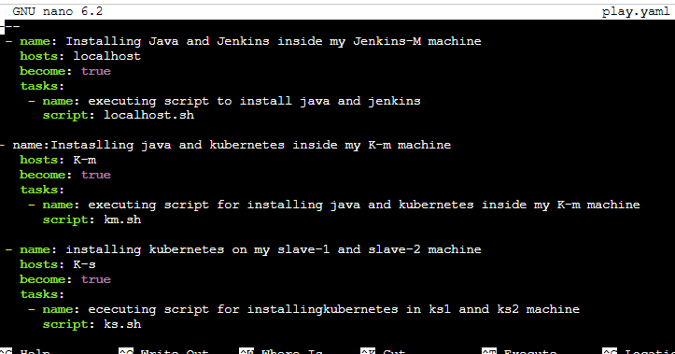

- Similarly, create localhost.sh, km.sh and ks.sh files
localhost.sh
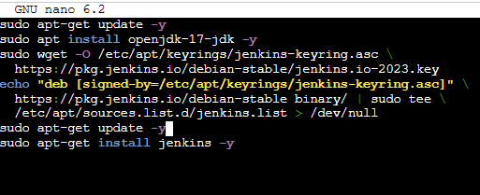
km.sh
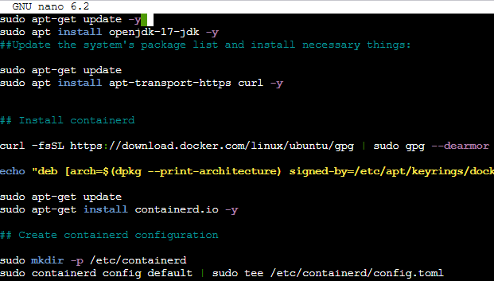

Ks.sh
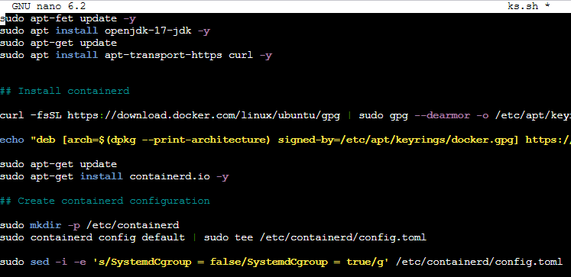

- Execute the ansible playbook to install necessary tools to all the machine
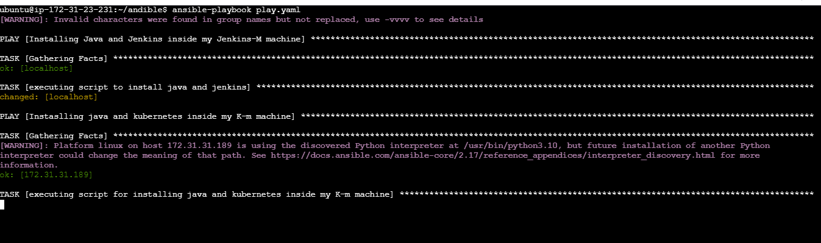

- After setting up the machines check on the kubernetes master machine if the nodes(slaves are connected)
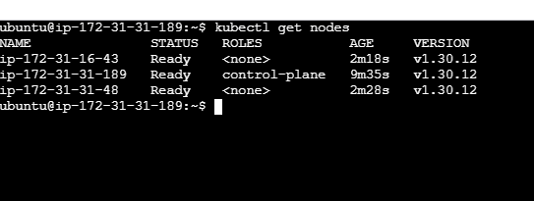

- Using the Jenkins master ip-address setup Jenkins
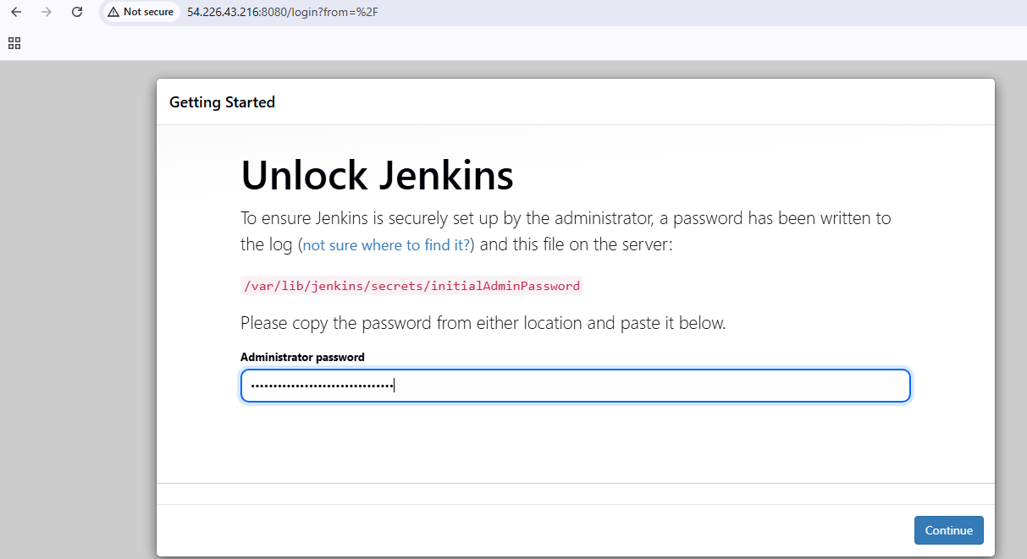

- Setup the Jenkins
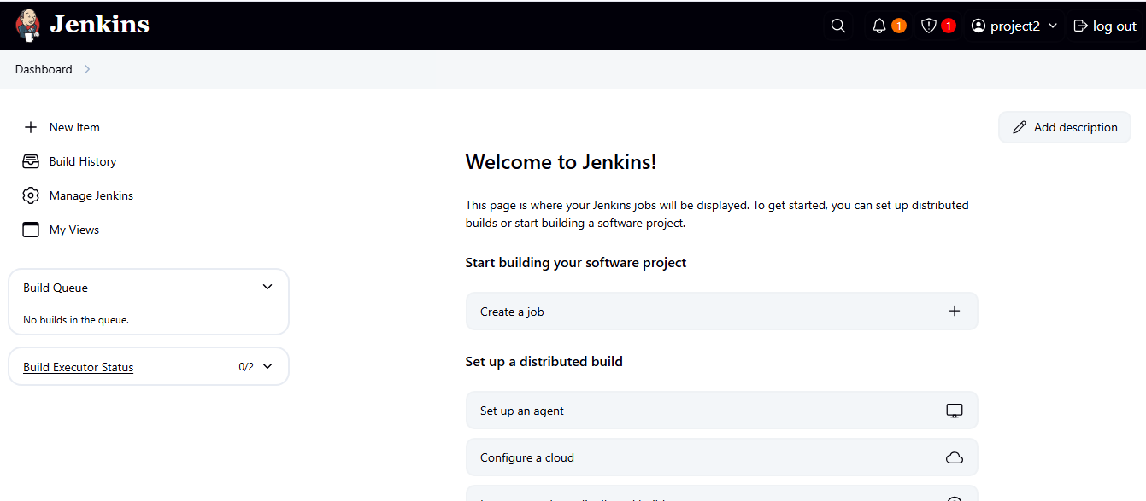

- Adding a slave node to Jenkins
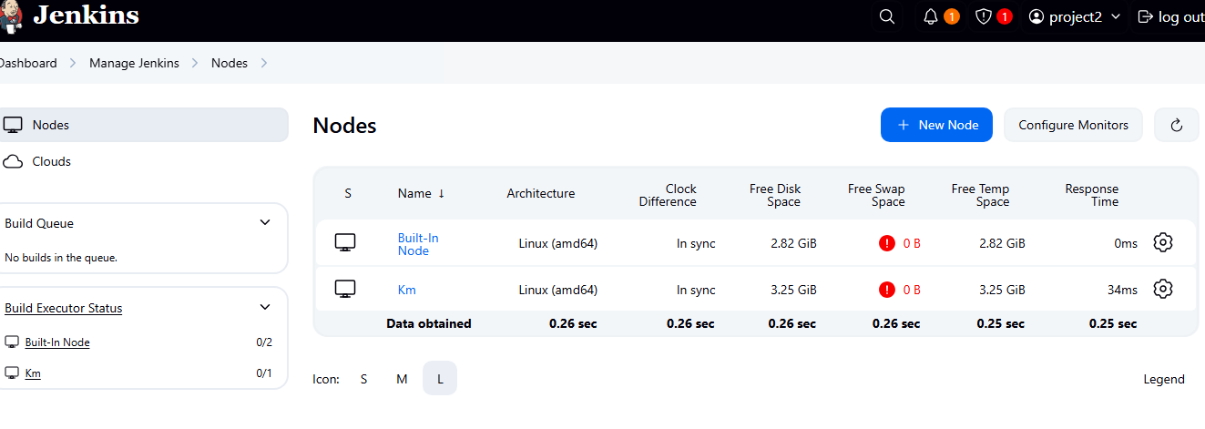

- Creating webhook for github
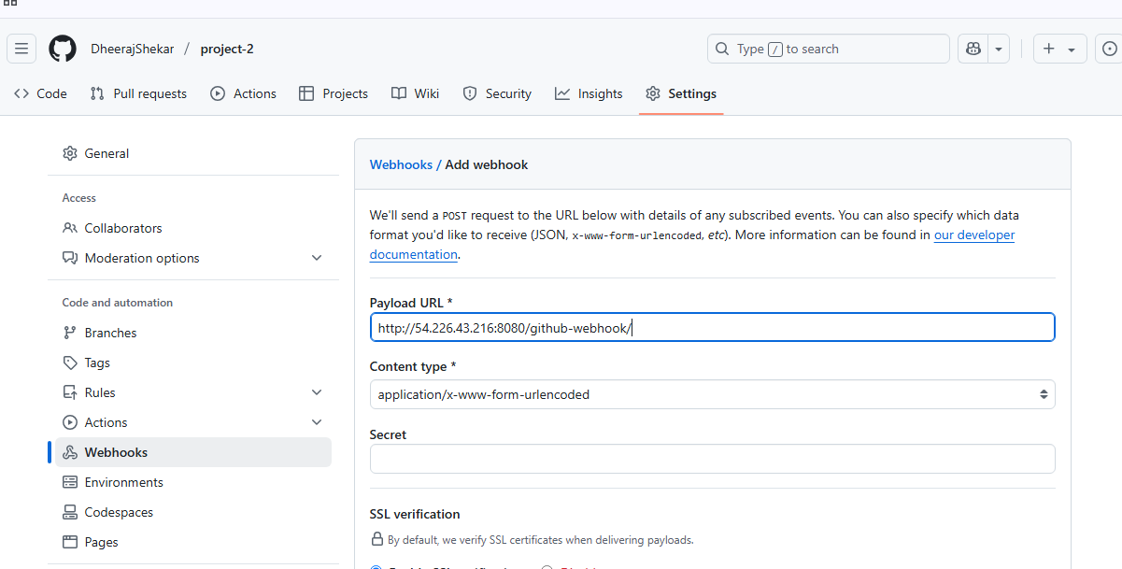

- Create a docker file
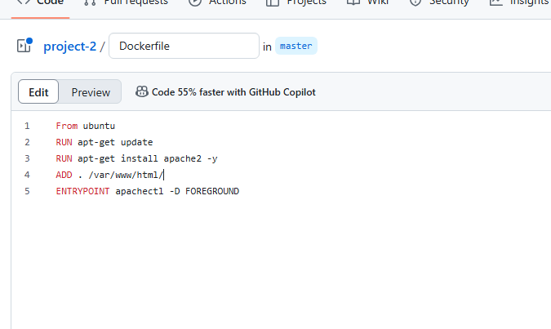

- Create a new pipeline job
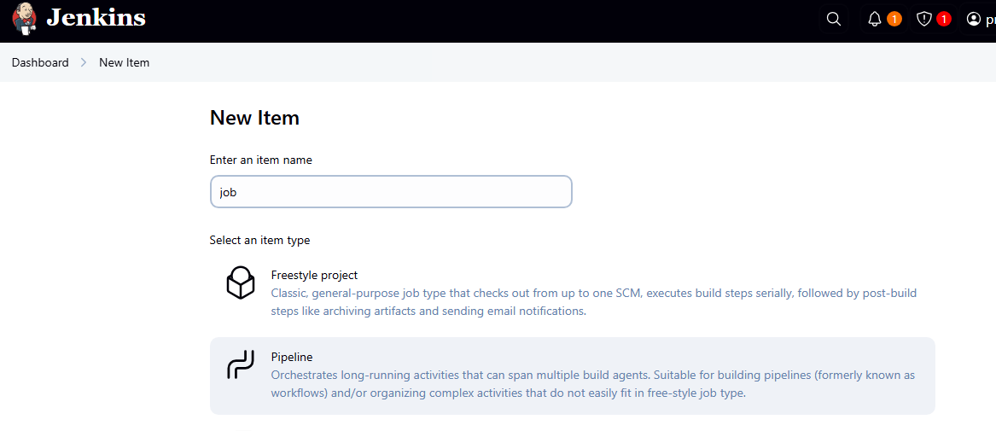
- Write a pipeline script
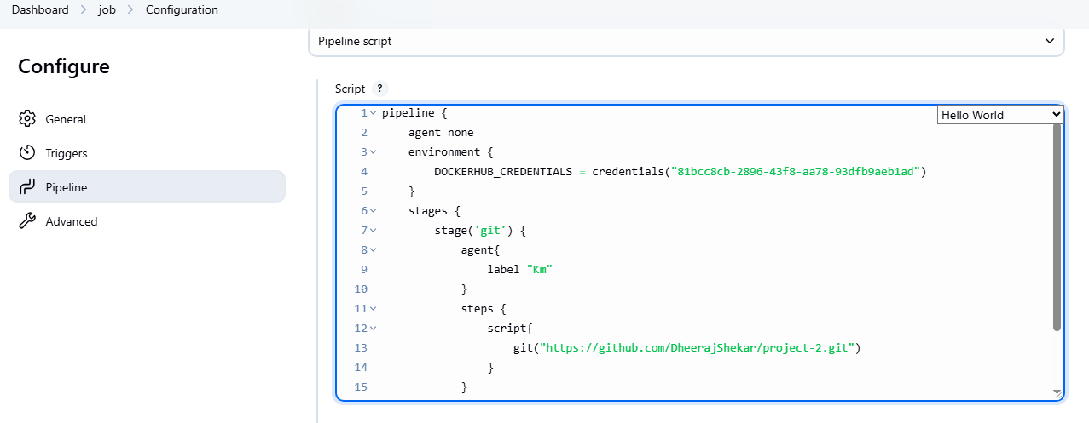

- Run the job
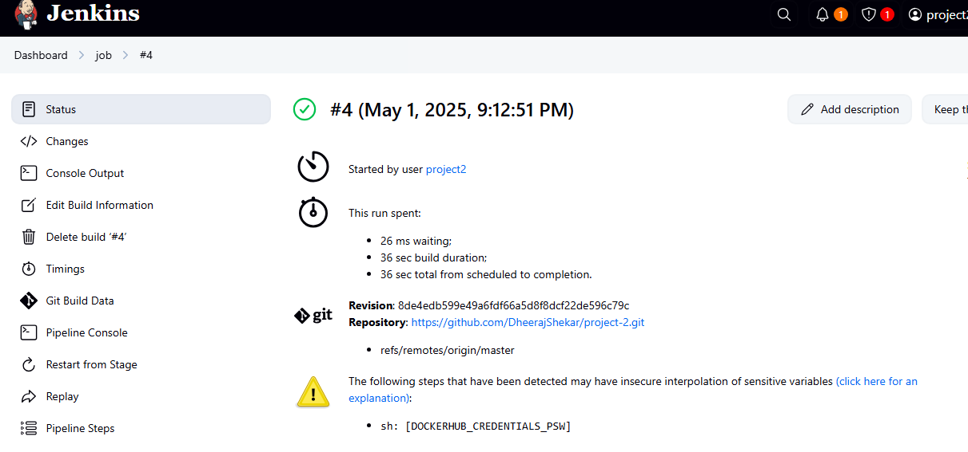

- Check in the Jenkins node machine if the docker images is created
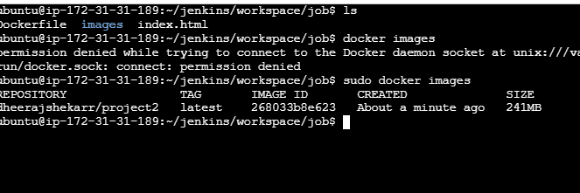

- Check in the dockerhub if the image as been pushed
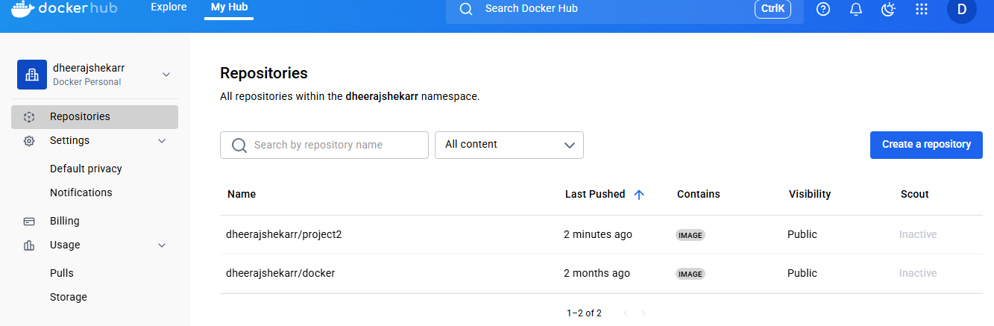

- Creating Deployent.yaml file
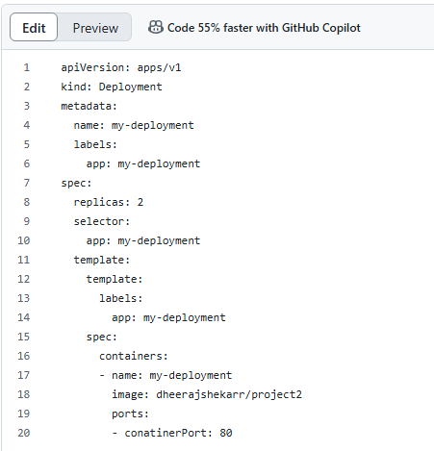

- Create service.yaml file for creating nodePort service
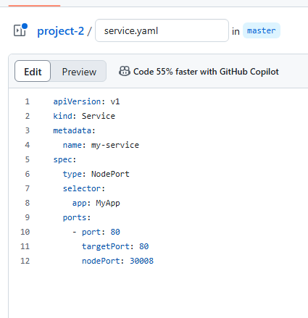

- Finally, update the pipeline script in Jenkins to include deployment and service.yaml file
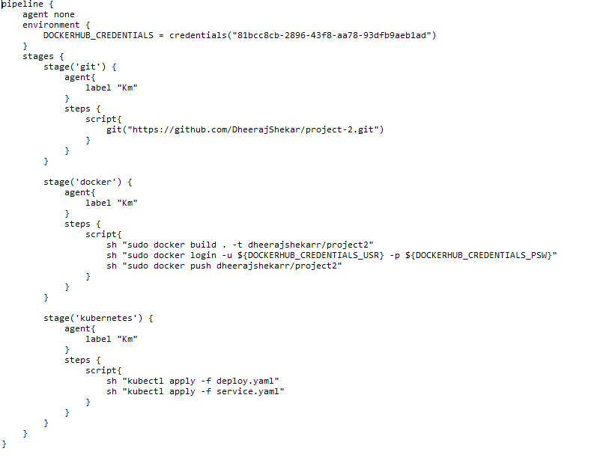
- Run the pipeline job and check on the Jenkins master machine for the content of the Jenkins path for deploy.yaml and service.yaml files. And, check for docker images, kubernetes deployment and service running
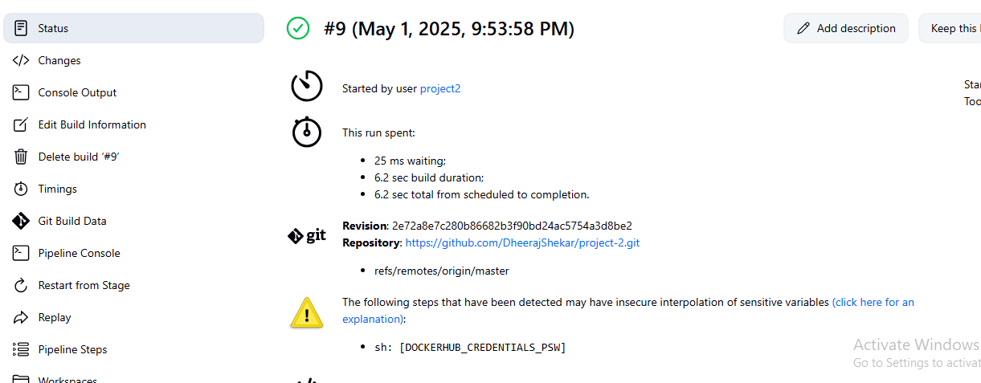

- Check in the kubernets master machine
