Question 1 and 3

Sentiment analysis using twitter streaming and Trend Notification to smart phone.

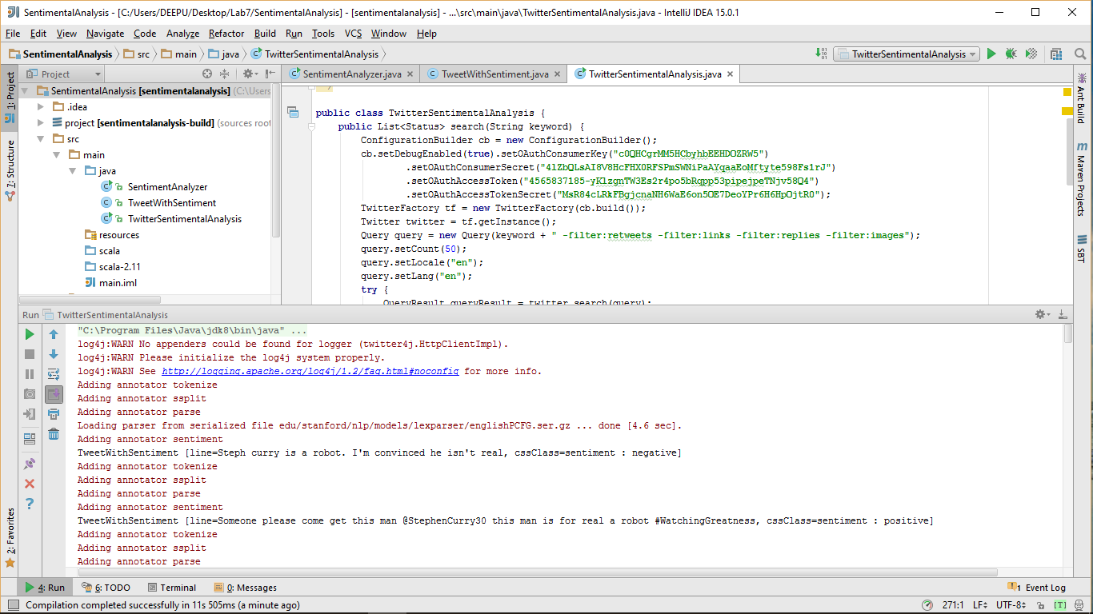

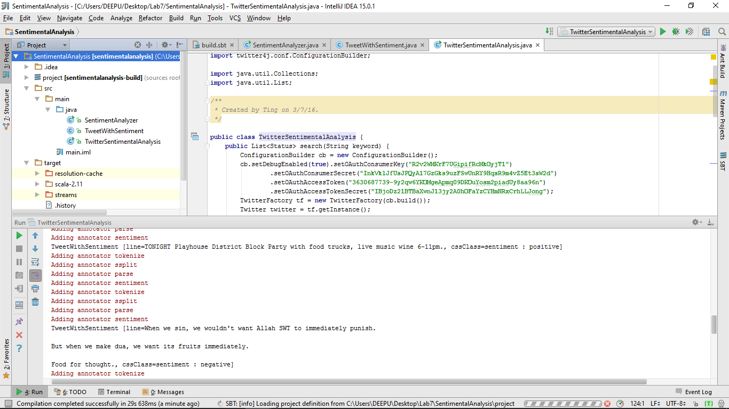

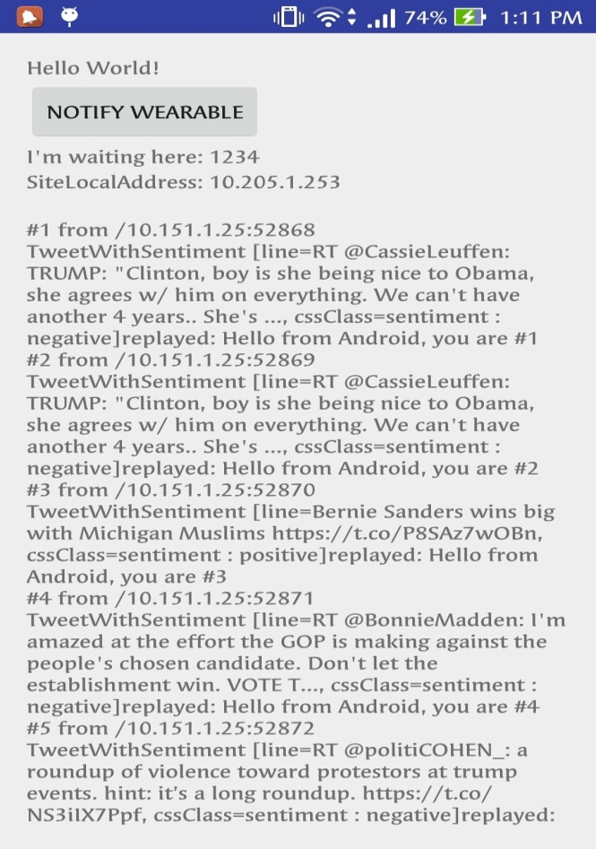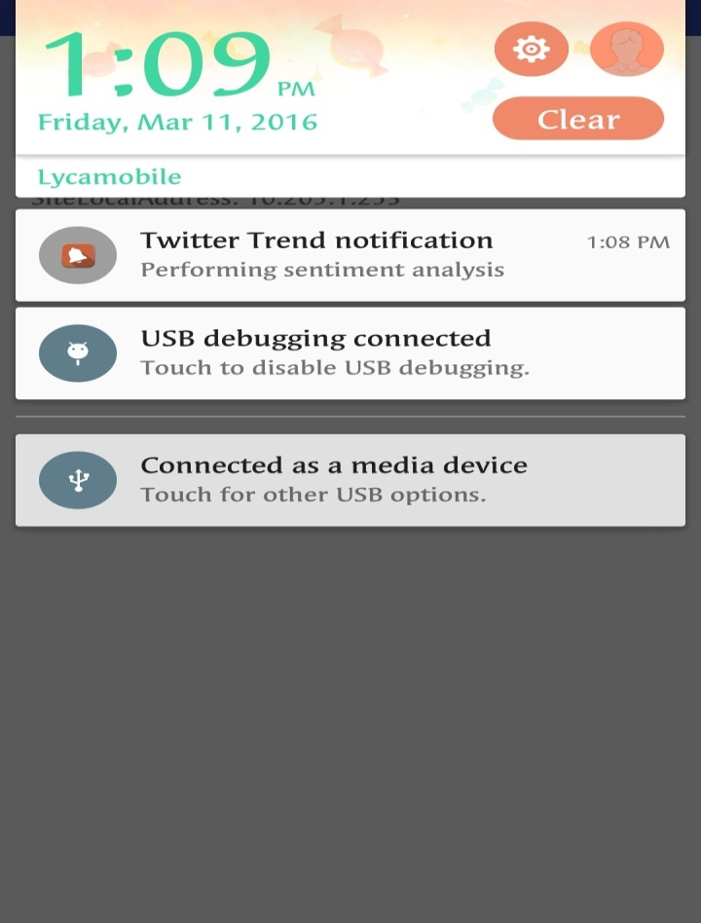

Question 2 and 4

Make recommendations

a. Training Datasets: Twitter Streaming/categorized data (The categorization here would be from your previous lab 5&6).

b. Testing Datasets e.g., UserId, Category, Rating (Twitter Streaming & Smart device data)

c. The rating based on sentiment analysis, retweet count would be interesting.

d. Expected outcome is to make a recommendation based on user profile (e.g., preferences, location, gender, age)

And notification to smart phone about the recommended category of tweets to a particular user(user id based).

**Description**:

1. With GetCateroryTrainingData.java we collected tweets based on keywords like music, movies, technology etc which are categorized into 10 categories as shown in screenshot below. And each category consists of 100 tweets, with each tweet in a separate text file.

2. Now with SentimentAnalysis.java we collected tweets for test dataset and for each tweet we got -> (user id, category and rating). The rating is based on sentiment analysis. And these features are appended to rating.txt file.

3. The data is collected from smart phone too. The features(user id 12345,category,rating) gets appended to rating.txt as shown in screenshot below.

4. Next we have got category.txt with category id and category name.

5. Now finally the recommendation is done to the user(user id) about the recommended category of tweets.

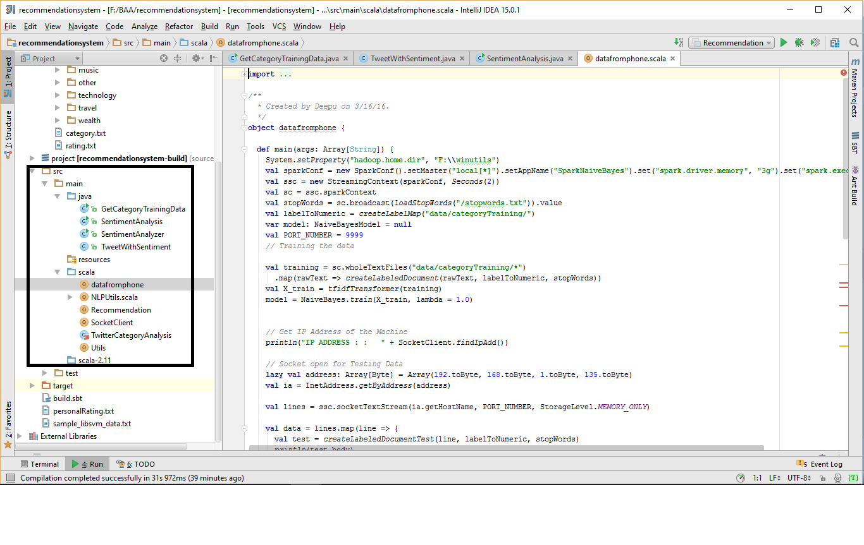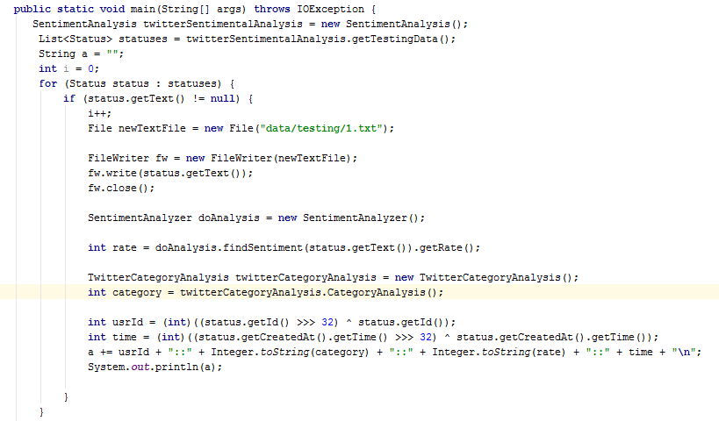

Category mapping file:

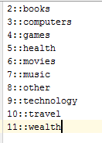

Data added to rating.txt with user id 12345(smart phone data)

