Lab Assignment 9

**1) Image collection and sentimental analysis based on the image tags using Instagram streaming (related to your project)**

**a. Training Datasets: Instagram Streaming/Categorized Image (e.g., Static UEC Food Dataset) and metadata**

**b. Testing Datasets e.g., Image, UserGroup, Category, Rating (Instagram streaming)**

**2) Image Classification based on the categories related to your project**

**3) Image-based Recommendation system (related to your own project)**

**a. The rating based on sentiment analysis of Instagram metadata**

**b. Expected outcome is to make a recommendation based on user image input or profile (e.g., preferences, location, gender, age)**

**4) Instagram trend notification to smartphone/smartwatch**

**5) Mobile Recommendation through smartphone/smartwatch using your ML application**

Description:

1. With TrainDataCollection.scala I collected image datasets from instagram.The list of tag categories are list of companies(apple,cerner,google,DST,intel,microsoft,qualcomm,samsung).

2.I also collected recommendation.txt which contain image tags based on usergroup and image links and is of the format “username;caption;tag;tagId;link”

3. Testing data is live streaming data from instagram.

4.Image classification and prediction.

5. Image Recommendation.

**1.Train Data Collection:**

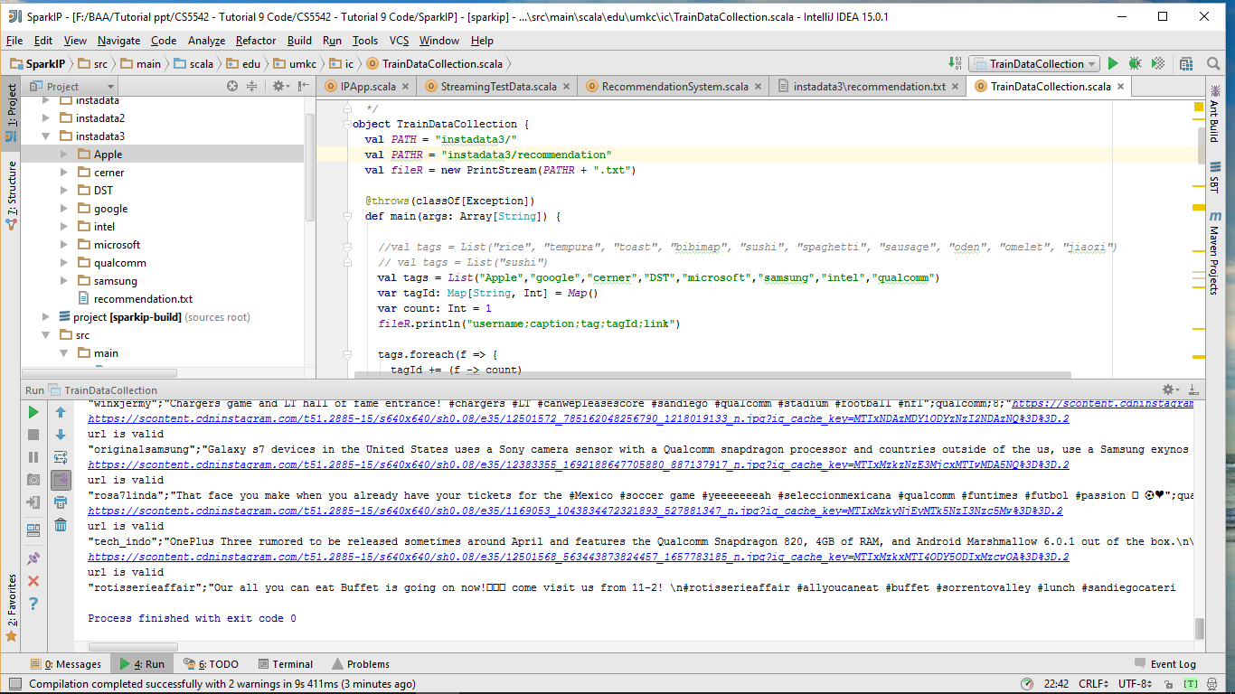

**Live stream Data to predict the current image for the particular tags:**

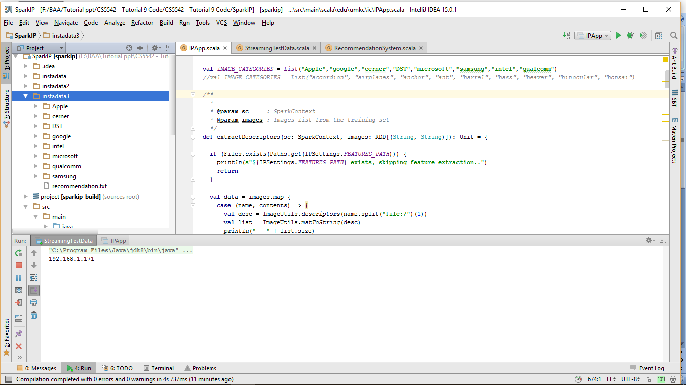

**2. Image Classification based on categories:**

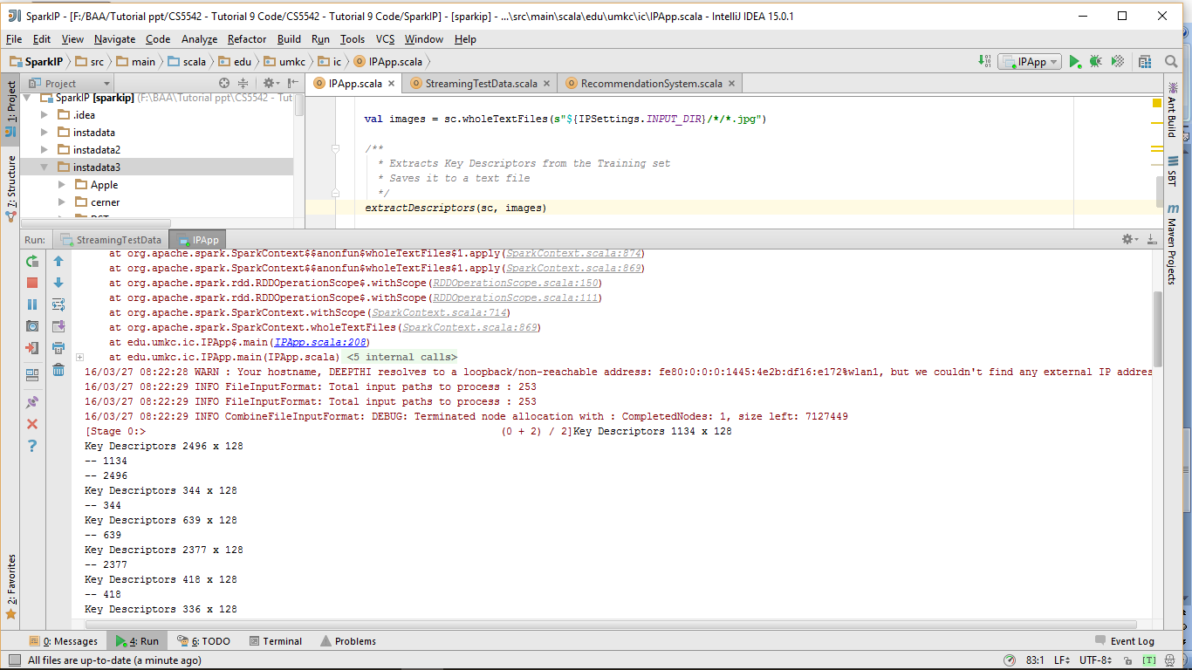

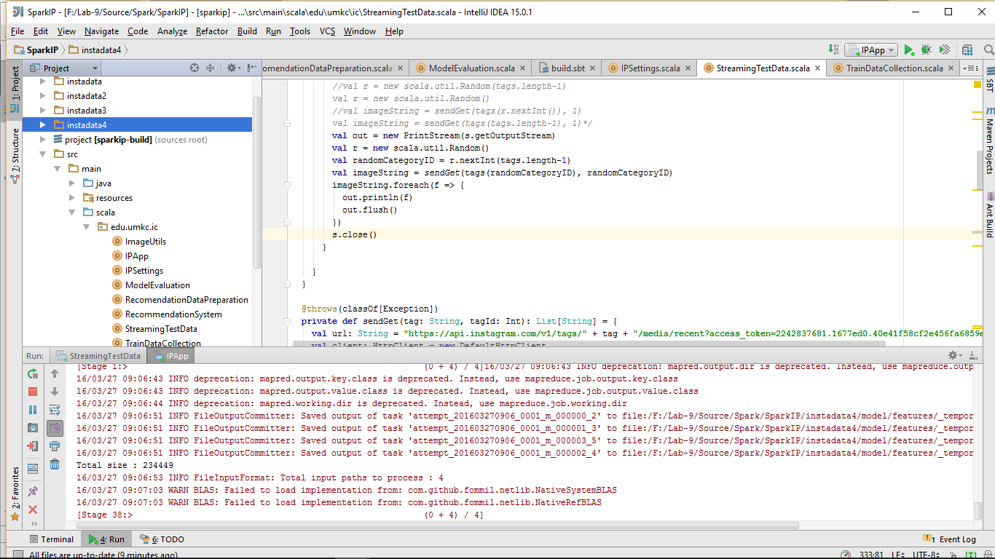

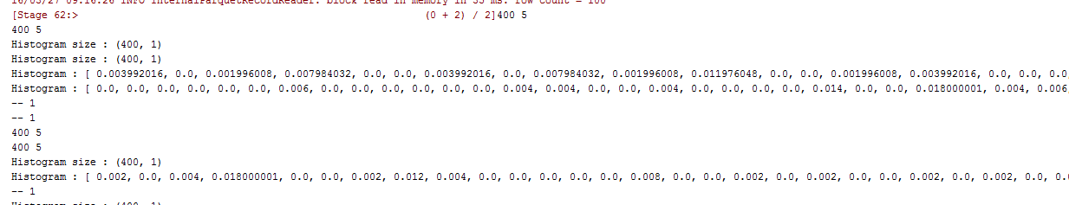

**Actual category of image:**

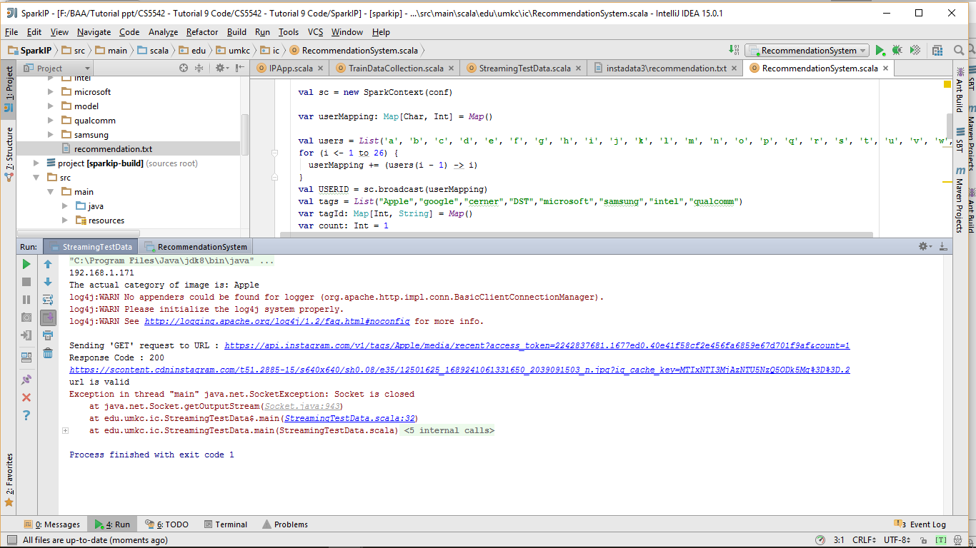

**Predicted category of image:**

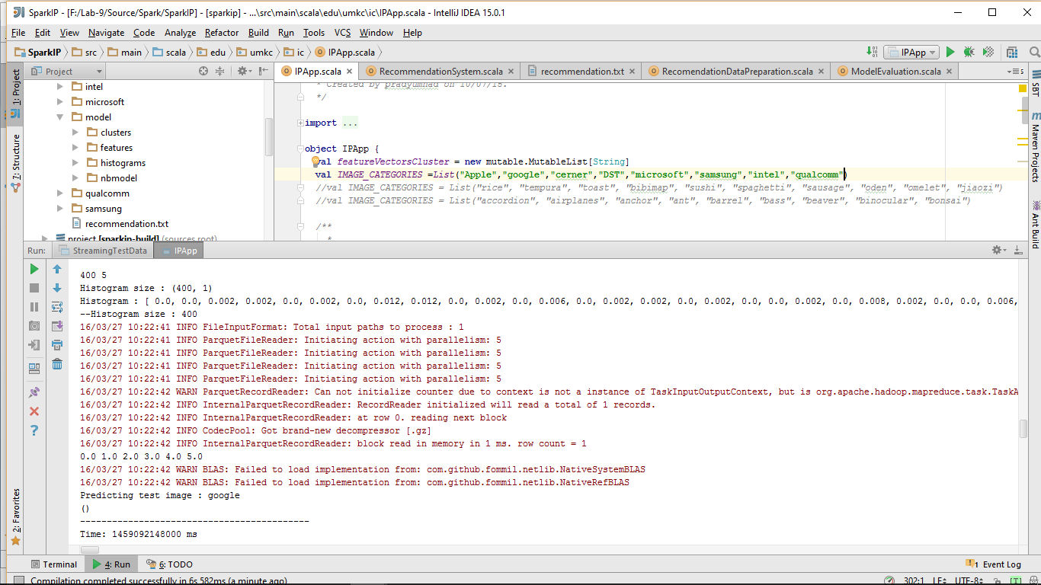

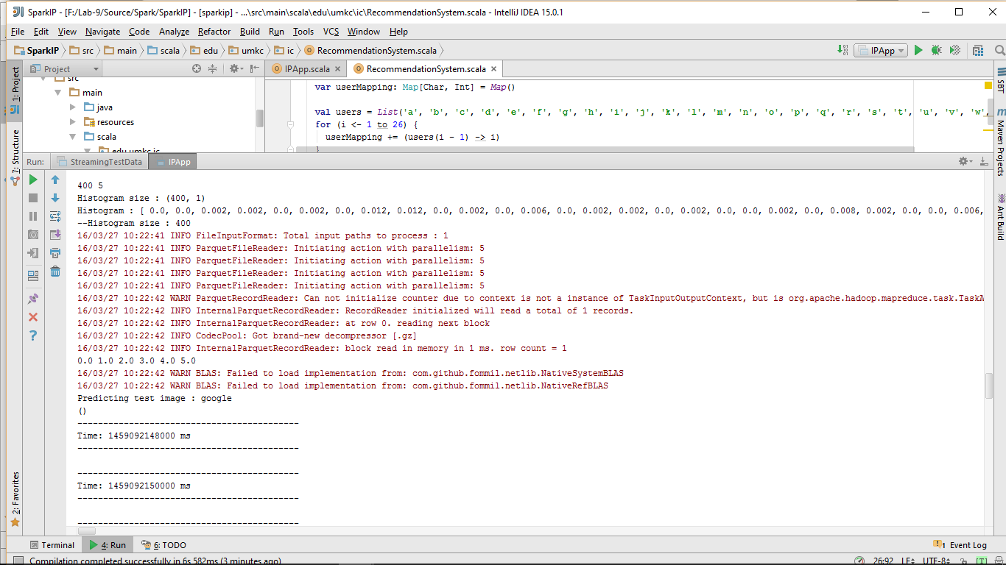

**3. Image Recommendation:**

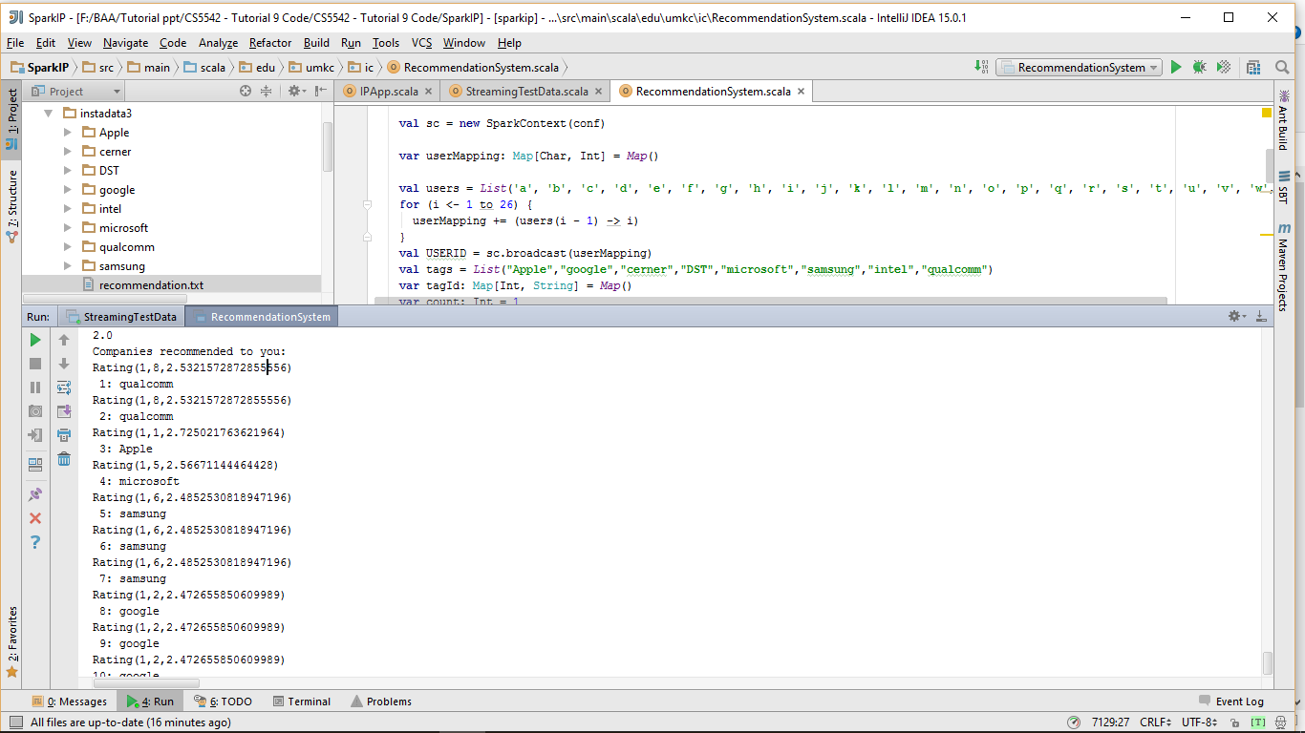

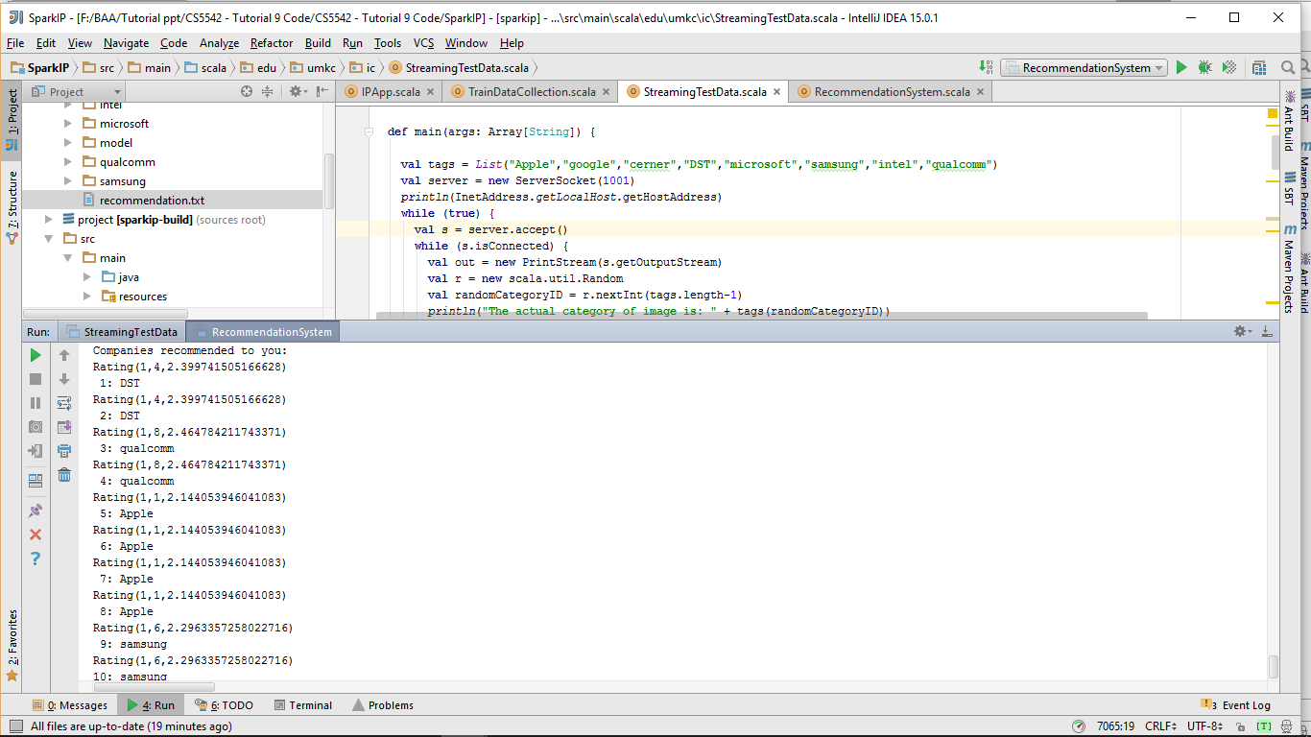

4. **Mobile Recommendation through smartphone**

