Documenting contestability in public sector algorithmic decisions
Initial research proposal
Module Interdisciplinary Elective AI Power and Responsibility Governing Intelligence
Team Avengers | Project 2 Public sector contestability
Group number Gr10
Members Fatih Ridvan Kizik and Dheeraj Erpa
Date 2 November 2026

Research purpose and journal fit
We propose a documentary audit of whether UK public-sector algorithmic transparency records describe a traceable pathway for individuals to challenge algorithm-assisted decisions. The intended contribution connects procedural elements, nonapplicability explanations and the distinction between routine oversight and citizen-initiated review. The study concerns published disclosures and cannot measure actual appeal success, citizen understanding or legal compliance.
Target journal: Government Information Quarterly (Elsevier). Its focus on policy, information technology, government and the public makes the citizen-state accountability question relevant. Journal scope: https://shop.elsevier.com/journals/government-information-quarterly/0740-624X
Reference publication: de Almeida and dos Santos Júnior (2025), Artificial intelligence governance: Understanding how public organizations implement it, Government Information Quarterly 42(1), 102003. DOI: https://doi.org/10.1016/j.giq.2024.102003. The publisher abstract describes organizational AI governance research across 28 organizations. We use its governance framing rather than replicate its questionnaires, interviews or QCA design.

Background motivation and research gap
AI governance requires institutions to translate responsibility principles into processes and assigned roles [1,3,7]. Meaningful contestability additionally involves decision subjects’ information and procedural needs [2]. Procedural justice offers a complementary perspective on public AI governance [4]. Power dynamics and digital ethics policies provide institutional context for these arrangements [5,6].
Documentation alone cannot establish effective accountability: record-keeping can reshape oversight [8], while recent contestability research distinguishes institutional and technical mechanisms [9,10]. Our candidate gap is narrower than general transparency auditing: how challenge channels, reviewers, review scope, timing, remedies and escalation connect within public disclosures, and whether nonapplicability explanations align with the decision role. Novelty remains provisional until a fuller review of existing ATRS audits and complete relevant papers. No first-study or guaranteed-publication claim is made.

Research questions
RQ1. To what extent do eligible UK ATRS records document a traceable pathway for affected individuals to challenge an algorithm-assisted decision, and which procedural elements are most frequently unspecified?
RQ2. How do records justify describing appeals as unnecessary or not applicable, and how consistent are these explanations with the system’s documented role in decision-making?
RQ3. How does the specificity of documented contestation procedures vary across systems that determine outcomes, recommend decisions or prioritize cases for review?
RQ4. What relationship exists between disclosure length and the procedural information specified in transparency records, and what gaps remain in records with similar lengths?
RQ5. How do documented arrangements for routine human oversight differ from arrangements for review initiated by an affected individual?

Data sources accessibility and scope
Primary dataset: 153 unique UK ATRS records downloaded on 26 October 2026, with source JSON, archived text and derived CSV/Excel. The official public repository is https://www.gov.uk/algorithmic-transparency-records and the lecturer’s hub is https://www.gov.uk/government/collections/algorithmic-transparency-recording-standard-hub. Records are publicly accessible without registration. The live portal showed 155 records when checked on 2 November; this study retains the dated 153-record snapshot rather than silently changing the corpus. The input archive is included with the code for reproducibility.
One record is the unit of analysis. Fields include organization, function, deployment stage, decision process, human review, contact and appeals. We will screen all 153 records and include systems determining, recommending or prioritizing identifiable individual decisions. Purely internal productivity tools without that role will be excluded with reasons. The final eligible sample is unknown; 60–100 is a planning target, not a cap. Production, pilot, planned and retired systems and template versions remain distinguishable.
Supplementary dataset: official appeals guidance linked from eligible records. We will collect it separately, retain original and final URLs, retrieval dates, file hashes and relevance judgments. Later guidance will not be treated as contemporaneous with the frozen record. Record-only indicators and guidance supplementation will be reported separately. Neither source contains observed appeal outcomes for this design.

Operational definitions
Seven procedural indicators: a challenge-specific channel; submission requirements; identified reviewing actor; scope of review; response timing; possible remedy; and escalation route. Each indicator distinguishes present, not disclosed, explicitly absent and justified not applicable. A general contact address does not automatically establish a challenge channel, and routine human review does not automatically establish review initiated by an affected person. Every judgment retains an exact passage, source location, reviewer and rationale.

Proposed methodology and experimental design
- Freeze and verify the source JSON checksum, unique record IDs, source URLs and archived-response hashes; retain deployment stage and template version.
- Screen every record for the inclusion criterion. Record include/exclude, reason, reviewer and source evidence; resolve unclear cases before final analysis.
- Pilot the coding guide on 10 eligible records. Revise ambiguous definitions and recode affected pilot material before freezing the guide.
- Independently double-code a seeded random sample of at least 25% of the eligible set with two distinct reviewers; check coverage of stages and versions. Keep machine suggestions separate from independent judgments.
- Code the seven indicators, decision role, appeals rationale, consistency, routine oversight and citizen-initiated review. Retain source evidence and notes for nonapplicability and uncertainty.
- Archive linked official guidance and review whether it supplies additional procedural information. Keep a separate contextual audit and report source-date differences.
- Report agreement and Cohen’s kappa before adjudication; retain a disagreement log. Resolve differences and complete adjudicated codes for all eligible records.
- RQ1: compute item-level proportions with applicability denominators, recurring profiles and nested intersections; do not interpret the sequence as an observed appeal journey.
- RQ2: compare rationale classes by decision role and deployment stage; manually assess consistency and present source-linked cases without legal verdicts.
- RQ3: describe within-role distributions and repeat comparisons for production and template-version subsets; retain mixed and unclear groups and avoid unstable small-group claims.
- RQ4: calculate descriptive Spearman rank associations with archived word count; inspect non-overlapping cases within 10% word count and contrasting procedural counts. This is not causal matching.
- RQ5: cross-tabulate routine oversight and citizen review, show conditional proportions and inspect evidence cases. Export 20 outputs with captions, source traces, metadata and a reproducible ZIP.

Evaluation metrics and safeguards
Purpose | Planned metric or check
Coding reliability | Per-variable agreement and Cohen kappa before adjudication; report n and undefined values
Lexical assistance | Precision recall and F1 against adjudicated applicable cases; analyze false positives and misses
Documentary comparison | Counts percentages and applicability denominators; descriptive seven-element count
Length association | Spearman rho with ties; same-length cases; no population p-values
Robustness | Production-only and version subsets; uncertain roles; record-only versus supplemented guidance
Kappa below 0.70 triggers definition review and discussion, not automatic acceptance above that value. The indicator count is an explicitly descriptive summary, not a validated fairness or usability scale. No participant recruitment, model training or predictive-performance benchmark is required.

Expected contribution feasibility and limitations
Expected contribution: a source-traceable coding scheme and descriptive account of how public records connect individual challenge procedures to internal oversight. A reusable corpus and documented coding process should support future research, subject to substantive validation and literature positioning. The expected output is the structure of the comparisons, not a predicted direction or effect size.
Feasibility: the frozen public corpus is available locally; Python, pandas and matplotlib suffice for the documentary analyses. Both members will participate in screening, independent coding and adjudication. Work phases are corpus verification and screening, pilot and guide revision, independent coding and guidance collection, adjudication and analysis, then writing and sensitivity checks. The code submission is an initial unexecuted implementation; this proposal reports no new empirical findings.
Limitations: selective register coverage, organizational self-reporting, template differences, possible extraction errors, changes to linked guidance and unresolved applicability. Missing disclosure does not prove absence of a safeguard. Findings cannot establish appeal usability, success, operational fairness, legal compliance or causal effects. Sparse eligible groups may require fewer comparisons and a stronger qualitative emphasis.

Expected results design
The following five pages contain four outputs per research question: two figures and two tables, twenty in total. ALL NUMERICAL VALUES ON THOSE PAGES ARE DUMMY DATA. They illustrate layout and analysis design only and are not observations, estimates, forecasts or notebook execution results. The toy analytical dataset contains 80 invented records with S-prefixed IDs. No dummy values are supplied to the research notebook. Final figures will replace these illustrations after human coding.
The publication-oriented design uses readable labels, explicit denominators and reproducible exports. Main-article versus supplementary selection will follow the completed analysis and journal requirements; twenty outputs need not all appear in the main article.

Responsible use of AI assistance
AI assistance supported proposal structure, literature discovery, methodological drafting and code preparation. Team members remain responsible for checking citations, source evidence, judgments and implementation. A shareable conversation link is supplied in a separate text file. No human annotations or agreement results are invented. Public source attribution and retained licence notices accompany the frozen input archive.

RQ1 expected results with dummy data
DUMMY DATA ONLY Illustrative design No empirical findings
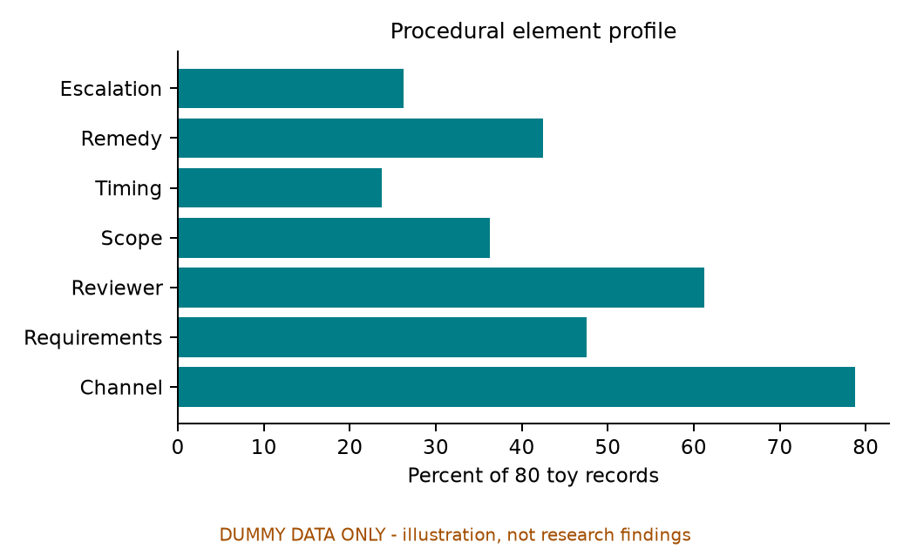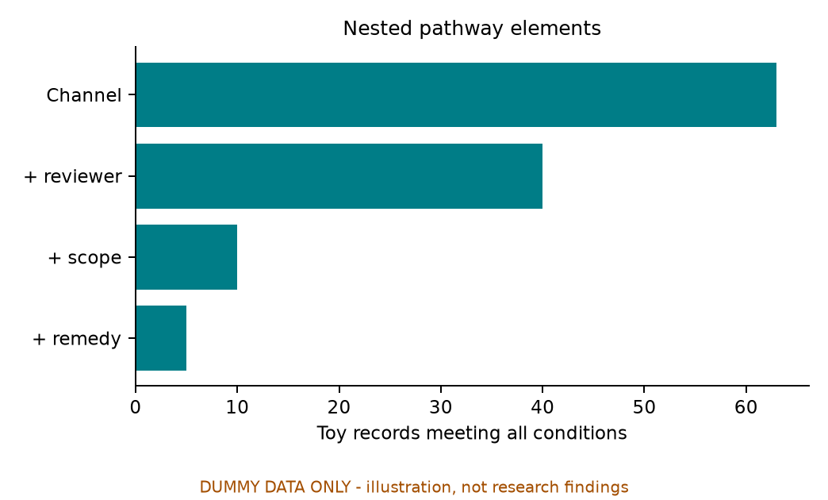
RQ1_F1 Procedural element profile DUMMY DATA ONLY
RQ1_F2 Nested pathway elements DUMMY DATA ONLY
RQ1_T1 Illustrative screening flow DUMMY DATA ONLY
Stage | Records
Frozen corpus | 153
Illustrative eligible | 80
Illustrative excluded | 73
RQ1_T2 Illustrative recurring profiles DUMMY DATA ONLY
Profile | Records
1010010 | 5
1010000 | 5
1110001 | 4
Interpretation planned: Report what is documented using item-level applicability denominators; profile order is not a real appeal journey. Profile bit order: channel, requirements, reviewer, scope, timing, remedy, escalation; 1 indicates present in the toy data.

RQ2 expected results with dummy data
DUMMY DATA ONLY Illustrative design No empirical findings
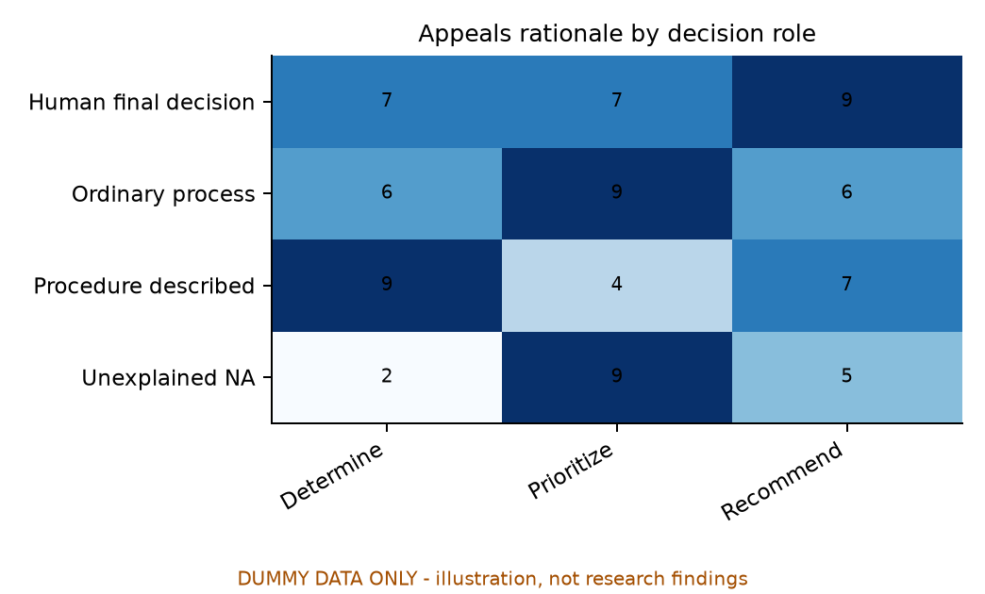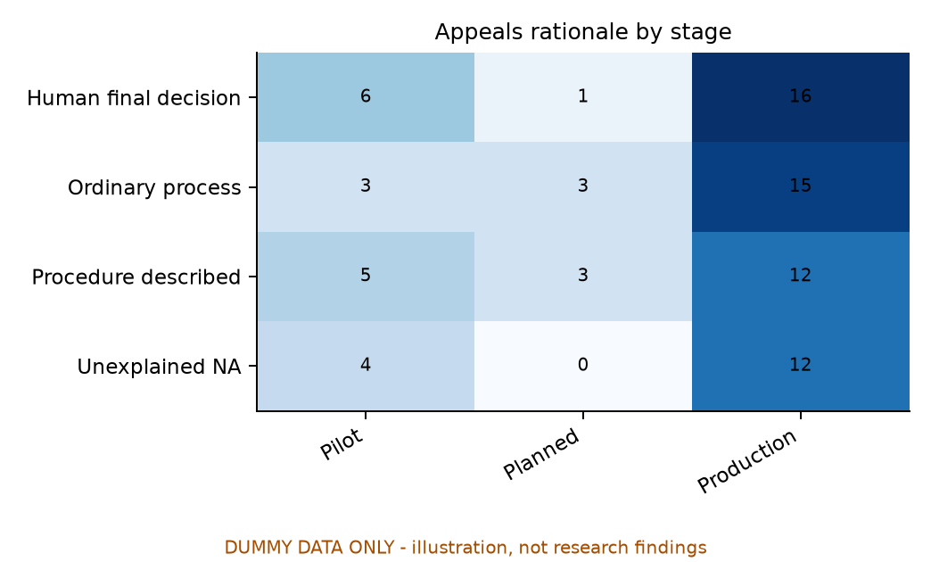
RQ2_F1 Appeals rationale by decision role DUMMY DATA ONLY
RQ2_F2 Appeals rationale by stage DUMMY DATA ONLY
RQ2_T1 Illustrative rationale prevalence DUMMY DATA ONLY
Rationale | Records
Human final decision | 23
Ordinary process | 21
Procedure described | 20
Unexplained NA | 16
RQ2_T2 Illustrative rationale review cases DUMMY DATA ONLY
Toy case | Rationale | Human review question
Case A | Ordinary process | Is the ordinary route specified?
Case B | Human final decision | Can a person request review?
Case C | Unexplained NA | Is nonapplicability justified?
Interpretation planned: Use source-grounded human interpretation to evaluate rationales; toy cases are invented examples, not quotations.

RQ3 expected results with dummy data
DUMMY DATA ONLY Illustrative design No empirical findings
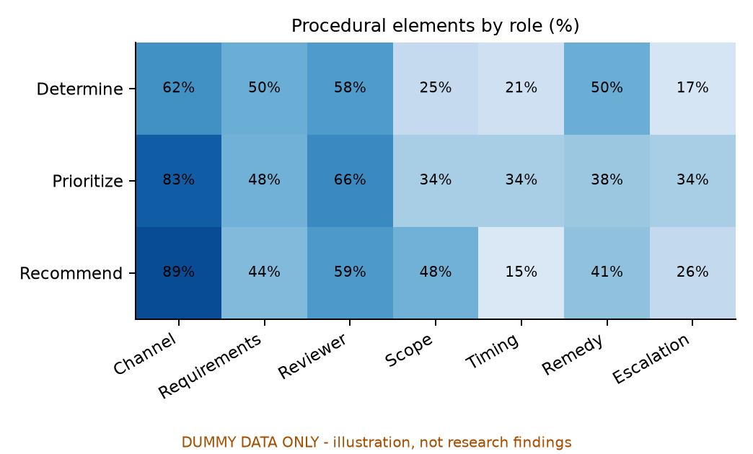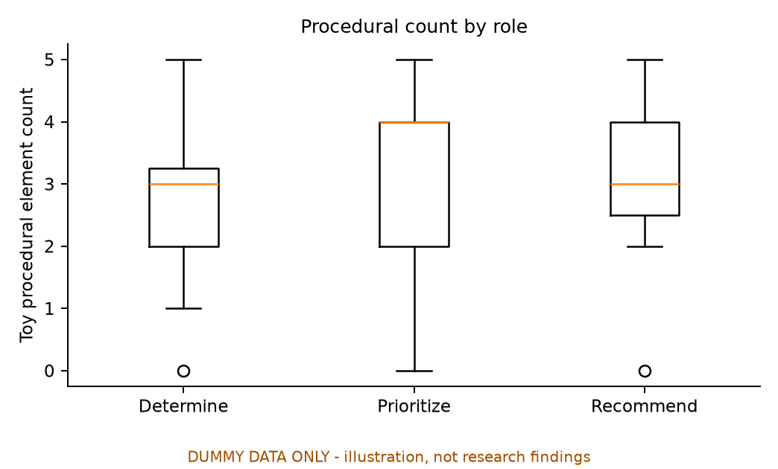
RQ3_F1 Procedural elements by role DUMMY DATA ONLY
RQ3_F2 Procedural count by role DUMMY DATA ONLY
RQ3_T1 Illustrative group composition DUMMY DATA ONLY
role | Records | Median words
Determine | 24 | 2976.5
Prioritize | 29 | 2921.0
Recommend | 27 | 3309.0
RQ3_T2 Illustrative sensitivity summaries DUMMY DATA ONLY
Subset | Records | Median elements
Production | 55 | 3.0
v3 | 38 | 3.0
v4 | 42 | 3.0
Interpretation planned: Describe differences by decision role alongside group sizes, stage and version; do not infer causation.

RQ4 expected results with dummy data
DUMMY DATA ONLY Illustrative design No empirical findings
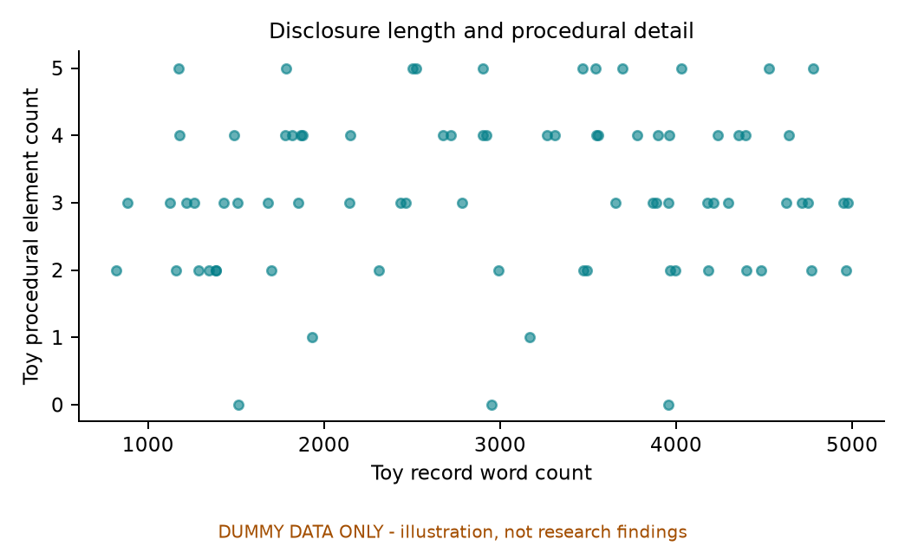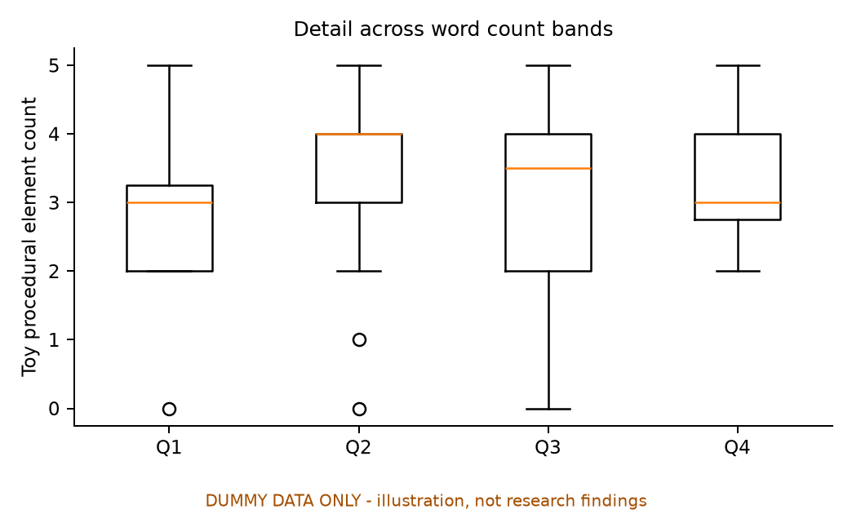
RQ4_F1 Disclosure length and procedural detail DUMMY DATA ONLY
RQ4_F2 Detail across word count bands DUMMY DATA ONLY
RQ4_T1 Illustrative rank association checks DUMMY DATA ONLY
Subset | Records | Spearman rho
All toy records | 80 | 0.065
Production | 55 | 0.09
v3 | 38 | -0.0
v4 | 42 | 0.165
RQ4_T2 Illustrative similar length cases DUMMY DATA ONLY
Toy A | Toy B | Words A | Words B | Elements A | Elements B
S001 | S005 | 3869 | 3693 | 3 | 5
S002 | S006 | 2951 | 2921 | 0 | 4
S003 | S027 | 4176 | 3968 | 3 | 2
Interpretation planned: Assess descriptive association and inspect similarly long records without assuming usefulness or causality.

RQ5 expected results with dummy data
DUMMY DATA ONLY Illustrative design No empirical findings
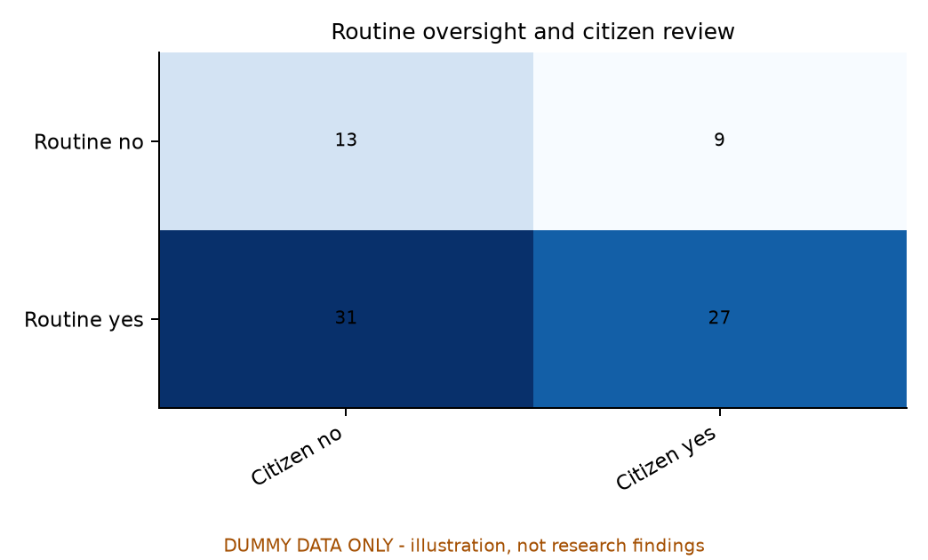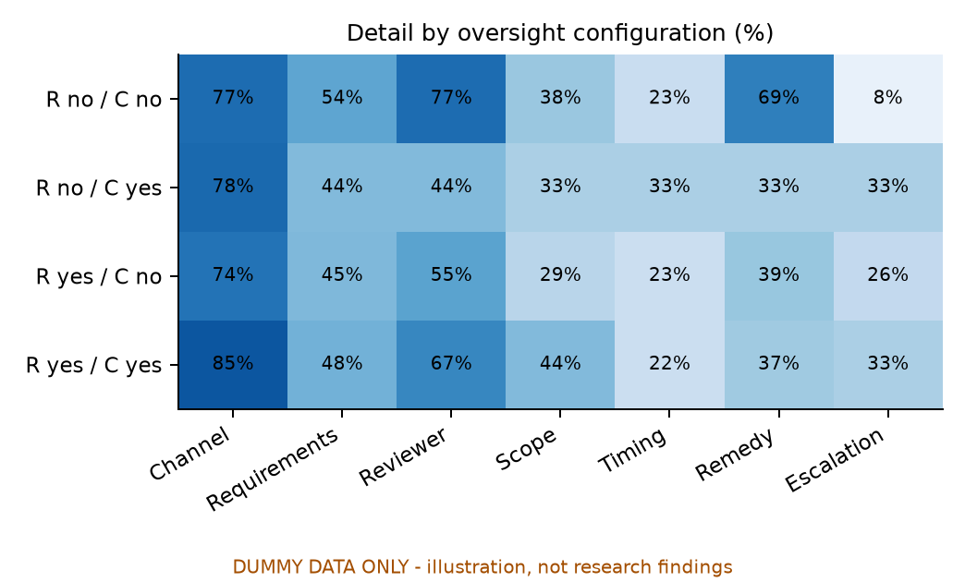
RQ5_F1 Routine oversight and citizen review DUMMY DATA ONLY
RQ5_F2 Detail by oversight configuration DUMMY DATA ONLY
RQ5_T1 Illustrative conditional review rates DUMMY DATA ONLY
routine | Records | Citizen review rate
False | 22 | 0.409
True | 58 | 0.466
RQ5_T2 Illustrative oversight case matrix DUMMY DATA ONLY
Toy case | Routine | Citizen review
A | No | No
B | No | Yes
C | Yes | No
D | Yes | Yes
Interpretation planned: Distinguish routine oversight from affected-person-initiated review; neither proves effectiveness.

References published after 2024
[1] de Almeida, P. G. R., & dos Santos Júnior, C. D. (2025). Artificial intelligence governance: Understanding how public organizations implement it. Government Information Quarterly, 42(1), 102003. https://doi.org/10.1016/j.giq.2024.102003
[2] Yurrita, M., Verma, H., Balayn, A., Alfrink, K., Gadiraju, U., & Bozzon, A. (2025). Identifying Algorithmic Decision Subjects’ Needs for Meaningful Contestability. Proceedings of the ACM on Human-Computer Interaction, 9(7), CSCW234. https://doi.org/10.1145/3757415
[3] Papagiannidis, E., Mikalef, P., & Conboy, K. (2025). Responsible artificial intelligence governance: A review and research framework. The Journal of Strategic Information Systems, 34(2), 101885. https://doi.org/10.1016/j.jsis.2024.101885
[4] de Fine Licht, K. (2025). Resolving value conflicts in public AI governance: A procedural justice framework. Government Information Quarterly, 42(2), 102033. https://doi.org/10.1016/j.giq.2025.102033
[5] Mahroof, K., Weerakkody, V., Hussain, Z., & Sivarajah, U. (2025). Navigating power dynamics in the public sector through AI-driven algorithmic decision-making. Government Information Quarterly, 42(3), 102053. https://doi.org/10.1016/j.giq.2025.102053
[6] Guenduez, A. A., Walker, N., & Demircioglu, M. A. (2025). Digital ethics: Global trends and divergent paths. Government Information Quarterly, 42(3), 102050. https://doi.org/10.1016/j.giq.2025.102050
[7] Batool, A., Zowghi, D., & Bano, M. (2025). AI governance: a systematic literature review. AI and Ethics, 5, 3265–3279. https://doi.org/10.1007/s43681-024-00653-w
[8] Chappidi, S., Cobbe, J., Norval, C., Mazumder, A., & Singh, J. (2025). Accountability Capture: How Record-Keeping to Support AI Transparency and Accountability (Re)shapes Algorithmic Oversight. arXiv preprint; listed as to appear at AIES 2025. https://doi.org/10.48550/arXiv.2510.04609
[9] Moreira, C., Palatkina, A., Braca, D., Walsh, D. M., Leihn, P. J., Chen, F., & Hubig, N. C. (2025). Explainable AI Systems Must Be Contestable: Here’s How to Make It Happen. arXiv preprint. https://doi.org/10.48550/arXiv.2506.01662
[10] Jahromi, M. N. S., Holm, S., Moeslund, T. B., & Ploug, T. (2026). Operationalizing AI contestability through technical feasibility analysis. Discover Artificial Intelligence, 6, 648. https://doi.org/10.1007/s44163-026-01381-2

Official data and journal sources
Government Digital Service. Algorithmic Transparency Recording Standard Hub. Updated 8 May 2025. https://www.gov.uk/government/collections/algorithmic-transparency-recording-standard-hub
GOV.UK. Published algorithmic transparency records. Snapshot 26 October 2026; live access checked 2 November 2026. https://www.gov.uk/algorithmic-transparency-records
Elsevier. Government Information Quarterly journal description. Accessed 2 November 2026. https://shop.elsevier.com/journals/government-information-quarterly/0740-624X

