RIDES ANALYSIS DASHBOARD
End-to-End Power BI Project Documentation
Interactive Ride, Revenue, Driver & Customer Performance Analysis

Item | Details
Tool | Microsoft Power BI
Project Type | Business Intelligence / Data Analytics
Dashboard | Rides Analysis Dashboard
Primary Analysis | Rides, Revenue, Drivers, Vehicles, Payments, Tips and Time

Prepared from the dashboard design, model relationships, KPI list and dashboard screenshots supplied for this project.

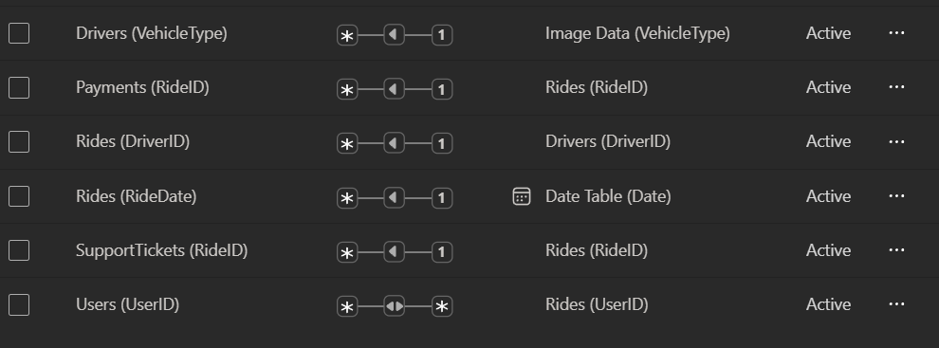
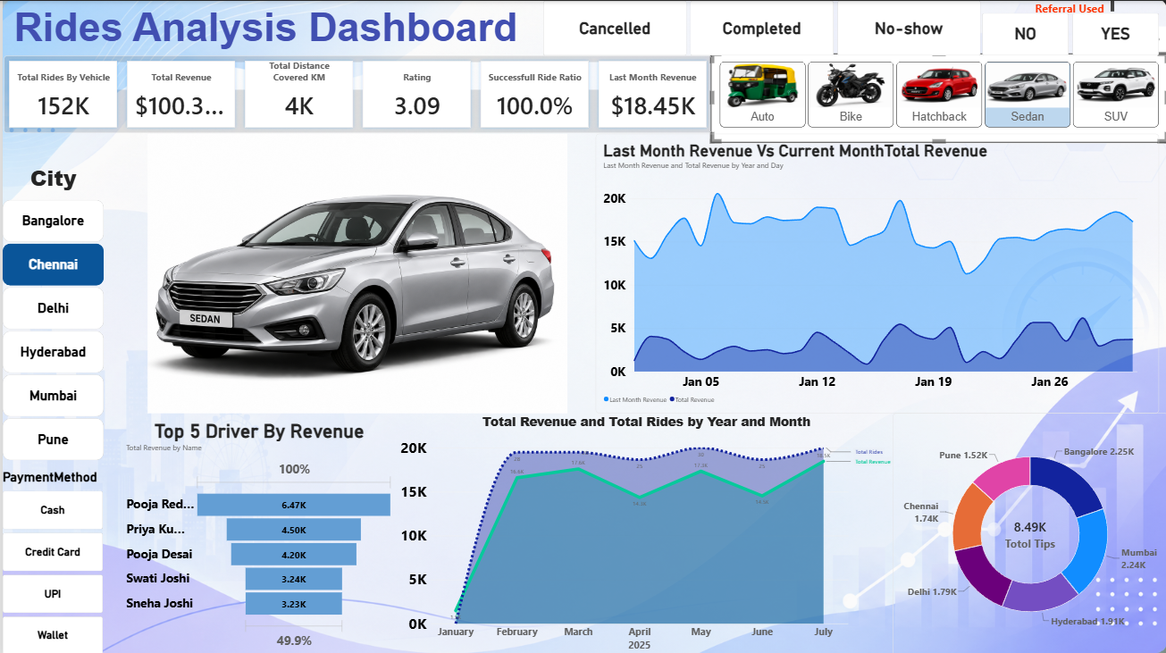

1. Project Overview
The Rides Analysis Dashboard is an interactive Power BI dashboard designed to analyze ride-service performance across cities, vehicle types, ride status, payment methods and referral usage. The dashboard combines ride-level data with driver, user, payment, support-ticket, date and image data to provide a single analytical view for operational and business decision-making.
The dashboard is filter-driven: users can select a city, vehicle type, payment method, referral usage and ride status, and the KPIs and visuals update to reflect the selected segment.

2. Business Objectives
- Measure overall ride activity and revenue performance.
- Track distance covered and customer rating performance.
- Evaluate successful ride performance using the Successful Ride Ratio KPI.
- Compare current-month and previous-month revenue behavior.
- Identify the top revenue-generating drivers.
- Analyze revenue and ride trends by year and month.
- Understand tip contribution across cities.
- Compare vehicle categories and analyze their performance interactively.
- Analyze payment-method and referral-usage segments.
- Provide a management-friendly dashboard for faster performance monitoring.

3. Dataset & Data Sources
The Power BI model shown for the project contains a central Rides table and supporting tables for drivers, users, payments, support tickets, dates and vehicle images. A dedicated Measures table is also used to organize DAX measures.
Table | Purpose | Key fields visible in the model
Rides | Central ride/fact table | RideID, RideDate, UserID, DriverID, Distance_km, Duration_min, Fare, PaymentMethod, Rating, Revenue, End_Location
Drivers | Driver and vehicle attributes | DriverID, City, FName, IsActive, JoinDate, Name, TotalRides, VehicleType
Users | Customer/user attributes | UserID, City, FirstName, LastName, JoinDate, Name, ReferralUsed, TotalRides
Payments | Payment transaction details | PaymentID, RideID, PaymentDate, PaymentMethod, Amount, PromoApplied, Status
SupportTickets | Customer/support activity | TicketID, RideID, UserID, IssueType, OpenDate, CloseDate, Status
Date Table | Time intelligence and date analysis | Date, Rider Per KM
Image Data | Vehicle image mapping | VehicleType, Image link
Measures (2) | Dedicated DAX measure storage | Last Month Revenue and other report measures

4. Data Model & Relationships
The Rides table functions as the central analytical table. Supporting tables provide descriptive or transactional attributes that enrich ride analysis. The relationship view supplied for the project shows the following active relationships:
From | Relationship | To | Purpose
Drivers[VehicleType] | Many-to-One | Image Data[VehicleType] | Maps vehicle category to the corresponding vehicle image.
Payments[RideID] | Many-to-One | Rides[RideID] | Connects payment transactions to rides.
Rides[DriverID] | Many-to-One | Drivers[DriverID] | Connects rides to driver attributes.
Rides[RideDate] | Many-to-One | Date Table[Date] | Enables date-based and time-intelligence analysis.
SupportTickets[RideID] | Many-to-One | Rides[RideID] | Connects support activity to rides.
Users[UserID] | Many-to-Many | Rides[UserID] | Connects users with their ride activity as shown in the supplied model.
The dedicated Date Table supports monthly/yearly analysis and revenue comparisons, while Image Data enables the vehicle image displayed in the dashboard to respond to the selected vehicle category.

5. Data Preparation & Modeling Approach
- Bring the source tables into Power BI and verify data types for dates, numeric fields and identifiers.
- Use RideID, DriverID and UserID as the main business keys for cross-table analysis.
- Use a dedicated Date Table for consistent time-based analysis.
- Create active relationships between transactional tables and their related dimension/master data.
- Create a vehicle image lookup table containing VehicleType and Image link.
- Organize report calculations in a dedicated Measures table for easier maintenance.
- Validate relationships and filter behavior before building dashboard visuals.
Note: The screenshots document the model and relationships supplied for this project. Exact Power Query transformation steps were not provided, so this section describes the documented modeling approach rather than inventing transformation operations.

6. KPI Framework
KPI | Business meaning | Purpose
Total Rides by Vehicle | Ride volume associated with the selected vehicle context. | Measure ride demand and vehicle-level activity.
Total Revenue | Total revenue generated from rides in the active filter context. | Primary financial performance indicator.
Total Distance Covered KM | Total distance covered by rides. | Measure operational activity and service utilization.
Rating | Ride/customer rating shown by the dashboard. | Monitor service quality/customer experience.
Successful Ride Ratio | Ratio of successful/completed rides under the dashboard's logic. | Evaluate ride completion performance.
Last Month Revenue | Revenue for the previous month relative to the current analysis period. | Support month-over-month revenue comparison.
The supplied dashboard screenshot shows the following KPI values for the illustrated filtered state (Bangalore + Auto): Total Rides by Vehicle 160K, Total Revenue $97.40K, Total Distance Covered 4K KM, Rating 2.94, Successful Ride Ratio 100.0%, and Last Month Revenue $13.52K.

7. Dashboard Layout & Visual Components
Visual / Section | What it shows | Analytical purpose
KPI Cards | Ride volume, revenue, distance, rating, successful ride ratio and last-month revenue. | Fast executive-level performance summary.
Last Month Revenue vs Current Month Total Revenue | Daily revenue trend comparison between the previous and current month. | Identify revenue movement, peaks and dips over time.
Top 5 Driver By Revenue | Five highest-revenue drivers. | Identify top individual driver contributors.
Total Revenue and Total Rides by Year and Month | Monthly trend of revenue and ride performance. | Understand seasonality and month-to-month movement.
Total Tips by City | Tip contribution split by city. | Compare customer tip contribution geographically.
Vehicle selector | Auto, Bike, Hatchback, Sedan and SUV. | Analyze performance by vehicle category.
City selector | Bangalore, Chennai, Delhi, Hyderabad, Mumbai and Pune. | Perform city-level analysis.
Payment Method selector | Cash, Credit Card, UPI and Wallet. | Segment ride/payment performance by payment channel.
Referral Used selector | No / Yes. | Compare referred and non-referred user segments.
Ride Status selector | Cancelled, Completed and No-show. | Analyze ride outcomes and operational performance.

8. Dashboard Example — Bangalore + Auto
The supplied screenshot represents an example dashboard state where Bangalore and Auto are selected. It demonstrates the visual hierarchy of the report, including KPI cards, interactive selectors, revenue trends, driver ranking, monthly analysis and city-wise tips.
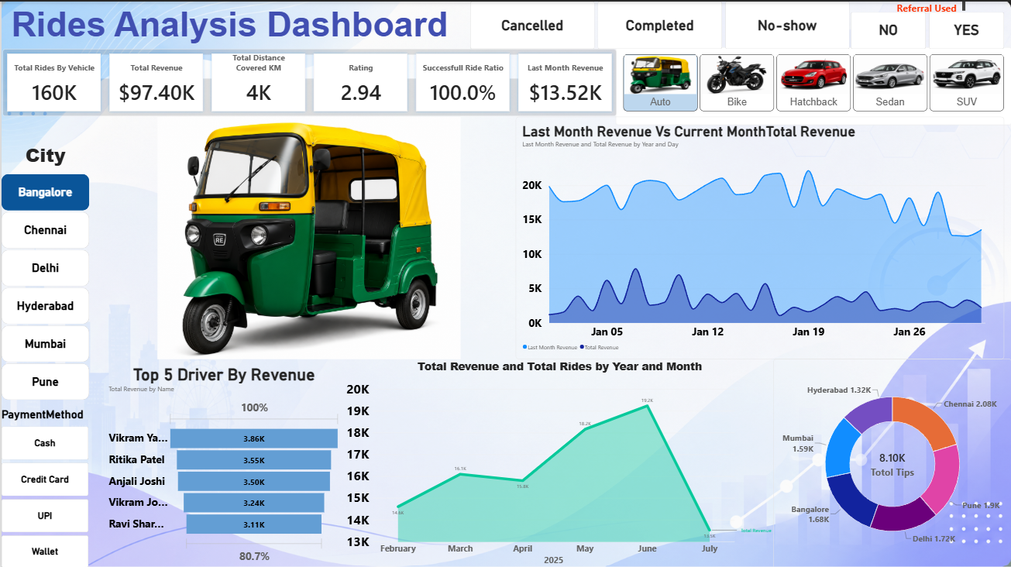
Figure 1. Rides Analysis Dashboard — Bangalore + Auto filtered view

9. Interactivity & User Experience
The dashboard is designed around interactive filtering. A user can combine filters to move from a broad business view to a specific segment. For example, selecting Bangalore + Auto changes the visible KPI and analytical context to that segment. The vehicle selector also drives the vehicle image shown in the central dashboard area through the Image Data relationship.
- City filtering supports geographic comparison.
- Vehicle filtering supports fleet/category comparison.
- Payment Method filtering supports payment behavior analysis.
- Referral Used filtering supports customer-acquisition analysis.
- Ride Status filtering supports completed/cancelled/no-show analysis.
- Multiple filters can be combined for targeted segment analysis.

10. DAX & Measure Layer
The report uses a dedicated Measures table, with Last Month Revenue visible in the supplied model. The dashboard KPI list indicates a measure-driven design for the principal calculations.
Measure / Calculation | Expected analytical logic
Total Rides by Vehicle | Count ride records within the current filter context, segmented by vehicle type.
Total Revenue | Aggregate ride revenue within the current filter context.
Total Distance Covered KM | Aggregate Distance_km within the current filter context.
Rating | Calculate the dashboard's rating metric from the Rating field using the selected filter context.
Successful Ride Ratio | Calculate successful/completed rides as a proportion of the relevant ride population according to the report logic.
Last Month Revenue | Use the Date Table to shift the revenue context to the previous month.
Exact DAX expressions were not included in the supplied screenshots, so the documentation records the business logic rather than fabricating code that may differ from the implemented measures.

11. Business Questions Answered
- How many rides are being generated for the selected vehicle/category?
- How much revenue is being generated?
- How much total distance has been covered?
- What is the current rating performance?
- What proportion of rides are successful?
- How does last month's revenue compare with the current month's revenue?
- Which five drivers generate the highest revenue?
- How does revenue and ride volume change month by month?
- Which cities contribute the most tips?
- How does performance vary by city, vehicle, payment method and referral usage?
- How do completed, cancelled and no-show rides affect the selected analysis?

12. Example Insights from the Supplied Dashboard State
- In the illustrated Bangalore + Auto view, the dashboard reports 160K for Total Rides by Vehicle.
- The displayed Total Revenue is $97.40K, while Last Month Revenue is $13.52K.
- The displayed Total Distance Covered is 4K KM.
- The displayed Rating is 2.94, providing a direct service-quality indicator.
- The displayed Successful Ride Ratio is 100.0% for the illustrated filter context.
- The Top 5 Driver visual highlights the highest revenue contributors, with the leading displayed driver at approximately 3.86K revenue.
- The monthly visual shows revenue movement across the displayed 2025 period, with a visible peak around June followed by a sharp drop in July.
- The Total Tips visual compares tip contribution across Bangalore, Chennai, Delhi, Hyderabad and Mumbai, with city-level values displayed in the chart.

13. Business Recommendations
- Use city-level filtering to identify locations with weaker revenue or ride activity and investigate local operational causes.
- Review high-performing drivers and identify practices that could be replicated across the driver network.
- Monitor month-over-month revenue changes to detect declining or improving business performance early.
- Use vehicle-level analysis to understand which vehicle categories generate stronger ride activity and revenue.
- Analyze cancelled and no-show segments separately to identify operational or customer-experience issues.
- Compare payment methods to understand adoption and performance of different payment channels.
- Compare referred vs non-referred users to evaluate the effectiveness of referral-driven acquisition.
- Track rating trends alongside ride volume and revenue so growth does not come at the expense of customer experience.
- Use tip-by-city analysis as an additional indicator of customer engagement and service experience.

14. End-to-End Technical Workflow
Stage | Implementation
1. Data Collection | Load ride, driver, user, payment and support-related datasets into Power BI.
2. Data Preparation | Validate fields, data types, keys and analytical attributes required for reporting.
3. Data Modeling | Build relationships around the central Rides table and connect the Date Table and Image Data.
4. Measure Development | Create reusable DAX measures for KPIs and time-based comparisons.
5. Visual Development | Create KPI cards, trend charts, ranking charts and the tips donut chart.
6. Interactivity | Add city, vehicle, payment, referral and ride-status controls.
7. Dynamic Vehicle Image | Map VehicleType to Image Data so the displayed image changes with the selected vehicle.
8. Validation | Test filter propagation, KPI values, visual interactions and relationship behavior.
9. Business Analysis | Interpret revenue, ride, driver, vehicle, customer and service-quality patterns.
10. Dashboard Delivery | Publish the final report for interactive business analysis.

15. Key Dashboard Strengths
- Executive-friendly KPI summary.
- Multiple business dimensions available through interactive filters.
- Combination of financial, operational and customer-experience metrics.
- Top-driver performance ranking for actionable operational analysis.
- Time-series analysis for revenue and ride trends.
- City-wise tip analysis for geographic comparison.
- Dynamic vehicle imagery improves visual context and user experience.
- Dedicated Date Table supports structured time analysis.
- Dedicated Measures table improves measure organization and maintainability.

16. Future Enhancements
- Add a dedicated cancellation-rate KPI and cancellation trend.
- Add average fare, average revenue per ride and revenue per KM.
- Add driver utilization metrics such as rides per active driver.
- Add customer retention/repeat-user analysis.
- Add support-ticket rate and issue-type analysis.
- Add target vs actual KPIs for revenue, rides and rating.
- Add tooltips or drill-through pages for driver, city and vehicle details.
- Add a clear data-refresh indicator and report last-refresh date.
- Document and standardize the exact DAX definitions for all business KPIs.

17. Conclusion
The Rides Analysis Dashboard provides a consolidated analytical view of ride-service performance. By combining ride activity, revenue, driver performance, vehicle categories, customer attributes, payments, support activity and time intelligence, the dashboard supports both high-level monitoring and focused segment analysis.
Its filter-driven design allows users to move from overall performance to specific combinations such as a city and vehicle type. The supplied Bangalore + Auto example demonstrates how the dashboard communicates financial, operational and service-quality information in a single view.

18. Portfolio / Interview Explanation
A concise way to explain the project in an interview is:
“I developed an interactive Rides Analysis Dashboard in Power BI to analyze ride volume, revenue, distance, ratings, successful rides, driver performance and city-level tips. I built a relational data model around the Rides table, connected supporting driver, user, payment, support and date tables, and created KPI measures for business analysis. I also implemented interactive filters for city, vehicle, payment method, referral usage and ride status, along with dynamic vehicle imagery. The dashboard helps users quickly identify revenue trends, top drivers and performance differences across segments.”

Appendix A — Dashboard Filter Options
Filter | Values shown in supplied dashboard
City | Bangalore, Chennai, Delhi, Hyderabad, Mumbai, Pune
Vehicle Type | Auto, Bike, Hatchback, Sedan, SUV
Payment Method | Cash, Credit Card, UPI, Wallet
Referral Used | NO, YES
Ride Status | Cancelled, Completed, No-show

Appendix B — Documented KPI Snapshot
KPI | Bangalore + Auto screenshot value
Total Rides by Vehicle | 160K
Total Revenue | $97.40K
Total Distance Covered KM | 4K
Rating | 2.94
Successful Ride Ratio | 100.0%
Last Month Revenue | $13.52K

— End of Documentation —

