Internship Report
On
AI Business Strategy: Market Analysis, Strategic Roadmap Development and Implementation Planning in the Retail & E-Commerce Sector
Submitted
To
School of Computer Science and Engineering
IILM University, Greater Noida, U.P.
In partial fulfilment of the requirement of degree of
B.Tech CSE

By
Roll Number of Student: CS23411263
Name of Student: DHEERAJ TRIPATHI
Program & Semester: B.Tech CSE, Semester 7
Batch: 2023-2027

CANDIDATE'S DECLARATION
I, DHEERAJ TRIPATHI, do hereby declare that the internship report titled "AI Business Strategy: Market Analysis, Strategic Roadmap Development and Implementation Planning in the Retail & E-Commerce Sector" has been completed by me to fulfil the requirement for the award of the degree of Bachelor of Technology in CSE. All the references have been quoted and I have not taken as such any material from any other source. I affirm that this report is my own and has not been submitted to any other institute for any degree/diploma requirement, and further I shall be solely responsible for any kind of copyright violation in this regard.
Signature: ______________________
Student Name: DHEERAJ TRIPATHI
Roll No.: CS23411263

ACKNOWLEDGEMENT
I am using this opportunity to express my gratitude to everyone who supported me throughout the Internship Program. I am thankful for their aspiring guidance, invaluably constructive criticism and friendly advice during this work. I am sincerely grateful to them for sharing their truthful and illuminating views on a number of issues related to this work.
I would like to thank Mr. Kounal Gupta, Founder of YuvaIntern, and the entire YuvaIntern team for providing me the opportunity to undertake this internship as a Junior AI Business Strategy Intern and for their continuous support and mentorship throughout the internship duration.
I would also like to extend my sincere thanks to the faculty of the School of Computer Science and Engineering, IILM University, for their guidance and encouragement throughout this internship and the preparation of this report.
Finally, I express my gratitude to my parents and friends for their constant blessings, motivation and support.
Signature: ______________________
Student Name: DHEERAJ TRIPATHI
Roll No.: CS23411263

TABLE OF CONTENTS

Chapter No. | Chapter Name | Page Nos.
 | Cover Page | ----
1. | Candidate's Declaration | i
2. | Acknowledgment | ii
3. | Internship Completion Certificate | ----
4. | Project Description | 1
 | 4.1 Introduction | 1
 | 4.2 Organization Profile | 1
 | 4.3 Problem Statement | 2
 | 4.4 Project Objectives | 2
 | 4.5 Scope of the Project | 3
 | 4.6 Technologies and Tools Used | 3
 | 4.7 System Architecture | 4
 | 4.8 Methodology | 4
 | 4.9 Expected Outcomes | 7
 | 4.10 Certificates of Completion and Communication Proof | 8
5. | Bibliography/References | 9

INTERNSHIP COMPLETION CERTIFICATE
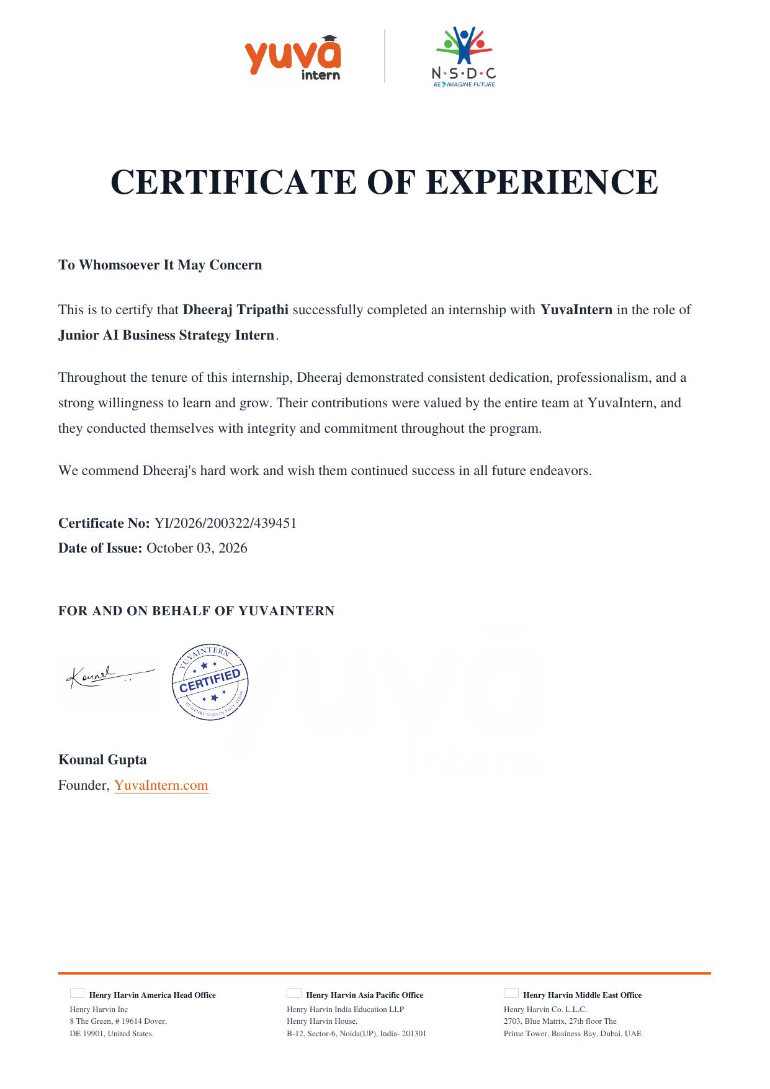

4. PROJECT DESCRIPTION
4.1 Introduction
Artificial Intelligence (AI) has rapidly evolved from an emerging technology into a core driver of competitive advantage across industries. Organizations are increasingly integrating AI-powered tools into their strategic decision-making, customer engagement, and operational processes to improve efficiency, personalize experiences, and unlock new revenue streams. This report documents the work undertaken during a five-week virtual internship as a Junior AI Business Strategy Intern with YuvaIntern, an internship platform operated in association with Henry Harvin Education and recognized under the National Skill Development Corporation (NSDC).
The internship focused on applying AI business strategy concepts to real-world market scenarios within the Retail and E-Commerce sector, an industry undergoing significant transformation due to AI adoption in areas such as personalized recommendations, demand forecasting, inventory optimization, conversational commerce, and dynamic pricing. Over the course of the internship, five structured tasks were completed, each contributing to a progressively deeper understanding of how AI can be strategically planned, implemented, measured, and governed within a business organization.
This report is organized to reflect the overall internship journey: it begins with an overview of the host organization, followed by the problem statement, objectives, and scope of the work undertaken, the tools and conceptual frameworks used, a proposed system/strategic architecture, a detailed account of the methodology followed across all five weeks, the outcomes achieved, and finally the certificates and references that support this work.
4.2 Organization Profile
YuvaIntern is a skill-development and internship platform that provides students and early-career professionals with practical, project-based learning experiences across domains such as AI business strategy, data analytics, digital marketing, and management. YuvaIntern operates in association with Henry Harvin Education, a globally recognized training and certification organization with offices across the United States, India, and the Middle East, and is aligned with the National Skill Development Corporation (NSDC) under its "Reimagine Future" initiative.
The organization's internship programs are designed to be industry-relevant and outcome-driven, requiring interns to produce real deliverables each week that simulate the kind of strategic and analytical work expected in a professional business environment. As a Junior AI Business Strategy Intern, the work assigned during this internship was centred on helping a hypothetical/real business segment plan, structure, and evaluate the adoption of AI technologies.
4.3 Problem Statement
Despite widespread awareness of AI's potential, many retail and e-commerce businesses — particularly small and mid-sized players — struggle to translate AI interest into a coherent business strategy. Common challenges include an inability to identify where AI can create the most value, a lack of structured roadmaps for phased implementation, unclear metrics to evaluate the success of AI initiatives, and insufficient risk planning around data privacy, technology integration, and change management.
The core problem addressed through this internship's tasks was: How can a retail/e-commerce business systematically identify, plan, implement, measure, and de-risk the adoption of AI technologies in a way that is strategically aligned with business goals and produces measurable value?
4.4 Project Objectives
- To conduct a comprehensive market opportunity analysis of AI adoption within the retail and e-commerce industry, including trends, competitor strategies, and consumer needs.
- To design a phased strategic AI roadmap that aligns AI investments with business goals, resources, and timelines.
- To develop an AI-driven business innovation proposal that identifies a specific business challenge and proposes a practical AI-based solution.
- To design a set of performance metrics and KPIs to measure the impact of AI strategy initiatives on business outcomes.
- To create a detailed AI implementation plan supported by a thorough risk assessment and mitigation strategy.
4.5 Scope of the Project
The scope of this internship was limited to secondary research and strategic planning exercises within the retail and e-commerce industry segment, rather than the deployment of live AI systems. All analysis was based on publicly available industry reports, articles, and well-established market trends, and any organization referenced for the roadmap, innovation proposal, KPI framework, and implementation plan was treated as a representative/hypothetical mid-sized retail business.
The project intentionally did not extend into actual software development, model building, or deployment of AI systems, since the internship's objective was to build strategic and analytical capability rather than technical AI engineering skills. The five weekly tasks were designed to be cumulative, with each week building upon the insights of the previous one to form a complete strategic narrative — from opportunity identification to implementation and risk management.
4.6 Technologies and Tools Used
Although this internship was strategy-oriented rather than development-oriented, a range of tools, frameworks, and AI concepts were used and studied throughout the five weeks:
- Research & Reference Tools: Google Scholar, publicly available industry reports (e.g., McKinsey, NASSCOM, Statista-type sources), business news portals, and company websites for secondary research.
- Analytical Frameworks: SWOT Analysis, PESTEL Analysis, Porter's Five Forces, and the Balanced Scorecard for structuring the market analysis and KPI design.
- AI Concept Areas Studied: recommendation engines, predictive/demand forecasting analytics, conversational AI/chatbots, computer vision for visual search, dynamic pricing algorithms, and inventory/supply-chain optimization.
- Documentation & Presentation Tools: Microsoft Word for report writing, Microsoft PowerPoint/Excel for roadmap timelines, KPI dashboards, and flowcharts.
- Project & Risk Planning Tools: Gantt-style timelines, RACI-style responsibility charts, and risk matrices (probability × impact) for implementation planning.
4.7 System Architecture
Since the internship focused on business strategy rather than software engineering, the "system architecture" for this project is represented as a conceptual AI Strategy Framework rather than a technical system diagram. This framework describes the layers through which a retail organization would move from raw data to strategic AI-driven decisions, and it was used as a reference structure throughout all five weekly tasks:
- Layer 1 — Data Layer: Customer transaction data, browsing behaviour, inventory data, and market/competitor data collected from internal systems and external public sources.
- Layer 2 — AI/ML Capability Layer: Core AI capabilities such as recommendation systems, forecasting models, natural language processing for customer service, and computer vision for product search.
- Layer 3 — Business Application Layer: Practical use cases built on top of AI capabilities — personalized marketing, dynamic pricing, chatbot-based customer support, and automated inventory replenishment.
- Layer 4 — Strategy & Decision Layer: Translating AI capabilities into strategic initiatives through roadmaps, innovation proposals, and prioritization based on business impact and feasibility.
- Layer 5 — Governance & Measurement Layer: KPIs, risk management, data privacy compliance, and continuous review mechanisms that ensure AI initiatives remain aligned with business objectives.
Each of the five weekly deliverables corresponds primarily to one or more layers of this framework: Week 1 mapped the Data and AI/ML Capability layers to market opportunities; Week 2 and Week 3 operated at the Strategy & Decision layer; and Week 4 and Week 5 focused on the Governance & Measurement layer.
4.8 Methodology
The internship followed a structured, week-by-week methodology in which each week's task built upon the previous week's findings, moving from broad market research toward a fully-formed, risk-assessed implementation plan. The retail and e-commerce sector was selected as the focus industry throughout, ensuring continuity and depth across all deliverables.
4.8.1 Week 1 — AI Market Opportunity Analysis
The first week's objective was to conduct a comprehensive market opportunity analysis of AI adoption within the retail and e-commerce industry. The retail sector was selected because of the prominence and visibility of AI integration in this space, ranging from large e-commerce marketplaces to brick-and-mortar chains adopting smart retail technologies.
Secondary research was conducted using publicly available industry reports, business articles, and market trend analyses to understand the current state of AI adoption in retail. The research covered how leading retailers use AI for personalized product recommendations, chatbot-driven customer support, demand forecasting, and dynamic pricing, and it identified common gaps such as underutilization of AI for supply-chain optimization among mid-sized retailers.
Competitor strategies were analyzed by comparing how different categories of retailers (large marketplaces, specialty e-commerce brands, and traditional retailers moving online) have adopted AI at different levels of maturity. Based on this analysis, the report highlighted specific opportunities for AI-driven value creation — including hyper-personalization, AI-assisted visual search, and predictive inventory management — along with growth projections and a market-entry/expansion recommendation for a mid-sized retail business seeking to adopt AI-driven personalization and forecasting as an initial, low-risk entry point.
4.8.2 Week 2 — Strategic AI Roadmap Development
Building on the opportunities identified in Week 1, the second week's task involved designing a phased strategic AI roadmap for a retail business. Foundational AI business strategy concepts around phased implementation and change management were reviewed, and long-term strategic goals — such as improving customer retention and reducing inventory costs — were aligned with specific, sequenced AI initiatives.
The roadmap was structured into three phases: a Foundation Phase (0–6 months) focused on data infrastructure and pilot recommendation-engine deployment; a Growth Phase (6–18 months) introducing predictive demand forecasting and AI-powered customer service; and a Scale Phase (18–36 months) expanding into dynamic pricing and computer-vision-based visual search. Each phase included a timeline, key milestones, and success measures.
Resource requirements were identified across three dimensions — personnel (data analysts, AI vendors/partners, and a project sponsor), technology (cloud infrastructure, AI platform licensing, and integration tools), and budget (phased capital allocation weighted toward the Foundation Phase to reduce early risk). Potential risks such as data-quality issues, resistance to change among staff, and vendor dependency were identified along with corresponding mitigation strategies, including staff training programs and phased vendor contracts with performance clauses.
4.8.3 Week 3 — AI-Driven Business Innovation Proposal
The third week focused on developing a specific AI-driven innovation proposal to address a concrete business challenge. The challenge selected was high cart-abandonment and low personalization in the online shopping journey of a mid-sized retail business, an issue widely reported across the e-commerce industry.
The proposed solution was an AI-powered conversational shopping assistant combined with a real-time personalization engine that would use browsing and purchase history to provide contextual product suggestions, answer customer queries instantly, and send personalized re-engagement prompts to reduce cart abandonment. The proposal detailed how the AI solution would be implemented in three stages — data integration, model training and pilot testing on a subset of customers, and full-scale rollout with continuous learning from customer interactions.
The expected business impact was framed around three outcomes: improved conversion rates through timely and relevant recommendations, reduced customer service costs through automation of routine queries, and improved customer satisfaction and loyalty through faster, more personalized service. A high-level implementation plan with an estimated timeline of four months and the resource needs (a small cross-functional team of a product manager, data analyst, and customer-experience lead) was outlined to demonstrate feasibility.
4.8.4 Week 4 — AI Strategy Performance Metrics and KPI Design
The fourth week's task translated the strategic objectives from Weeks 1–3 into measurable outcomes by designing a set of Key Performance Indicators (KPIs) for evaluating the retail business's AI initiatives. Business strategy principles were reviewed to ensure that each KPI was directly traceable to a strategic objective rather than being a generic technology metric.
The KPI framework was organized into four categories: Customer Impact KPIs (conversion rate uplift, average order value, customer satisfaction score, and cart-abandonment rate), Operational Efficiency KPIs (inventory forecast accuracy, reduction in stockouts/overstock, and average customer-service response time), Financial KPIs (incremental revenue attributable to AI-personalization and cost savings from automation), and Adoption/Governance KPIs (percentage of AI-recommended actions accepted by staff, and data-quality/compliance scores).
For each KPI, the rationale, target range, data source, and measurement frequency were defined, and simple dashboard-style visual summaries were prepared to illustrate how these metrics could be tracked over time. A quarterly review cycle was proposed so that KPI targets could be adjusted as the AI roadmap progressed from the Foundation to the Growth and Scale phases.
4.8.5 Week 5 — AI Implementation Planning and Risk Assessment
The final week consolidated the previous four weeks' work into a comprehensive implementation plan and risk assessment for the AI-powered conversational shopping assistant and personalization engine proposed in Week 3, treated as the flagship project for the roadmap defined in Week 2.
The implementation plan defined the project scope and objectives, a detailed phase-wise timeline covering requirement-gathering, vendor/platform selection, pilot deployment, and full rollout, and hypothetical roles and responsibilities (project sponsor, AI/ML vendor, data analyst, customer-experience lead, and IT/security officer) using a RACI-style responsibility structure. A budget outline covering technology licensing, integration, training, and contingency reserve was also included.
The risk assessment identified risks across four categories — technological (data-quality and integration risk), operational (staff adoption and workflow disruption), financial (cost overrun and unclear ROI in early phases), and regulatory (data-privacy and consumer-protection compliance) — and rated each on a probability–impact matrix. Mitigation strategies included phased rollout with pilot testing, staff training and change-management communication, contingency budgeting, and a data-privacy compliance review prior to full deployment. Monitoring mechanisms, including monthly risk-review checkpoints tied to the KPI dashboard from Week 4, were proposed to ensure risks were tracked throughout the project lifecycle.
4.9 Expected Outcomes
- A structured understanding of how to conduct an industry-focused AI market opportunity analysis using publicly available secondary research.
- The ability to design a phased, resource-aware strategic roadmap that aligns AI initiatives with business goals and timelines.
- Practical experience translating a business problem into an actionable, innovation-driven AI solution proposal.
- The ability to design meaningful KPIs that connect AI initiatives to measurable business outcomes.
- Competence in developing an implementation plan supported by a structured, category-wise risk assessment and mitigation strategy.
- Overall, a strengthened ability to think and communicate like an AI business strategist — bridging technical AI capabilities with practical business value.
4.10 Certificates of Completion and Communication Proof
The following pages present the official Internship Offer Letter issued by YuvaIntern at the start of the internship, confirming the role, duration, and terms of the internship, in addition to the Certificate of Experience presented earlier in this report (Section 3), which was issued upon successful completion of the internship.
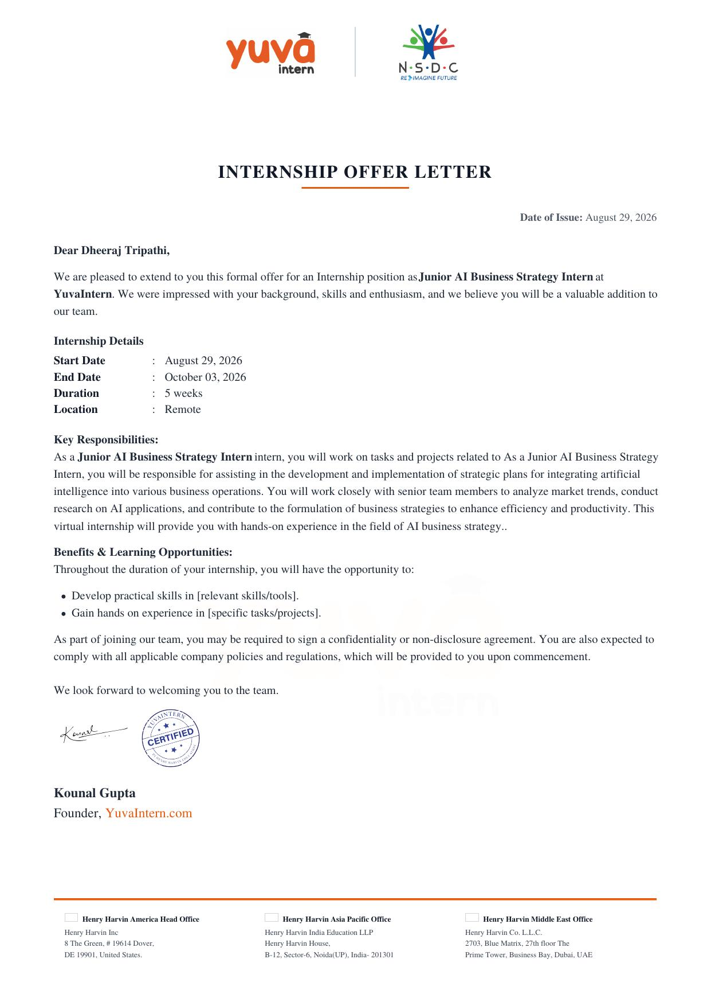
Fig. 4.10.1: Internship Offer Letter — YuvaIntern
5. BIBLIOGRAPHY / REFERENCES
McKinsey & Company, "The State of AI" — annual global survey reports on enterprise AI adoption trends, McKinsey.com.
NASSCOM, AI adoption and skilling reports for the Indian technology and retail industry, nasscom.in.
Statista, "Artificial Intelligence in Retail" — industry statistics and market-size projections, statista.com.
Gartner, research notes on retail technology trends and AI in customer experience, gartner.com.
Harvard Business Review, articles on AI strategy, personalization, and digital transformation in retail, hbr.org.
YuvaIntern, Internship Task Briefs — Junior AI Business Strategy Intern Program, YuvaIntern.com.
Henry Harvin Education, organizational and program information, henryharvin.com.

