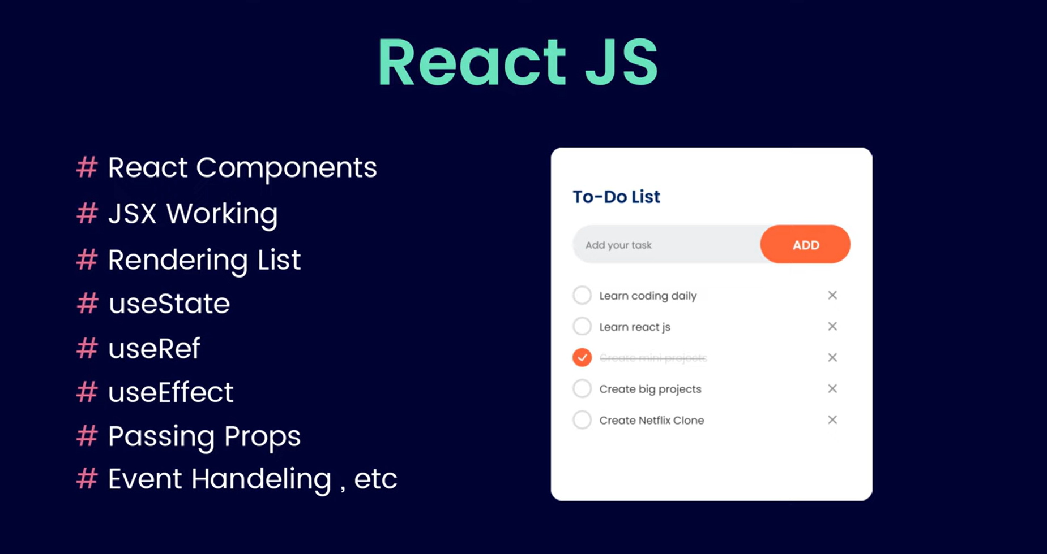

WE CAN CREATE THESE WITH THE HELP OF REACT JS…

* Portfolio website
* E-commerce website
* Social website

React is a Fontend JavaScript library that is used to create interactive user interface.

Using react we can create single page application.



* Npm –version
* Npm create vite@latest
* Name your project
* A folder is now created you can open it using vscode editor
* Npm install
* Npm install dev
* A local host url is generated there you can see the interface of your project.

