Svelte is a lightweight framework for building web applications. When you use it, it looks and feels a lot like other frontend frameworks like React and Vue, but leaves the virtual DOM behind. That, along with other optimisations means it does far less work in the browser, optimising user experience and load time.

CREATE FIRST SVELTE APP

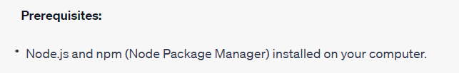

To Check---

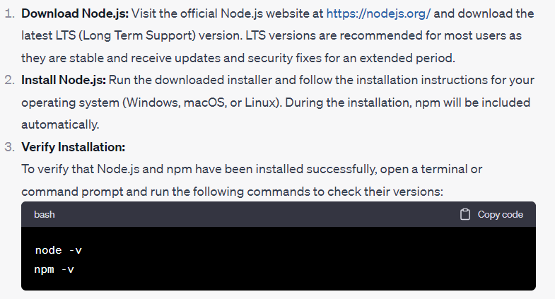



**Step 1: Install the Svelte Template**

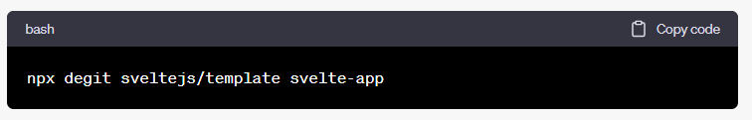

This command will create a new directory called "svelte-app" with the Svelte template files.

**Step 2: Navigate to Your App Directory**

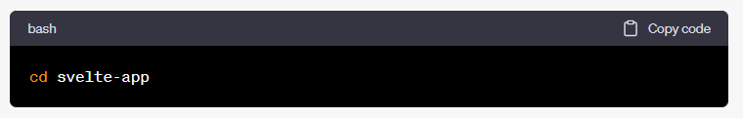

**Step 3: Install Dependencies**

Install the project's dependencies by running: 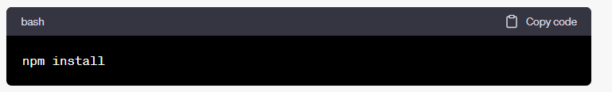

**Step 4: Run the Development Server**

To start a development server and preview your Svelte app, run the following command: 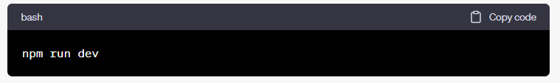

This command will start a development server, and you should see output indicating that your app is available at [**http://localhost:5000**](http://localhost:5000).

Now open browser Go to that address.

**Step 5: Edit Your Svelte App**

Now, you can start editing your Svelte app.

The main entry point for your app is located in the **src/App.svelte** file.

You can make changes there and see them reflected in your browser as you save the file.

For example, you can modify the content in **src/App.svelte** to something like: 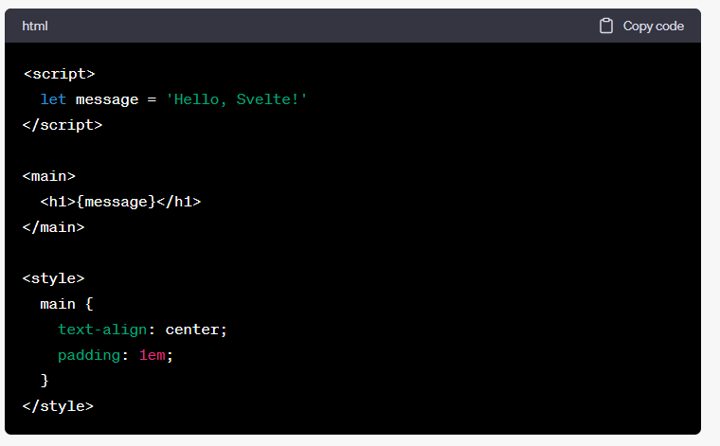

Save the file, and you'll see the changes immediately in your browser.

**Step 6: Build Your Svelte App for Production**

When you're ready to deploy your Svelte app, you can build it for production by running:

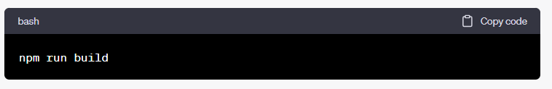

This command will generate optimized and minified files in the **public** directory that you can then deploy to a web server.

That's it! You've created your first Svelte app and can now start building more complex web applications using this framework.

Explore the Svelte documentation for more information on Svelte's features and capabilities.

<https://svelte.dev/docs>