Computer Network is the collection of computers which are connected with each other and can communicate more easily.

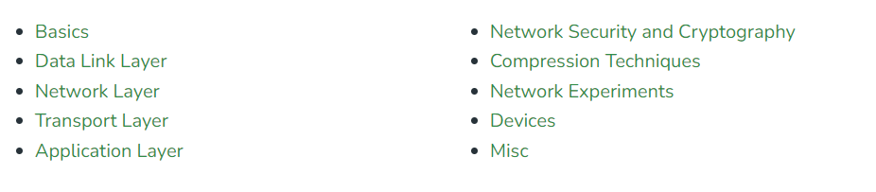

Basics building blocks of a Computer network are Nodes and Links.

Nodes ex---Modem, Router

Links ex---

How can we identify devices?

Each device has an IP Address, that helps in identifying a device.

**1.Basic Terminologies of Computer Networks**

* **Protocol:**A protocol is a set of rules and standards that govern how data is transmitted over a network. Examples of protocols include [TCP/IP](https://www.geeksforgeeks.org/tcp-ip-model/), [HTTP](https://www.geeksforgeeks.org/http-full-form/), and [FTP](https://www.geeksforgeeks.org/file-transfer-protocol-ftp-in-application-layer/).
* **Topology:** Network topology refers to the physical and logical arrangement of nodes on a network. The common network topologies include bus, star, ring, mesh, and tree.
* **Service Provider Networks:**These types of Networks give permission to take Network Capacity and Functionality on lease from the Provider. Service Provider Networks include Wireless Communications, Data Carriers, etc.
* **IP Address**: An IP address is a unique numerical identifier that is assigned to every device on a network. IP addresses are used to identify devices and enable communication between them.
* **DNS:**The [Domain Name System (DNS)](https://www.geeksforgeeks.org/domain-name-system-dns-in-application-layer/) is a protocol that is used to translate human-readable domain names (such as www.google.com) into IP addresses that computers can understand.

## 2.Types of Enterprise Computer Networks

* **LAN:**A [Local Area Network (LAN)](https://www.geeksforgeeks.org/types-of-area-networks-lan-man-and-wan/)is a network that covers a small area, such as an office or a home. LANs are typically used to connect computers and other devices within a building or a campus.
* **WAN:**A [Wide Area Network (WAN)](https://www.geeksforgeeks.org/wan-full-form/) is a network that covers a large geographic area, such as a city, country, or even the entire world. WANs are used to connect LANs together and are typically used for long-distance communication.
* **Cloud Networks:**[Cloud Networks](https://www.geeksforgeeks.org/cloud-networking/) can be visualized with a Wide Area Network (WAN) as they can be hosted on public or private cloud service providers and cloud networks are available if there is a demand. Cloud Networks consist of Virtual Routers, Firewalls, etc.
* **Open system:** A system that is connected to the network and is ready for communication.
* **Closed system:** A system that is not connected to the network and can’t be communicated with.

## 3.Types of Computer Network Architecture

* **Client-Server Architecture:** [Client-Server Architecture](https://www.geeksforgeeks.org/client-server-model/) is a type of Computer Network Architecture in which Nodes can be Servers or Clients. Here, the server node can manage the Client Node Behaviour.
* **Peer-to-Peer Architecture:**In [P2P (Peer-to-Peer) Architecture](https://www.geeksforgeeks.org/what-is-p2ppeer-to-peer-process/), there is not any concept of a Central Server. Each device is free for working as either client or server.

Network Devices

An interconnection of multiple devices, also known as hosts.

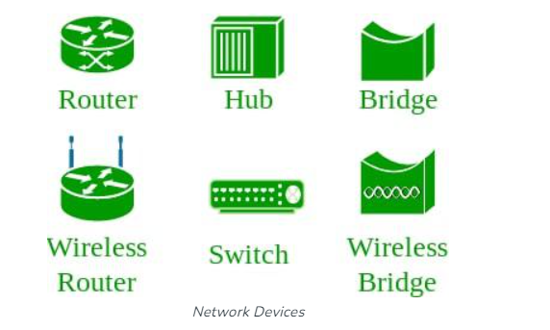

Network Topology

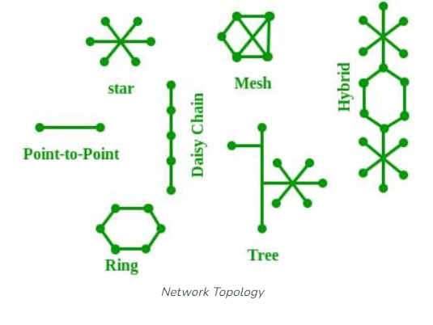

OSI Model

OSI stands for openSystemsInterconnection

Developed by International Organization For Standardization

It is 7 layer architecture

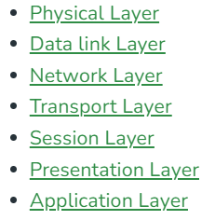

Protocol

Protocol is the set of rule which defines the way how two entities can communicate across the network.

Ex---TCP, IP, UDP, ARP, DHCP, FTP

Unique Identifiers of Network

Hostname --- Unique name of device (cmd command:hostname)

IP address (internet protocol) also known as Logical address (cmd command:ipconfig)

MAC address (media access control address)

Port (cmd command : netstat-a)

Socket (ip-address + port)

DNS server (domain name system ) (cmd command : nslookup)

ARP (address resolution protocol)  
RARP (reverse address resolution protocol)

Hardware layers 🡪 network support layer

Software layers 🡪user support layer

HTTPs protocol

hyperText transfer protocol secure

its port number is 443 by default

it uses SSL/TLS protocol by default