The specific tech stack needed to start contributing to Google Summer of Code (GSoC) projects can vary significantly depending on the open-source organization and project you choose to work on. GSoC encompasses a wide range of open-source projects, and each project may have its own technology stack and requirements. However, here are some general guidelines to get started with GSoC contributions:

1. Research and Choose a Project: Start by browsing the list of participating open-source organizations in GSoC and select a project that aligns with your interests, skills, and experience. Look for projects that match your technical expertise and interests.
2. Communication and Collaboration Tools: Familiarize yourself with the communication and collaboration tools used by the project. These may include email, mailing lists, chat platforms (e.g., Slack, IRC), version control systems (e.g., Git), issue trackers (e.g., GitHub Issues, Jira), and project-specific communication channels.
3. Programming Languages and Technologies: Understand the programming languages, frameworks, and technologies used by the project. GSoC projects can involve a wide variety of programming languages, such as Python, JavaScript, Java, C++, etc., and frameworks specific to the project's domain.
4. Version Control: Make sure you are comfortable with version control concepts, particularly Git, which is widely used in open-source development. Learn how to fork a repository, create branches, commit changes, and submit pull requests.
5. Build and Testing: Get familiar with the build and testing procedures for the project. Some projects may have automated build pipelines and testing frameworks that you'll need to work with.
6. Development Tools: Depending on the project, you may need to use specific development tools, such as integrated development environments (IDEs), text editors, and debugging tools.
7. Collaboration and Code Review: Understand the project's collaboration and code review processes. This typically involves submitting pull requests, responding to feedback, and iteratively improving your code.
8. Project-Specific Knowledge: Gain domain-specific knowledge related to the project's focus. If the project is related to a particular domain (e.g., machine learning, web development, scientific research), you might need to have relevant knowledge or be willing to learn quickly.
9. Contribution Guidelines: Each open-source project will have its own contribution guidelines and coding standards. Familiarize yourself with these and follow them when making contributions.
10. Community Engagement: Actively engage with the project's community, mentors, and other contributors. Join mailing lists or chat channels, ask questions, and seek guidance when needed.
11. Problem-Solving Skills: Develop strong problem-solving skills. You may encounter complex technical challenges that require creativity and determination to solve.
12. Commitment: GSoC is a full-time, three-month program, so be prepared to commit your time and effort to the project. You will need to plan your schedule accordingly.

Keep in mind that GSoC projects can be highly diverse, so the key is to research and adapt to the specific project's needs. Once you've selected a project, reach out to the mentors and maintainers for guidance and clarification on their tech stack and requirements. Your success in GSoC will depend on your ability to adapt to the specific project's technical environment and work effectively with the project's community.

OpenSource Lecture by Somya maam

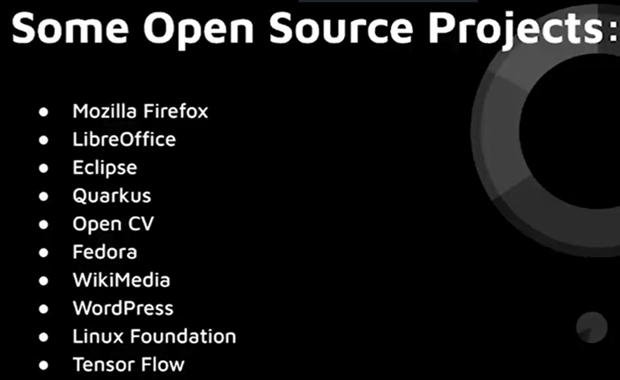



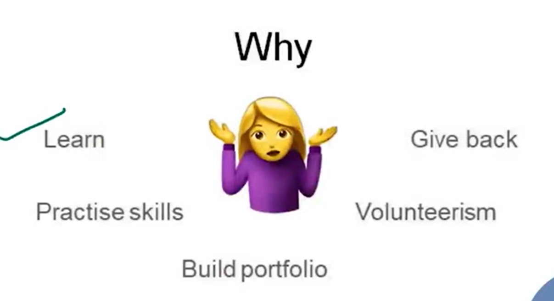



Write the name of organisations which are related to your techstack.

