Linux is based on Unix, a powerful, multi-user, multitasking system developed in the 1970s at Bell Labs.

It's used in servers, desktops, and embedded systems across the globe.

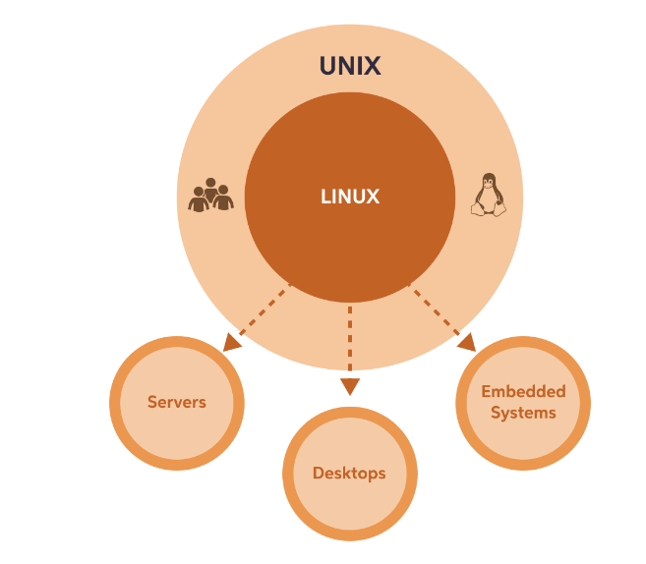

Question1: Why is Linux considered a preferred choice for servers and other high-risk systems?

Answer: Linux is less vulnerable to viruses and malware due to its open-source nature.

Explanation:

Linux is less vulnerable to viruses and malware due to its open-source nature. This means that a global community of developers is always working on updates and improvements, making it a secure choice for servers and other high-risk systems.

Question2: Why Use Linux?

Answer: Linux is known for how stable and secure it is, making it a reliable choice. It rarely crashes, and its open-source nature means that a global community of developers is always working on updates and improvements. Linux is less vulnerable to viruses and malware than other operating systems, making it a popular choice for servers and other high-risk systems. It's also highly customizable, as users can modify the system to meet their specific needs.

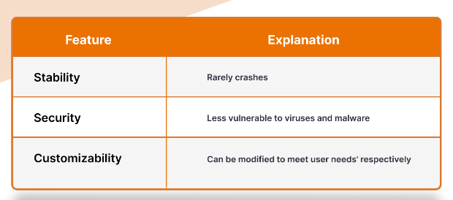

Linux Distributions

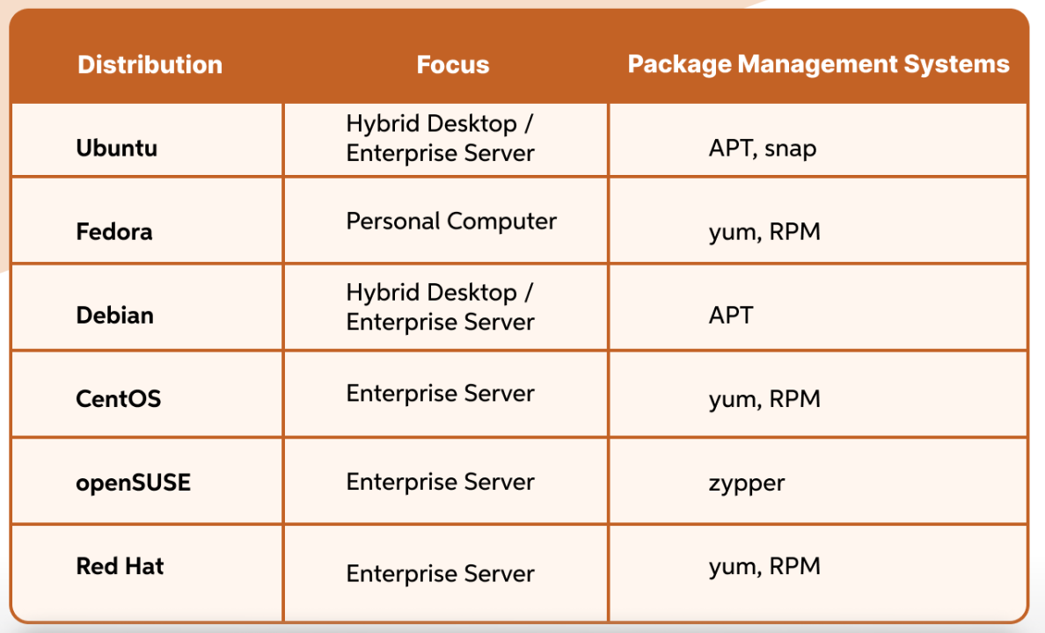

Advantages of Linux

* it's free
* it's open-source , which means it's highly customizable and secure.
* it's compatible with a wide range of hardware and runs efficiently even on older systems.
* there's a large and active Linux community that can provide support and resources.