Atomic data types:

In R, there are several atomic data types that you can use to represent and manipulate data. These atomic data types include:

1. **Numeric (double)**: This data type is used to represent real numbers with decimal points. In R, this is the default data type for numbers. For example:

RCopy code

x <- 3.14

1. **Integer (int)**: This data type represents whole numbers without decimal points. You can explicitly specify an integer by adding an "L" at the end of the number. For example:

RCopy code

y <- 42L

1. **Complex**: Complex numbers with real and imaginary parts. They are written in the form **a + bi**, where **a** and **b** are real numbers, and **i** is the imaginary unit. For example:

RCopy code

z <- 2 + 3i

1. **Character (char)**: This data type is used to store text, such as strings of characters. Text data in R is enclosed in double or single quotes. For example:

RCopy code

text <- "Hello, World!"

1. **Logical (bool)**: Represents binary values, either **TRUE** or **FALSE**. These are often used for conditional and logical operations. For example:

RCopy code

is_valid <- TRUE

1. **Raw**: Represents binary data, often used for working with low-level binary data. It's less commonly used than other data types.
2. **Date and Time**: R has specialized data types for handling dates and times, such as **Date** and **POSIXct**.
3. **Factor**: A data type used for categorical data, where each level represents a category. Factors are used for statistical and modeling purposes.
4. **NULL**: Represents the absence of a value or an undefined value. It is often used to initialize variables before assigning a value.
5. **NA**: Represents missing or undefined data. It is used when data is not available or is not applicable.

These atomic data types in R are the basic building blocks for working with data. Depending on the type of data you're handling, you can choose the appropriate data type to represent and manipulate your data effectively. It's important to understand these data types and their properties when working with R for data analysis and statistical computing.

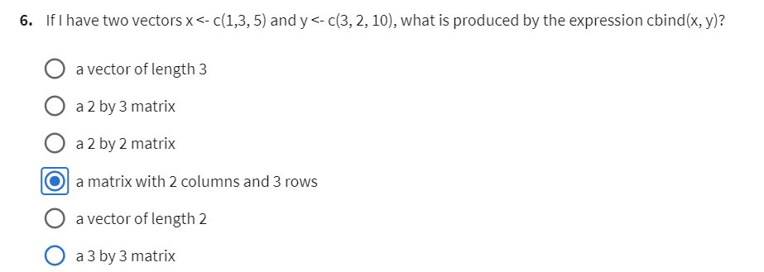

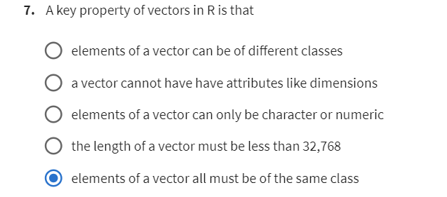

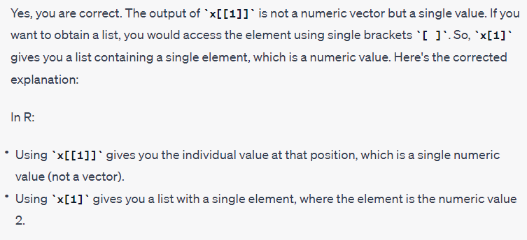

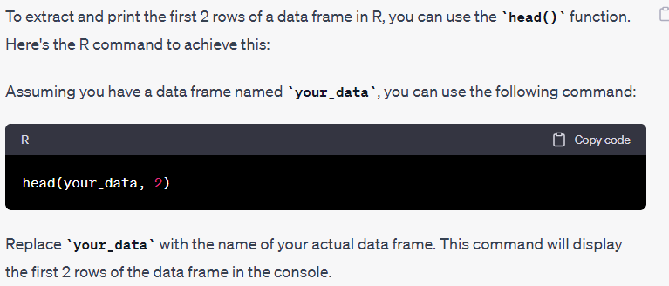

What is the mean of the Ozone column in this dataset? Exclude missing values (coded as NA) from this calculation.

*mean(your_data$Ozone, na.rm = TRUE)*

data frame subsetting

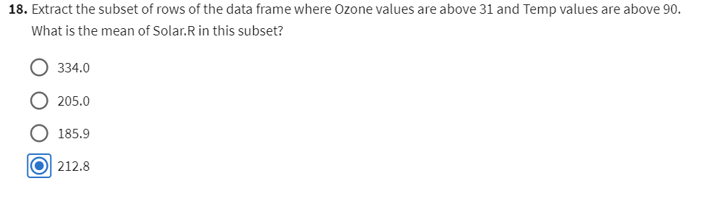

install.packages("dplyr")

