Use manual Camera App…

**4 Important settings in Manual Camera App**

1. **Frame rate Cinematic images (24 fps) SlowMotion (60 fps) …more the details more is the frame rate…**
2. **Shutter speed ChangesYourExposureButAlsoEffectsMotionBlur** 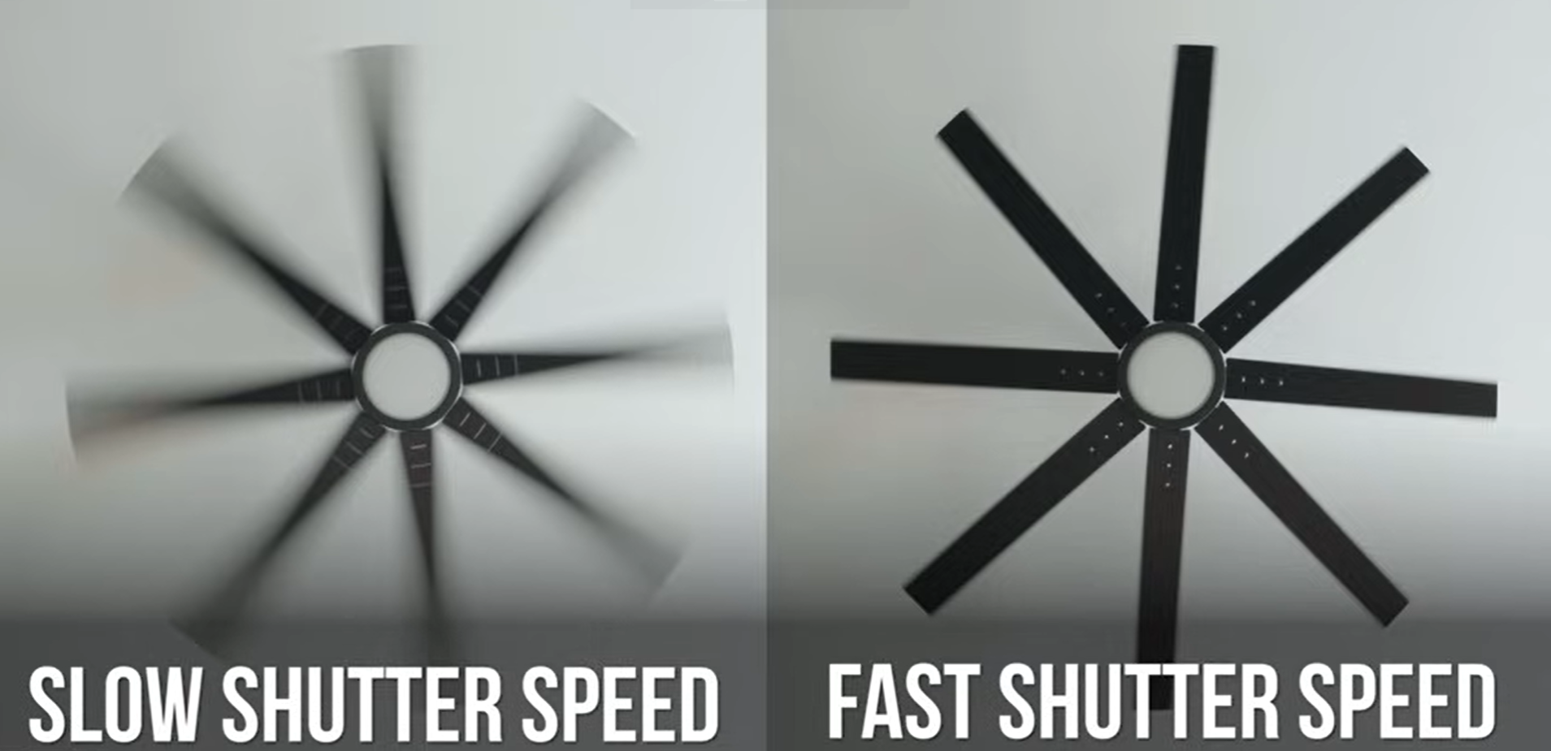

**Like for 24 fps shutterSpeed : 1/48**

**For 30 fps shutterSpeed : 1/60**

1. **ISO ChangesYourExposure(stay below 800 iso in phones)**
2. **White Balance**

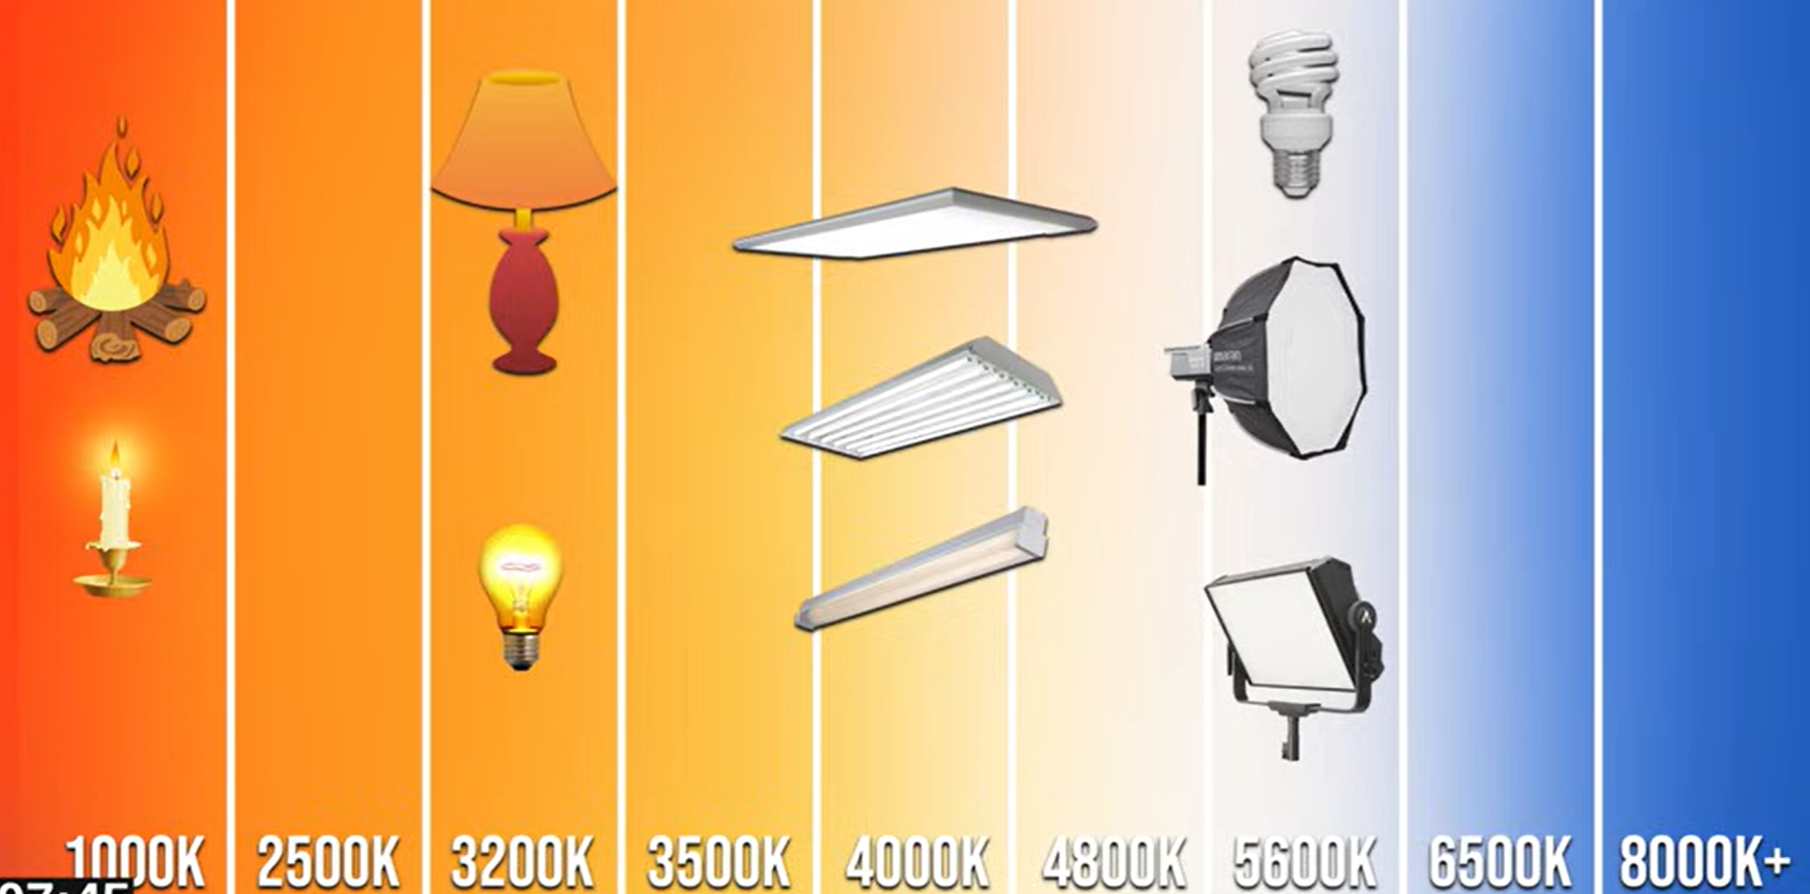

1. **Aperture**

Neutral Density Filter used in some really bright situations.

**Continue …**

[**https://youtu.be/4LDbloNewgk?si=NCWPuFYWQBlzn3TP**](https://youtu.be/4LDbloNewgk?si=NCWPuFYWQBlzn3TP)

[**https://youtu.be/97p9KtN8G7g?si=3dXBlnlyxqZnogRA**](https://youtu.be/97p9KtN8G7g?si=3dXBlnlyxqZnogRA)

[**https://youtu.be/nHzOuJ3l1tc**](https://youtu.be/nHzOuJ3l1tc)