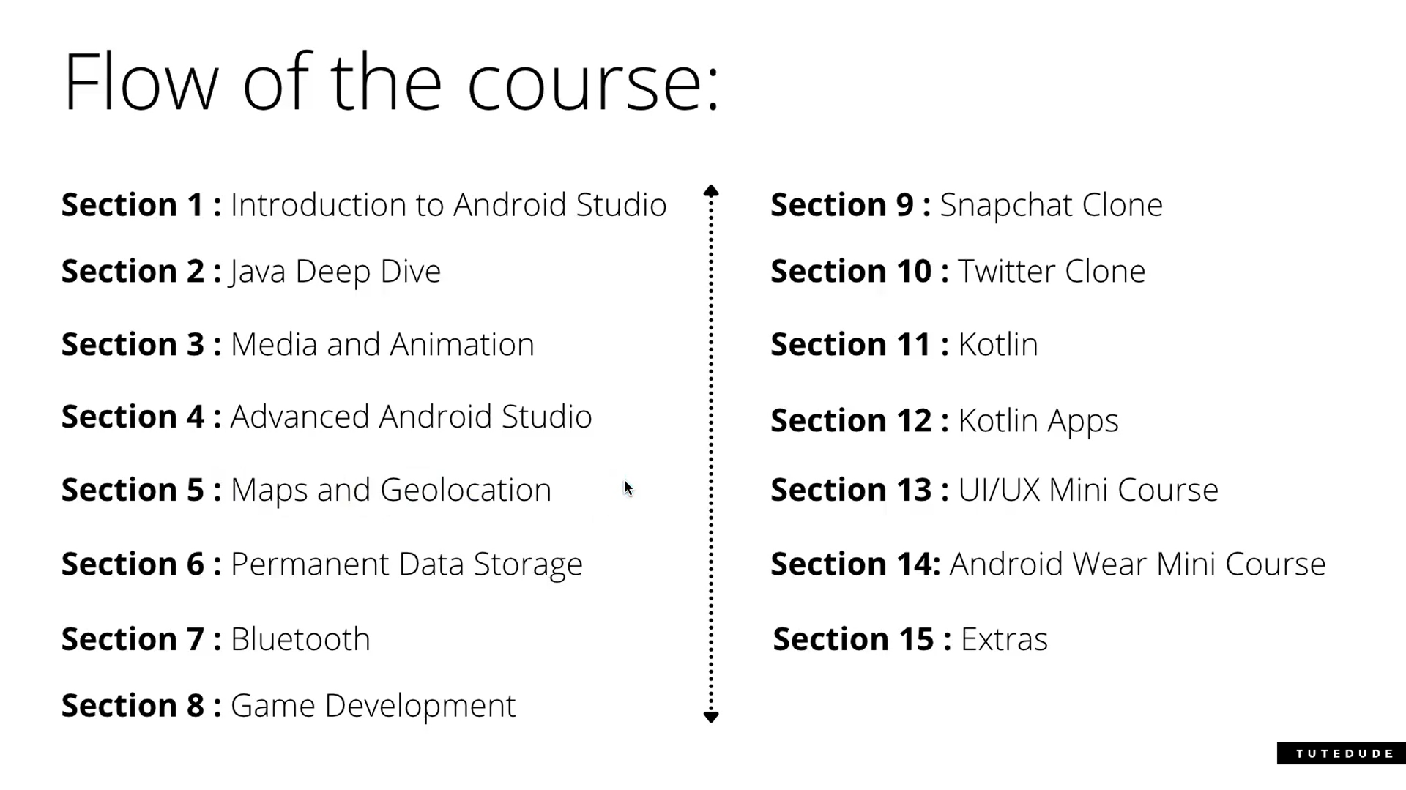

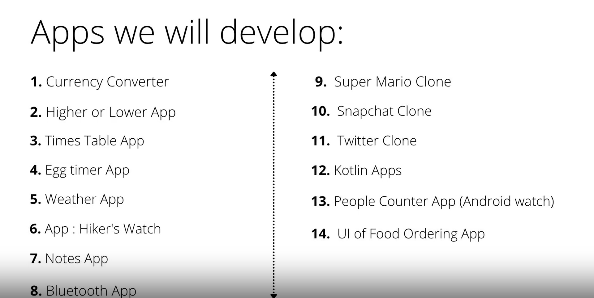

JAVA LANGUAGE FOR ANDROID DEVELOPMENT

<https://www.geeksforgeeks.org/java/>

refer this document for extensive knowledge about Java programming language.