1.map

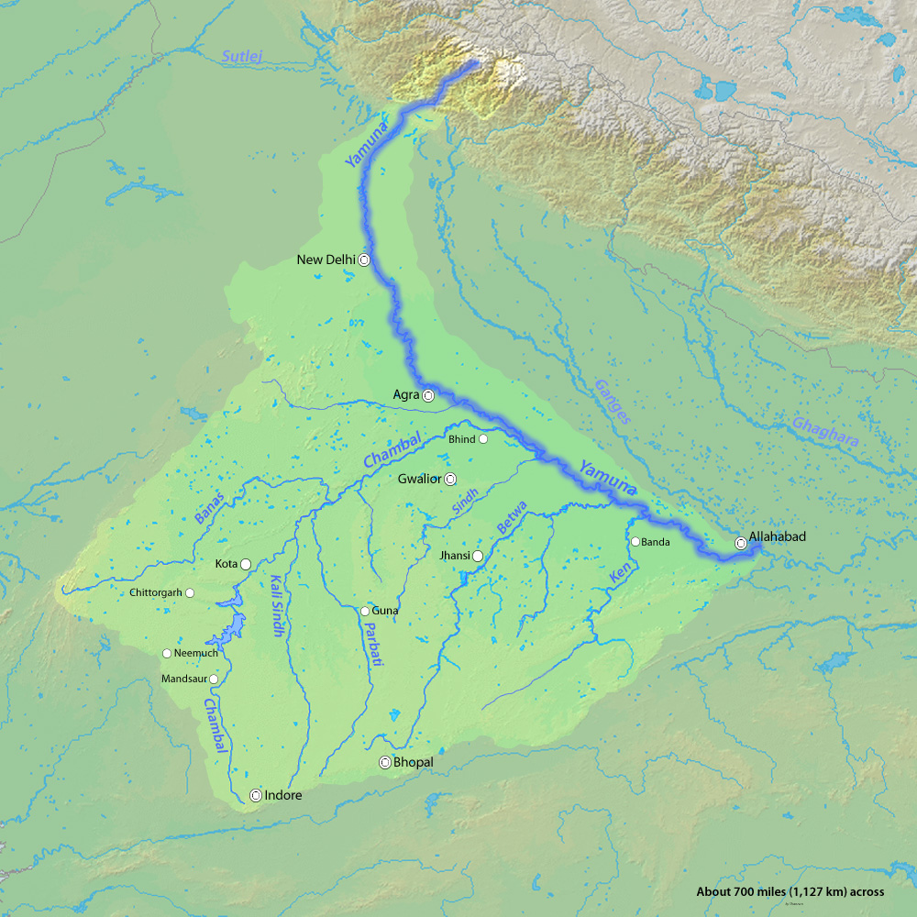

2. Historical importance



Vasudev carrying baby Lord Krishna across the Yamuna, an important legend of Bhagavata Purana, mid-18th century.

3. Collaborating Bodies

Cleaning the Yamuna River is a complex and challenging task due to the high levels of pollution it has suffered over the years. Efforts to clean the river involve multiple stakeholders, including government bodies, non-governmental organizations (NGOs), and the general public.

STEPS TAKEN TO CLEAN YAMUNA RIVER…

1. **Assessment of Pollution Sources**:
   * Identify and assess the major sources of pollution entering the river, such as industrial discharge, sewage, agricultural runoff, and solid waste.
2. **Sewage Treatment Plants (STPs)**:
   * Build and upgrade sewage treatment plants to treat domestic sewage before it enters the river. Ensure that these plants are functioning efficiently.
3. **Industrial Effluent Control**:
   * Enforce strict regulations on industries to treat and manage their effluents properly. Regularly monitor and inspect industrial discharge points to ensure compliance.
4. **Stormwater Management**:
   * Implement effective stormwater management systems to prevent rainwater runoff from carrying pollutants into the river. This may include building retention ponds, permeable surfaces, and green infrastructure.
5. **Solid Waste Management**:
   * Develop a comprehensive waste management system to prevent the dumping of solid waste into the river. Promote recycling and waste reduction practices.
6. **Wetland Restoration**:
   * Restore and create natural wetlands along the riverbanks, which can act as natural filters to remove pollutants and improve water quality.
7. **Afforestation and Riparian Zone Restoration**:
   * Plant native trees and vegetation in the riparian zones to stabilize banks, reduce soil erosion, and improve water quality.
8. **Monitoring and Data Collection**:
   * Establish a robust water quality monitoring system to continuously assess the state of the river. Regular data collection helps in tracking improvements and identifying areas of concern.
9. **Public Awareness**:
   * Conduct extensive public awareness campaigns to educate local communities about the importance of a clean river and their role in its protection. Encourage responsible water use and waste disposal.
10. **Regulatory Framework**:
    * Strengthen and enforce environmental laws and regulations related to water quality. Ensure that industries and municipalities adhere to these regulations.
11. **Collaboration and Funding**:
    * Collaborate with neighboring states and countries since the Yamuna flows through multiple regions. Seek financial assistance from various sources, including national and international funding agencies.
12. **Sewer Line Rehabilitation**:
    * Repair and upgrade old and leaky sewage lines to prevent groundwater contamination and leakage into the river.
13. **Desilting**:
    * Regularly remove silt and sediments from the riverbed to maintain adequate flow and prevent stagnation.
14. **Ecological Restoration**:
    * Restore the natural ecosystems of the river, including the reintroduction of native aquatic species and aquatic plants.
15. **Legal Action**:
    * Take legal action against entities or individuals responsible for polluting the river, imposing fines, and penalties to deter pollution.
16. **Government Oversight and Coordination**:
    * Establish a dedicated authority or board responsible for the management and protection of the Yamuna River, ensuring coordination among various government agencies.
17. **Long-term Planning**:
    * Develop a long-term plan for the sustainable management and restoration of the river, considering the needs of the growing population and changing environmental conditions.

Cleaning the Yamuna River is a complex and long-term process that requires consistent efforts, significant investment, and collaboration among various stakeholders. It's essential to prioritize this task to ensure the river's ecological health and its significance to the communities that depend on it.

4. Who is Responsible for River pollution

1. **Sewage Discharge**: Municipalities and urban areas are responsible for the discharge of untreated or poorly treated sewage into the river. Inadequate sewage treatment infrastructure and poor maintenance can result in a significant amount of pollution.
2. **Industrial Discharge**: Industries located along the riverbanks release effluents and pollutants into the river. These industries may not always adhere to environmental regulations or may lack proper treatment facilities.
3. **Agricultural Runoff**: Excessive use of fertilizers, pesticides, and chemicals in agriculture can result in the runoff of pollutants into the river when it rains.
4. **Waste Disposal**: Improper disposal of solid waste and construction debris near the river can lead to contamination and contribute to the pollution problem.
5. **Stormwater Runoff**: Urban areas often have poor stormwater management systems, allowing rainwater to wash pollutants from roads and urban areas into the river.
6. **Deforestation and Land Use Changes**: Alterations in land use and deforestation in the river's catchment area can impact water quality, as they affect erosion and sedimentation rates.
7. **Lack of Public Awareness and Responsibility**: A lack of awareness and irresponsible behavior among the public can also contribute to the problem. Littering, open defecation, and dumping of waste in or near the river are examples.
8. **Government and Regulatory Authorities**: Government agencies responsible for enforcing environmental regulations and monitoring water quality may not always be effective in their oversight and enforcement.
9. **Lack of Funds and Infrastructure**: A lack of financial resources and infrastructure for sewage treatment, industrial effluent control, and waste management can hinder pollution control efforts.
10. **Interstate and International Issues**: The Yamuna River flows through multiple states in India and has international borders with Nepal and Tibet. This can complicate pollution control efforts, as it requires coordination among various jurisdictions and countries.