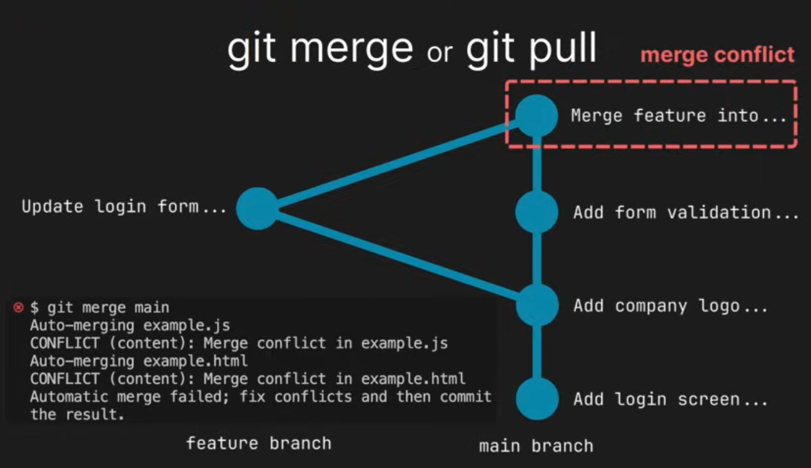

- Git merge --abort
To revert the merge, set everything to the same state as it was before.
- <<<<<
==
>>>>>
Above are conflict markers
- Head equals name of the branch or commit at which I am currently checked out.
- Git add file_name_with_extension
- After solving the conflicts, we run above commands to tell git that we have solved the git merge.
- Git pull --rebase

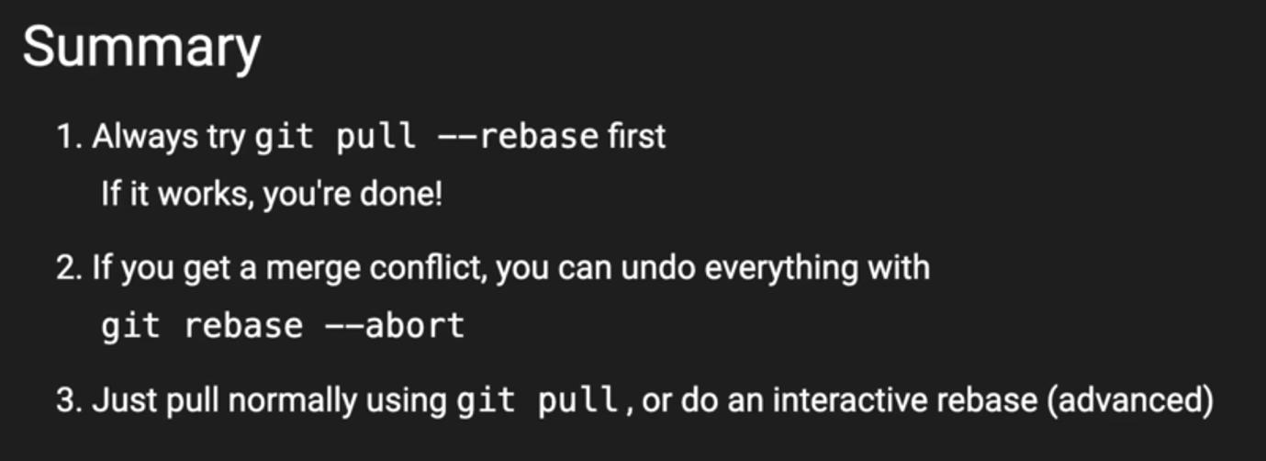

https://youtu.be/xNVM5UxlFSA?si=dHl5FXVWLRKJuSna

How to do git merge?

Git merge
Git merge –abort

