**INTRODUCTION**

**1. INTRODUCTION**

**1.1 Purpose**

Our project Hospital Management System includes registration of patients, storing their details into the system. Our software has the facility to give a unique id for every patient and stores the details of every patient. The Hospital Management system can be entered using a username and password. It is accessible by an administrator, patient or doctor. Only the administrator can add data into the database. The data can be retrieved easily. The interface is very user-friendly. The data are well protected for personal use and makes the data processing very fast. The main function is to register the new patients by giving id to them, updating of patient and doctor details by the admin, providing a user friendly interface to the doctor and patient. This is accomplished by providing four modules: one for the patients to view their details, second for the doctor to view the patient details, patients diagnosed by them and their status in recovery. And last page for administrator to update all these details.

**1.2 Problem Statement**

The purpose of the project entitled as “HOSPITAL MANAGEMENT SYSTEM” is to computerize the Front Office Management of Hospital to develop software which is user friendly, simple, fast, and cost – effective. It deals with the collection of patient’s information, diagnosis details, etc. Traditionally, it was done manually. The main function of the system is to register and store patient details and doctor details and retrieve these details as and when required, and also to manipulate these details  
meaningfully System input contains patient details, diagnosis details; while system output is to get these details on to the CRT screen.

1. Efficiently maintains the details about the patient  
2. Simultaneously updates changes made to any data, item in the entire database.  
3. It is faster than manual system

**1.3 Scope of the Study**

It can be used in any Hospital, Clinic, Dispensary or Pathology labs for maintaining patient details and their test results.

**1.4 Limitations:**

It is very difficult to retrieve the data from case files. It is also very difficult to handle all the data manually. Redundancy of data may occur and this may lead to inconsistency. It is also time-consuming.

**2. SYSTEM FEATURES**

**2.1.1 Use Case Diagram:**

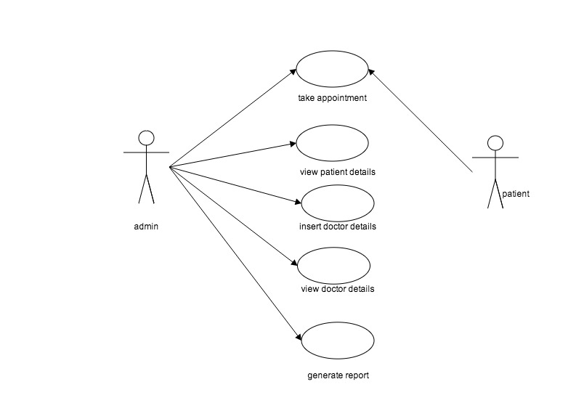

**2.1.2 Activity Diagram:**

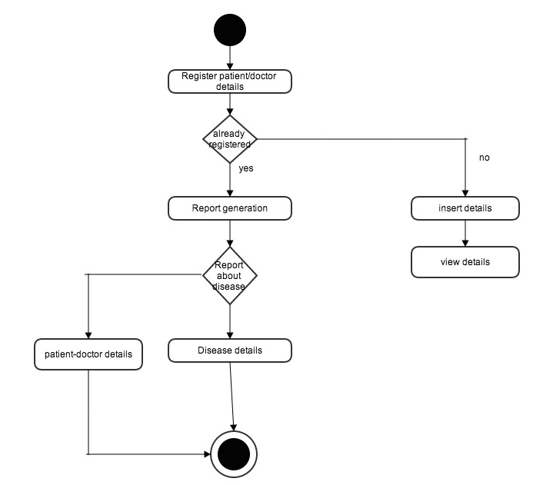

**3.CONFIGURATION MANAGEMENT**

**3.1 Functional Requirements**

* Customer can request details of the last ‘n’ number of transactions he has performed on any account.
* Customer can make a funds transfer to another account in the same bank.
* Customer can request for cheque book
* Customer can view his monthly statement. She/he can also take print out of the same.
* Customer can make EFT’s to accounts at their and other banks.
* The system is providing balance enquiry facility

**3.2 NON FUNCTIONAL REQUIREMENT:**

**3.2.1 SOFTWARE REQUIREMENTS:**

|  |  |  |
| --- | --- | --- |
| • | Operating system | : Windows XP or higher versions |
| • | Front End | : Microsoft Visual Studio .Net 2010 |
| • | Coding Language | : C# |
| • | Database | : Microsoft SQL Server 2005 |
| **3.2.2 HARDWARE REQUIREMENTS:** | | |
| • Pentium 233-megahertz (MHz) processor or faster . | | |
| • | At least 64 megabytes (MB) of RAM. | |
| **3.2.3** | **TOOLS:** |  |

The tools used are

* Microsoft Visual Studio 2010 IDE
* My-SQL Server

**4. LITERATURE REVIEW**

**4.1 MySQL DATABASE**

The MySQL database server is an open-source database that is growing very fast, either in technologies enhancements or on the market. It is the world's second most widely used open-source relational database management system (RDBMS). It is named after co-founder Michael Widenius's daughter, The SQL phrase stands for Structured Query Language.

MySQL is a popular choice of database for use in web applications, and is a central component of the widely used LAMP open source web application software stack (and other 'AMP' stacks). LAMP is an acronym for "Linux, Apache, MySQL, Perl/PHP/Python." Free-software-open source projects that require a full-featured database management system often use MySQL.

**4.2 .NET FRAMEWORK**

C# is a modern, general-purpose, object-oriented programming language developed by Microsoft and approved by Ecma and ISO.

C# was developed by Anders Hejlsberg and his team during the development of

.Net Framework.

C# is designed for Common Language Infrastructure (CLI), which consists of the executable code and runtime environment that allows use of various high-level languages to be used on different computer platforms and architectures.

The following reasons make C# a widely used professional language:

* Modern, general-purpose programming language
* Object oriented.
* Component oriented.
* Easy to learn.
* Structured language.
* It produces efficient programs.
* It can be compiled on a variety of computer platforms.
* Part of .Net Framework.

**4.1.1 Strong Programming Features of C#**

Although C# constructs closely follow traditional high-level languages like C, C++ and being an object-oriented programming language, it has strong resemblance with Java. Also it has numerous strong programming features that make it endearing to multitude of programmers worldwide.

Following is the list of few important features:

* Boolean Conditions
* Automatic Garbage Collection
* Standard Library
* AssemblyVersioning
* Properties and Events
  + Delegates and Events Management
  + Easy-to-use Generics
  + Indexers
  + Conditional Compilation
  + Simple Multithreading
  + LINQ and Lambda Expressions
  + Integration with Windows

**6. SOFTWARE TESTING**

**6.1 UNIT TESTING**

**PATIENT :**

|  |  |  |  |  |
| --- | --- | --- | --- | --- |
| MODULE | INPUT | EXPECTED OUTPUT | ACTUAL OUTPUT | RESULT |
| INSERT | 1  Nithya  Pnuemonia  d001 | Registered successfully | Registered successfully | PASS |
| VIEW | 1 | data found | data found | PASS |

**DOCTOR :**

|  |  |  |  |  |
| --- | --- | --- | --- | --- |
| MODULE | INPUT | EXPECTED OUTPUT | ACTUAL OUTPUT | RESULT |
| INSERT | d001  Mohana  ortho | Registered successfully | Registered successfully | PASS |
| SEARCH | d001 | Data found | Data found | PASS |

**REPORT GENERATION :**

|  |  |  |  |  |
| --- | --- | --- | --- | --- |
| MODULE | INPUT | EXPECTED OUTPUT | ACTUAL OUTPUT | RESULT |
| DOCTOR  -> PATIENT | d001 | Nithya,  Fever | Nithya,Fever  Sathya,cold | PASS |
| DISEASE  -> PATIENT | Fever | Nithya | Nithya | PASS |

**7. CONCLUSION**

The HOSPITAL MANAGEMENT SYSTEM is a great improvement over the manual system using case fields and paper. The computerization of the system has sped up the process. In the current system, the front office managing is very slow. The hospital managing system was thoroughly checked and tested with dummy data and thus is found to be very reliable.

**8. FUTURE ENHANCEMENTS**

The proposed system is Hospital Management System. We can enhance this system by including more facilities like billing system, inpatient room allotment for the admitted patients and the stock details of medicines in the pharmacy.

Providing such features enable the users to include more comments into the system.