ARTIFICIAL INTELLIGENCE — PROJECT REPORT
NashForge
A Multi-Agent Framework for Comparative Evaluation of Game-Theoretic, Evolutionary, and Reinforcement Learning Agents in Imperfect-Information Games
Submitted by DHEIRAV Roll No. 2023103027
1. ABSTRACT
Imperfect-information games such as poker present a fundamentally harder problem than perfect-information games like chess, because a player must act without knowing the opponent's private cards and must therefore reason about probability distributions over hidden states rather than about a single known position. Conventional approaches to building poker agents rely on hand-crafted heuristics or on machine learning methods that optimise an agent against opponents drawn from its own population, which produces systems that appear to improve while having no measurable relationship to strong play.
This project proposes NashForge, a framework for training and, more importantly, comparatively evaluating three distinct families of agent on a single verified poker engine: counterfactual regret minimization, which converges provably toward a game-theoretic equilibrium; evolutionary search, which optimises a population by selection and mutation; and proximal policy optimization, a reinforcement learning method that improves a policy from experience. The three are measured against a common benchmark panel using identical instrumentation, so that differences between them reflect the algorithms rather than differences in how each was evaluated.
The framework's distinguishing characteristic is that its measurement apparatus is itself validated before any result is reported. The solver is checked against Kuhn poker's analytically known game value of −1/18 and against exact exploitability computed by full tree traversal on Leduc Hold'em; the card abstraction's cost and benefit are measured rather than assumed; and every published figure carries a confidence interval. During development this discipline caused several previously published results to be formally withdrawn, and that correction is reported here as a finding in its own right rather than omitted. The system is covered by 195 automated regression tests.
2. LITERATURE SURVEY
The work below is grouped by the problem it addresses: establishing the theory, making it scale, reducing the game to a tractable size, measuring the result honestly, and the systems and learning methods that define the current state of the art. Each is summarised together with its bearing on the present project.
Theoretical Foundations
Kuhn (1950), "Simplified Two-Person Poker." Kuhn introduced a three-card poker variant small enough to be solved analytically by hand, and derived its exact game value of −1/18 to the first player along with the full family of equilibrium strategies. Although the game is far too simple to be interesting as poker, its analytic solution makes it the standard first test for any solver: an implementation that fails to reproduce −1/18 is provably incorrect, regardless of how plausible its behaviour appears. NashForge uses precisely this property, treating Kuhn as a correctness check performed before any larger game is attempted.
Zinkevich, Johanson, Bowling and Piccione (2007), "Regret Minimization in Games with Incomplete Information." This paper introduced Counterfactual Regret Minimization, the algorithm underpinning essentially all subsequent progress in computer poker. Its central insight is that the overall regret of a strategy in an extensive-form game can be decomposed into independent regret terms at each information set, so that minimising regret locally minimises it globally, and the average strategy over many iterations — not the current one — converges to a Nash equilibrium. This decomposition is what makes an otherwise intractable optimisation possible, and it is the algorithm NashForge implements as its game-theoretic agent and validates against known game values.
Making the Algorithm Scale
Lanctot, Waugh, Zinkevich and Bowling (2009), "Monte Carlo Sampling for Regret Minimization in Extensive Games." Vanilla CFR must traverse the entire game tree on every iteration, which is impossible for games the size of no-limit Hold'em. The authors introduced a family of sampling variants, of which external sampling is the most widely used: chance outcomes and the opponent's actions are sampled while the traverser's own actions are still fully enumerated, preserving the convergence guarantee in expectation while reducing the per-iteration cost by orders of magnitude. NashForge implements external-sampling MCCFR as the only practical route to training on no-limit, and retains vanilla CFR for the small games where exact traversal remains feasible.
Tammelin (2014), "Solving Large Imperfect Information Games Using CFR+." CFR+ modifies the regret update so that accumulated regrets are floored at zero rather than allowed to become arbitrarily negative, and weights the average strategy linearly by iteration. The paper reports order-of-magnitude faster convergence than vanilla CFR, and the method was subsequently used to essentially solve heads-up limit Hold'em. NashForge implements CFR+ as one of four comparable update rules; notably, the present experiments found it converging more slowly than vanilla under external sampling, a discrepancy attributed to the rule having been designed for full traversal.
Brown and Sandholm (2019), "Solving Imperfect-Information Games via Discounted Regret Minimization." This work generalises the weighting idea by discounting early regrets and strategy contributions according to tunable schedules, on the reasoning that iterations performed before the strategy has stabilised carry misleading information. Discounted CFR and Linear CFR are shown to outperform CFR+ on several benchmarks. Both are implemented in NashForge, and the comparison between all four rules is reported as an experimental result rather than adopted from the literature — a distinction that proved material, since the published ordering did not reproduce under this project's sampling regime.
Abstraction
Johanson, Burch, Valenzano and Bowling (2013), "Evaluating State-Space Abstractions in Extensive-Form Games." Since no-limit Hold'em contains on the order of 10^160 information sets, hands must be grouped into a bounded number of buckets before any solver can run. This paper systematically evaluates competing bucketing schemes and establishes clustering on hand-strength distributions as the strongest general approach. NashForge follows this method directly, clustering sampled postflop situations by one-dimensional k-means, and extends it by treating the choice of the underlying strength signal as an experimental question rather than a settled one.
Waugh, Schnizlein, Bowling and Szafron (2009), "Abstraction Pathologies in Extensive Games." This paper reports the counter-intuitive and important finding that refining an abstraction — giving the solver a more detailed view of the game — can produce a strategy that is more exploitable, not less. The relationship between abstraction granularity and final strategy quality is therefore not monotonic and cannot be assumed. This result is the direct justification for NashForge's central experiment: rather than presuming the finer card abstraction is better, the project measures the two against each other across a range of training budgets and finds that which one wins depends on the budget available.
Ganzfried and Sandholm (2013), "Action Translation in Extensive-Form Games with Large Action Spaces." An agent trained on a handful of discrete bet sizes must still respond when a human or another program bets an amount outside that set. The authors show that the obvious solution — rounding to the nearest available size — is exploitable, because the mapping has a deterministic boundary that an opponent can deliberately sit just inside, and they derive the pseudo-harmonic mapping, which distributes an off-tree bet probabilistically across its two neighbours in a way that bounds this exploitation. NashForge implements this mapping so that its adversarial evaluator can bet sizes the solver never trained against without the resulting measurement being an artifact of the translation itself.
Measuring Strategy Quality
Southey, Bowling, Larson, Piccione, Burch, Billings and Rayner (2005), "Bayes' Bluff: Opponent Modelling in Poker." Alongside its contribution on Bayesian opponent modelling, this paper introduced Leduc Hold'em, a six-card two-round variant deliberately sized so that exact best responses and true exploitability can be computed by exhaustive traversal while the game still exhibits genuine bluffing and card-abstraction structure. Leduc has since become the standard intermediate benchmark, and NashForge uses it exactly as intended: as the largest game in which the solver's convergence can be verified against ground truth rather than estimated.
Lisý and Bowling (2017), "Equilibrium Approximation Quality of Current No-Limit Poker Bots." Because exact exploitability cannot be computed for no-limit, the authors propose Local Best Response, a computationally cheap adversary that maintains a belief over the opponent's holdings and greedily selects the action maximising immediate expected value under a one-step lookahead. Since LBR explores only a subset of the strategies available to a true best response, whatever it wins constitutes a rigorous lower bound on exploitability: a large value proves an agent is weak, while a small value proves nothing at all. The paper's striking result was that several published bots proved far more exploitable than their head-to-head records suggested. NashForge implements LBR and reports this one-sided guarantee explicitly, having found — after correcting four defects in its own implementation — that a converged strategy in this abstraction resists it entirely.
Landmark Systems
Moravčík, Schmid, Burch, Lisý, Morrill, Bard, Davis, Waugh, Johanson and Bowling (2017), "DeepStack: Expert-Level Artificial Intelligence in Heads-Up No-Limit Poker." DeepStack was the first program to defeat professional players at heads-up no-limit, and it did so by replacing precomputed abstraction with continual re-solving: rather than looking up a strategy from a table computed in advance, it solves a local subgame at every decision, using deep neural networks to estimate the values of states beyond its lookahead horizon. The work demonstrated that the abstraction bottleneck NashForge measures directly can, given sufficient computational resources, be substantially circumvented.
Brown and Sandholm (2018), "Superhuman AI for Heads-Up No-Limit Poker: Libratus Beats Top Professionals." Libratus defeated four top professionals over 120,000 hands, using a three-part architecture: a blueprint strategy computed over a coarse abstraction, nested subgame solving that refines the strategy in real time as a hand progresses, and a self-improvement module that repairs the parts of the abstraction opponents were successfully exploiting. Its significance for the present project lies in the third component, which illustrates that a fixed abstraction is a persistent liability rather than a one-time simplification — the same weakness this project quantifies at much smaller scale.
Brown and Sandholm (2019), "Superhuman AI for Multiplayer Poker." Pluribus extended these results to six-player no-limit, where the theoretical guarantees of two-player zero-sum games no longer apply, since a Nash equilibrium in a multiplayer game need not be either unique or safe to play. It nevertheless defeated elite professionals using a comparatively inexpensive blueprint combined with limited-lookahead search. This work motivates NashForge's deliberate ordering of heads-up before six-max: the guarantees that make the two-player case measurable simply do not transfer.
Learning-Based Approaches
Schulman, Wolski, Dhariwal, Radford and Klimov (2017), "Proximal Policy Optimization Algorithms." PPO improves a policy from sampled experience while constraining each update through a clipped surrogate objective, preventing the destructively large policy changes that destabilise simpler policy-gradient methods, at a fraction of the implementation complexity of trust-region approaches. Its robustness and simplicity have made it a default choice across reinforcement learning. NashForge adopts PPO as its reinforcement learning agent, while noting the theoretical caveat that self-play policy gradient does not converge to a Nash equilibrium in imperfect-information games and therefore yields a strong but exploitable strategy.
Heinrich and Silver (2016), "Deep Reinforcement Learning from Self-Play in Imperfect-Information Games." Neural Fictitious Self-Play combines reinforcement learning against the opponent's average strategy with supervised learning of the agent's own average behaviour, approximating fictitious play with neural networks and converging toward equilibrium in imperfect-information games without domain-specific abstraction. The work is directly relevant as the principled alternative to plain self-play, and identifies precisely the weakness NashForge expects its PPO agent to exhibit.
Brown, Lerer, Gross and Sandholm (2019), "Deep Counterfactual Regret Minimization." Deep CFR replaces CFR's explicit regret tables with neural networks trained to approximate them, removing the requirement for a hand-designed card abstraction and allowing the method to generalise across similar information sets. It represents the natural continuation of the trajectory this project follows, and is the approach NashForge's tabular solver would most sensibly be extended toward once the abstraction limits it measures become binding.
Salimans, Ho, Chen, Sidor and Sutskever (2017), "Evolution Strategies as a Scalable Alternative to Reinforcement Learning." This paper demonstrates that a population-based black-box optimiser, perturbing network parameters and selecting on total episode return, can rival gradient-based reinforcement learning on demanding control tasks while parallelising far more cleanly, since workers need exchange only scalar returns. It provides the justification for including an evolutionary agent in this comparison — though it also implies the limitation NashForge expects to observe, namely that an optimiser receiving one scalar per episode performs no credit assignment across the individual decisions within it.
3. MODULAR ARCHITECTURE
The system is organised as nine modules arranged in a layered pipeline, in which each layer depends only on the layers beneath it. This separation is what allows three very different learning algorithms to be compared fairly: they share the game, the abstraction, and the evaluation harness, and differ only in the module that produces a strategy.
1. Poker Engine
The foundation of the system is a complete Texas Hold'em implementation that handles card dealing, the four betting rounds, minimum-raise enforcement, side pots for all-in situations, and hand evaluation across all eleven hand categories. It is built as an event-driven state machine in which each player action transitions the game to a new legal state. Correctness here is non-negotiable, since every result in the project is denominated in chips this module accounts for: it was verified by driving 2,400 randomised hands and confirming exact chip conservation, correct side-pot allocation, and agreement between two independent hand evaluators over 2,000 random seven-card showdowns.
2. Traversable Game Interface
Counterfactual regret minimization does not play a game, it traverses one: at every decision it must recurse into all available actions and back up, which a conventional simulator cannot support because it mutates state in place and consumes a dealt deck. This module therefore provides an immutable-state interface in which each state is a value rather than an object being modified, implemented for three games of increasing difficulty — Kuhn poker, Leduc Hold'em, and abstracted heads-up no-limit Hold'em. The two smaller games exist specifically so the solver can be checked against known answers.
3. Card Abstraction
No-limit Hold'em contains on the order of 10^160 information sets, which no computer can enumerate, so hands must be grouped into a bounded number of strength buckets. This module uses two different clustering strategies: preflop, all 169 strategically distinct starting hands are enumerated exactly and grouped by the Chen formula; postflop, where enumeration is impossible, situations are sampled and clustered by one-dimensional k-means. Two competing strength signals are implemented — Monte Carlo equity, which accounts for draws, and made-hand strength, which is far cheaper but blind to them — and choosing between them is treated as an experimental question rather than a design assumption.
4. Bet Abstraction
Alongside card abstraction, the space of possible bet sizes must also be bounded, since no-limit poker permits any wager up to a player's stack. This module defines a six-action space — fold, check/call, half-pot raise, pot raise, double-pot raise, and all-in — and enumerates the resulting betting tree combinatorially, so the size of the abstract game is computed exactly rather than estimated. Multiplying that count by the available buckets gives the memory requirement before any training is attempted.
5. Regret Minimization Solvers
This is the game-theoretic learner. It implements vanilla CFR, which traverses the entire tree and is feasible only for small games, and external-sampling Monte Carlo CFR, which samples chance outcomes and so scales to no-limit. Four regret update rules are implemented and compared experimentally. The module accumulates counterfactual regret at every information set and derives the average strategy, which is the quantity that converges toward equilibrium — a fact that is easy to state and easy to implement incorrectly, which is why the validation module exists.
6. Exploitability Measurement
An agent's true quality is measured by exploitability: how much a perfectly-informed adversary could win against it. On small games this module computes exploitability exactly by traversing the tree and constructing a best response. On no-limit, where exact computation is impossible, it implements Local Best Response, a greedy adversary that tracks what the opponent's betting reveals about their holding and exploits it. This yields a one-sided guarantee — a large value proves an agent is exploitable, whereas a small value proves nothing — and the framework reports that asymmetry explicitly rather than treating a small number as evidence of strength.
7. Action Translation
When an adversary bets an amount the abstraction does not contain, something must decide what the trained agent believes it faced. This module implements the pseudo-harmonic mapping of Ganzfried and Sandholm, which maps an off-tree bet probabilistically onto its two neighbouring abstract sizes. The obvious alternative — rounding to the nearest size — was rejected deliberately, because a deterministic mapping creates a boundary that an adversary can sit just inside, inflating the measured exploitability with an artifact of the mapping rather than a property of the agent.
8. Evaluation Harness
This module decides what every reported number means, and is therefore the component whose own correctness matters most. It plays two agents against each other using duplicate play, a variance-reduction technique borrowed from competitive bridge: each hand is dealt twice with the seats swapped and the identical cards replayed, so that both position and card luck cancel between the two runs rather than being averaged over. Every result carries a standard error, and the harness refuses to declare a winner when the difference between two agents lies inside its own noise.
9. Observation and Learning Layer
The evolutionary and reinforcement learning agents do not consume abstract buckets; they consume a numerical feature vector describing the current decision. This module extracts that vector — position, stack depth, pot odds, betting round, and hand strength — and feeds it to a policy network trained either by evolutionary selection and mutation or by proximal policy optimization. The quality of this representation was itself audited experimentally, with results reported below, because a learning algorithm cannot recover information its inputs never contained.
4. AGENTS IMPLEMENTED
Six agent types are implemented against a common interface, so that any of them can be substituted into any matchup without changing the harness. This uniformity is what makes the comparison meaningful.
1. CFR Agent — plays a strategy produced by regret minimization. It is the only agent in the system with a theoretical guarantee about what it converges toward, and it therefore serves as the framework's reference point.
2. Evolutionary Agent — a policy network whose weights are optimised by selection and Gaussian mutation across generations, with elite preservation between them.
3. PPO Agent — a policy network trained by proximal policy optimization from self-play experience, using clipped policy updates and generalised advantage estimation.
4. Local Best Response Agent — an adversary rather than a competitor. It exists to attack a trained strategy and thereby measure its exploitability, tracking a belief over the opponent's possible holdings and updating it by Bayes after every action observed.
5. Random Agent — chooses uniformly among legal actions. The floor any trained agent must clear, and a diagnostic when one does not.
6. Always-Call Agent — never folds and never raises. A specific, reproducible weak opponent whose exploitation requires an agent to actually bet for value.
5. TECHNOLOGY STACK
The implementation is deliberately dependency-light, because a project whose central claim is about measurement should not rest on components it cannot inspect. The engine, the solvers, the abstraction and the evaluation harness are written from scratch in Python 3.12 using NumPy for vectorised arithmetic and Numba for just-in-time compilation of the hand evaluator, which sits on the hot path of every traversal. The reinforcement learning component uses PyTorch for the actor-critic network. Testing is by pytest, with 195 regression tests; version control and reproducibility are handled through Git, with every experimental result stored as JSON alongside the script that produced it.
6. PERFORMANCE METRICS AND ANALYSIS
Key figures at a glance
Regression tests | Kuhn game value | Cost ratio | Headline separation
195, from zero before the audit | −1/18 reproduced | 5.4× equity over made-hand | 7.8σ

Validating the solver
Before any comparison is meaningful, the solver must be shown to converge. Leduc Hold'em is small enough that exploitability can be computed exactly by traversing the tree, so convergence is observed directly rather than inferred. Four regret update rules were run for 64,000 iterations across three random seeds each.
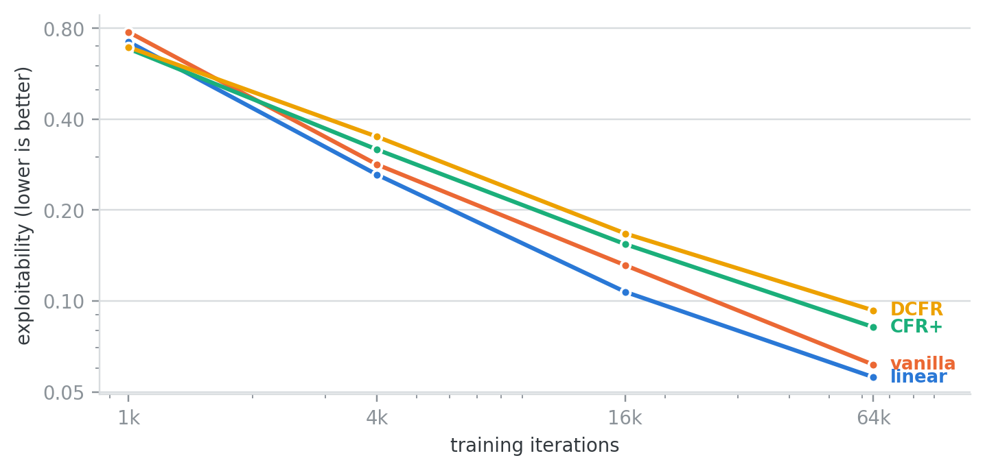
Figure 1. Exact exploitability on Leduc Hold'em. Logarithmic on both axes; lower is closer to equilibrium. All four rules converge, which is the property being verified. The ordering is a secondary and slightly awkward observation: CFR+ and DCFR finish worse than plain vanilla (0.0819 and 0.0930 against 0.0615), where the literature reports them substantially faster. The likely explanation is that those rules were designed for full tree traversal while this experiment uses external sampling. It is reported rather than omitted.
The cost and benefit of card abstraction
The central experiment of the project asks a question a practitioner actually faces: given a fixed amount of training time, is the more informative but more expensive card abstraction worth using? Monte Carlo equity costs 44.05 ms per solver iteration against 8.11 ms for made-hand strength — a factor of 5.4 — so the cheaper signal buys roughly five times more training. Whether the extra iterations outweigh the lost information is not obvious, and was resolved by playing the two resulting agents against each other across a ladder of training budgets.
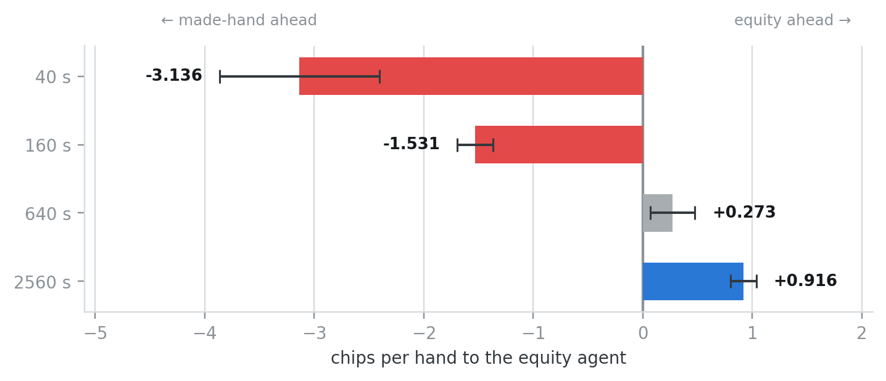
Figure 2. Head-to-head result by training budget. Chips per hand to the equity agent; bars right of zero mean equity is winning. Three seeds, 20,000 hands per matchup, seats alternating, with 95% confidence intervals. A crossover exists: the cheap abstraction wins at short budgets, the lead disappears around 640 seconds, and the expensive abstraction wins by 2560 seconds at roughly 7.8σ — while training on 60,117 iterations against its opponent's 288,050.
Table 1. The same result, with the iteration counts behind it
Budget | Equity iterations | Made-hand iterations | Chips/hand | Verdict
40 s | 1,075 | 5,600 | −3.136 ± 0.729 | made-hand
160 s | 3,808 | 19,758 | −1.531 ± 0.164 | made-hand
640 s | 14,850 | 73,158 | +0.273 ± 0.203 | not separated
2560 s | 60,117 | 288,050 | +0.916 ± 0.118 | equity

Auditing the learning agents' observation
Because the evolutionary and reinforcement learning agents consume a feature vector rather than an abstract bucket, the quality of that vector places a ceiling on what either can learn. It was therefore audited experimentally: 1,500 decision states were sampled, each state's true equity was computed by Monte Carlo simulation, and the vector's ability to recover that equity was measured by regression.
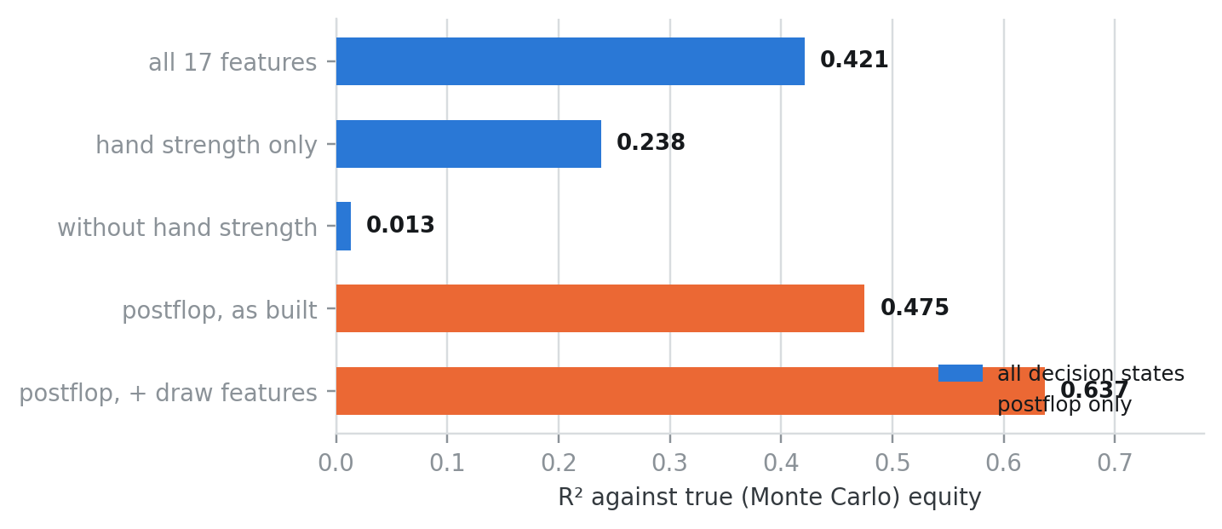
Figure 3. How much of a hand's true value the observation recovers. Coefficient of determination against Monte Carlo equity. The third bar is the finding: removing a single feature — hand strength — collapses the vector's explanatory power to 0.013, meaning the remaining sixteen features carry almost no information about the player's own cards. Adding four inexpensive binary features (flush draw, open-ended straight draw, paired board, three-to-a-flush) raises the postflop figure from 0.475 to 0.637, a relative improvement of 34%.
Table 2. Measured properties, by module
Module | Property measured | Result
Poker Engine | Chip conservation, 2,400 hands | exact
Poker Engine | Evaluator agreement, 2,000 showdowns | 0 disagreements
Traversable Interface | Kuhn game value vs analytic −1/18 | reproduced
Regret Solvers | Leduc exploitability at 64k iterations | 0.0559 – 0.0930
Card Abstraction | Cost per iteration, equity vs made-hand | 44.05 / 8.11 ms
Bet Abstraction | Information sets, 6 buckets, 1 raise | 32,800 – 410,000
Evaluation Harness | Noise reduction from duplicate play | ≈ 14%
Observation Layer | Effective dimensionality of 17 slots | 6
Exploitability | Bound on a converged strategy | not established

7. FINAL RESULT OBTAINED
The final results are produced progressively through the pipeline rather than assigned. A card abstraction is first fitted by sampling situations and clustering them into strength buckets. The solver then traverses the abstracted game repeatedly, accumulating counterfactual regret at each information set and deriving the average strategy, which is the quantity that converges toward equilibrium. Two such strategies — one per card abstraction — are trained to identical wall-clock budgets and then played against each other through the evaluation harness using duplicate play, and the resulting chip differential, together with its confidence interval, is the reported figure.
The headline result is that a crossover exists. Made-hand bucketing wins decisively at short budgets, where its fivefold iteration advantage dominates; the advantage disappears at approximately 640 seconds; and equity bucketing wins by 2560 seconds at +0.916 ± 0.118 chips per hand, roughly 7.8 standard errors from zero, while training on about one fifth of its opponent's iterations. All three random seeds agree in direction at every budget.
8. OBSERVATIONS OF THE OUTPUT
Poker Engine. Chip conservation held exactly across 2,400 randomised hands and both hand evaluators agreed on all 2,000 test showdowns. Observation: the engine's correctness is the precondition for every other measurement, since all results are denominated in chips it accounts for.
Traversable Interface. The solver reproduced Kuhn poker's analytic value of −1/18 and drove Leduc exploitability steadily downward. Observation: these small games have no practical value as poker, and exist purely so the solver can be checked against answers that are known independently of the implementation.
Card Abstraction. Monte Carlo equity produced better-informed buckets at 5.4 times the cost per iteration of made-hand strength. Observation: the trade-off is genuine rather than a matter of preference, and its resolution depends on the training budget — which is why a single measurement would have produced a misleading answer.
Regret Solvers. All four update rules converged, but CFR+ and DCFR finished worse than plain vanilla, contrary to published results. Observation: those rules were designed for full tree traversal, and this system uses external sampling; the discrepancy is reported rather than suppressed.
Exploitability Measurement. Local Best Response could not establish a bound on a well-trained strategy despite four defects being corrected and three successive valuation models being implemented. Observation: the honest reading is that a greedy one-step adversary genuinely cannot beat a converged strategy in this abstraction, which is a legitimate if weak result rather than an outstanding defect.
Evaluation Harness. Duplicate play reduced the standard error by approximately 14%, considerably less than expected. Observation: per-hand outcomes swing by a whole stack depending on whether an all-in occurred, and that variation is driven by the actions taken rather than by the cards dealt, so sharing cards cannot cancel it.
Observation Layer. The seventeen-slot feature vector was found to carry only six independent dimensions, with all card information concentrated in a single feature. Observation: two states the agent receives as identical inputs were measured to differ by as much as 0.907 in true equity, meaning one hand may be a 5% underdog and the other a 95% favourite while appearing indistinguishable — a limit no amount of training can overcome.
9. COMPARATIVE ANALYSIS
Table 3. NashForge against conventional approaches
Capability | Heuristic Bot | Standard RL System | Proposed NashForge
Strategy source | Hand-written rules | Learned policy | Three families compared
Theoretical guarantee | None | None | Equilibrium convergence
Correctness of engine | Assumed | Assumed | Verified, 2,400 hands
Validation against known answers | None | Rare | Kuhn and Leduc
Exploitability measurement | None | None | Exact and bounded
Card abstraction | Fixed | Implicit | Two, compared
Benchmark independence | Self-play only | Self-play only | Unrelated panel
Variance reduction | None | More hands | Duplicate play
Confidence intervals | No | Rare | On every figure
Observation quality audited | No | No | Yes, measured

10. OVERALL RESULT ANALYSIS
The experimental results indicate that the framework achieves its objective of making three distinct learning paradigms comparable on equal terms. The engine and traversable interface supply a game whose correctness is verified rather than assumed; the abstraction modules reduce an intractable game to one that fits in memory, at a cost that is measured; and the evaluation harness converts matches into figures carrying explicit uncertainty. The regret solver provides the only agent in the system with a theoretical guarantee, and therefore serves as the reference against which the evolutionary and reinforcement learning agents are measured.
The principal advantage of NashForge is therefore not the strength of any single agent but the integrity of the comparison between them. Its most instructive outcome is a negative one: the observation audit demonstrated that the feature representation used by the learning agents discards most of the information distinguishing a strong hand from a weak one, which places a ceiling on those agents that no amount of additional training can raise. Identifying such a limit before investing in training is precisely what a measurement-first framework is intended to deliver, and it is a conclusion that a system reporting only its successes would never have reached.

