NashForge: A Multi-Agent Framework for Comparative Evaluation of Game-Theoretic, Evolutionary, and Reinforcement Learning Agents in Imperfect-Information Games
Dheirav
Roll No. 2023103027
Department of Computer Science and Engineering

Abstract—Imperfect-information games such as poker require an agent to act without knowing the opponent's private state, and conventional approaches evaluate such agents against opponents drawn from their own population, producing systems that appear to improve while bearing no measurable relation to strong play. This paper presents NashForge, a framework for training and comparatively evaluating three families of agent — counterfactual regret minimization, evolutionary search, and proximal policy optimization — on a single verified poker engine using identical instrumentation. The framework validates its own measurement apparatus before reporting any result: the solver is checked against Kuhn poker's analytic game value of −1/18 and against exact exploitability on Leduc Hold'em, and every figure carries a confidence interval. The principal experimental finding is a crossover in card abstraction quality: a cheap made-hand bucketing outperforms Monte Carlo equity bucketing below approximately 640 seconds of training, after which equity bucketing wins by 0.916 ± 0.118 chips per hand while using one fifth of the opponent's iterations. A secondary and negative finding is that the feature representation used by the learning agents recovers almost none of a hand's true value once its single card feature is removed, placing a ceiling on those agents that additional training cannot raise.
Index Terms—counterfactual regret minimization, imperfect-information games, card abstraction, exploitability, reinforcement learning, computer poker
I. INTRODUCTION
Imperfect-information games present a fundamentally harder computational problem than perfect-information games such as chess. A player must act without observing the opponent's private cards, and must therefore reason about a probability distribution over hidden states rather than about a single known position. This distinction removes the guarantees that make minimax search effective and requires an entirely different family of algorithms.
The dominant approach is counterfactual regret minimization [2], which decomposes the regret of a strategy into independent terms at each information set and converges toward a Nash equilibrium in two-player zero-sum games. Its practical application to no-limit Texas Hold'em requires two forms of approximation — grouping similar hands into buckets, and restricting the continuous space of bet sizes to a small discrete set — each of which introduces error that is rarely measured.
This paper argues that the measurement apparatus deserves at least as much scrutiny as the learning algorithm. The framework described here was developed after an internal audit established that every result previously produced by its evolutionary training pipeline had been generated by a fitness function that scored the wrong player, and by a card dealer that re-dealt identical hands. An untrained random network scored +451 BB/100 under that metric, where a score of approximately zero is required by the zero-sum property of the game. All such results were withdrawn.
The contributions of this work are threefold. First, a verified poker engine and solver validated against independently known answers. Second, an experimental determination of when a finer card abstraction repays its computational cost, which is shown to depend on the training budget rather than being a fixed property of the abstraction. Third, an empirical audit of the observation supplied to learning agents, which quantifies an information limit that no amount of training can overcome.
II. RELATED WORK
A. Theoretical Foundations
Kuhn [1] introduced a three-card poker variant small enough to solve analytically, deriving an exact game value of −1/18 to the first player. Although trivial as poker, its closed-form solution makes it the standard first correctness test for any solver: an implementation that fails to reproduce −1/18 is provably incorrect regardless of how plausible its play appears. Zinkevich et al. [2] subsequently introduced counterfactual regret minimization, showing that overall regret in an extensive-form game decomposes into independent regret terms at each information set, and that the average strategy across iterations — not the current strategy — converges to equilibrium. This decomposition makes an otherwise intractable optimisation feasible and underpins essentially all later progress in the field.
B. Scaling Regret Minimization
Vanilla CFR traverses the entire game tree per iteration, which is impossible at the scale of no-limit Hold'em. Lanctot et al. [3] introduced Monte Carlo sampling variants, of which external sampling is most widely used: chance outcomes and opponent actions are sampled while the traverser's own actions remain fully enumerated, preserving convergence in expectation while reducing per-iteration cost by orders of magnitude. Tammelin [4] proposed CFR+, which floors accumulated regrets at zero and weights the average strategy linearly, reporting order-of-magnitude faster convergence; the method was later used to essentially solve heads-up limit Hold'em. Brown and Sandholm [5] generalised this weighting through discounted and linear schedules, on the reasoning that iterations performed before the strategy stabilises carry misleading information. All four rules are implemented and compared here, and notably the published ordering did not reproduce under external sampling.
C. Abstraction
Because no-limit Hold'em contains on the order of 10^160 information sets, hands must be grouped before any solver can run. Johanson et al. [6] systematically evaluated competing bucketing schemes and established clustering on hand-strength distributions as the strongest general approach, a method this work follows directly. Waugh et al. [7] reported the counter-intuitive result that refining an abstraction can produce a strategy that is more exploitable rather than less, demonstrating that the relationship between granularity and quality is not monotonic. That finding is the direct justification for the central experiment presented in Section VI. Ganzfried and Sandholm [8] addressed the complementary problem of responding to bet sizes outside the abstraction, showing that rounding to the nearest size is exploitable because it creates a deterministic boundary an opponent can sit just inside, and deriving the pseudo-harmonic mapping that this framework adopts.
D. Measuring Strategy Quality
Southey et al. [9] introduced Leduc Hold'em, a six-card two-round variant sized so that exact best responses can be computed by exhaustive traversal while genuine bluffing structure remains. It has since become the standard intermediate benchmark and is used here as the largest game in which convergence can be verified against ground truth. For no-limit, where exact computation is impossible, Lisý and Bowling [10] proposed Local Best Response, a cheap adversary that maintains a belief over opponent holdings and greedily maximises immediate expected value. Because it explores only a subset of the strategies available to a true best response, its winnings constitute a rigorous lower bound: a large value proves weakness, while a small value proves nothing. Their striking result was that several published bots proved far more exploitable than head-to-head records suggested.
E. Landmark Systems
DeepStack [11] was the first program to defeat professionals at heads-up no-limit, replacing precomputed abstraction with continual re-solving of local subgames and using neural networks to estimate values beyond its lookahead horizon. Libratus [12] defeated four top professionals over 120,000 hands using a coarse blueprint strategy, nested subgame solving, and a self-improvement module that repaired the abstraction regions opponents were exploiting — illustrating that a fixed abstraction is a persistent liability rather than a one-time simplification. Pluribus [13] extended these results to six-player poker, where equilibrium guarantees no longer apply, which motivates the deliberate ordering of heads-up before multi-player evaluation adopted in this work.
F. Learning-Based Approaches
Proximal policy optimization [14] constrains each policy update through a clipped surrogate objective, preventing the destructive updates that destabilise simpler policy-gradient methods, and is adopted here as the reinforcement learning agent. Its known limitation is that self-play policy gradient does not converge to equilibrium in imperfect-information games. Neural Fictitious Self-Play [15] addresses this by combining reinforcement learning against the opponent's average strategy with supervised learning of the agent's own average behaviour. Deep CFR [16] replaces CFR's regret tables with neural networks, removing the need for hand-designed card abstraction entirely. Salimans et al. [17] demonstrated that population-based black-box optimisation can rival gradient methods while parallelising more cleanly, justifying the inclusion of an evolutionary agent — though it also implies the limitation expected here, that an optimiser receiving one scalar per episode performs no credit assignment across the decisions within it.
III. SYSTEM ARCHITECTURE
The system is organised as nine modules in a layered pipeline, each depending only on those beneath it. This separation is what permits three dissimilar learning algorithms to be compared fairly: they share the game, the abstraction and the evaluation harness, and differ only in the module that produces a strategy.
A. Poker Engine
A complete Texas Hold'em implementation handling dealing, four betting rounds, minimum-raise enforcement, side pots and hand evaluation across eleven categories, built as an event-driven state machine in which each action transitions the game to a new legal state. Since every result is denominated in chips this module accounts for, it was verified by driving 2,400 randomised hands and confirming exact chip conservation, correct side-pot allocation, and agreement between two independent evaluators over 2,000 showdowns.
B. Traversable Game Interface
Regret minimization traverses a game rather than playing it, recursing into all actions and backing up, which a conventional simulator cannot support because it mutates state in place. This module provides an immutable-state interface in which each state is a value, implemented for Kuhn poker, Leduc Hold'em and abstracted heads-up no-limit Hold'em.
C. Card Abstraction
Two clustering strategies are used. Preflop, all 169 strategically distinct starting hands are enumerated exactly and grouped by the Chen formula. Postflop, where enumeration is impossible, situations are sampled and clustered by one-dimensional k-means. Two competing strength signals are implemented — Monte Carlo equity, which accounts for draws, and made-hand strength, which is far cheaper but blind to them.
D. Bet Abstraction
A six-action space — fold, check/call, half-pot raise, pot raise, double-pot raise and all-in — bounds the continuous space of wagers. The resulting betting tree is enumerated combinatorially so that the size of the abstract game is computed exactly, and multiplying by the available buckets yields the memory requirement before training begins.
E. Regret Minimization Solvers
Vanilla CFR is implemented for small games where full traversal is feasible, and external-sampling Monte Carlo CFR for no-limit. Four regret update rules are implemented and compared. The module accumulates counterfactual regret at each information set and derives the average strategy, which is the quantity that converges toward equilibrium.
F. Exploitability Measurement
On small games exploitability is computed exactly by constructing a best response through tree traversal. On no-limit, Local Best Response provides a lower bound. The framework reports the one-sided nature of that guarantee explicitly rather than treating a small value as evidence of strength.
G. Action Translation
The pseudo-harmonic mapping distributes an off-tree bet probabilistically across its two neighbouring abstract sizes. Nearest-neighbour rounding was rejected because its deterministic boundary permits an adversary to inflate measured exploitability with an artifact of the mapping rather than a property of the agent.
H. Evaluation Harness
Agents are played against each other using duplicate play, a variance-reduction technique in which each hand is dealt twice with the seats swapped and identical cards replayed, so that position and card luck both cancel. Every result carries a standard error, and the harness declines to declare a winner when a difference lies inside its own noise.
I. Observation and Learning Layer
The evolutionary and reinforcement learning agents consume a numerical feature vector — position, stack depth, pot odds, betting round and hand strength — rather than an abstract bucket. This vector feeds a policy network trained either by evolutionary selection and mutation or by proximal policy optimization. Its quality was audited experimentally, since a learning algorithm cannot recover information its inputs never contained.
IV. AGENTS AND IMPLEMENTATION
Six agent types are implemented against a common interface, so that any may be substituted into any matchup without modifying the harness. The CFR agent plays a strategy produced by regret minimization and is the only agent with a theoretical guarantee, serving as the reference point. The evolutionary agent is a policy network optimised by selection and Gaussian mutation with elite preservation. The PPO agent is a policy network trained from self-play experience using clipped updates and generalised advantage estimation. The Local Best Response agent is an adversary rather than a competitor, existing to attack a trained strategy and measure its exploitability. A random agent and an always-call agent provide reproducible baselines: the former is the floor any trained agent must clear, and the latter can only be exploited by an agent that bets for value.
The implementation is deliberately dependency-light, since a project whose central claim concerns measurement should not rest on components it cannot inspect. The engine, solvers, abstraction and harness are written from scratch in Python 3.12 using NumPy for vectorised arithmetic and Numba for just-in-time compilation of the hand evaluator, which lies on the hot path of every traversal. PyTorch provides the actor-critic network. The system carries 195 regression tests, and every experimental result is stored as JSON alongside the script that produced it.
V. EXPERIMENTAL METHODOLOGY
All experiments are conducted in heads-up no-limit Hold'em with 200-chip stacks and blinds of one and two chips. Card abstractions use six buckets per street and the betting abstraction permits one raise per street, which is the parameter that determines whether the abstract game fits in memory. Every reported figure is averaged over three random seeds and carries a standard error computed as the larger of the within-seed and between-seed estimates, so that a configuration which is merely fortunate in one seed cannot appear precise.
Matches use duplicate play with 20,000 hands per matchup and alternating seats. Training budgets are expressed in wall-clock seconds, because the practical question a practitioner faces is which abstraction to use given available time rather than given a fixed iteration count. Machine load is sampled during each training window and stored with every measurement, since a wall-clock budget measures the machine as much as the algorithm.
VI. RESULTS AND ANALYSIS
A. Solver Validation
Before any comparison is meaningful the solver must be shown to converge. Leduc Hold'em is small enough for exploitability to be computed exactly by traversal, so convergence is observed directly rather than inferred. Four update rules were run for 64,000 iterations across three seeds each; results appear in Fig. 1.
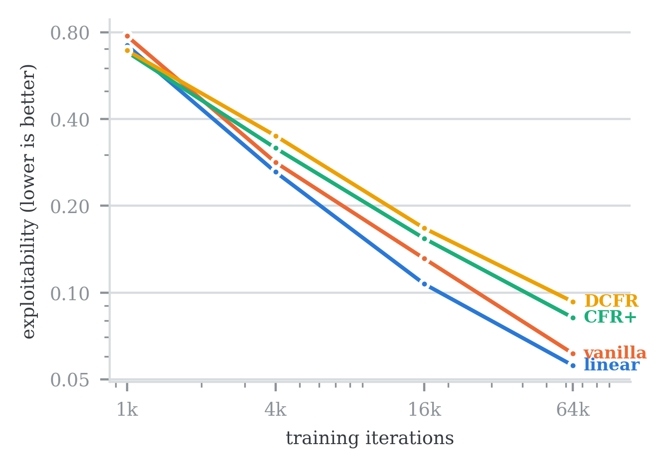
Fig. 1. Exact exploitability on Leduc Hold'em, logarithmic on both axes. All four update rules converge. CFR+ and DCFR finish worse than plain vanilla (0.0819 and 0.0930 against 0.0615), contrary to published results [4], [5]; the likely cause is that those rules were designed for full traversal whereas this experiment uses external sampling.
B. The Cost and Benefit of Card Abstraction
Monte Carlo equity costs 44.05 ms per solver iteration against 8.11 ms for made-hand strength, a factor of 5.4, so the cheaper signal purchases roughly five times more training. Whether the additional iterations outweigh the lost information is not obvious a priori, and following the pathology reported by Waugh et al. [7] it cannot be assumed. It was resolved by playing the two resulting agents against each other across a ladder of training budgets, shown in Fig. 2 and Table I.
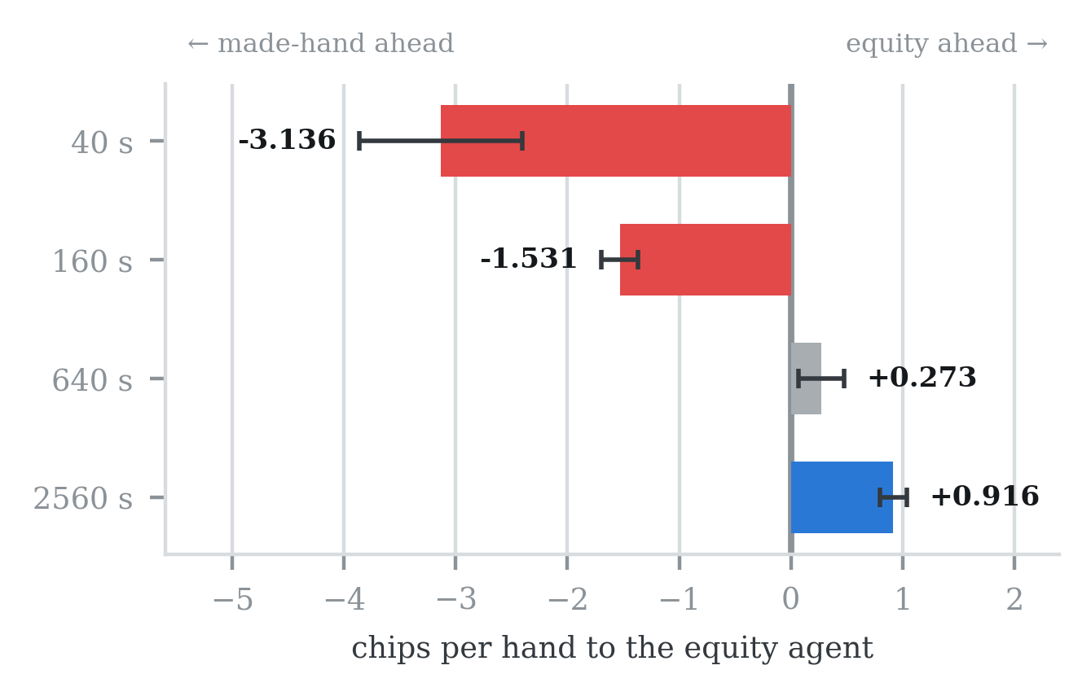
Fig. 2. Head-to-head result by training budget, in chips per hand to the equity agent. Bars right of zero indicate equity bucketing winning. Three seeds, 20,000 hands per matchup, with 95% confidence intervals. A crossover exists between 640 and 2560 seconds.
TABLE I
HEAD-TO-HEAD RESULT WITH UNDERLYING ITERATION COUNTS
Budget | Equity it. | Made-hand it. | Chips/hand | Verdict
40 s | 1,075 | 5,600 | −3.136 ± 0.729 | made-hand
160 s | 3,808 | 19,758 | −1.531 ± 0.164 | made-hand
640 s | 14,850 | 73,158 | +0.273 ± 0.203 | not sep.
2560 s | 60,117 | 288,050 | +0.916 ± 0.118 | equity

The cheap abstraction wins decisively at short budgets, where its fivefold iteration advantage dominates. The advantage vanishes near 640 seconds, and by 2560 seconds equity bucketing wins by 0.916 ± 0.118 chips per hand, approximately 7.8 standard errors from zero, while training on 60,117 iterations against its opponent's 288,050. All three seeds agree in direction at every budget.
C. Audit of the Learning Agents' Observation
Because the evolutionary and reinforcement learning agents consume a feature vector rather than an abstract bucket, the quality of that vector bounds what either can learn. It was audited by sampling 1,500 decision states, computing each state's true equity by Monte Carlo simulation, and measuring by regression how much of that equity the vector recovers. Results appear in Fig. 3.
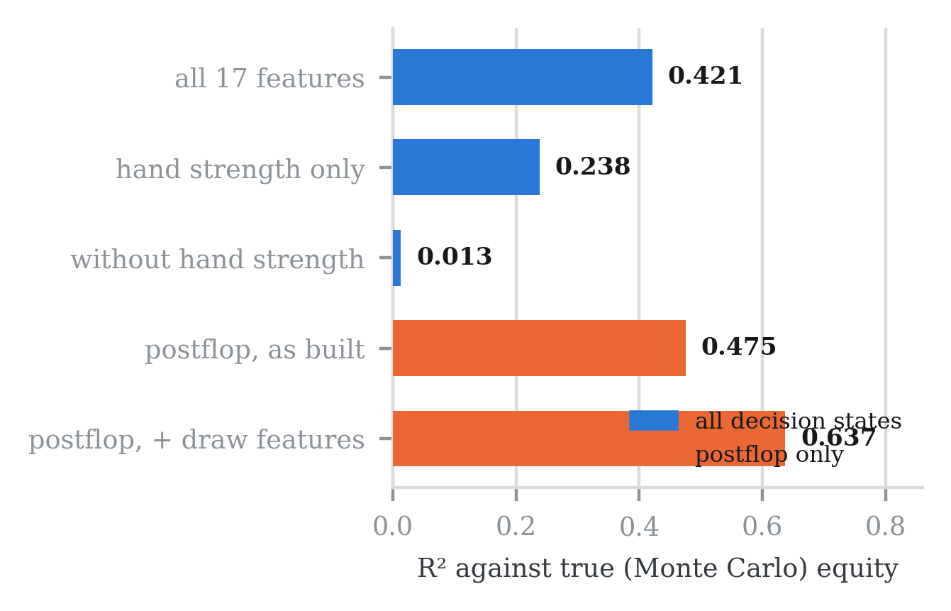
Fig. 3. Coefficient of determination against true equity. Removing a single feature — hand strength — collapses explanatory power to 0.013, showing that the remaining sixteen features carry almost no information about the player's own cards. Four inexpensive binary draw and texture features raise the postflop figure from 0.475 to 0.637.
Principal component analysis established that the seventeen-slot vector carries only six independent dimensions. More consequentially, postflop states sharing a near-identical hand-strength value — states the agent receives as indistinguishable inputs — were measured to differ in true equity by as much as 0.907, meaning one hand may be a 5% underdog and another a 95% favourite while appearing identical to the network. This is an information limit rather than a modelling one, and no amount of additional training can overcome it.
TABLE II
MEASURED PROPERTIES BY MODULE
Module | Property measured | Result
Engine | Chip conservation, 2,400 hands | exact
Engine | Evaluator agreement, 2,000 showdowns | 0 disagreements
Interface | Kuhn value vs analytic −1/18 | reproduced
Solvers | Leduc exploitability at 64k it. | 0.0559–0.0930
Card abstr. | Cost per iteration | 44.05 / 8.11 ms
Bet abstr. | Information sets, 6 buckets | 32,800–410,000
Harness | Noise cut by duplicate play | ≈ 14%
Observation | Effective dimensionality of 17 | 6
Exploitability | Bound on converged strategy | not established

VII. DISCUSSION
Several results warrant comment beyond their numerical value. The ordering of update rules in Fig. 1 contradicts published comparisons, and is reported rather than suppressed; the most plausible explanation is the interaction between those rules and external sampling rather than an implementation defect, since all four converge correctly.
Local Best Response failed to establish a bound on a well-trained strategy despite four defects being corrected and three successive valuation models being implemented. The honest interpretation is that a greedy one-step adversary genuinely cannot beat a converged strategy within this abstraction — a legitimate if weak result, given that the guarantee is one-sided, rather than an outstanding defect. It is reported as such because a measurement that quietly fails is more damaging than one that fails visibly.
Duplicate play reduced the standard error by approximately 14%, considerably less than anticipated. Investigation showed that per-hand outcomes swing by an entire stack depending on whether an all-in occurred, and that this variation is driven by the actions taken rather than the cards dealt, so sharing cards cannot cancel it. The technique remains in use as it is free and strictly beneficial, but hand count remains the dominant lever.
VIII. COMPARATIVE ANALYSIS
TABLE III
NASHFORGE COMPARED WITH CONVENTIONAL APPROACHES
Capability | Heuristic | Standard RL | NashForge
Strategy source | Rules | Learned | Three compared
Theoretical guarantee | None | None | Equilibrium
Engine correctness | Assumed | Assumed | Verified
Validated vs known answers | None | Rare | Kuhn, Leduc
Exploitability measured | No | No | Exact + bound
Card abstraction | Fixed | Implicit | Two, compared
Benchmark independence | Self-play | Self-play | Unrelated panel
Variance reduction | None | More hands | Duplicate play
Confidence intervals | No | Rare | Every figure
Observation audited | No | No | Yes

IX. CONCLUSION AND FUTURE WORK
This paper presented NashForge, a framework for comparatively evaluating game-theoretic, evolutionary and reinforcement learning agents in imperfect-information games under identical instrumentation. The framework's engine and solver are validated against independently known answers, its abstractions are measured rather than assumed, and every reported figure carries an explicit confidence interval.
The principal experimental result is that the value of a finer card abstraction depends on the training budget: made-hand bucketing wins below approximately 640 seconds and equity bucketing wins above it, at 7.8 standard errors and on one fifth of the opponent's iterations. The most instructive result, however, is negative — the observation audit demonstrated that the feature representation used by the learning agents discards most of the information distinguishing a strong hand from a weak one, imposing a ceiling that further training cannot raise. Identifying such a limit before investing in training is precisely what a measurement-first framework is intended to deliver.
Future work follows three directions. The observation layer will be rebuilt to include draw and board-texture features, which the audit shows raises postflop explanatory power by 34%. The evolutionary and PPO agents will then be trained and measured against the solver-derived reference. Finally, extending Local Best Response with multi-street lookahead may yield a bound that the present one-step formulation cannot.
REFERENCES
[1] H. W. Kuhn, "Simplified two-person poker," in Contributions to the Theory of Games, vol. 1, Princeton, NJ, USA: Princeton Univ. Press, 1950, pp. 97–103.
[2] M. Zinkevich, M. Johanson, M. Bowling, and C. Piccione, "Regret minimization in games with incomplete information," in Proc. Adv. Neural Inf. Process. Syst. (NIPS), 2007.
[3] M. Lanctot, K. Waugh, M. Zinkevich, and M. Bowling, "Monte Carlo sampling for regret minimization in extensive games," in Proc. Adv. Neural Inf. Process. Syst. (NIPS), 2009.
[4] O. Tammelin, "Solving large imperfect information games using CFR+," arXiv:1407.5042, 2014.
[5] N. Brown and T. Sandholm, "Solving imperfect-information games via discounted regret minimization," in Proc. AAAI Conf. Artif. Intell., 2019.
[6] M. Johanson, N. Burch, R. Valenzano, and M. Bowling, "Evaluating state-space abstractions in extensive-form games," in Proc. Int. Conf. Auton. Agents Multi-Agent Syst. (AAMAS), 2013.
[7] K. Waugh, D. Schnizlein, M. Bowling, and D. Szafron, "Abstraction pathologies in extensive games," in Proc. Int. Conf. Auton. Agents Multi-Agent Syst. (AAMAS), 2009.
[8] S. Ganzfried and T. Sandholm, "Action translation in extensive-form games with large action spaces," in Proc. Int. Joint Conf. Artif. Intell. (IJCAI), 2013.
[9] F. Southey, M. Bowling, B. Larson, C. Piccione, N. Burch, D. Billings, and C. Rayner, "Bayes' bluff: Opponent modelling in poker," in Proc. Conf. Uncertainty Artif. Intell. (UAI), 2005.
[10] V. Lisý and M. Bowling, "Equilibrium approximation quality of current no-limit poker bots," arXiv:1612.07547, 2016.
[11] M. Moravčík, M. Schmid, N. Burch, V. Lisý, D. Morrill, N. Bard, T. Davis, K. Waugh, M. Johanson, and M. Bowling, "DeepStack: Expert-level artificial intelligence in heads-up no-limit poker," Science, vol. 356, no. 6337, pp. 508–513, 2017.
[12] N. Brown and T. Sandholm, "Superhuman AI for heads-up no-limit poker: Libratus beats top professionals," Science, vol. 359, no. 6374, pp. 418–424, 2018.
[13] N. Brown and T. Sandholm, "Superhuman AI for multiplayer poker," Science, vol. 365, no. 6456, pp. 885–890, 2019.
[14] J. Schulman, F. Wolski, P. Dhariwal, A. Radford, and O. Klimov, "Proximal policy optimization algorithms," arXiv:1707.06347, 2017.
[15] J. Heinrich and D. Silver, "Deep reinforcement learning from self-play in imperfect-information games," arXiv:1603.01121, 2016.
[16] N. Brown, A. Lerer, S. Gross, and T. Sandholm, "Deep counterfactual regret minimization," in Proc. Int. Conf. Mach. Learn. (ICML), 2019.
[17] T. Salimans, J. Ho, X. Chen, S. Sidor, and I. Sutskever, "Evolution strategies as a scalable alternative to reinforcement learning," arXiv:1703.03864, 2017.

