A Multi-Modal Explainable AI System for PCOS Detection and Clinical Risk Assessment

Report submitted to the SASTRA Deemed to be University as the
requirement for the course

INT500R01: PROJECT WORK & VIVA VOCE

Submitted by
NAME: DHEIVA PRIYA V
REG. NO : 126150057

May 2026


SCHOOL OF ARTS, SCIENCES, HUMANITIES AND EDUCATION
THANJAVUR, TAMIL NADU, INDIA – 613 401

SCHOOL OF ARTS, SCIENCES, HUMANITIES AND EDUCATION
THANJAVUR, TAMIL NADU, INDIA – 613 401

Bonafide Certificate
This is to certify that the report titled “A Multi-Modal Explainable AI System for PCOS Detection and Clinical Risk Assessment” submitted as a requirement for the course INT500R01: PROJECT WORK & VIVA VOCE for M.Sc. Data Science programme, is a bona fide record of the work done by (Ms. DHEIVA PRIYA V , Reg. No: 126150057) during the academic year 2024-2026, in the School of Arts, Sciences, Humanities and Education, under my supervision.
Signature of Project Supervisor : 
Name with Affiliation : Dr. SATHIAMOORTHY G / AP III / SASHE
Date :

Project Viva voce held on ________________

Examiner 1 Examiner 2

SCHOOL OF ARTS, SCIENCES, HUMANITIES AND EDUCATION
THANJAVUR, TAMIL NADU, INDIA – 613 401

Declaration

I declare that the report titled “A Multi-Modal Explainable AI System for PCOS Detection and Clinical Risk Assessment” submitted by me is an original work done by me under the guidance of Dr. SATHIAMOORTHY G, Assistant Professor Grade III during the fourth semester of the academic year 2024 - 2026, in the School of Arts, Sciences, Humanities and Education. The work is original and wherever I have used materials from other sources, I have given due credit and cited them in the text of the report. This report has not formed the basis for the award of any degree, diploma, associate-ship, fellowship or other similar title to any candidate of any University.
Signature of the candidate(s) :
Name of the candidate(s) : DHEIVA PRIYA V
Date :

Acknowledgements
My sincere thanks to Prof R. Sethuraman, Chancellor, Shanmugha Arts, Science, Technology & Research Academy (SASTRA Deemed to be University) for facilitating us to do this project.
I am grateful to our Vice Chancellor Dr. S. Vaidhyasubramaniam, Shanmugha Arts, Science, Technology & Research Academy (SASTRA Deemed to be University) for being a source of inspiration.
I thank our Registrar Dr. R. Chandramoulli, Shanmugha Arts, Science, Technology & Research Academy (SASTRA Deemed to be University) for encouraging and supporting me for this project.
I sincerely thank our Dean Dr. K. Uma Maheswari, SASHE, Shanmugha Arts, Science, Technology & Research Academy (SASTRA Deemed to be University) for encouraging our endeavors for this project.
I am grateful to my project guide Dr. G. SATHIAMOORTHY , Dept. of Mathematics, SASHE, Shanmugha Arts, Science, Technology & Research Academy (SASTRA Deemed to be University) for his valuable suggestions, guidance, constant supervision and supporting me in all stages for the successful completion of this project.
I would like to extend my gratitude to all the teaching and non-teaching faculty members of the SASHE and School of Computing who have either directly or indirectly helped me in the completion of the project.

TABLE OF CONTENTS

BONAFIDE CERTIFICATE ............................................................................................... 2
DECLARATION ................................................................................................................. 3
ACKNOWLEDGEMENTS ................................................................................................. 4
LIST OF FIGURES ............................................................................................................. 6
LIST OF TABLES ............................................................................................................... 7
ABSTRACT ......................................................................................................................... 8
CHAPTER 1: INTRODUCTION ........................................................................................ 9
1.1 Problem Statement ..................................................................................................... 9
1.2 Literature Survey ....................................................................................................... 10
CHAPTER 2: METHODOLOGY ....................................................................................... 12
2.1 Research Workflow .................................................................................................... 12
2.2 Data Collection and Description ................................................................................ 13
2.3 Data Preprocessing ..................................................................................................... 15
2.4 Feature Engineering and Severity Scoring ................................................................. 15
2.5 Model Development ................................................................................................... 16
2.6 Explainable AI Techniques ........................................................................................ 17
2.7 Risk Assessment for Clinical Purposes ...................................................................... 17
2.8 Deployment ................................................................................................................ 17
CHAPTER 3: RESULTS AND DISCUSSION ................................................................... 18
3.1 Existing Results ......................................................................................................... 18
3.2 Clinical Dataset Model Results ................................................................................. 19
3.3 Ultrasound Image Model Outcomes .......................................................................... 21
3.4 Model Interpretability and Risk Analysis .................................................................. 22
3.5 Deployment and System Implementation .................................................................. 25
3.6 Discussion .................................................................................................................. 26
CHAPTER 4: CONCLUSION AND FUTURE SCOPE ..................................................... 27
4.1 Conclusion ................................................................................................................. 27
4.2 Future Work ............................................................................................................... 27
4.3 Challenges and Limitations ....................................................................................... 28
CHAPTER 5: REFERENCES ............................................................................................. 29

LIST OF FIGURES

Figure No. | Title | Page No.
1 | Workflow of the Proposed Multi-Modal Framework for PCOS Detection | 13
2 | ROC and PR Curve for Clinical Models | 19
3 | ROC Curve, PR Curve, and Confusion Matrix of Stacked Ensemble Model | 20
4 | Model Accuracy Comparison – Clinical Machine Learning Models | 20
5 | Confusion Matrix – DenseNet121 Model | 21
6 | Model Accuracy Comparison – Deep Learning Models on Ultrasound Images | 22
7 | Global SHAP Beeswarm Plot – Clinical Models | 23
8 | SHAP-Based Model Contributions for Ensemble Model | 23
9 | Grad-CAM Heatmap – DenseNet121 on PCOS Ultrasound Image | 24
10 | Clinical Prediction Interface of the Proposed PCOS System | 25
11 | Ultrasound Image Upload and Prediction Interface | 25

LIST OF TABLES

Table No. | Title | Page No.
1 | Review of Literature | 11
2 | Description of Datasets Used for PCOS Detection | 14
3 | Clinical Feature Domain Grouping and Weight Assignment | 16
4 | Existing Clinical Model Results from Base Paper | 18
5 | Performance Comparison of Clinical Machine Learning Models | 19
6 | Performance Comparison of Deep Learning Models on Ultrasound Images | 21
7 | Patient Risk Stratification Categories and Clinical Recommendations | 24

ABSTRACT
PCOS is the most frequent hormonal abnormality encountered in women at their reproductive years. Many symptoms are related with this syndrome such as problems with menstrual period, unexplained weight gain, development of cysts in the ovary, issues with getting pregnant, and metabolic issues to some extend. These variations make it difficult to diagnose the disorder in everyday medical practice, and the failure to diagnose the disease is still a common problem, allowing secondary complications to develop before proper treatment begins.This study develops a machine learning framework that approaches PCOS detection through two data sources - structured clinical measurements and ovarian ultrasound scans. On the clinical side, patient features were grouped into four physiologically meaningful categories: Metabolic, Reproductive, Hyperandrogenic, and General. Severity scores were derived for each group before model training, and four classifiers were built and validated through stratified cross-validation. Their outputs were then combined through a stacking arrangement to improve prediction reliability. A separate infertility risk scoring module was developed alongside, linking reproductive severity indicators and biomarker patterns to fertility risk at the individual patient level.For the imaging component, four pretrained convolutional networks were fine-tuned on a cleaned and stratified ultrasound dataset. DenseNet121 produced the strongest results, achieving a ROC-AUC of 0.971 with high sensitivity - performance that holds up well against recently reported deep learning benchmarks, with the added advantage of interpretable outputs. SHAP values were computed for the clinical models, while Grad-CAM maps identified the scan regions driving image-based classifications. A three-tier stratification module further grouped patients into Low, Moderate, and High risk categories to support clinical follow-up decisions. The results indicate that drawing on both clinical and imaging data, alongside tools that explain how predictions are reached, yields a more dependable and practically useful screening system than single-modality approaches reported in prior literature.

CHAPTER 1
INTRODUCTION
Polycystic ovary syndrome (PCOS) is among the common health issues related to hormones that occur in women during their reproductive years. Some of the symptoms that could be easily noted include irregular menses, unwarranted weight gain, and inability to conceive as well as metabolism challenges The disease phenotypic heterogeneity implies that diagnosing PCOS in different patients is a complex process hence it takes a substantial amount of time for diagnosis. Diagnosis of the condition usually involves clinical assessment, hormone profile analysis and ultrasonography however interpretation on these investigations may not be consistent or even sometimes cysts are not visualized clearly. To address these challenges, this project develops a multi-modal framework using both clinical data and ovarian ultrasound images for PCOS detection and risk assessment. Machine learning models are applied to clinical features, while deep learning models are used for ultrasound image classification. The framework also incorporates explainability techniques and risk stratification to support more reliable and interpretable clinical decision-making.

1.1 Problem Statement
PCOS is well known, however a large proportion of cases are still identified late or missing totally during routine clinical visits. The problem does not stem from a lack of diagnostic tools; blood tests, hormone panels, and ultrasound scans are all available and commonly employed. The trouble is that none of these research are conclusive on their own. Because the ailment manifests differently in each patient, obtaining a meaningful diagnosis requires combining various sources of information, a procedure that takes time and varies greatly depending on clinical experience and the thoroughness of the workup.
Most machine learning research addressing PCOS has approached the problem using only one data source at a time. Some studies work with structured clinical records, others with ultrasound image classification, but rarely are both combined within a single system. This is a practical gap, because in real clinical settings a doctor draws on both simultaneously. A predictive model that works with only one modality is, by definition, operating with less information than the clinician it is meant to support. Interpretability is a further issue that most published systems do not address adequately. Models that produce a risk score or classification without indicating what drove that output are of limited practical value in clinical environments. A clinician cannot comfortably act on a prediction they cannot explain to a patient or account for professionally. For a system to be genuinely useful in practice, its reasoning needs to be visible and examinable.
This study addresses these gaps together - limited modality coverage, and inadequate interpretability - by building a framework that combines clinical measurements and ultrasound imaging and includes explanation tools that make the basis of each prediction clear. The aim is a system that is not only more accurate but also more usable and trustworthy in real clinical settings.

1.2 Literature Survey
The latest literature has found that machine learning and deep learning models can be helpful in diagnosing Polycystic Ovary Syndrome at an early stage based on clinical and ultrasound imaging data. Various models such as Logistic Regression, Random Forest, XGBoost, and CNNs have been used in order to increase the prediction accuracy. A number of research papers made use of both clinical and imaging data to enhance the effectiveness, and some have implemented the use of explainable AI techniques like SHAP and Grad-CAM. Although many existing techniques produced impressive outcomes, some papers were restricted due to the small sample size, absence of explainability, lack of clinical risk assessment, and reliance on one type of data only.
Table 1: Review of Literature
S.No | Title | Author(s) & Year | Approach | Key Findings | Limitation
1 | Explainable Ensemble-Based Machine Learning Model for PCOS Detection Using Hybrid Feature Selection^{[1]} | Rao & Malik (2025) | Hybrid feature selection + XGBoost + SHAP | ~94% accuracy with explainability | No external validation
2 | Hybrid Deep Learning Framework for PCOS Detection Using MobileNetV2^{[2]} | Mohanasundaram et al. (2025) | MobileNetV2 + clinical + ultrasound data | Improved multimodal prediction performance | High model complexity
3 | Polycystic Ovary Syndrome Detection Through Deep Learning^{[6]} | Bairagi et al. (2024) | CNN + ultrasound imaging | High accuracy on ultrasound classification | No explainability
4 | Empowering Early Detection: A Web-Based Machine Learning Approach for PCOS Prediction^{[9]} | Rahman et al. (2024) | Random Forest + AdaBoost | Good early screening accuracy (~94%) | Limited feature set
5 | PCOS Perception Analysis Prediction Using Machine Learning Algorithms^{[12]} | Kumar & Singh (2022) | LR, RF, SVM, KNN comparison | >90% prediction accuracy | Small dataset size

CHAPTER 2

METHODOLOGY

This chapter describes the methodology adopted to design and implement the proposed machine learning framework for churn prediction. The workflow consists of multiple stages — beginning with data acquisition and preprocessing, followed by resampling, model development, evaluation, interpretability analysis, and business impact estimation.

2.1 Research Workflow
The study was performed under the multi-modal paradigm involving the use of clinical data and ovarian ultrasound images for detecting PCOS. The procedure included data collection and preprocessing, during which missing values were imputed, clinical features were normalized, and ultrasounds were preprocessed and resized. Next, clinical features were categorized according to their similarity and were used alongside generated severity scores to train models. Multiple models based on machine learning algorithms were trained on clinical data, whereas pre-trained deep learning models were fine-tuned using ultrasound images. Afterward, SHAP and Grad-CAM analyses were conducted to investigate how models functioned. The obtained results were utilized in patient risk assessment and model deployment preparation.

Fig 1: Workflow of the Proposed Multi-Modal Framework for PCOS Detection
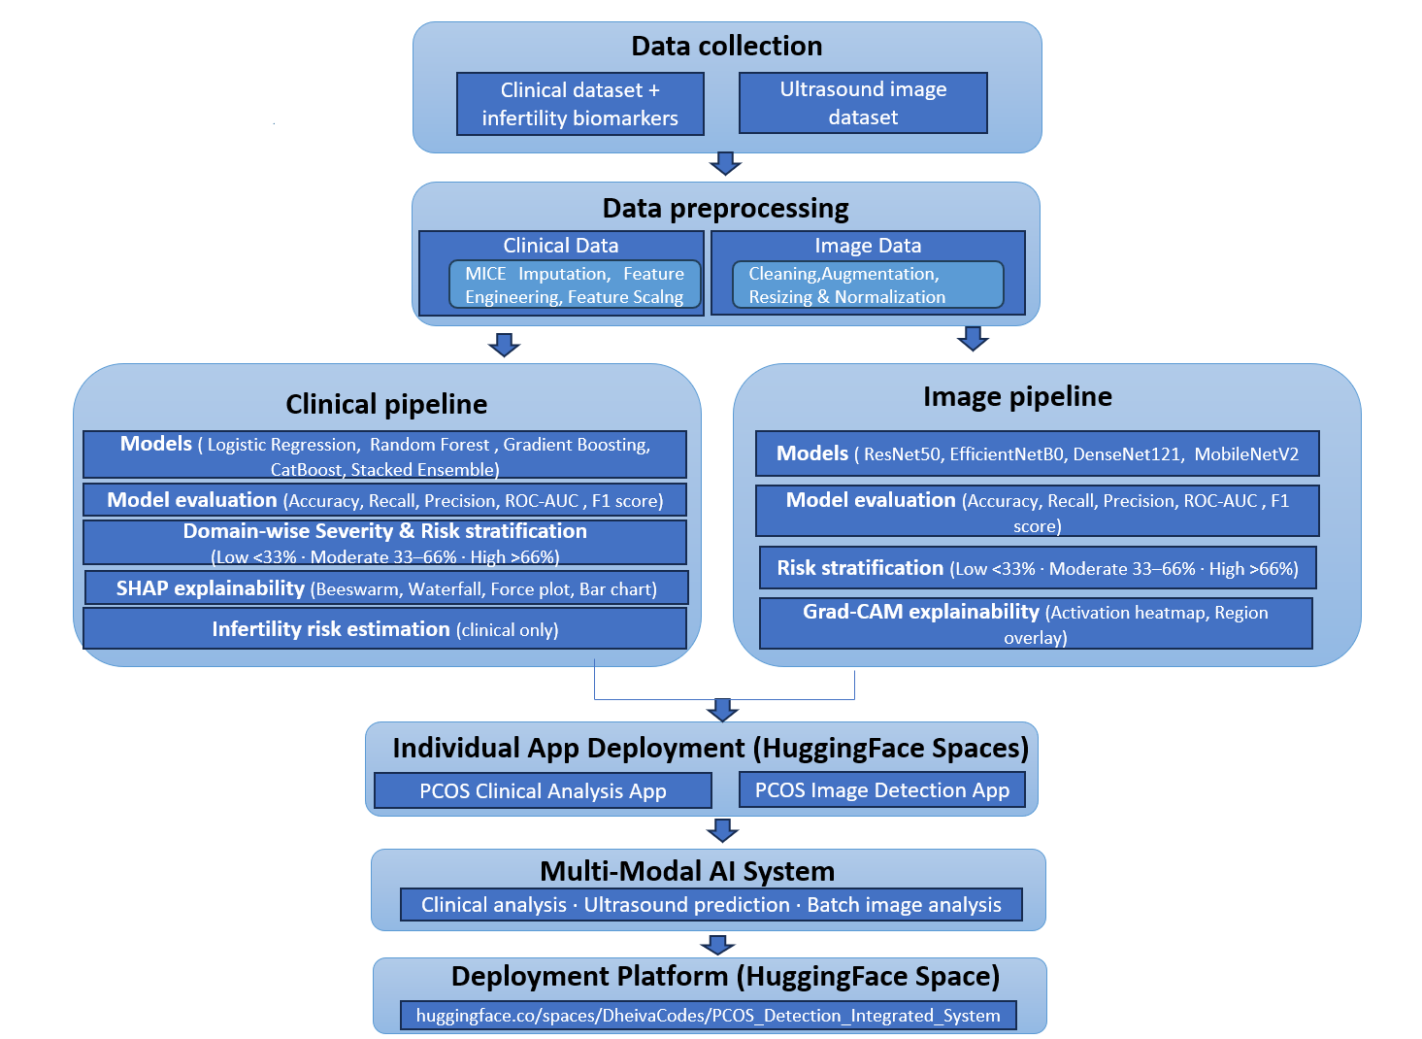

2.2 Data Collection and Description
The work carried out in this study used two different forms of data for PCOS detection: structured clinical records and ovarian ultrasound images. The idea behind using both was to make the system closer to actual clinical practice, where doctors usually depend on laboratory findings together with scan observations before confirming a diagnosis.
The clinical dataset consisted of a publicly available PCOS dataset containing the records of 541 patients, including the patient's medical data (e.g. reproductive history, hormonal imbalance, metabolism) and physiological data (disease specific). Features included in the medical and physiological datasets comprised of such variables as body weight, BMI, menstrual cycle information, hormone levels, blood sugar values and follicle count. However, because the raw clinical dataset also contained a small number of administrative variables and less useful attributes, only those clinical features were retained for analysis and development of diagnosis models.
Along with the clinical records, an ultrasound image dataset was also used in the study. The dataset consisted of ovarian ultrasound scans grouped into PCOS and non-PCOS categories. Before the modelling phase, the images were examined for duplicate samples and poorly-structured files. The scans came from different sources and had a variety of quality and resolution levels, thus requiring some degree of preprocessing before the modelling phase.
Table 2: Description of Datasets Used for PCOS Detection
Dataset Name | Source | Records | Features | Target Variable | Description
PCOS Clinical Dataset (Without Infertility) | Kaggle^{[13]} | 541 | 44 Clinical Features | PCOS (Y/N) | Clinical dataset containing hormonal, metabolic, anthropometric, and reproductive health parameters collected for PCOS diagnosis
PCOS Ultrasound Image Dataset | Kaggle^{[14]} | 11784  Images | Ovarian Ultrasound Images (224 × 224) | PCOS / Non-PCOS | Preprocessed ovarian ultrasound scan images used for deep learning–based PCOS classification

2.3 Data Preprocessing
The data were preprocessed before modeling. Some columns were removed from the clinical dataset as they were irrelevant for predictions. There were some missing values in some of the records; however, those were not removed as removing them would have meant losing information about more patients. Therefore, appropriate imputation techniques were applied. The range of feature values was also different. The levels of hormones and body measurements differed significantly in terms of their scales. In order to address this issue, scaling was performed before modeling. Then, the data were split between training and test sets, ensuring an equal proportion of PCOS and non-PCOS samples. In the case of the ultrasound dataset, duplicates were found and eliminated during the data cleansing phase using MD5 chunk-based hashing. Before applying the model, all of the images were resized to 224×224 pixels. Transformations including flipping, small rotations, and zooming were also applied to images when training the model. Now, the datasets were ready for further processing.
2.4 Feature Engineering and Severity Scoring
The initial features were clustered into small categories before the model training process was carried out. This is because the features involving body conditions and metabolism remained in one category, whereas hormone levels and menstrual cycles formed another. Health-related and hyperandrogenic symptoms were also clustered separately. The four categories were Metabolic, Reproductive, Hyperandrogenic and General. This was followed by the creation of domain-specific severity scores from the features clustered above. The scores were developed in order to provide a generalized representation of patient conditions within each category. These scores were included in the dataset, and both the generated scores and original clinical values were used in the modeling training process.
Table 3: Clinical Feature Domain Grouping and Weight Assignment
Domain | Key Features | Feature Count | Domain Weight
Metabolic | BMI, Weight, Blood Pressure, RBS, Waist-Hip Ratio | 11 | 0.35
Reproductive | FSH, LH, AMH, Follicle Count, Cycle Length | 12 | 0.40
Hyperandrogenic | Hair Growth, Pimples, Hair Loss, PRL | 5 | 0.20
General | Age, Hemoglobin, TSH, Vitamin D3 | 6 | 0.05

2.5 Model Development
A variety of machine learning and deep learning models were constructed for PCOS prediction based on the clinical data and ultrasound images. In case of the clinical data, such models as Logistic Regression, Random Forest, Gradient Boosting, and CatBoost were created and analyzed. Stratified cross-validation was used for training in order to guarantee an equal balance between the patients with and without PCOS in all folds. Outputs of these models were later stacked together for obtaining better prediction results.
For the ultrasound data, transfer learning was applied with the use of such pre-trained convolutional neural network models as ResNet50, EfficientNetB0, MobileNetV2, and DenseNet121. In this regard, DenseNet121 model demonstrated the best performance results after the evaluation. Evaluation of the models was carried out through the use of criteria including Accuracy, ROC-AUC, Precision, Recall, F1-Score, Sensitivity, Specificity, and MCC. These criteria were employed to determine the best performing models.
2.6 Explainable AI Techniques
Interpretability was incorporated into the framework to provide insight into the process of predicting. In this case, SHAP analysis was carried out to determine how the prediction results were affected by different features. Through this technique, it was possible to establish which clinical parameters contributed significantly to detecting PCOS. On the other hand, the ultrasound models were explained using the Grad-CAM visualization technique. It is worth noting that the visualization was performed by highlighting the regions of interest in the scans. The purpose was to understand how the model captured the patterns associated with PCOS from ovarian ultrasound images.
2.7 Risk Assessment for Clinical Purposes
Risk assessment was added to facilitate the classification of patients according to their risk classes using the scores predicted by the models. Depending on the probability score and relevant clinical parameters, the patient will be classified as either having a low, moderate, or high risk. This was necessary as the purpose of incorporating the risk assessment module is to provide additional meaning to the predictions other than determining the status of the patient.
2.8 Deployment
Once the models and the corresponding pre-processing modules had been trained and evaluated, they were then made ready for deployment. The trained models, pre-processing modules, scaling methods, as well as the configurations were saved so as to make the framework available for making predictions using patient data. The design of the framework was such that it made it possible to make predictions from both the patient's clinical data as well as the ultrasound image. This made it possible to deploy the framework for PCOS detection in the future.
CHAPTER 3
RESULTS AND DISCUSSION
The proposed framework has yielded the experimental results that are detailed in this chapter. The analysis aims to highlight the differences between the existing work and the proposed system with respect to accuracy of predictions, and interpretability of models. Python was the programming language used for carrying out all the experiments, employing Scikit-learn and SHAP libraries.
3.1 Existing Results
The previous researches on the detection of PCOS have been carried out independently using either clinical dataset or ultrasound image data. Machine learning algorithms trained on the clinical data have achieved promising results for PCOS prediction. In addition, there have been deep learning algorithms that performed excellently in classifying the ovarian ultrasound images.
Moreover, a common drawback found in most of the current techniques is the lack of explainability and risk score calculation of patients. In other words, previous works were only able to give predictions and did not give the reasons behind those predictions of the patients.
Table 4: Existing Clinical Model Results from Base Paper^{[9]}
Model | Accuracy | Precision | Recall | F1-Score | ROC Score
Random Forest (RF) | 94% | 96.67 | 82.86 | 0.89 | 90.75
AdaBoost (AB) | 94% | 93.94 | 88.57 | 0.91 | 92.93
Gradient Boosting (GB) | 93% | 93.55 | 82.86 | 0.88 | 90.08
Linear SVC | 92% | 90.62 | 82.86 | 0.87 | 89.40
Logistic Regression (LR) | 91% | 87.88 | 82.86 | 0.85 | 88.73

3.2 Clinical Dataset Model Results
Training and evaluation of the ML models was performed based on the structured clinical dataset. Logistic Regression, Random Forest, Gradient Boosting, and CatBoost ML algorithms were used for testing with various evaluation criteria. ML models successfully recognized relevant clinical patterns for PCOS based on hormonal, metabolic, and reproductive variables.

Table 5: Performance Comparison of Clinical Machine Learning Models
Model | Accuracy | ROC-AUC | Sensitivity | Specificity | F1-Score | PR-AUC
Logistic Regression | 0.8991 | 0.9570 | 0.9167 | 0.8904 | 0.8571 | 0.9422
Random Forest | 0.9174 | 0.9581 | 0.7778 | 0.9863 | 0.8615 | 0.9475
Gradient Boosting | 0.9083 | 0.9623 | 0.7500 | 0.9863 | 0.8438 | 0.9527
CatBoost | 0.9266 | 0.9578 | 0.8611 | 0.9589 | 0.8857 | 0.9427
Stacked Ensemble | 0.9541 | 0.9532 | 0.8889 | 0.9863 | 0.9275 | 0.9413

Fig 2: ROC and PR curve for clinical models
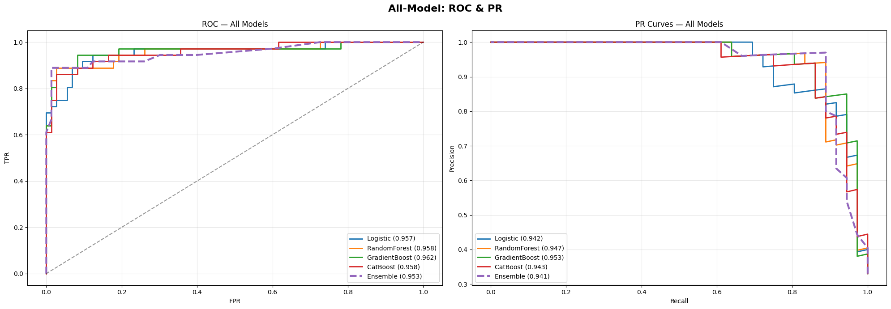
From all the models examined, the stacked ensemble proved to provide the highest quality performance. The method improved the model's reliability through integration of several classifiers' outcomes rather than basing predictions on the single classifier's output. The obtained results prove that the stacked ensemble showed the highest ROC-AUC and F1-scores among all clinical models. It can be concluded that the combination of classifiers has positively affected PCOS prediction.

Fig 3: ROC Curve, PR Curve, Confusion Matrix of Stacked Ensemble Model
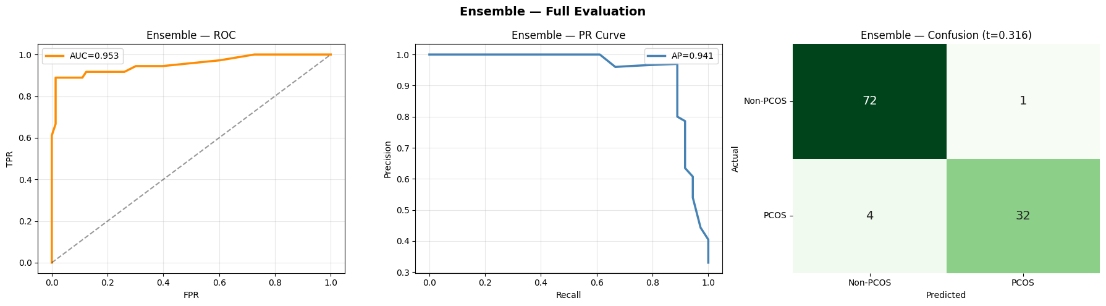

Fig 4: Model Accuracy Comparison - Clinical Machine Learning Models
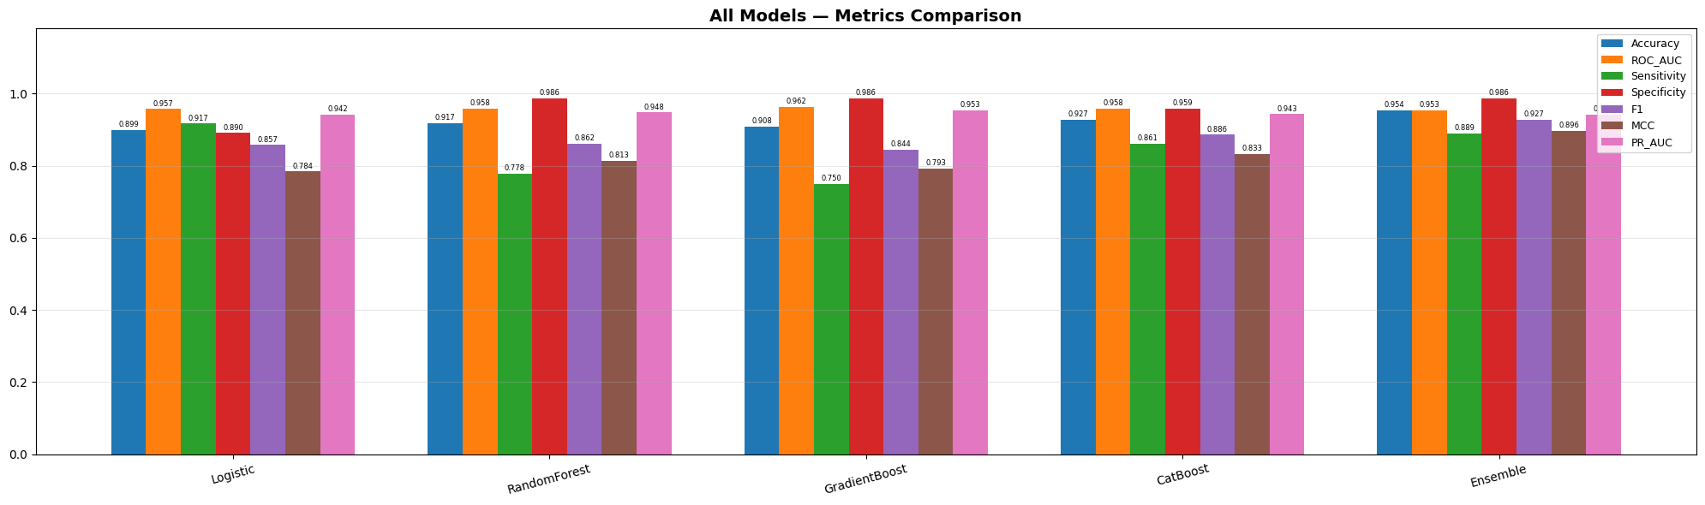
3.3 Ultrasound Image Model Outcomes
The results of transfer learning experiments using four distinct models (ResNet50, EfficientNetB0, MobileNetV2, and DenseNet121) indicated appropriate deep learning architectures for identifying the features of Polycystic Ovary Syndrome (PCOS) using the ovarian ultrasound image dataset. All four of the models employed were tested. DenseNet121 was found to demonstrate strong ability to detect ultrasound features related to PCOS and also achieved an ROC-AUC of 0.975.
Table 6: Performance Comparison of Deep Learning Models on Ultrasound Images
Model | Accuracy | ROC-  AUC | Recall | Specificity | Precision | F1-Score
ResNet50 | 0.9800 | 0.9999 | 0.9749 | 1.0000 | 1.0000 | 0.9873
EfficientNetB0 | 0.9883 | 0.9993 | 0.9895 | 0.9836 | 0.9958 | 0.9927
DenseNet121 | 0.9883 | 0.9994 | 0.9874 | 0.9918 | 0.9979 | 0.9926
MobileNetV2 | 0.9833 | 0.9998 | 0.9791 | 1.0000 | 1.0000 | 0.9894

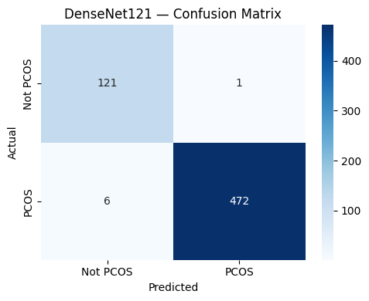
Fig 5 : Confusion Matrix — DenseNet121 Model
These results suggest that the DenseNet121 model outperformed the other three available deep learning models regarding identification of PCOS through ultrasound imaging. The high sensitivity achieved by the model will be beneficial in medical applications because it will decrease the chance of undetected positive cases based on this type of screening.

Fig 6: Model Accuracy Comparison - Deep Learning Models on Ultrasound Images
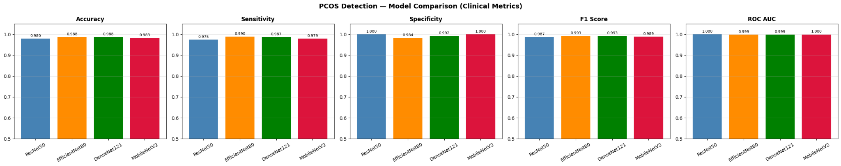

3.4 Model Interpretability and Risk Analysis
Various interpretability techniques were performed to determine the reasoning behind the prediction of the models. In the case of clinical data models, the SHAP method was conducted to detect which features contribute most to the PCOS prediction. Follicle count, AMH concentration, menstrual irregularities, and the FSH-LH ratio are some of the features found to contribute heavily towards the positive PCOS classification, in accordance with common clinical parameters.Furthermore, SHAP charts for each patient also allowed us to better understand how the various physiological and metabolic characteristics affect each prediction. By doing so, we have added clarity to our models' processes.

Fig 7: Global SHAP Beeswarm Plot — Clinical Models
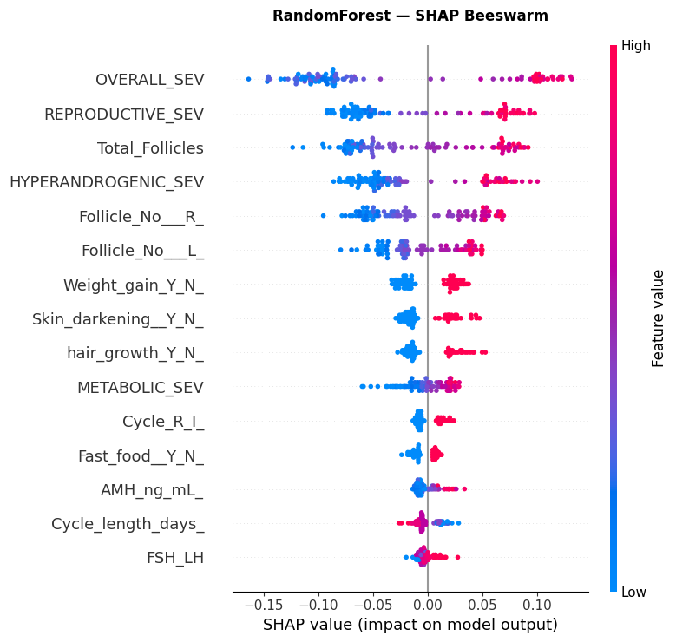
Fig 8: SHAP-Based Model Contributions for Ensemble Model
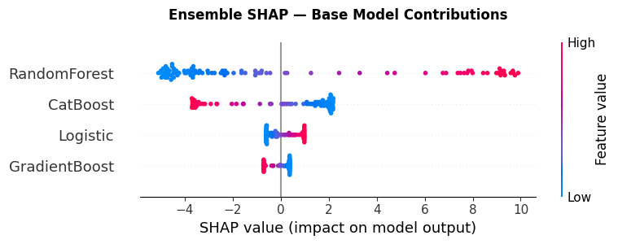

On the other hand, for ultrasound models, we obtained Grad-CAM heatmaps indicating important areas in the ovarian ultrasound images that affect predictions. It has been shown that the model focused primarily on ovarian images containing more than one follicle, which is characteristic of PCOS morphology.

Fig 9: Grad-CAM Heatmap — DenseNet121 on PCOS Ultrasound Image
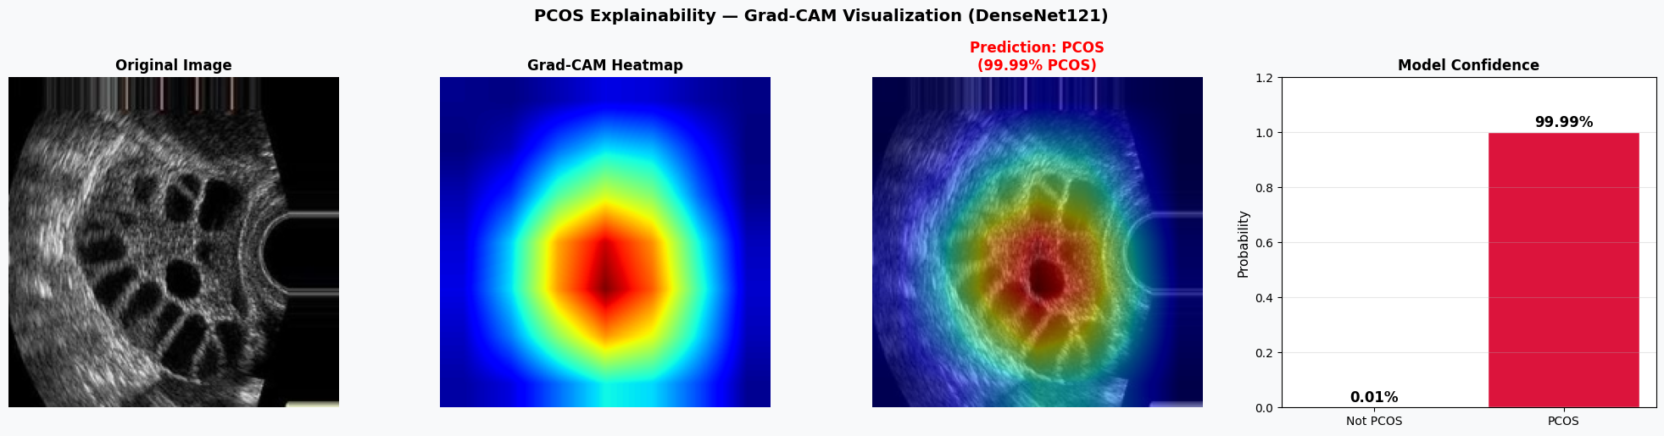
Another part of the framework was the risk analysis module. With the help of severity scores and prediction probability, patients are sorted into three risk levels – low, medium, and high risks.

Table 7: Patient Risk Stratification Categories and Clinical Recommendations
Risk Category | Probability Range | Clinical Interpretation | Recommended Action
Low Risk | < 0.33 | Low likelihood of PCOS | Routine monitoring
Moderate Risk | 0.33 – 0.66 | Moderate clinical indicators | Further clinical testing
High Risk | > 0.66 | Strong indicators of PCOS | Immediate medical evaluation

3.5 Deployment and System Implementation
AI system developed in this study has completed all pre-deployment preparations. The system stores its data preprocessing workflow, model weights, and prediction thresholds, supports dual-modal input of clinical parameters and ovarian ultrasound data, and can output classification results, prediction probabilities, risk groups, as well as interpretable content generated via SHAP and Grad-CAM.
Fig 10 : Clinical Prediction Interface of the Proposed PCOS System
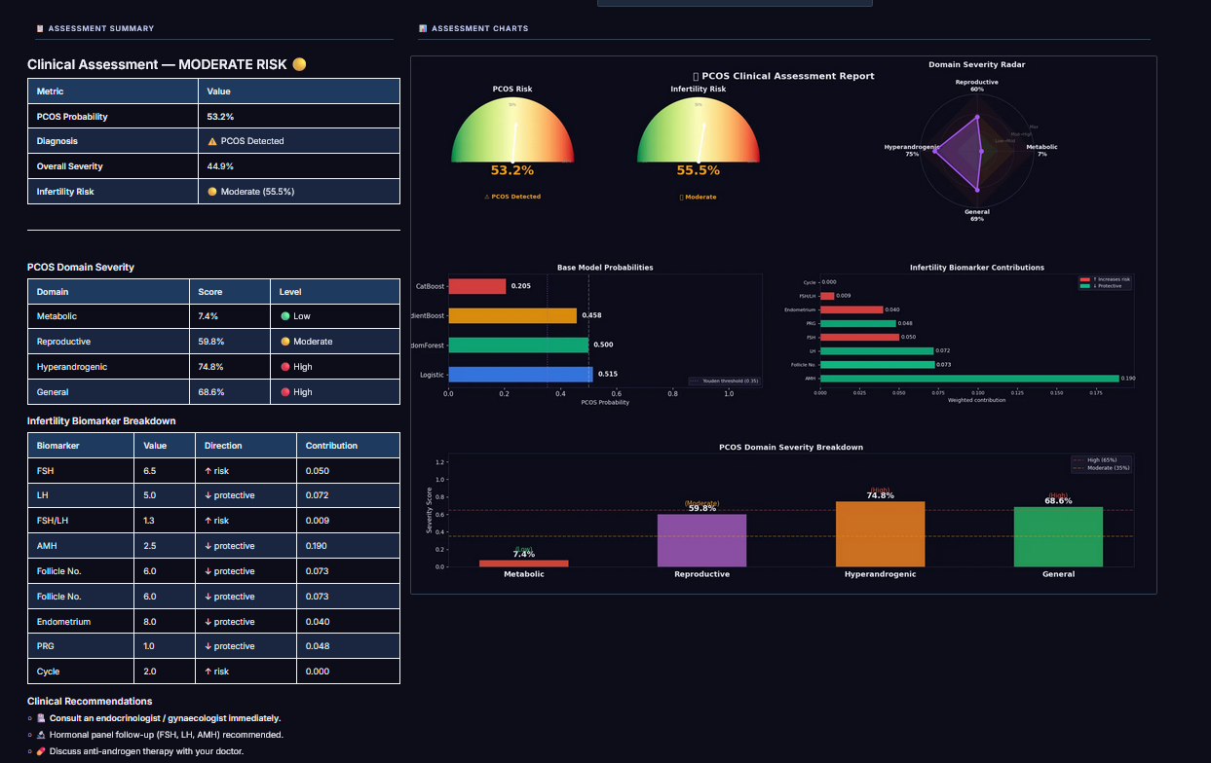
Fig 11: Ultrasound Image Upload and Prediction Interface
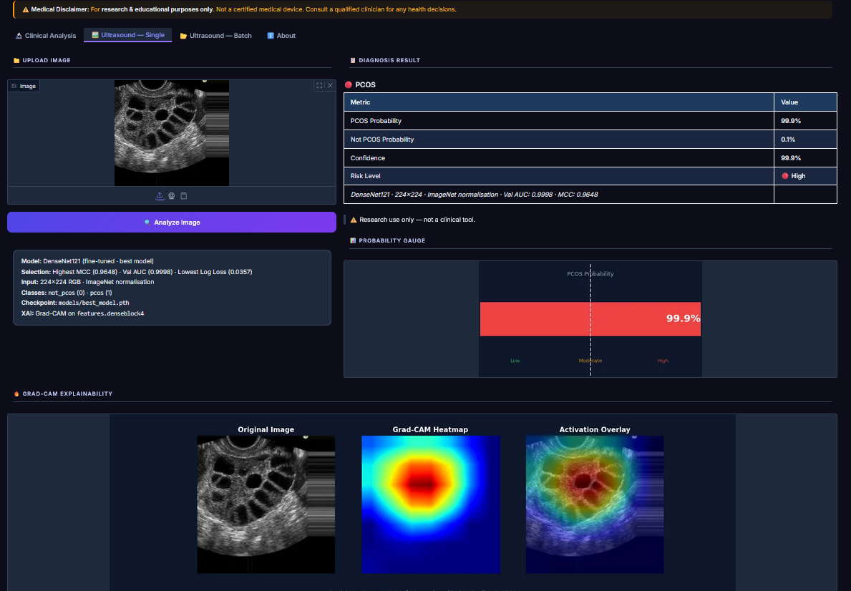
The deployed application can be accessed through the following link:
Deployment Links:
https://huggingface.co/spaces/DheivaCodes/PCOS_detection_clinical
https://huggingface.co/spaces/DheivaCodes/PCOS_Ultrasound_Image_Detection
https://huggingface.co/spaces/DheivaCodes/An_Integrated_System_For_PCOS_Detection
3.6 Discussion
From the overall results, it is clear that combining the use of structured clinical data with ultrasound images increases the accuracy of detecting the existence of PCOS. All machine learning classifiers had a good performance in the clinical features. On the other hand, deep learning models showed high accuracy in recognizing important ovarian traits in ultrasound images. Therefore, using both approaches gives a comprehensive view of the patient's condition.In this study, the stacked ensemble algorithm outperformed the standalone classifiers in all the metrics. Similarly, the DenseNet121 model outperformed other architectures by providing higher performance scores based on the ROC-AUC and sensitivity metrics. The use of explainable methods such as SHAP and Grad-CAM significantly helped to make the framework more interpretable. In particular, these algorithms allowed clinicians to understand the reasoning behind a prediction for a particular image.Despite the promising performance, some weaknesses still existed in this research. First, the dataset used had a relatively small size and was gathered from particular sources. Moreover, clinical and imaging data were not fully integrated at the feature level but independently. Even though some challenges still exist, this research proves that a combination of multiple modality and interpretability is applicable in PCOS screening.

CHAPTER 4
CONCLUSION AND FUTURE SCOPE
4.1 Conclusion
In this study, a multi-modal system for the diagnosis of PCOS is proposed based on clinical structured data and ovarian ultrasound images. The former were studied using machine learning models and the latter via deep learning algorithms. The outputs of various machine learning models used for the prediction task were integrated by means of a stacked ensemble method.
As for the image models, DenseNet121 turned out to yield better results in the ultrasound-based detection of PCOS compared to other models used in this study. In order to increase the explainability of model predictions, SHAP and Grad-CAM methods have been employed to reveal the key clinical factors and image regions affecting model performance. Moreover, a clinical risk assessment system has been created in this work to classify patients' risk of PCOS. The obtained outcomes demonstrate the positive influence of the integration of clinical information and ultrasound images on the diagnosis of PCOS.

4.2 Future Work
The proposed system will continue to expand by utilising a wider variety of contextual data from existing centres, as well as from future centres. This includes larger datasets with greater diversity, including additional patient characteristics such as improvements in genomics and lifestyle information, which can contribute to improving the overall predictive power of the system, as well as producing more detailed reports on patients. Long-term, development of new methods for combining the different modalities (i.e. combining imaging (e.g. ultrasound, CT, etc.) with clinical data) will lead to the creation of new models that will be more complete in nature. In addition, new deep-learning models will be investigated and used for diagnosis through ultrasound imaging. Ultimately, as the integration of these projects into mobile health applications or clinical decision support tools takes place, increased accessibility to and utility of this framework will be gained in real-world environments.

4.3 Challenges and Limitations
There are a number of limitations of this study that need to be considered. First, the clinical dataset is relatively small in size, and data come from some particular sources, which might have an impact on the generalisability potential of the deep learning model. Differences in ultrasound image quality and examination conditions can also affect deep learning results. Another limitation in this study is that clinical and imaging datasets are independently processed, without complete integration at the feature level. Besides, deep learning and ensembling techniques demand more computing power during training and testing processes. Despite the limitations mentioned above, the proposed framework exhibits good performance in PCOS identification and proves the feasibility of the combination of explainable machine learning and ultrasound image analysis for clinical risk estimation.

CHAPTER 5
REFERENCES
[1] K. Rao and A. Malik, “Explainable ensemble-based machine learning model for PCOS detection using hybrid feature selection,” International Journal of Information Technology, Springer, Dec. 2025. [Online]. Available: https://link.springer.com/article/10.1007/s41870-025-03044-4
[2] V. Mohanasundaram, R. K., E. K. Eswari, D. Viswanathan, K. Tamizharasu, and S. Hemalatha, “Hybrid deep learning framework for PCOS detection using MobileNetV2 and clinical features,” in Proceedings of the International Conference on Computing and Communications (COMPUTINGCON), Sep. 2025. [Online]. Available: https://doi.org/10.1109/COMPUTINGCON64838.2025.11377444
[3] S. Panjwani, A. Sharma, R. Gupta, P. Singh, and N. Verma, “Optimized machine learning for the early detection of polycystic ovary syndrome in women,” Sensors, vol. 25, no. 4, Feb. 2025. [Online]. Available: https://www.mdpi.com/1424-8220/25/4/1166
[4] L. Chen, “Association of PCOS with clinical, physical, and reproductive factors: A data-driven analysis,” Diagnostics, vol. 15, no. 6, Mar. 2025. [Online]. Available: https://www.mdpi.com/2075-4418/15/6/711
[5] V. D. N. Varshitha, G. B. S. Gowrishankar, S. Mulakaluri, C. N. J. Nayak, S. Choudhary, V. T. V. Varshiya, and S. B. N. Sanjana, “Automated detection of polycystic ovary syndrome using convolutional neural networks on ultrasound images,” Salud, Ciencia y Tecnología, vol. 5, Art. no. 2272, 2025. [Online]. Available: https://doi.org/10.56294/saludcyt20252272
[6] V. K. Bairagi, M. S. Vanjale, A. Dolas, S. Zende, A. Nanthaamornphong, and S. Harpale, “Polycystic ovarian syndrome (PCOS) detection through deep learning,” International Journal of Engineering Trends and Technology, vol. 72, no. 10, pp. 159–170, Oct. 2024. [Online]. Available: https://doi.org/10.14445/22315381/IJETT-V72I10P116
[7] P. Singh and R. Verma, “A machine learning approach for non-invasive PCOS diagnosis from ultrasound and clinical features,” Scientific Reports, Sep. 2024. [Online]. Available: https://www.nature.com/articles/s41598-025-10453-9
[8] A. Sharma and R. Gupta, “SmartScanPCOS: A feature-driven approach to PCOS prediction using ML and XAI,” Heliyon, Elsevier, Oct. 2024. [Online]. Available: https://doi.org/10.1016/j.heliyon.2024.e39205
[9] M. M. Rahman, A. Islam, F. Islam, M. Zaman, M. R. Islam, M. S. A. Sakib, and H. M. H. Babu, “Empowering early detection: A web-based machine learning approach for PCOS prediction,” Informatics in Medicine Unlocked, vol. 47, Art. no. 101500, 2024. [Online]. Available: https://doi.org/10.1016/j.imu.2024.101500
[10] J. Mehta, “PCOS detection using machine learning and medical app development,” in Proc. IEEE Conference, Dec. 2024. [Online]. Available: https://doi.org/10.1109/SUSTAINED63638.2024.11073834
[11] N. Agarwal and P. Verma, “Machine learning-based classification of PCOS using clinical data,” Biomedical Informatics, Nov. 2023. [Online]. Available: https://pubmed.ncbi.nlm.nih.gov/40975882/
[12] V. Kumar and R. Singh, “PCOS perception analysis prediction using machine learning algorithms,” in Proceedings of IEEE Conference, 2022. [Online]. Available: https://ieeexplore.ieee.org/document/10054279
[13] PCOS Clinical Dataset (Without Infertility), Kaggle, 2020. [Online]. Available: https://www.kaggle.com/datasets/prasoonkottarathil/polycystic-ovary-syndrome-pcos?select=PCOS_data_without_infertility.xlsx
[14] PCOS XAI Ultrasound Dataset, Kaggle, 2024. [Online]. Available: https://www.kaggle.com/datasets/ibadeus/pcos-xai-ultrasound-dataset



