PROCESS DOCUMENT
RPA Automation Request — Client Submission

1. Request Information
Client Name:
Dherick Jay Paalam_________________________________________________________________________________________
Department:
BIT__________________________________________________________________________________________
Submission Date:
April 8, 2026__________________________________________________________________________________________

2. Process Overview
Describe the process and why you want it automated:
What does this process do? What pain points does it cause when done manually?
This process involves manually downloading reports from Xero and compiling them into one consolidated Excel file. BAS will be run every quarter (March, June, September, December)

3. Current Tools Used
List the software and tools involved in this process:
e.g., Xero, Microsoft Excel, Outlook, MYOB, specific web portals, etc.
Xero, Microsoft Excel, Asana, Onedrive

4. Step-by-Step Process
Describe each step of the process in order:
Fill in each step below. In the Screenshot / Notes column, insert a screenshot or describe what the screen looks like at that step. Add more rows if needed.

Step # | Description | Screenshot / Notes
1 | Login to Xero
2 | Switch to desired tenant/organization
3 | Go to Activity Statements section and download Activity Statements report. | 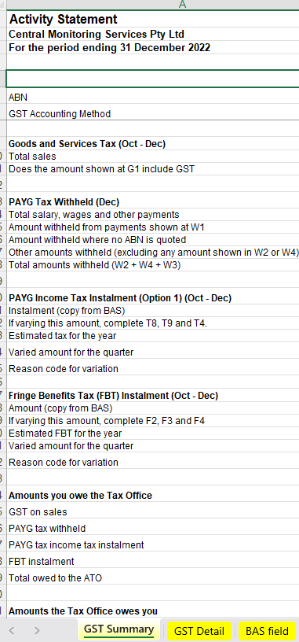
4 | Download Balance Sheet | 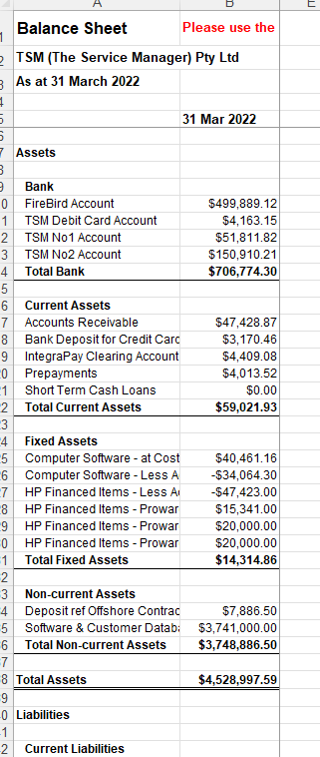
5 | Download Profit Loss | 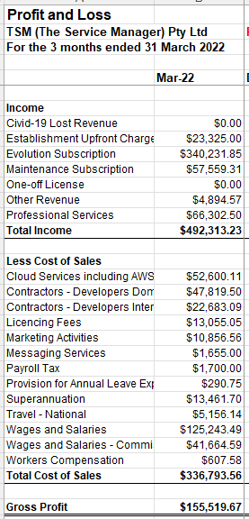
6 | On database (currently on Masterfile), check if tenant is Cash Basis or Accrual Basis.
7 | If Cash Basis, download Aged Payable Detail Report and Aged Receivables Report Detail. In this section, ensure to check the “Outstanding GST” part in columns, so that when report is generated, this column will be included (not checked by default in Xero). If Accrual Basis, ignore this two reports. | 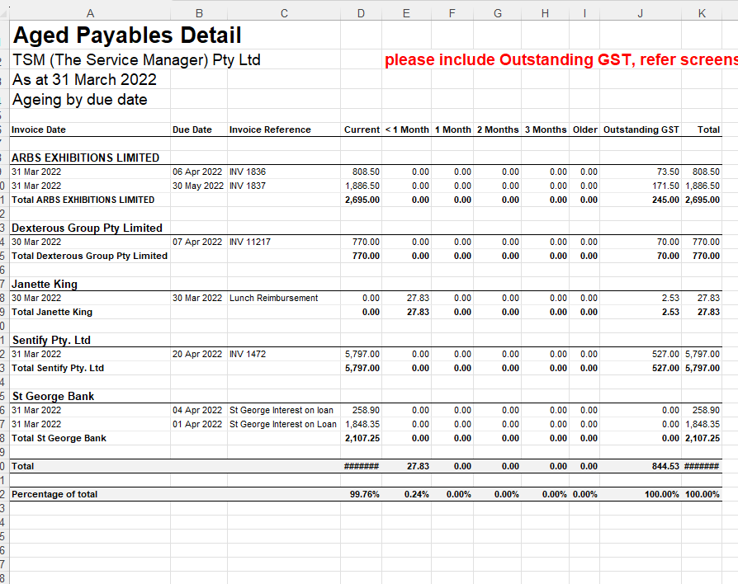
8 | On database (currently on Masterfile), check “PAYGI” column to see if tenant’s Payroll Activity Summary will be downloaded depending on frequency (either Monthly, Quarterly, or No Payroll) | See attached masterlist file
9 | Consolidate all the reports into one single file and rename it as (tenant name + “-“ + Quarter + Year + BAS.xlsx | 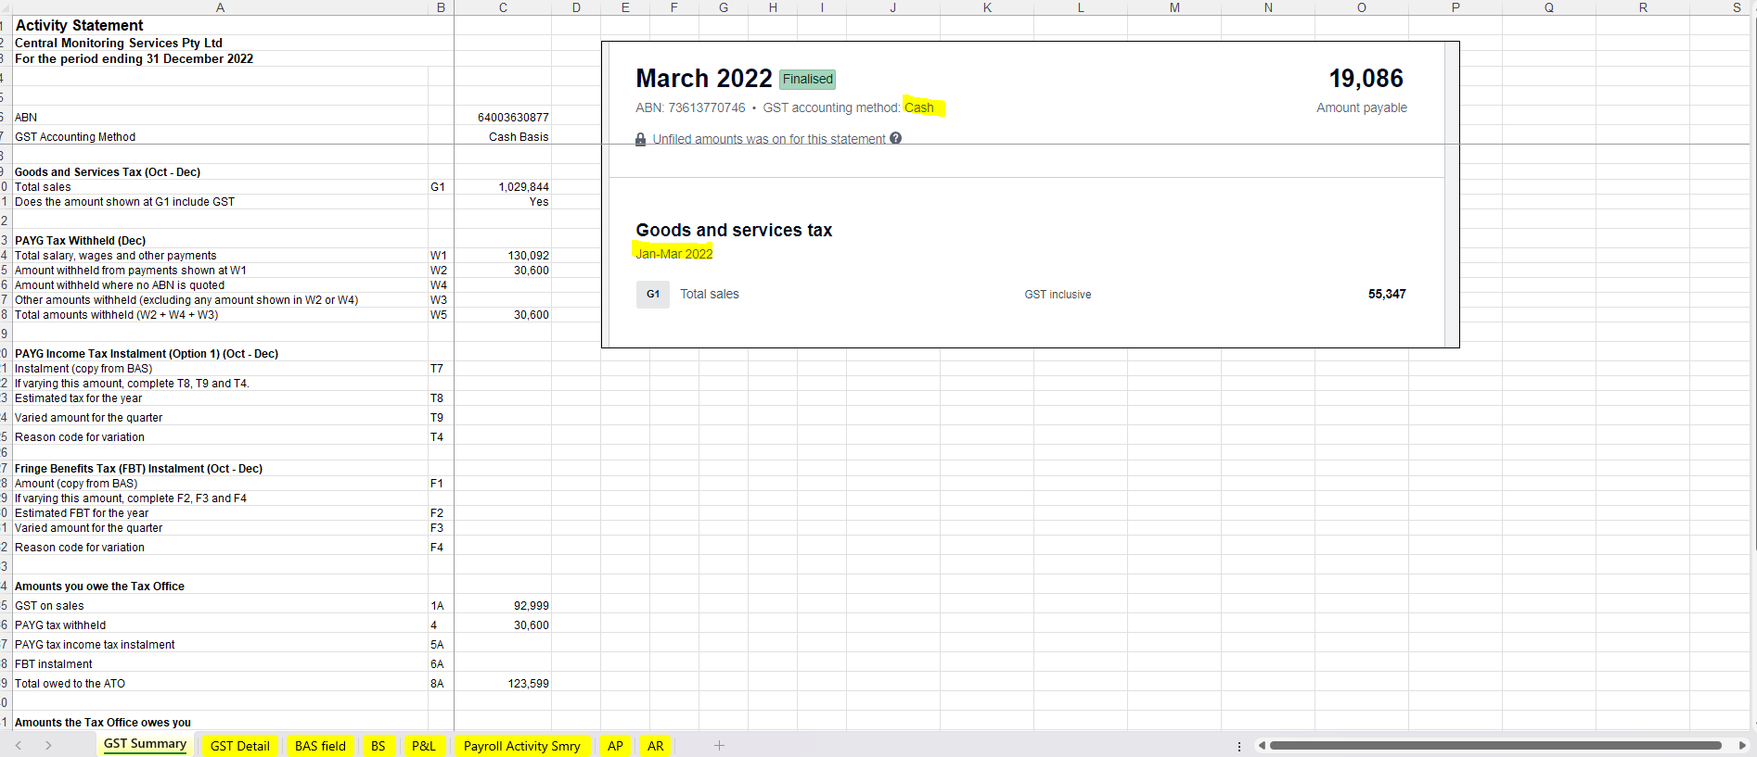
10 | Store the file inside Onedrive. The file path will be determined on database (masterlist currently) | 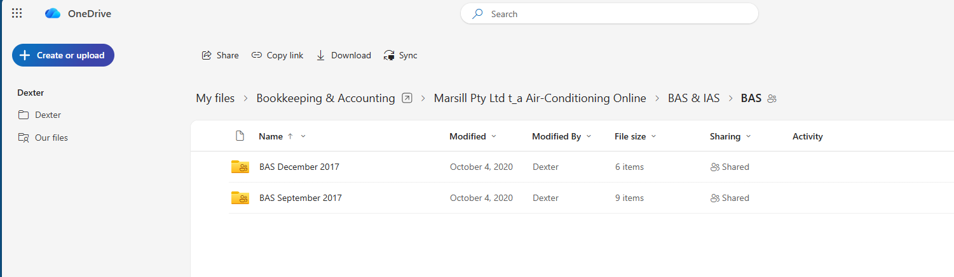
11 | In Asana task for this project, update the status from “BAS Report Exportation” to “Ready to Prepare”, changed due date to Friday (if run day is Friday, move due date to Monday next week), and add a comment tagging the Income Tax team which includes the Onedrive URL of the file. | 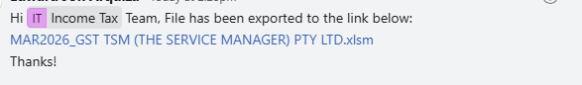
12

5. Frequency & Volume
How often is this process performed?
e.g., Daily, Weekly, Monthly, End of month, Ad-hoc
Quarterly (March, June, September, December) ___________________________________________________________________________
Approximate number of records/transactions per run:
e.g., ~50 invoices per week, ~200 rows per report
__________________________________________________________________________________________

6. Success Criteria
How will you know the automation is working correctly?
Describe what the expected output looks like. What should the automation produce? What would make you confident it has completed successfully?
Correct reports are downloaded and consolidated into one report file. This report file is placed correctly in specified client folder. An Asana comment will be added to inform other users about the consolidated report.

This document is part of the RPA Automation Request process. It will be reviewed by the development team before your discovery call.

