Berry saturation and the statistics of the Riemann zeros from $t≈{10}^{4}$ to ${10}^{21}$: a reproducible numerical study
David Hess (MAYAN ALFA V1008 LAB v.34.47)
30.10.2026
Abstract
We compare the number variance $Σ^{2}\left(L\right)$ and the spectral rigidity $Δ_{3}\left(L\right)$ of the non-trivial zeros of the Riemann zeta function with Berry’s semiclassical formula, which contains no free parameter. The data are 18 blocks of zeros at heights from $t≈{10}^{4}$ (LMFDB) through ${10}^{6}$ (2,001,052 zeros) to ${10}^{11}$, ${10}^{20}$ and ${10}^{21}$ (Odlyzko’s tables near the zeros number ${10}^{12}$, ${10}^{21}$, ${10}^{22}$). Berry’s formula reproduces the measured $Σ^{2}\left(L\right)$ for $0.5≤L≤100$ with a root-mean-square relative deviation of 0.26–1.21 %, including the oscillations caused by the shortest prime orbit ($p=2$). The same formula with random primes of the same density (Cramér model) misses by 5.4–9.9 %, and the GUE prediction by 15–82 %. The saturation level of $Σ^{2}$ grows with height (0.34 at $t≈{10}^{4}$, 0.56 at $t≈{10}^{21}$), so $Σ^{2}$ in unfolded units is not independent of the height. $Δ_{3}$ computed from Berry’s $Σ^{2}$ through the Dyson–Mehta relation agrees with the measured $Δ_{3}$ within 3.3 %. Small gaps approach GUE only logarithmically slowly, and the projection of $S\left(t\right)$ on $sin\left(tlnp\right)$ reproduces the explicit-formula amplitude $-1/\left(π\sqrt{p}\right)$ within 1 % at $t≈{10}^{21}$. A four-stage sieve shows that a GUE random matrix reproduces the local statistics but neither the prime content nor the saturation. These are known results (Berry 1988); the contribution of this study is their systematic, reproducible verification over 17 orders of magnitude in height with independent checks. Nothing here bears on the Riemann hypothesis.

1. Introduction
Montgomery [1] conjectured that the pair correlation of the zeros of $ζ\left(s\right)$ coincides with that of the eigenvalues of large random matrices from the Gaussian Unitary Ensemble (GUE); he proved it, assuming the Riemann hypothesis, for test functions whose Fourier transform is supported in $\left(-1,1\right)$. Odlyzko [4] confirmed the agreement numerically near the zero number ${10}^{12}$. GUE, however, describes only short distances. On long distances the zeros “remember” the primes: Berry [2, 3] showed semiclassically that the number variance $Σ^{2}\left(L\right)$ saturates instead of growing logarithmically, and gave an explicit formula for it in terms of prime powers $p^{k}$ — the analogue of the periodic orbits of a chaotic system.
This note reports a systematic test of Berry’s formula on 18 blocks of zeros at heights from ${10}^{4}$ to ${10}^{21}$, together with null models (GUE, random primes), the spectral rigidity $Δ_{3}$, small gaps, the prime content of $S\left(t\right)$, and a sieve for candidate spectra. All numbers are produced by the scripts that accompany this article and are cross-checked by an independent implementation; every file is identified by its SHA-256 hash (Section 6).

2. Data
block | zeros | height $t$ | source
LMFDB 1–5 | $$5×20 000$$ | 14 … 74 921 | LMFDB [11]
zeros6 1–10 | $$10×200 000$$ | 14 … $1.13⋅{10}^{6}$ | Odlyzko’s table of the first 2,001,052 zeros [13]
Odlyzko ${10}^{12}$ | 10 000 | $$≈2.68⋅{10}^{11}$$ | zeros no. ${10}^{12}+1…$ [13]
Odlyzko ${10}^{21}$ | 10 000 | $$≈1.44⋅{10}^{20}$$ | zeros no. ${10}^{21}+1…$ [13]
Odlyzko ${10}^{22}$ | 10 000 | $$≈1.37⋅{10}^{21}$$ | zeros no. ${10}^{22}+1…$ [13]
The zeros are unfolded by the smooth counting function $x_{n}=N_{s}\left(t_{n}\right)$, $N_{s}\left(t\right)=\frac{t}{2π}\left(ln\frac{t}{2π}-1\right)+\frac{7}{8}$. Odlyzko’s high tables give offsets $δ_{n}=t_{n}-B$ from a large integer base $B$; there we unfold locally, $x_{n}=δ_{n}H/\left(2π\right)+δ_{n}^{2}/\left(4πB\right)$ with $H=ln\left(B/2π\right)$.

3. Methods
Number variance. $Σ^{2}\left(L\right)=⟨{\left(N\left(x,x+L\right)-⟨N⟩\right)}^{2}⟩$ in unfolded units, averaged over the window position $x$; window starts are spaced by 0.37 (an irrational-like step that samples all offsets; a fixed offset biases $Σ^{2}$, e.g. $Σ^{2}\left(10\right)$ ranges from 0.18 to 0.46 with the offset).
Spectral rigidity. $Δ_{3}\left(L\right)=⟨\min_{a,b}\frac{1}{L}\int_{x}^{x+L}{{\left[N\left(y\right)-ay-b\right]}^{2}} dy⟩$, computed exactly (normal equations for the staircase) on 800 uniformly spaced windows.
Berry’s formula [3]. With $H=ln\left(t/2π\right)$ (the Heisenberg time),
ΣB2L;t=1π2pk≤t/2π​1-cos2πL klnp/Hk2pk+1-cos2πLπ2+L1-2π Si2πL.
Prime orbits shorter than the Heisenberg time enter individually; longer ones are replaced by their GUE (diagonal) average. Primes up to ${10}^{6}$ are summed explicitly; above ${10}^{6}$ the prime number theorem gives $\int_{u_{0}}^{H}{\left(1-cos\left(2πLu/H\right)\right)} du/u$. For a block, the formula is averaged over 48 heights spread uniformly in index (one height for the Odlyzko blocks). No parameter is fitted.
Null models. (i) GUE: $Σ_{GUE}^{2}\left(L\right)=\frac{1}{π^{2}}\left[ln2πL+γ+1-cos2πL-Ci\left(2πL\right)\right]+L\left[1-\frac{2}{π}Si\left(2πL\right)\right]$ [5, 6]. (ii) Cramér: Berry’s formula with random “primes”, each $n≤{10}^{6}$ chosen with probability $1/lnn$ (fixed seed), i.e. the same density but different positions.
$Δ_{3}$ from $Σ^{2}$. $Δ_{3}\left(L\right)=\frac{2}{L^{4}}\int_{0}^{L}{\left(L^{3}-2L^{2}r+r^{3}\right)} Σ^{2}\left(r\right) dr$ [5]. For each prime term the integral is exact, $\frac{2}{L^{4}}\int_{0}^{L}{\left(L^{3}-2L^{2}r+r^{3}\right)}\left(1-cosbr\right) dr=2A\left(bL\right)$ with $A\left(x\right)=\frac{1}{4}-\frac{cosx+2}{x^{2}}+\frac{6sinx}{x^{3}}-\frac{6\left(1-cosx\right)}{x^{4}}$; the smooth part is integrated numerically.
Prime content of $S\left(t\right)$. With $S_{n}=n-\frac{1}{2}-N_{s}\left(t_{n}\right)$, the projection ap=2Nn​Sn-Ssintnlnp is compared with the explicit-formula amplitude $-1/\left(π\sqrt{p}\right)$. At the Odlyzko heights the phase $Blnp mod 2π$ is computed to 60 digits.
Sieve for candidate spectra. A candidate spectrum of 20,000 levels must pass (1) density and rigidity: $\left|\overset{‾}{S}\right|<0.25$, $σ_{S}<1.5$; (2) gaps: nearest class GUE and Kolmogorov–Smirnov distance $≤0.05+1.36/\sqrt{N}$; (3) primes: $a\left(p\right)/\left(-1/π\sqrt{p}\right)∈\left(0.85,1.15\right)$ for $p=2,3,5,7$; (4) saturation: $Σ^{2}\left(30\right)-Σ^{2}\left(10\right)$ below half of the GUE growth (0.056).

4. Results

4.1 Berry’s formula against the zeros
block | $$t≈$$ | $Σ^{2}\left(10\right)$ zeros / Berry | $Σ^{2}\left(30\right)$ zeros / Berry / GUE | RMS Berry | RMS Cramér | RMS GUE | saturation level
LMFDB 40 001–60 000 | $$4.0⋅{10}^{4}$$ | 0.343 / 0.342 | 0.420 / 0.417 / 0.691 | 0.71 % | 7.4 % | 79 % | 0.361
zeros6 1.8–2.0 M | $$1.1⋅{10}^{6}$$ | 0.421 / 0.420 | 0.383 / 0.383 / 0.691 | 0.26 % | 8.3 % | 57 % | 0.403
Odlyzko ${10}^{12}$ | $$2.7⋅{10}^{11}$$ | 0.510 / 0.508 | 0.448 / 0.445 / 0.691 | 0.56 % | 6.1 % | 30 % | 0.463
Odlyzko ${10}^{21}$ | $$1.4⋅{10}^{20}$$ | 0.534 / 0.536 | 0.566 / 0.565 / 0.691 | 0.60 % | 5.4 % | 16 % | 0.554
Odlyzko ${10}^{22}$ | $$1.4⋅{10}^{21}$$ | 0.540 / 0.538 | 0.574 / 0.573 / 0.691 | 0.54 % | 5.6 % | 15 % | 0.562
RMS = root-mean-square relative deviation over $L=0.5…100$ (Odlyzko: $0.5…50$); saturation level = mean $Σ^{2}$ over $L=20…50$.
Over all 18 blocks the RMS deviation of Berry’s formula is 0.26–1.21 % (largest for the lowest blocks), including the oscillations of $Σ^{2}\left(L\right)$ with period $≈H/ln2$ in $L$ caused by the prime 2 (Figure 1). On the whole zeros6 set, with windows up to $L=1000$ (about 2,000 independent windows), $Σ^{2}\left(200/300/500/1000\right)=0.393/0.395/0.385/0.387$ against Berry $0.391/0.391/0.387/0.389$ and GUE $0.88/0.92/0.98/1.05$.
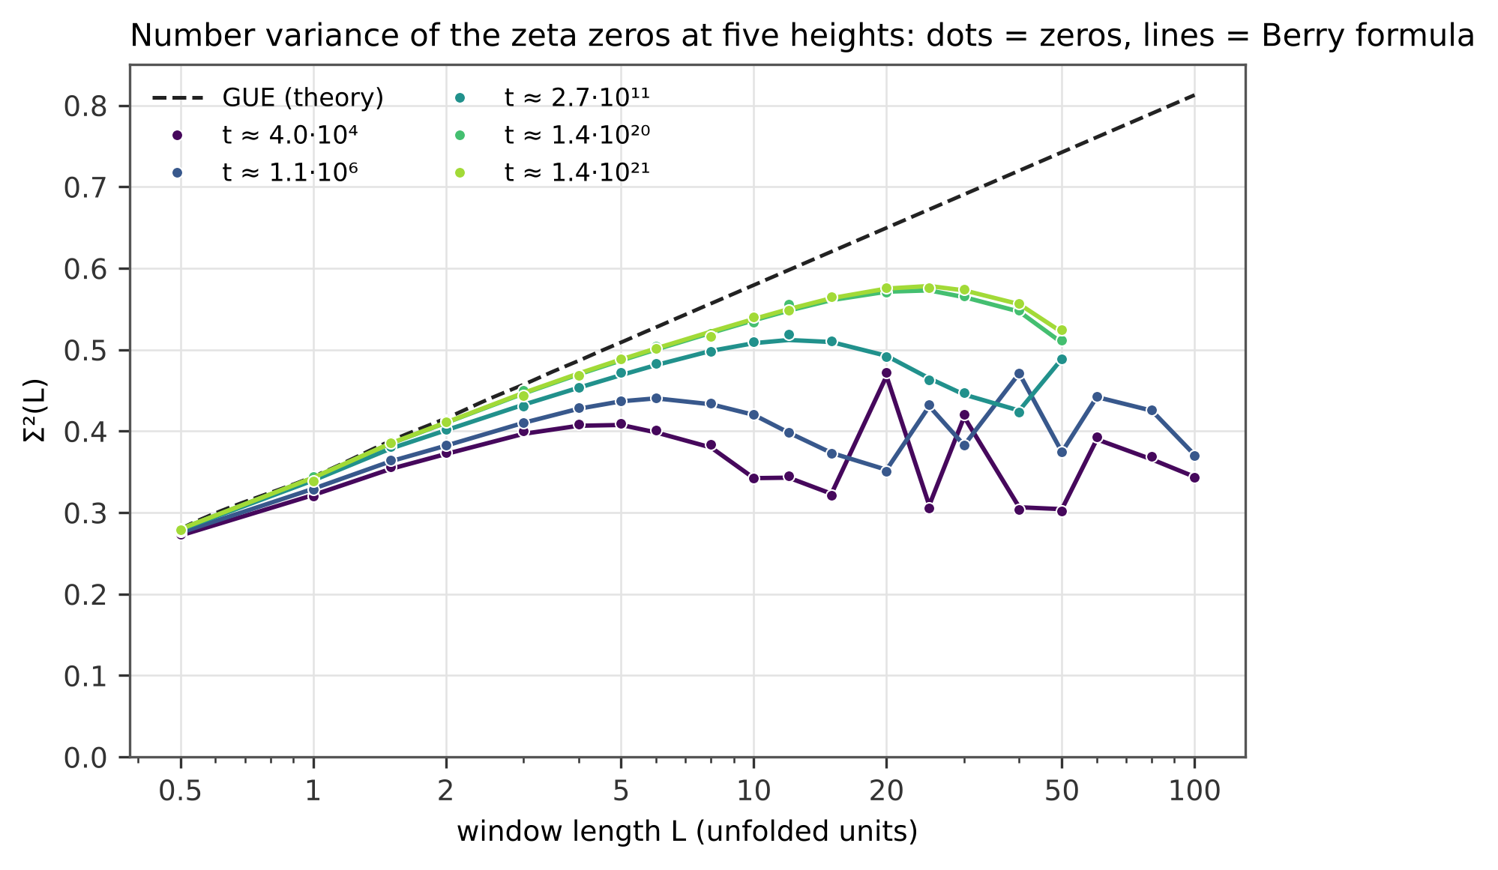
Figure 1. Number variance $Σ^{2}\left(L\right)$ of the zeros at five heights (dots) against Berry’s formula (lines, no free parameter) and GUE (dashed). The oscillations with period $≈H/ln2$ come from the prime 2.

4.2 The exact position of the primes matters
Berry’s formula with Cramér’s random primes — same density $1/lnn$, different positions — deviates by 5.4–9.9 % in all blocks above the lowest ones, i.e. ten to twenty times more than with the true primes (Figure 2). The oscillations of $Σ^{2}\left(L\right)$ are carried by the exact positions of the small primes 2, 3, 5, …
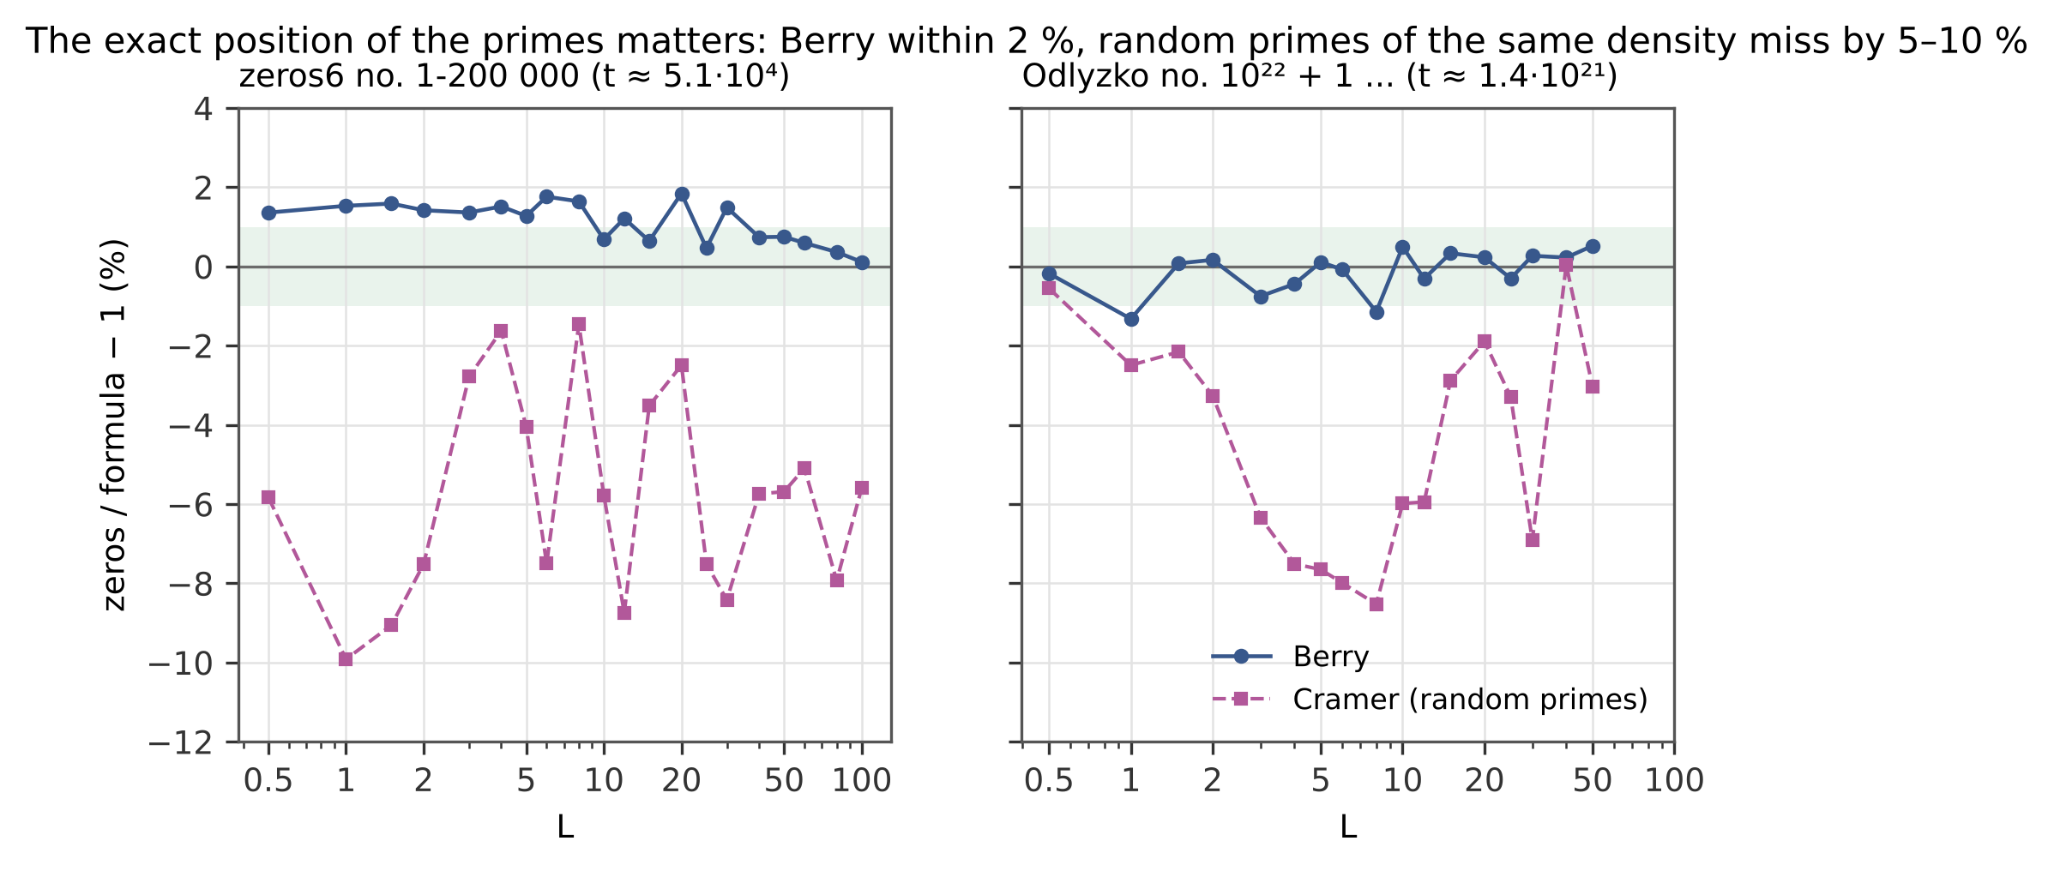
Figure 2. Relative deviation of the measured $Σ^{2}\left(L\right)$ from Berry’s formula with the true primes (solid) and with Cramér’s random primes of the same density (dashed); green band $±1 \%$. Left: the lowest block of zeros6; right: Odlyzko’s zeros near ${10}^{22}$.

4.3 The saturation level grows with height
The level of saturation grows from 0.34 ($t≈{10}^{4}$) through 0.40 (${10}^{6}$) and 0.46 ($3⋅{10}^{11}$) to 0.55–0.56 (${10}^{20}$–${10}^{21}$), along Berry’s curve and below GUE (0.69) (Figure 3). Unfolding removes the mean density but not the number of primes below the Heisenberg time, pk<t/2π​1/k2pk∼lnlnt. Hence the statement “$Σ^{2}$ in unfolded units does not depend on the height” holds for GUE but not for the zeros of $ζ$.
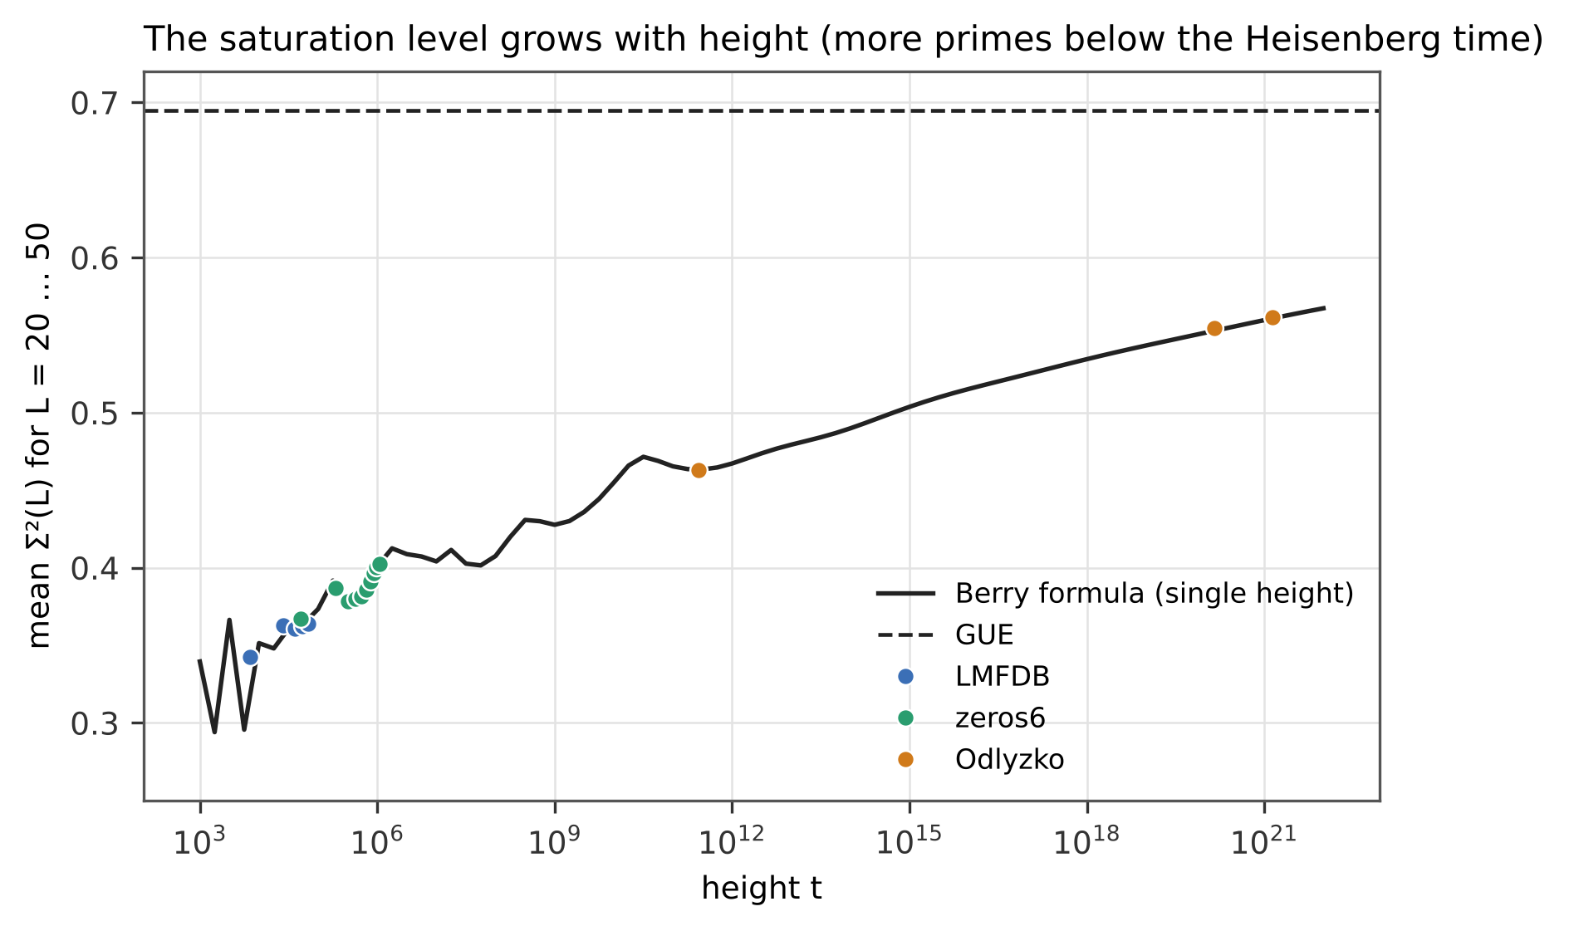
Figure 3. Saturation level (mean $Σ^{2}$ over $L=20…50$) in 18 blocks against height, with Berry’s formula evaluated at a single height (line) and the GUE value (dashed).

4.4 Spectral rigidity
$Δ_{3}$ measured on 800 windows and $Δ_{3}$ computed from Berry’s $Σ^{2}$ agree within 3.3 % (mean 1.5 %; the scatter is statistical) (Figure 4). At short windows the zeros coincide with GUE ($Δ_{3}\left(2\right)=0.094$ for both); at long windows they saturate below GUE: $Δ_{3}\left(100\right)=0.17$ ($t≈{10}^{4}$) to $0.26$ ($t≈{10}^{21}$) against GUE 0.29 and the crystal value $1/12≈0.083$.
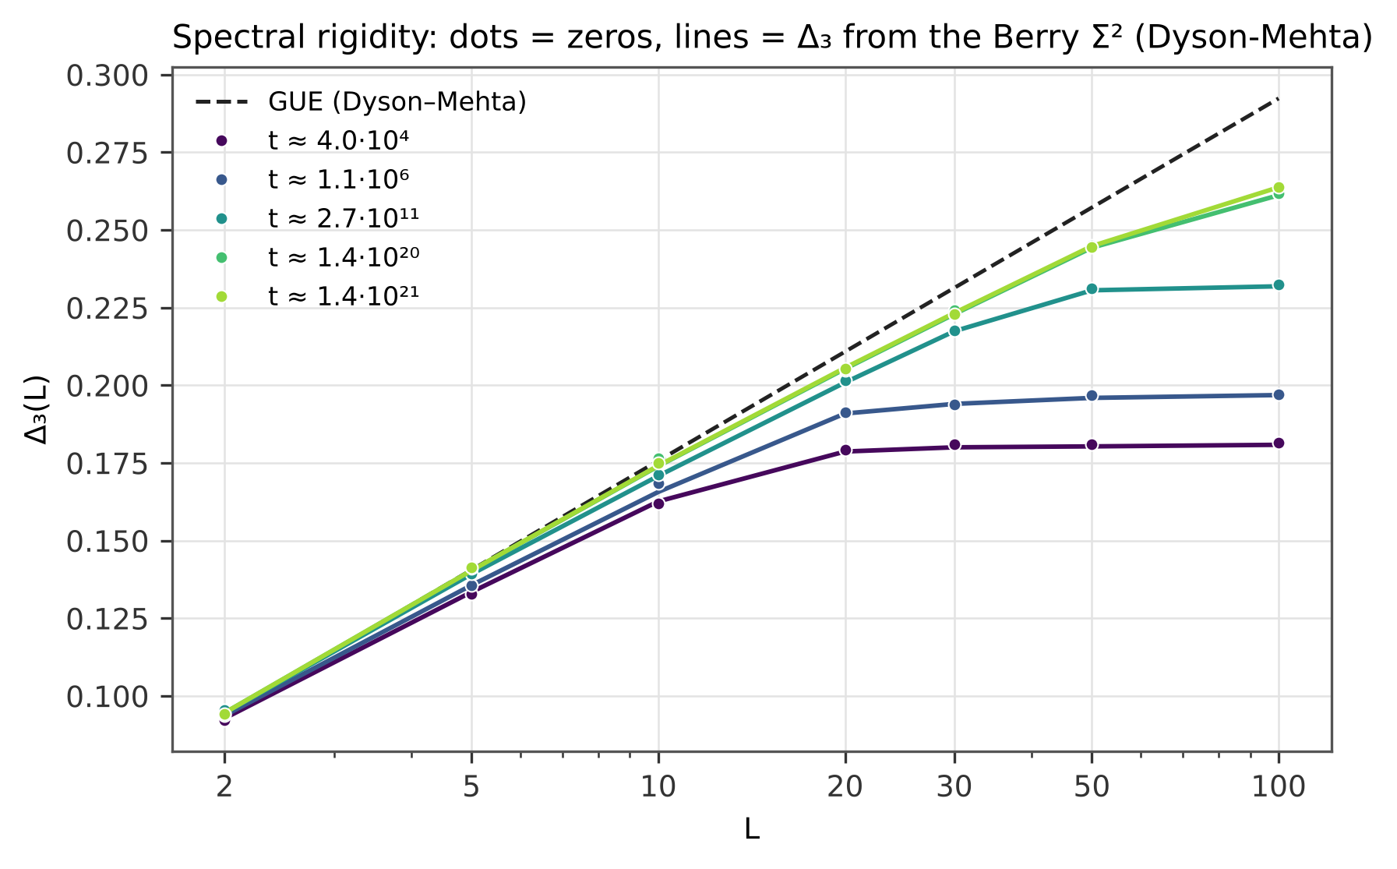
Figure 4. Spectral rigidity $Δ_{3}\left(L\right)$: measured on 800 windows (dots) and computed from Berry’s $Σ^{2}$ through the Dyson–Mehta relation (lines); GUE dashed.

4.5 Small gaps
The share of unfolded gaps below 0.3 grows from 1.8 % (first 20,000 zeros) through 2.2 % (${10}^{5}$) and 2.4 % (${10}^{6}$) to 2.6 % ($3⋅{10}^{11}$ to ${10}^{21}$), against the GUE value 2.76 % (Figure 5). The approach is logarithmically slow, as predicted by the finite-height corrections of Bogomolny et al. [12].
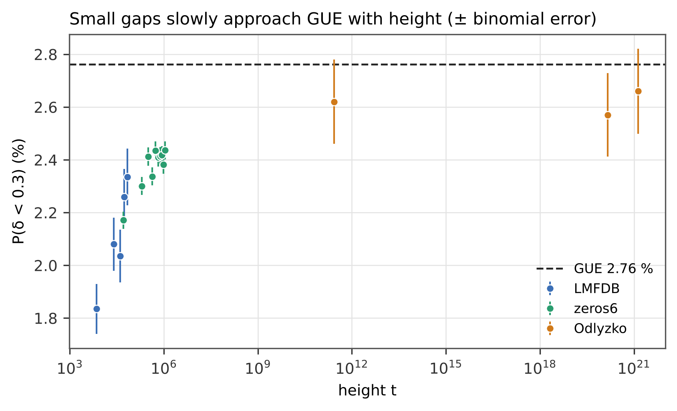
Figure 5. Share of unfolded gaps below 0.3 in each block with binomial error bars; GUE value dashed.

4.6 Primes in $S\left(t\right)$ at large heights
At the zeros no. ${10}^{22}+1…{10}^{22}+{10}^{4}$ ($t≈1.4⋅{10}^{21}$) the ratio $a\left(p\right)/\left(-1/π\sqrt{p}\right)$ equals 1.007, 1.010, 1.007, 0.996, 0.999, 0.999 for $p=2…13$ (Figure 6); near ${10}^{12}$ and ${10}^{21}$ also within 1.2 %. The decline of the ratio with $p$ seen at low heights (up to 12 % for the first ${10}^{4}$ zeros) is an effect of sampling $S\left(t\right)$ at the zeros and disappears with height.
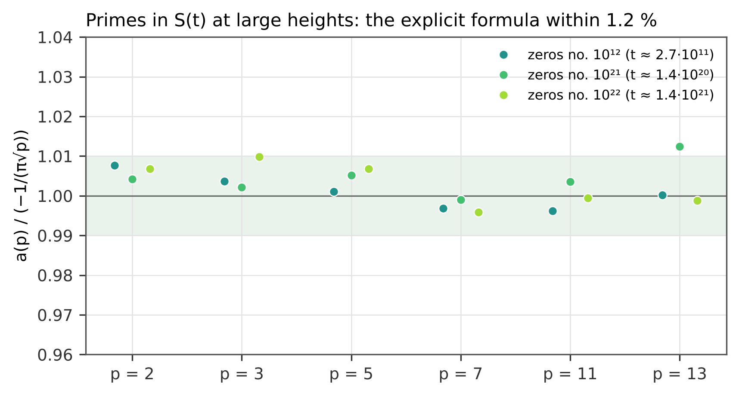
Figure 6. Projection of $S\left(t\right)$ on $sin\left(tlnp\right)$ divided by the explicit-formula amplitude $-1/\left(π\sqrt{p}\right)$ at Odlyzko’s heights; green band $±1 \%$.

4.7 The crossover scale
Defining the departure from GUE as the smallest $L^{*}$ at which the zeros lie 5 % (10 %) below GUE gives $L^{*}≈0.09$–$0.15 H$ ($0.21$–$0.37 H$), from $L^{*}=0.67$ at $H=7$ to $L^{*}=6.0$ at $H=46.8$, equal to the value from Berry’s formula (Figure 7). The transition is a smooth crossover whose scale grows with the Heisenberg time $ln\left(t/2π\right)$, not a sharp threshold; the threshold itself (5 % or 10 %) changes $L^{*}$ by a factor of about three.
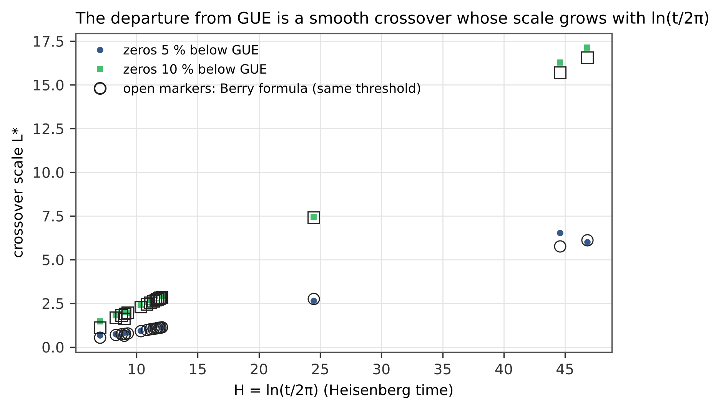
Figure 7. Crossover scale $L^{*}$ at which the zeros fall 5 % (circles) or 10 % (squares) below GUE, against $H=ln\left(t/2π\right)$; open markers: the same threshold applied to Berry’s formula.

4.8 Sieve for candidate spectra
candidate (20,000 levels) | density | GUE gaps | primes | saturation
true zeros | pass | pass | pass | pass
levels $xp$ (Berry–Keating) | pass | fail | fail | pass
$xp$ + prime orbits $p^{k}≤997$ | pass | pass | pass | pass
GUE matrix | pass | pass | fail | fail
GOE matrix | pass | fail | fail | fail
Poisson | fail | fail | fail | fail
zeros + noise $σ=0.3$ | pass | fail | fail | pass
A GUE random matrix reproduces the local statistics but has no prime content and no saturation. The levels of $xp$ completed by the prime orbits of the explicit formula pass all four stages — a construction that shows what an operator would have to contain, not an operator. The zeros of twelve Dirichlet $L$-functions $L\left(s,χ_{q}\right)$, $q=3…41$, pass with the weights $χ\left(p\right)$, and the sign of $a\left(p\right)$ equals $χ\left(p\right)$ in 67 of 67 pairs: the signal is the arithmetic of the particular function.

5. Discussion
Berry’s formula is the diagonal approximation of the explicit (trace) formula; its success over 17 orders of magnitude in height, without a free parameter, confirms that the long-range statistics of the zeros are fixed by the primes. The residual of about 1 % in the lowest blocks is consistent with the expected size of the off-diagonal (Hardy–Littlewood) corrections computed by Bogomolny and Keating [8] together with finite-sample noise; separating the two is the subject of follow-up work. The saturation and the other statistics follow from the arithmetic of the primes, not from the position of the zeros: they neither confirm nor refute the Riemann hypothesis, and no self-adjoint operator with this spectrum is known (Hilbert–Pólya remains open). Berry compared his formula with Odlyzko’s zeros near ${10}^{12}$ in 1988; the present study repeats that comparison and extends it to ${10}^{21}$, ${10}^{22}$ and two million low zeros with independent checks.

6. Reproducibility
The script compute_rigidity.py recomputes every number of Sections 4.1–4.7 from the original text files of zeros (LMFDB, Odlyzko), and figures.py draws every figure from its output. The script independent_check.py recomputes the same quantities with partly different algorithms (primes by a segmented sieve, the prime tail above ${10}^{6}$ and $Δ_{3}$ from Berry’s $Σ^{2}$ by quadrature) and agrees within ${10}^{-11}$. The results of the sieve (Section 4.8) are given as data. The computations were developed and verified in the protected MAYAN ALFA V1008 laboratory (internal, version 34.47; mayanalfa.com), which is not part of this package. The package lists the SHA-256 hash of every file. Text, figures and data are released under the Creative Commons Attribution 4.0 International licence (CC BY 4.0); the scripts under the MIT licence.

References
- Montgomery, H. L. (1973). The pair correlation of zeros of the zeta function. Proc. Symp. Pure Math. 24, 181–193.
- Berry, M. V. (1985). Semiclassical theory of spectral rigidity. Proc. R. Soc. A 400, 229–251.
- Berry, M. V. (1988). Semiclassical formula for the number variance of the Riemann zeros. Nonlinearity 1, 399–407.
- Odlyzko, A. M. (1987). On the distribution of spacings between zeros of the zeta function. Math. Comp. 48, 273–308.
- Dyson, F. J. & Mehta, M. L. (1963). Statistical theory of the energy levels of complex systems. IV. J. Math. Phys. 4, 701–712.
- Mehta, M. L. (2004). Random Matrices, 3rd ed. Academic Press.
- Berry, M. V. & Keating, J. P. (1999). The Riemann zeros and eigenvalue asymptotics. SIAM Rev. 41, 236–266.
- Bogomolny, E. B. & Keating, J. P. (1996). Gutzwiller’s trace formula and spectral statistics: beyond the diagonal approximation. Phys. Rev. Lett. 77, 1472–1475.
- Gonek, S. M., Hughes, C. P. & Keating, J. P. (2007). A hybrid Euler–Hadamard product for the Riemann zeta function. Duke Math. J. 136, 507–549.
- Dumitriu, I. & Edelman, A. (2002). Matrix models for beta ensembles. J. Math. Phys. 43, 5830–5847.
- The LMFDB Collaboration. The L-functions and Modular Forms Database. https://www.lmfdb.org/
- Bogomolny, E., Bohigas, O., Leboeuf, P. & Monastra, A. G. (2006). On the spacing distribution of the Riemann zeros: corrections to the asymptotic result. J. Phys. A 39, 10743–10754.
- Odlyzko, A. M. Tables of zeros of the Riemann zeta function. https://www-users.cse.umn.edu/~odlyzko/zeta_tables/

