**PIPELINE PROCESSOR DESIGN**

* **Diagram**

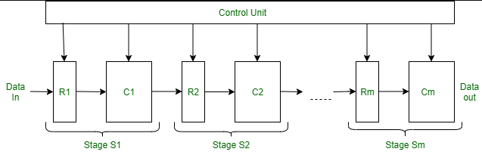

**CODE**

module pipelined_processor (

input wire clk,

input wire reset,

output reg [7:0] result

);

// Define pipeline registers

reg [15:0] IF_ID; // Instruction fetched

reg [15:0] ID_EX; // Decoded instruction

reg [15:0] EX_MEM; // Execution result or address

reg [7:0] MEM_WB; // Final result

// Memory and registers

reg [15:0] instruction_memory [0:15];

reg [7:0] data_memory [0:15];

reg [7:0] register_file [0:7];

// Instruction breakdown

wire [3:0] opcode;

wire [2:0] rs, rt, rd;

wire [7:0] immediate;

assign opcode = ID_EX[15:12];

assign rs = ID_EX[11:9];

assign rt = ID_EX[8:6];

assign rd = ID_EX[5:3];

assign immediate = ID_EX[7:0];

// Program Counter

reg [3:0] pc;

// Initialize memory and registers

initial begin

pc = 0;

result = 0;

IF_ID = 0; ID_EX = 0; EX_MEM = 0; MEM_WB = 0;

// Load instructions

instruction_memory[0] = 16'b0001_000_001_010_00; // ADD R2 = R0 + R1

instruction_memory[1] = 16'b0010_010_001_011_00; // SUB R3 = R2 - R1

instruction_memory[2] = 16'b0011_000_011_000001; // LOAD R0 = MEM[R3 + 1]

// Initialize registers

register_file[0] = 8'h05; // R0 = 5

register_file[1] = 8'h03; // R1 = 3

register_file[2] = 8'h00; // R2

register_file[3] = 8'h00; // R3

end

// Clock-driven operation

always @(posedge clk or posedge reset) begin

if (reset) begin

pc <= 0;

IF_ID <= 0; ID_EX <= 0; EX_MEM <= 0; MEM_WB <= 0;

end else begin

// Instruction Fetch (IF)

IF_ID <= instruction_memory[pc];

pc <= pc + 1;

// Instruction Decode (ID)

ID_EX <= IF_ID;

// Execute (EX)

case (opcode)

4'b0001: EX_MEM <= {8'b0, register_file[rs] + register_file[rt]}; // ADD

4'b0010: EX_MEM <= {8'b0, register_file[rs] - register_file[rt]}; // SUB

4'b0011: EX_MEM <= {register_file[rs] + immediate, 8'b0}; // LOAD Address

default: EX_MEM <= 16'b0;

endcase

// Memory Access (MEM)

if (opcode == 4'b0011) begin

MEM_WB <= data_memory[EX_MEM[15:8]]; // LOAD

end else begin

MEM_WB <= EX_MEM[7:0]; // Pass result for ADD/SUB

end

// Write Back

if (opcode != 4'b0011) begin

register_file[rd] <= MEM_WB;

end

result <= MEM_WB;

end

end

endmodule

module testbench;

reg clk;

reg reset;

wire [7:0] result;

// Instantiate the processor

pipelined_processor uut (

.clk(clk),

.reset(reset),

.result(result)

);

// Clock generation

initial begin

clk = 0;

forever #5 clk = ~clk; // 10 ns clock period

end

// Simulation sequence

initial begin

reset = 1;

#10 reset = 0; // Release reset

#100 $finish; // End simulation after 100 ns

end

endmodule

**Simulation**

The simulation will show the following sequence

| **Cycle** | **Stage** | **Instruction** | **Registers Updated** |
| --- | --- | --- | --- |
| 1 | IF | Fetch ADD R2, R0, R1 | - |
| 2 | ID | Decode ADD R2, R0, R1 | - |
| 3 | EX | Execute R2 = R0 + R1 | - |
| 4 | MEM | Write R2 = 8 | R2 updated |
| 5 | IF | Fetch SUB R3, R2, R1 | - |

* **WAVEFORM**

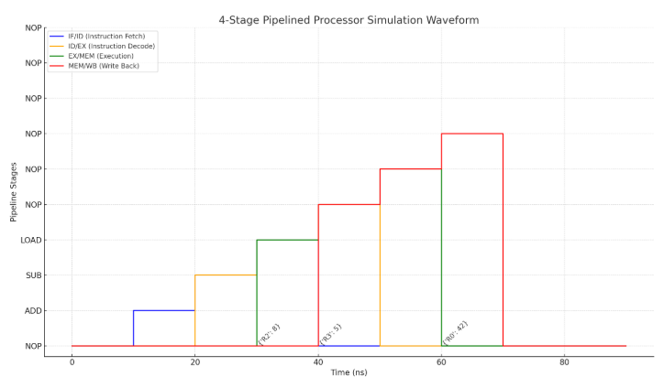

**Details**

1. **Stages:**
   * IF/ID: Fetching instructions.
   * ID/EX: Decoding and preparing operands.
   * EX/MEM: Executing arithmetic operations or calculating addresses.
   * MEM/WB: Accessing memory or writing back results.
2. **Register Updates:**
   * At specific time steps, the updated register values are annotated on the timeline:
     + Cycle 30 ns: R2 updated to 8 (result of ADD).
     + Cycle 40 ns: R3 updated to 5 (result of SUB).
     + Cycle 60 ns: R0 updated to 42 (result of LOAD).