**SUMMARY:**

The emerging RFID technology offers several features and advantages .This technology is undeniably powerful in terms of reliability, efficiency and accuracy. But, have you ever wondered what took RFID so long to become mainstream? Do you have an idea why investors were hesitant at first, before jumping into this modern technology? The simple answer is cost. Yes, the tags are highly expensive, and integrating RFID solutions to millions of items would mean high cost. But, will cost halt this technology from growing? Definitely not.

Before being entangled with the disadvantages, let's focus first on the basic principles of this technology. Together we'll learn the definition of RFID including its functions and components.

**What is RFID?**

RFID is an automated data collection technology that utilizes radio frequency waves to transfer data between a reader and a movable item in order to identify, categorize and track objects. Compared to conventional bar codes, it does not require physical line of sight or direct contact between the reader and tags. Basically, RFID devices are categorized as either active or passive.

## Active RFID

Active RFID uses tags that require power source for operation. They are either connected to a powered infrastructure or connected to a battery. When the power source is depleted, the active tags will no longer operate. The fact that having a battery embedded on the RFID package would make the product bulky, the use of active tags becomes impractical for retail trade.

## Passive RFID

This type of RFID uses passive tags. As opposed to the active ones, passive tags do not require a power source. It absorbs the energy propagated from a reader's radio frequency field to supply all the power it needs to operate. Passive tags are of interest because they do not require batteries or maintenance. The tags are also small enough to fit into a practical adhesive label.

## Components of RFID System

The RFID system is made up of few essential components. These components should work synchronously in order to achieve reliable data transmission and reception.

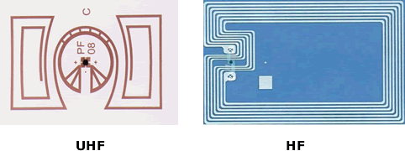

*RFID has been utilized in different trades, industries and businesses. It operates in different frequencies. The photo shows a tag that operates in HF (High Frequency) and UHF (Ultra-high Frequency).*| Source

## 1. RFID Tag

A tag is a transponder mounted on a substrate that is programmed with unique information. Tags are activated when they pass through a radio frequency field produced by the antenna of the reader.

## 2. Reader/Scanner

A reader (also known as transceiver or interrogator) handles radio communications through the antennas. A reader can transmit signals to a tag, synchronize a tag with the reader, and interrogates all or part of the tag's contents. Thus, the main purpose of the reader is to transmit and collect information.

## What's on your mind?

### If you were an investor or a business owner, would you choose to require RFID tags on all of your materials?

Top of Form

* Yes, RFID will do its best in providing reliable inventories. The benefits it can offer outweighs the cost.
* Probably No. The tags are quite expensive, it becomes impractical to put tags on all of the items. I will stick to conventional bar codes - they are less expensive.
* Maybe later. I need to read more about this emerging technology. Just want to weigh things out first.

[See results](https://turbofuture.com/industrial/What-is-RFID-technology-types-of-RFID-tags-RFID-reader-and-components)

Bottom of Form

## 3. Antenna

An antenna consists of a coil with a winding and a matching network. The primary purpose of an antenna is to radiate the electromagnetic waves produced by the reader, and in the same manner, receives radio frequency signals from the transponder.

## 4. Reader Interface Layer

The reader interface layer is used as a conduit between the readers and the hardware elements such as computers.

## How to Choose the Right RFID?

So, you decided to utilize this technology in your business. Below are the factors you should consider in choosing the right RFID.

## Frequency Range

The system utilizes electromagnetic waves, typically in Low Frequency (LF), High Frequency (HF) and Ultra High Frequency (UHF) band. In order to communicate, the tags and readers should operate in the same frequency

Bandwidth is a scarce resource, and because of this limitation, each country has regulations that specify the frequency ranges for RFID transmissions. When choosing an antenna, make sure to select the frequency range that is applicable for your region, or else your system will not work

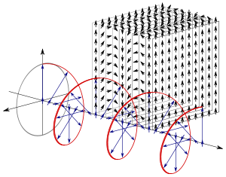

*The photo depicts a circularly polarized electromagnetic plane wave. The varying direction of the electric field along the axis of propagation is represented by the red helix. Each blue vector, indicating the perpendicular displacement*| Source

## Polarization

Most RFID antennas are either circularly polarized or linearly polarized. When we say that the antennas are linearly polarized, we mean to say that the antennas send radio frequency waves in a single plane (either horizontally or vertically). On the other hand, circularly polarized antennas send radio frequency waves in a circular motion, either clockwise or counterclockwise. When antennas face each other and emit waves in the same direction, null zones may occur where the waves overlap. Thus, it is important to determine the polarization of your antennas so as to maximize the functionality of RFID.

## Gain

Choose antennas with higher gain. The higher the gain, the narrower the beam width. Although higher gain antennas create a narrower area of coverage, but narrower beam will travel a longer distance.