WHO SEARO Daily Flood Early Warning Brief — 2026-10-31
Generated 2026-10-31 12:14 IST

Verdict (triage)
ALERT: India
WATCH: Nepal, Sri Lanka, Thailand
STABLE: Bangladesh, Myanmar

Flood Hub — country gauge summary
country | tier | total_gauges | Warning | Danger | Extreme | new_danger | new_extreme | cleared_hot
Bangladesh | STABLE | 894 | 0 | 0 | 0 | 0 | 0 | 0
India | ALERT | 16,340 | 63 | 15 | 0 | 0 | 0 | 5
Myanmar | STABLE | 3,177 | 0 | 0 | 0 | 0 | 0 | 0
Nepal | WATCH | 765 | 0 | 0 | 0 | 0 | 0 | 0
Sri Lanka | WATCH | 310 | 1 | 0 | 0 | 0 | 0 | 0
Thailand | WATCH | 2,143 | 0 | 0 | 0 | 0 | 0 | 0
ALERT: ≥1 Extreme gauge; or Danger gauges plus a GDACS orange/red flood/cyclone for that country; or newly elevated hot gauges with ≥3 Danger gauges.
WATCH: ≥1 Danger gauge, a GDACS orange/red hit, urban flash-flood signal (next ~24h), and/or newly elevated hot gauges — without meeting ALERT criteria.
STABLE: No Danger/Extreme gauges, no GDACS orange/red, and no urban flash-flood signal for that country.

Urban flash floods — next ~24 hours (SEARO)
country | iso2 | events | highly_likely_events | likely_events | period_hours | latest_issue
India | IN | 15 | 0 | 15 | 24 | 2026-10-31T00:36:01.593789Z
Thailand | TH | 6 | 0 | 6 | 24 | 2026-10-31T00:36:01.593789Z
Nepal | NP | 1 | 0 | 1 | 24 | 2026-10-31T00:36:01.593789Z
Sri Lanka | LK | 1 | 0 | 1 | 24 | 2026-10-31T00:36:01.593789Z
Urban flash floods: Flood Hub model of flash-flood likelihood in urban areas over the next ~24 hours (~20 km). Highly likely = stronger polygon signal. Decision support only — verify with national met/hydro.

GDACS — SEARO floods & cyclones (last 7 days)
alert_level | event_type | country | name | from_date | url
red | TC | India | Tropical Cyclone ARNAB-26 | 2026-10-26T00:00:00 | https://www.gdacs.org/report.aspx?eventid=1001345&episodeid=10&eventtype=TC
green | FL | India | Flood in India | 2026-10-20T01:00:00 | https://www.gdacs.org/report.aspx?eventid=1104248&episodeid=3&eventtype=FL
green | FL | Thailand | Flood in Thailand | 2026-10-18T01:00:00 | https://www.gdacs.org/report.aspx?eventid=1104241&episodeid=3&eventtype=FL

Flood Hub significant events (SEARO filter)
None touching SEARO right now.

Admin-1 screen (Danger/Extreme gauges only)
country | region_code | ADM1 | Danger | Extreme | hot_gauges
India | IN | Andhra Pradesh | 5 | 0 | 5
India | IN | Odisha | 5 | 0 | 5
India | IN | Rajasthan | 1 | 0 | 1
Hot gauges: Flood Hub stations currently at Danger (severe) or Extreme severity. Admin-1 units are listed only if they contain ≥1 hot gauge; use as a geographic filter and verify with gauges + national met/hydro before acting.

OpenMeteo Forecasting
Forecast data collected for 229 locations from 31 October 2026 to 06 November 2026. Across this forecast period, 11 Warning and 164 Watch alerts were identified (counts represent location–date forecasts).

Warning reasons: Daily rainfall above 100 mm; Extreme rainfall; Thunderstorm with hail.
Watch reasons: Heavy rain; Heavy rain showers; Heavy snow; Heavy snow showers; Thunderstorm.

Daily forecast alerts by location
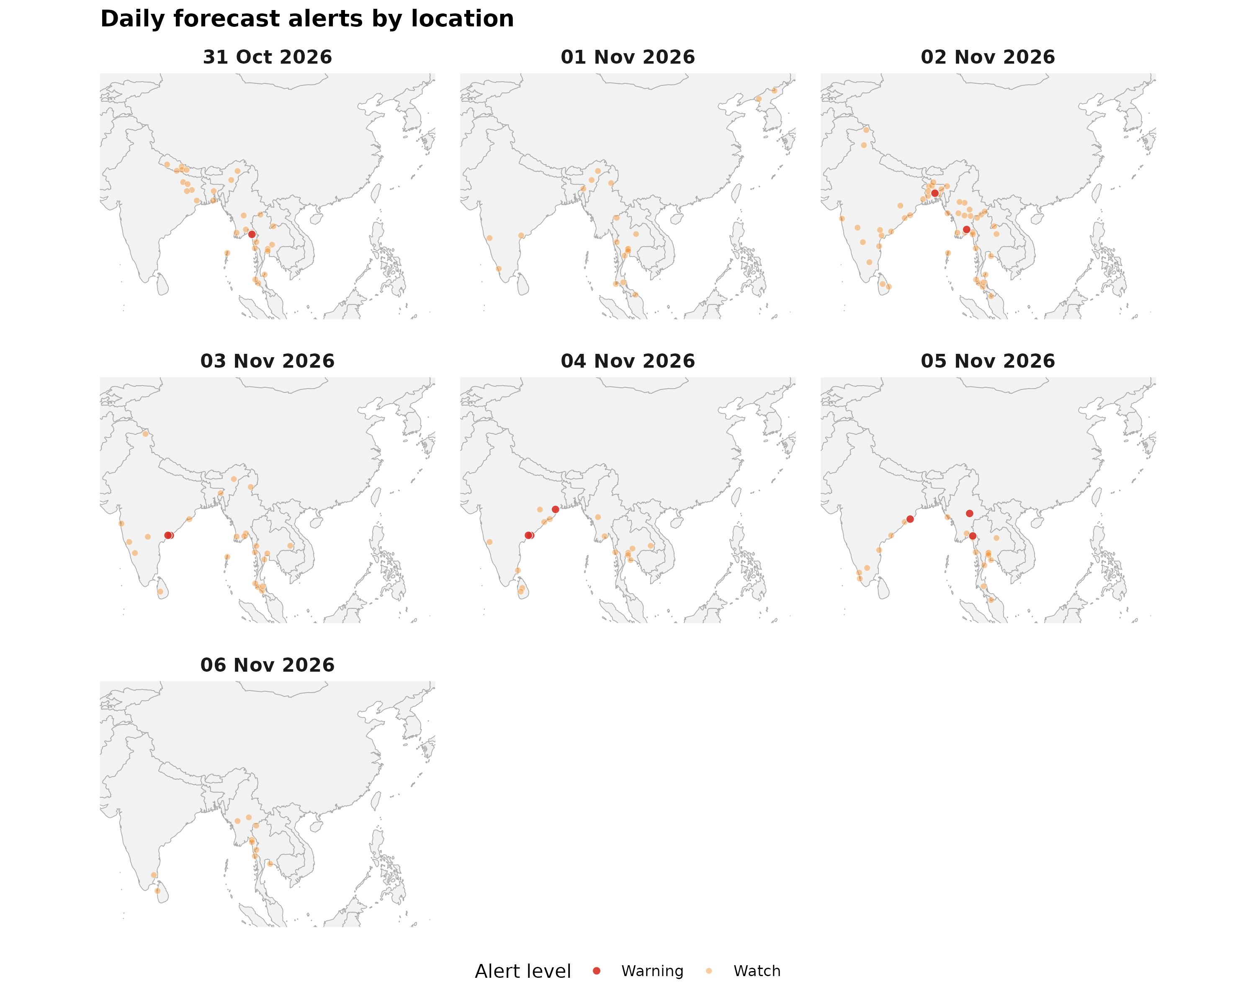

Forecast alerts by country
Country | Warning | Watch | Alert_Reasons
India | 6 | 51 | Daily rainfall above 100 mm; Extreme rainfall; Heavy rain showers; Heavy snow showers; Thunderstorm; Thunderstorm with hail
Myanmar | 4 | 35 | Thunderstorm; Thunderstorm with hail
Bangladesh | 1 | 10 | Thunderstorm; Thunderstorm with hail
Thailand | 0 | 55 | Thunderstorm
Sri Lanka | 0 | 6 | Thunderstorm
Nepal | 0 | 5 | Heavy rain showers; Thunderstorm
DPR Korea | 0 | 2 | Heavy rain; Heavy snow
Bhutan | 0 | 0 | —
Maldives | 0 | 0 | —
Timor-Leste | 0 | 0 | —

Forecast alerts by state/province
Country | State | Warning | Watch | Total
India | Andhra Pradesh | 4 | 6 | 10
India | Odisha | 2 | 8 | 10
Myanmar | Bago Region | 1 | 3 | 4
Myanmar | Kayin State | 1 | 3 | 4
Myanmar | Mon State | 1 | 3 | 4
Bangladesh | Dhaka Division | 1 | 2 | 3
Myanmar | Shan State | 1 | 2 | 3
Myanmar | Tanintharyi Region | 0 | 6 | 6
India | Karnataka | 0 | 5 | 5
India | Assam | 0 | 4 | 4
Thailand | Kanchanaburi | 0 | 4 | 4
Thailand | Nakhon Si Thammarat | 0 | 4 | 4
Thailand | Pathum Thani | 0 | 4 | 4
Thailand | Rayong | 0 | 4 | 4
Thailand | Samut Prakan | 0 | 4 | 4
India | Andaman and Nicobar Islands | 0 | 3 | 3
India | Kerala | 0 | 3 | 3
India | Maharashtra | 0 | 3 | 3
India | Tamil Nadu | 0 | 3 | 3
Myanmar | Ayeyarwady Region | 0 | 3 | 3
Myanmar | Magway Region | 0 | 3 | 3
Myanmar | Yangon Region | 0 | 3 | 3
Thailand | Khon Kaen | 0 | 3 | 3
Thailand | Krabi | 0 | 3 | 3
Thailand | Mae Hong Son | 0 | 3 | 3
Thailand | Nonthaburi | 0 | 3 | 3
Thailand | Phang Nga | 0 | 3 | 3
Bangladesh | Rajshahi Division | 0 | 2 | 2
Bangladesh | Sylhet Division | 0 | 2 | 2
India | Bihar | 0 | 2 | 2
India | Jharkhand | 0 | 2 | 2
India | Ladakh | 0 | 2 | 2
India | Nagaland | 0 | 2 | 2
India | Telangana | 0 | 2 | 2
India | West Bengal | 0 | 2 | 2
Myanmar | Kachin State | 0 | 2 | 2
Myanmar | Naypyidaw Union Territory | 0 | 2 | 2
Myanmar | Rakhine State | 0 | 2 | 2
Nepal | Bagmati Province | 0 | 2 | 2
Sri Lanka | Central Province | 0 | 2 | 2
Sri Lanka | Sabaragamuwa Province | 0 | 2 | 2
Thailand | Chiang Mai | 0 | 2 | 2
Thailand | Loei | 0 | 2 | 2
Thailand | Nakhon Ratchasima | 0 | 2 | 2
Thailand | Phetchaburi | 0 | 2 | 2
Thailand | Surat Thani | 0 | 2 | 2
Thailand | Trang | 0 | 2 | 2
Thailand | Ubon Ratchathani | 0 | 2 | 2
Thailand | Yala | 0 | 2 | 2
Bangladesh | Barisal Division | 0 | 1 | 1
Bangladesh | Chattogram Division | 0 | 1 | 1
Bangladesh | Khulna Division | 0 | 1 | 1
Bangladesh | Mymensingh Division | 0 | 1 | 1
DPR Korea | North Pyongan Province | 0 | 1 | 1
DPR Korea | Ryanggang Province | 0 | 1 | 1
India | Himachal Pradesh | 0 | 1 | 1
India | Meghalaya | 0 | 1 | 1
India | Puducherry | 0 | 1 | 1
India | Tripura | 0 | 1 | 1
Myanmar | Kayah State | 0 | 1 | 1
Myanmar | Mandalay Region | 0 | 1 | 1
Myanmar | Sagaing Region | 0 | 1 | 1
Nepal | Gandaki Province | 0 | 1 | 1
Nepal | Karnali Province | 0 | 1 | 1
Nepal | Lumbini Province | 0 | 1 | 1
Sri Lanka | Eastern Province | 0 | 1 | 1
Sri Lanka | North Western Province | 0 | 1 | 1
Thailand | Chiang Rai | 0 | 1 | 1
Thailand | Narathiwat | 0 | 1 | 1
Thailand | Phuket | 0 | 1 | 1
Thailand | Prachuap Khiri Khan | 0 | 1 | 1
Source: Open-Meteo. Alert counts represent location–date forecast rows across all forecast dates. Forecast alerts use WMO weather codes and country-specific thresholds for Bangladesh, Bhutan, India, Thailand, Nepal, and Sri Lanka, informed by national meteorological and disaster-management agencies. Custom rules apply where unavailable. The highest triggered severity determines the forecast alert level: Normal, Advisory, Watch, or Warning. These indicators are not official agency warnings.

Met / hydro verification checklist
[ ] India — https://mausam.imd.gov.in/ / https://ffs.india-water.gov.in/
[ ] Nepal — https://www.dhm.gov.np/
[ ] Sri Lanka — https://www.meteo.gov.lk/ / https://www.irrigation.gov.lk/
[ ] Thailand — https://www.tmd.go.th/ / https://www.thaiwater.net/

Sources: Google Flood Forecasting API / Flood Hub (gauges, significant events, urban flash floods); GDACS; national NMHS/hydro. Decision support only — not an official WHO warning.

