WHO SEARO Daily Flood Early Warning Brief — 2026-10-30
Generated 2026-10-30 12:26 IST

Verdict (triage)
ALERT: India
WATCH: Bangladesh, Myanmar, Nepal, Sri Lanka, Thailand

Flood Hub — country gauge summary
country | tier | total_gauges | Warning | Danger | Extreme | new_danger | new_extreme | cleared_hot
Bangladesh | WATCH | 894 | 0 | 0 | 0 | 0 | 0 | 0
India | ALERT | 16,340 | 46 | 16 | 4 | 0 | 0 | 54
Myanmar | WATCH | 3,177 | 0 | 0 | 0 | 0 | 0 | 0
Nepal | WATCH | 765 | 0 | 0 | 0 | 0 | 0 | 0
Sri Lanka | WATCH | 310 | 1 | 0 | 0 | 0 | 0 | 0
Thailand | WATCH | 2,143 | 2 | 0 | 0 | 0 | 0 | 0
ALERT: ≥1 Extreme gauge; or Danger gauges plus a GDACS orange/red flood/cyclone for that country; or newly elevated hot gauges with ≥3 Danger gauges.
WATCH: ≥1 Danger gauge, a GDACS orange/red hit, urban flash-flood signal (next ~24h), and/or newly elevated hot gauges — without meeting ALERT criteria.
STABLE: No Danger/Extreme gauges, no GDACS orange/red, and no urban flash-flood signal for that country.

Urban flash floods — next ~24 hours (SEARO)
country | iso2 | events | highly_likely_events | likely_events | period_hours | latest_issue
Thailand | TH | 16 | 2 | 16 | 24 | 2026-10-30T00:33:40.028541Z
India | IN | 13 | 2 | 13 | 24 | 2026-10-30T00:33:40.028541Z
Nepal | NP | 3 | 1 | 3 | 24 | 2026-10-30T00:33:40.028541Z
Bangladesh | BD | 2 | 0 | 2 | 24 | 2026-10-30T00:33:40.028541Z
Myanmar | MM | 2 | 0 | 2 | 24 | 2026-10-30T00:33:40.028541Z
Sri Lanka | LK | 1 | 0 | 1 | 24 | 2026-10-30T00:33:40.028541Z
Urban flash floods: Flood Hub model of flash-flood likelihood in urban areas over the next ~24 hours (~20 km). Highly likely = stronger polygon signal. Decision support only — verify with national met/hydro.

GDACS — SEARO floods & cyclones (last 7 days)
alert_level | event_type | country | name | from_date | url
red | TC | India | Tropical Cyclone ARNAB-26 | 2026-10-26T00:00:00 | https://www.gdacs.org/report.aspx?eventid=1001345&episodeid=10&eventtype=TC
green | FL | Thailand | Flood in Thailand | 2026-10-18T01:00:00 | https://www.gdacs.org/report.aspx?eventid=1104241&episodeid=3&eventtype=FL

Flood Hub significant events (SEARO filter)
None touching SEARO right now.

Admin-1 screen (Danger/Extreme gauges only)
country | region_code | ADM1 | Danger | Extreme | hot_gauges
India | IN | Andhra Pradesh | 7 | 2 | 9
India | IN | Odisha | 5 | 1 | 6
India | IN | Rajasthan | 1 | 0 | 1
Hot gauges: Flood Hub stations currently at Danger (severe) or Extreme severity. Admin-1 units are listed only if they contain ≥1 hot gauge; use as a geographic filter and verify with gauges + national met/hydro before acting.

OpenMeteo Forecasting
Forecast data collected for 229 locations from 30 October 2026 to 05 November 2026. Across this forecast period, 8 Warning and 174 Watch alerts were identified (counts represent location–date forecasts).

Warning reasons: Thunderstorm with hail.
Watch reasons: Heavy rain; Heavy rain showers; Heavy snow; Heavy snow showers; Thunderstorm.

Daily forecast alerts by location
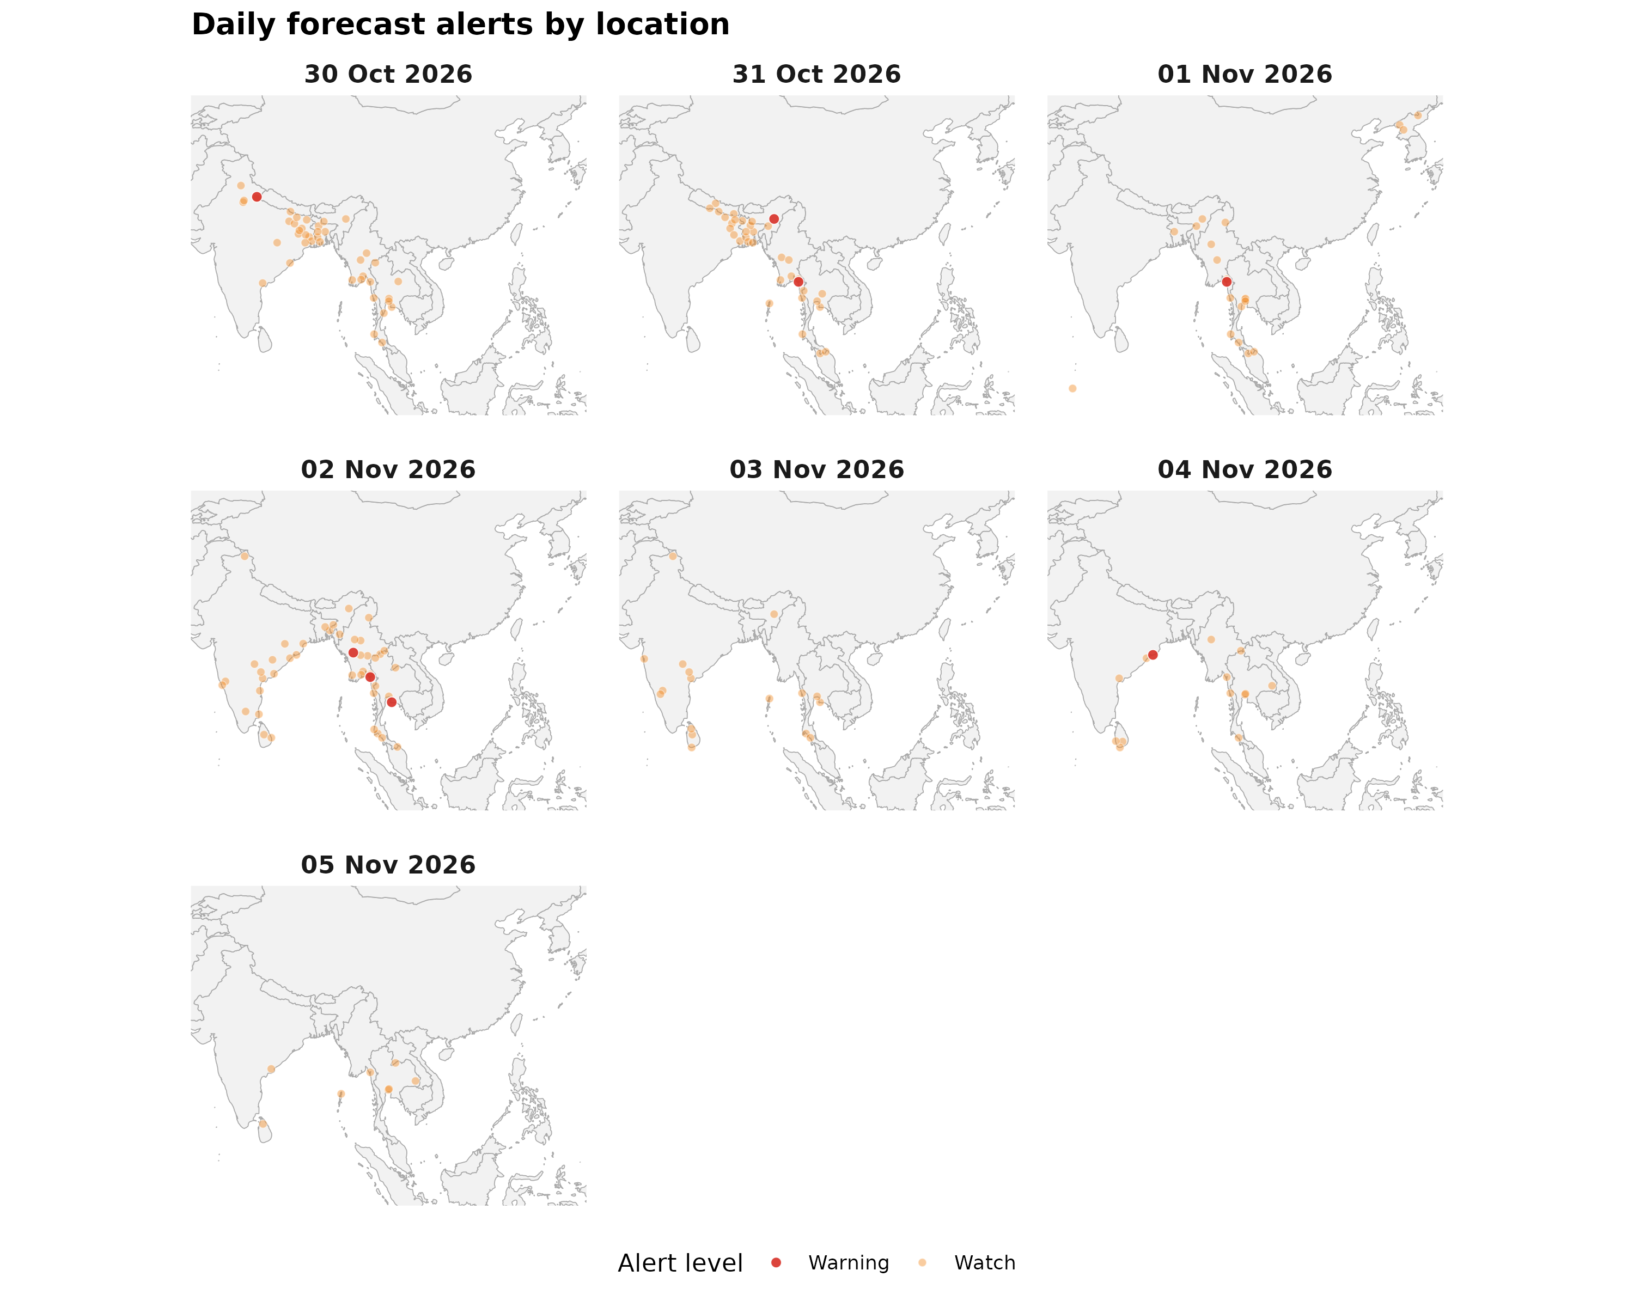

Forecast alerts by country
Country | Warning | Watch | Alert_Reasons
Myanmar | 4 | 33 | Thunderstorm; Thunderstorm with hail
India | 3 | 61 | Heavy rain showers; Heavy snow showers; Thunderstorm; Thunderstorm with hail
Thailand | 1 | 46 | Thunderstorm; Thunderstorm with hail
Bangladesh | 0 | 16 | Thunderstorm
Sri Lanka | 0 | 9 | Thunderstorm
Nepal | 0 | 5 | Thunderstorm
DPR Korea | 0 | 3 | Heavy rain; Heavy snow
Maldives | 0 | 1 | Thunderstorm
Bhutan | 0 | 0 | —
Timor-Leste | 0 | 0 | —

Forecast alerts by state/province
Country | State | Warning | Watch | Total
Myanmar | Mon State | 3 | 3 | 6
India | Odisha | 1 | 6 | 7
India | Nagaland | 1 | 3 | 4
Thailand | Rayong | 1 | 3 | 4
India | Uttarakhand | 1 | 1 | 2
Myanmar | Magway Region | 1 | 1 | 2
India | Andhra Pradesh | 0 | 7 | 7
India | Bihar | 0 | 7 | 7
India | West Bengal | 0 | 6 | 6
Myanmar | Tanintharyi Region | 0 | 6 | 6
Thailand | Samut Prakan | 0 | 5 | 5
Thailand | Trang | 0 | 5 | 5
Bangladesh | Khulna Division | 0 | 4 | 4
Bangladesh | Rajshahi Division | 0 | 4 | 4
India | Jharkhand | 0 | 4 | 4
India | Telangana | 0 | 4 | 4
Myanmar | Naypyidaw Union Territory | 0 | 4 | 4
Thailand | Pathum Thani | 0 | 4 | 4
Thailand | Phang Nga | 0 | 4 | 4
Bangladesh | Dhaka Division | 0 | 3 | 3
India | Andaman and Nicobar Islands | 0 | 3 | 3
India | Assam | 0 | 3 | 3
India | Karnataka | 0 | 3 | 3
Myanmar | Ayeyarwady Region | 0 | 3 | 3
Myanmar | Bago Region | 0 | 3 | 3
Myanmar | Kayin State | 0 | 3 | 3
Myanmar | Sagaing Region | 0 | 3 | 3
Thailand | Narathiwat | 0 | 3 | 3
Thailand | Nonthaburi | 0 | 3 | 3
India | Chhattisgarh | 0 | 2 | 2
India | Ladakh | 0 | 2 | 2
India | Meghalaya | 0 | 2 | 2
Myanmar | Kachin State | 0 | 2 | 2
Myanmar | Yangon Region | 0 | 2 | 2
Nepal | Madhesh Province | 0 | 2 | 2
Sri Lanka | Central Province | 0 | 2 | 2
Sri Lanka | Northern Province | 0 | 2 | 2
Sri Lanka | Southern Province | 0 | 2 | 2
Thailand | Chiang Rai | 0 | 2 | 2
Thailand | Kanchanaburi | 0 | 2 | 2
Thailand | Krabi | 0 | 2 | 2
Thailand | Loei | 0 | 2 | 2
Thailand | Mae Hong Son | 0 | 2 | 2
Thailand | Ubon Ratchathani | 0 | 2 | 2
Thailand | Yala | 0 | 2 | 2
Bangladesh | Barisal Division | 0 | 1 | 1
Bangladesh | Chattogram Division | 0 | 1 | 1
Bangladesh | Mymensingh Division | 0 | 1 | 1
Bangladesh | Rangpur Division | 0 | 1 | 1
Bangladesh | Sylhet Division | 0 | 1 | 1
DPR Korea | North Pyongan Province | 0 | 1 | 1
DPR Korea | Ryanggang Province | 0 | 1 | 1
DPR Korea | South Pyongan Province | 0 | 1 | 1
India | Goa | 0 | 1 | 1
India | Haryana | 0 | 1 | 1
India | Himachal Pradesh | 0 | 1 | 1
India | Maharashtra | 0 | 1 | 1
India | Mizoram | 0 | 1 | 1
India | Puducherry | 0 | 1 | 1
India | Tamil Nadu | 0 | 1 | 1
India | Uttar Pradesh | 0 | 1 | 1
Maldives | Gaafu Dhaalu Atoll | 0 | 1 | 1
Myanmar | Kayah State | 0 | 1 | 1
Myanmar | Mandalay Region | 0 | 1 | 1
Myanmar | Shan State | 0 | 1 | 1
Nepal | Gandaki Province | 0 | 1 | 1
Nepal | Koshi Province | 0 | 1 | 1
Nepal | Lumbini Province | 0 | 1 | 1
Sri Lanka | Eastern Province | 0 | 1 | 1
Sri Lanka | Uva Province | 0 | 1 | 1
Sri Lanka | Western Province | 0 | 1 | 1
Thailand | Chiang Mai | 0 | 1 | 1
Thailand | Khon Kaen | 0 | 1 | 1
Thailand | Nakhon Ratchasima | 0 | 1 | 1
Thailand | Phetchaburi | 0 | 1 | 1
Thailand | Prachuap Khiri Khan | 0 | 1 | 1
Source: Open-Meteo. Alert counts represent location–date forecast rows across all forecast dates. Forecast alerts use WMO weather codes and country-specific thresholds for Bangladesh, Bhutan, India, Thailand, Nepal, and Sri Lanka, informed by national meteorological and disaster-management agencies. Custom rules apply where unavailable. The highest triggered severity determines the forecast alert level: Normal, Advisory, Watch, or Warning. These indicators are not official agency warnings.

Met / hydro verification checklist
[ ] Bangladesh — https://www.bmd.gov.bd/ / https://www.ffwc.gov.bd/
[ ] India — https://mausam.imd.gov.in/ / https://ffs.india-water.gov.in/
[ ] Myanmar — https://www.moezala.gov.mm/
[ ] Nepal — https://www.dhm.gov.np/
[ ] Sri Lanka — https://www.meteo.gov.lk/ / https://www.irrigation.gov.lk/
[ ] Thailand — https://www.tmd.go.th/ / https://www.thaiwater.net/

Sources: Google Flood Forecasting API / Flood Hub (gauges, significant events, urban flash floods); GDACS; national NMHS/hydro. Decision support only — not an official WHO warning.

