WHO SEARO Daily Flood Early Warning Brief — 2026-11-14
Generated 2026-11-14 12:57 IST

Verdict (triage)
WATCH: Thailand
STABLE: Bangladesh, India, Myanmar, Nepal, Sri Lanka

Flood Hub — country gauge summary
country | tier | total_gauges | Warning | Danger | Extreme | new_danger | new_extreme | cleared_hot
Bangladesh | STABLE | 894 | 0 | 0 | 0 | 0 | 0 | 0
India | STABLE | 16,340 | 1 | 0 | 0 | 0 | 0 | 0
Myanmar | STABLE | 3,177 | 13 | 0 | 0 | 0 | 0 | 0
Nepal | STABLE | 765 | 0 | 0 | 0 | 0 | 0 | 0
Sri Lanka | STABLE | 310 | 3 | 0 | 0 | 0 | 0 | 0
Thailand | WATCH | 2,143 | 1 | 0 | 0 | 0 | 0 | 0
ALERT: ≥1 Extreme gauge; or Danger gauges plus a GDACS orange/red flood/cyclone for that country; or newly elevated hot gauges with ≥3 Danger gauges.
WATCH: ≥1 Danger gauge, a GDACS orange/red hit, urban flash-flood signal (next ~24h), and/or newly elevated hot gauges — without meeting ALERT criteria.
STABLE: No Danger/Extreme gauges, no GDACS orange/red, and no urban flash-flood signal for that country.

Urban flash floods — next ~24 hours (SEARO)
country | iso2 | events | highly_likely_events | likely_events | period_hours | latest_issue
Thailand | TH | 4 | 0 | 4 | 24 | 2026-11-14T00:34:54.783010Z
Urban flash floods: Flood Hub model of flash-flood likelihood in urban areas over the next ~24 hours (~20 km). Highly likely = stronger polygon signal. Decision support only — verify with national met/hydro.

GDACS — SEARO floods & cyclones (last 7 days)
alert_level | event_type | country | name | from_date | url
green | FL | Myanmar | Flood in Myanmar | 2026-11-10T01:00:00 | https://www.gdacs.org/report.aspx?eventid=1104280&episodeid=1&eventtype=FL
green | FL | Thailand | Flood in Thailand | 2026-11-06T01:00:00 | https://www.gdacs.org/report.aspx?eventid=1104283&episodeid=1&eventtype=FL

Flood Hub significant events (SEARO filter)
None touching SEARO right now.

OpenMeteo Forecasting
Forecast data collected for 229 locations from 14 November 2026 to 20 November 2026. Across this forecast period, 1 Warning and 50 Watch alerts were identified (counts represent location–date forecasts).

Warning reasons: Daily rainfall above 100 mm.
Watch reasons: Cold; Heavy snow showers; Thunderstorm.

Daily forecast alerts by location
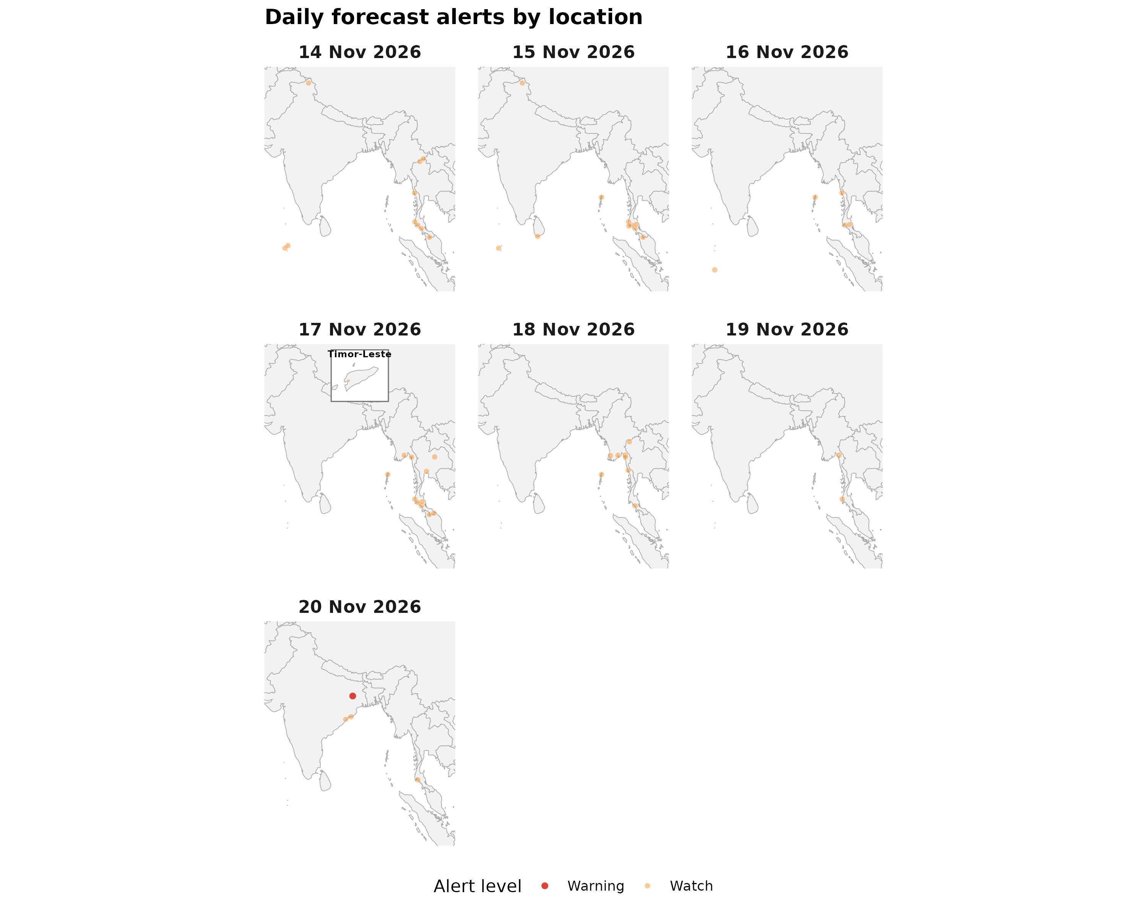

Forecast alerts by country
Country | Warning | Watch | Alert_Reasons
India | 1 | 8 | Daily rainfall above 100 mm; Heavy snow showers; Thunderstorm
Thailand | 0 | 26 | Cold; Thunderstorm
Myanmar | 0 | 10 | Thunderstorm
Maldives | 0 | 4 | Thunderstorm
Sri Lanka | 0 | 1 | Thunderstorm
Timor-Leste | 0 | 1 | Thunderstorm
Bangladesh | 0 | 0 | —
Bhutan | 0 | 0 | —
DPR Korea | 0 | 0 | —
Nepal | 0 | 0 | —

Forecast alerts by state/province
Country | State | Warning | Watch | Total
India | Jharkhand | 1 | 0 | 1
Thailand | Krabi | 0 | 5 | 5
India | Andaman and Nicobar Islands | 0 | 4 | 4
Thailand | Phang Nga | 0 | 4 | 4
Thailand | Trang | 0 | 4 | 4
Myanmar | Tanintharyi Region | 0 | 3 | 3
Thailand | Nakhon Si Thammarat | 0 | 3 | 3
Thailand | Yala | 0 | 3 | 3
India | Ladakh | 0 | 2 | 2
India | Odisha | 0 | 2 | 2
Maldives | Alif Dhaal Atoll | 0 | 2 | 2
Myanmar | Kayin State | 0 | 2 | 2
Myanmar | Mon State | 0 | 2 | 2
Myanmar | Yangon Region | 0 | 2 | 2
Maldives | Gnaviyani Atoll | 0 | 1 | 1
Maldives | Kaafu Atoll | 0 | 1 | 1
Myanmar | Ayeyarwady Region | 0 | 1 | 1
Sri Lanka | Southern Province | 0 | 1 | 1
Thailand | Chiang Mai | 0 | 1 | 1
Thailand | Chiang Rai | 0 | 1 | 1
Thailand | Khon Kaen | 0 | 1 | 1
Thailand | Mae Hong Son | 0 | 1 | 1
Thailand | Narathiwat | 0 | 1 | 1
Thailand | Nonthaburi | 0 | 1 | 1
Thailand | Phuket | 0 | 1 | 1
Timor-Leste | Bobonaro Municipality | 0 | 1 | 1
Source: Open-Meteo. Alert counts represent location–date forecast rows across all forecast dates. Forecast alerts use WMO weather codes and country-specific thresholds for Bangladesh, Bhutan, India, Thailand, Nepal, and Sri Lanka, informed by national meteorological and disaster-management agencies. Custom rules apply where unavailable. The highest triggered severity determines the forecast alert level: Normal, Advisory, Watch, or Warning. These indicators are not official agency warnings.

Met / hydro verification checklist
[ ] Thailand — https://www.tmd.go.th/ / https://www.thaiwater.net/

Sources: Google Flood Forecasting API / Flood Hub (gauges, significant events, urban flash floods); GDACS; national NMHS/hydro. Decision support only — not an official WHO warning.

