WHO SEARO Daily Flood Early Warning Brief — 2026-10-29
Generated 2026-10-29 12:23 IST

Verdict (triage)
ALERT: India
WATCH: Sri Lanka, Thailand
STABLE: Bangladesh, Myanmar, Nepal

Flood Hub — country gauge summary
country | tier | total_gauges | Warning | Danger | Extreme | new_danger | new_extreme | cleared_hot
Bangladesh | STABLE | 894 | 0 | 0 | 0 | 0 | 0 | 0
India | ALERT | 16,340 | 92 | 65 | 9 | 5 | 7 | 0
Myanmar | STABLE | 3,177 | 0 | 0 | 0 | 0 | 0 | 0
Nepal | STABLE | 765 | 0 | 0 | 0 | 0 | 0 | 0
Sri Lanka | WATCH | 310 | 5 | 0 | 0 | 0 | 0 | 1
Thailand | WATCH | 2,143 | 0 | 0 | 0 | 0 | 0 | 0
ALERT: ≥1 Extreme gauge; or Danger gauges plus a GDACS orange/red flood/cyclone for that country; or newly elevated hot gauges with ≥3 Danger gauges.
WATCH: ≥1 Danger gauge, a GDACS orange/red hit, urban flash-flood signal (next ~24h), and/or newly elevated hot gauges — without meeting ALERT criteria.
STABLE: No Danger/Extreme gauges, no GDACS orange/red, and no urban flash-flood signal for that country.

Urban flash floods — next ~24 hours (SEARO)
country | iso2 | events | highly_likely_events | likely_events | period_hours | latest_issue
Thailand | TH | 15 | 1 | 15 | 24 | 2026-10-29T00:36:13.862532Z
India | IN | 11 | 1 | 11 | 24 | 2026-10-29T00:36:13.862532Z
Sri Lanka | LK | 1 | 0 | 1 | 24 | 2026-10-29T00:36:13.862532Z
Urban flash floods: Flood Hub model of flash-flood likelihood in urban areas over the next ~24 hours (~20 km). Highly likely = stronger polygon signal. Decision support only — verify with national met/hydro.

GDACS — SEARO floods & cyclones (last 7 days)
alert_level | event_type | country | name | from_date | url
red | TC | India | Tropical Cyclone ARNAB-26 | 2026-10-26T00:00:00 | https://www.gdacs.org/report.aspx?eventid=1001345&episodeid=10&eventtype=TC
green | FL | India | Flood in India | 2026-10-20T01:00:00 | https://www.gdacs.org/report.aspx?eventid=1104248&episodeid=1&eventtype=FL

Flood Hub significant events (SEARO filter)
None touching SEARO right now.

Admin-1 screen (Danger/Extreme gauges only)
country | region_code | ADM1 | Danger | Extreme | hot_gauges
India | IN | Andhra Pradesh | 37 | 5 | 42
India | IN | Odisha | 21 | 4 | 25
India | IN | Rajasthan | 1 | 0 | 1
Hot gauges: Flood Hub stations currently at Danger (severe) or Extreme severity. Admin-1 units are listed only if they contain ≥1 hot gauge; use as a geographic filter and verify with gauges + national met/hydro before acting.

OpenMeteo Forecasting
Forecast data collected for 229 locations from 29 October 2026 to 04 November 2026. Across this forecast period, 10 Warning and 190 Watch alerts were identified (counts represent location–date forecasts).

Warning reasons: Extreme rainfall; Rainfall above 50 mm with wind above 60 km/h; Thunderstorm with hail; Very strong wind.
Watch reasons: Heavy rain; Heavy rain showers; Heavy snow; Thunderstorm; Very heavy rainfall.

Daily forecast alerts by location
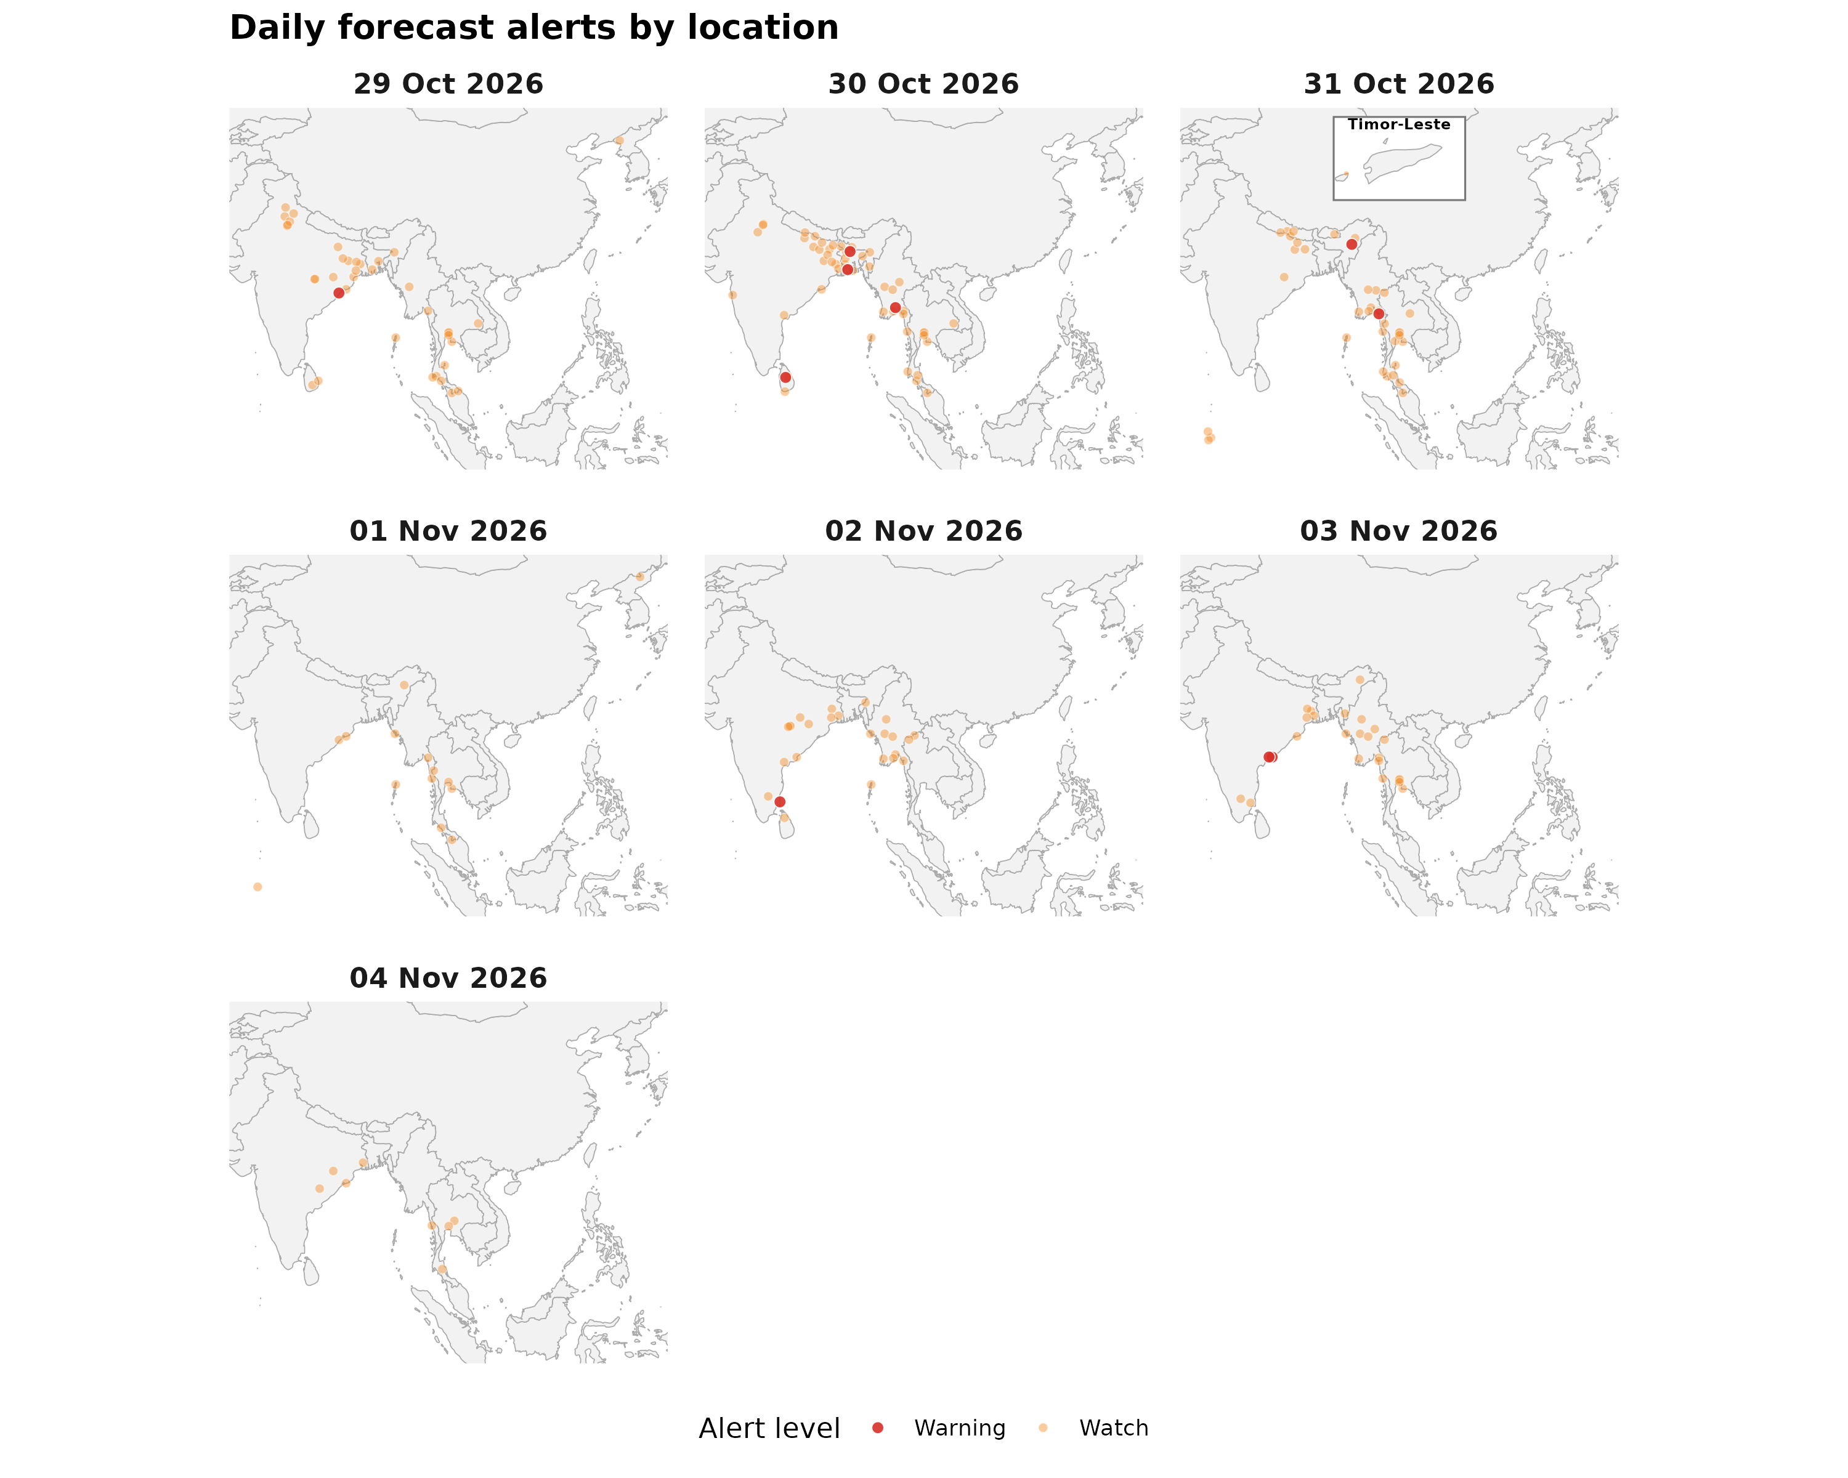

Forecast alerts by country
Country | Warning | Watch | Alert_Reasons
India | 5 | 76 | Extreme rainfall; Rainfall above 50 mm with wind above 60 km/h; Thunderstorm; Thunderstorm with hail; Very strong wind
Myanmar | 2 | 38 | Heavy rain showers; Thunderstorm; Thunderstorm with hail
Bangladesh | 2 | 8 | Thunderstorm; Thunderstorm with hail
Sri Lanka | 1 | 5 | Thunderstorm; Thunderstorm with hail
Thailand | 0 | 49 | Heavy rain showers; Thunderstorm
Nepal | 0 | 6 | Heavy rain showers; Thunderstorm; Very heavy rainfall
Maldives | 0 | 4 | Thunderstorm
DPR Korea | 0 | 2 | Heavy rain; Heavy snow
Bhutan | 0 | 1 | Thunderstorm
Timor-Leste | 0 | 1 | Thunderstorm

Forecast alerts by state/province
Country | State | Warning | Watch | Total
India | Andhra Pradesh | 2 | 3 | 5
India | Odisha | 1 | 11 | 12
Myanmar | Mon State | 1 | 3 | 4
Bangladesh | Khulna Division | 1 | 2 | 3
Myanmar | Bago Region | 1 | 2 | 3
Bangladesh | Mymensingh Division | 1 | 0 | 1
India | Nagaland | 1 | 0 | 1
India | Puducherry | 1 | 0 | 1
Sri Lanka | Central Province | 1 | 0 | 1
India | West Bengal | 0 | 14 | 14
India | Bihar | 0 | 9 | 9
India | Chhattisgarh | 0 | 7 | 7
India | Andaman and Nicobar Islands | 0 | 5 | 5
India | Assam | 0 | 5 | 5
India | Uttar Pradesh | 0 | 5 | 5
Myanmar | Kayin State | 0 | 5 | 5
Myanmar | Tanintharyi Region | 0 | 5 | 5
Thailand | Pathum Thani | 0 | 5 | 5
Thailand | Rayong | 0 | 5 | 5
Thailand | Samut Prakan | 0 | 5 | 5
India | Jharkhand | 0 | 4 | 4
Myanmar | Ayeyarwady Region | 0 | 4 | 4
Myanmar | Magway Region | 0 | 4 | 4
Myanmar | Naypyidaw Union Territory | 0 | 4 | 4
Thailand | Nonthaburi | 0 | 4 | 4
Thailand | Yala | 0 | 4 | 4
India | Tamil Nadu | 0 | 3 | 3
Myanmar | Rakhine State | 0 | 3 | 3
Myanmar | Yangon Region | 0 | 3 | 3
Thailand | Mae Hong Son | 0 | 3 | 3
Thailand | Nakhon Si Thammarat | 0 | 3 | 3
Thailand | Trang | 0 | 3 | 3
Bangladesh | Rajshahi Division | 0 | 2 | 2
India | Haryana | 0 | 2 | 2
India | Mizoram | 0 | 2 | 2
Maldives | Addu Atoll | 0 | 2 | 2
Myanmar | Sagaing Region | 0 | 2 | 2
Myanmar | Shan State | 0 | 2 | 2
Nepal | Bagmati Province | 0 | 2 | 2
Nepal | Lumbini Province | 0 | 2 | 2
Nepal | Madhesh Province | 0 | 2 | 2
Thailand | Kanchanaburi | 0 | 2 | 2
Thailand | Krabi | 0 | 2 | 2
Thailand | Phang Nga | 0 | 2 | 2
Thailand | Surat Thani | 0 | 2 | 2
Thailand | Ubon Ratchathani | 0 | 2 | 2
Bangladesh | Barisal Division | 0 | 1 | 1
Bangladesh | Dhaka Division | 0 | 1 | 1
Bangladesh | Rangpur Division | 0 | 1 | 1
Bangladesh | Sylhet Division | 0 | 1 | 1
Bhutan | Mongar | 0 | 1 | 1
DPR Korea | North Pyongan Province | 0 | 1 | 1
DPR Korea | Ryanggang Province | 0 | 1 | 1
India | Himachal Pradesh | 0 | 1 | 1
India | Maharashtra | 0 | 1 | 1
India | Meghalaya | 0 | 1 | 1
India | Rajasthan | 0 | 1 | 1
India | Tripura | 0 | 1 | 1
India | Uttarakhand | 0 | 1 | 1
Maldives | Gaafu Dhaalu Atoll | 0 | 1 | 1
Maldives | Gnaviyani Atoll | 0 | 1 | 1
Myanmar | Kayah State | 0 | 1 | 1
Sri Lanka | Eastern Province | 0 | 1 | 1
Sri Lanka | North Central Province | 0 | 1 | 1
Sri Lanka | Northern Province | 0 | 1 | 1
Sri Lanka | Southern Province | 0 | 1 | 1
Sri Lanka | Uva Province | 0 | 1 | 1
Thailand | Chiang Mai | 0 | 1 | 1
Thailand | Khon Kaen | 0 | 1 | 1
Thailand | Nakhon Ratchasima | 0 | 1 | 1
Thailand | Narathiwat | 0 | 1 | 1
Thailand | Phetchaburi | 0 | 1 | 1
Thailand | Phuket | 0 | 1 | 1
Thailand | Songkhla | 0 | 1 | 1
Timor-Leste | Special Administrative Region of Oecusse-Ambeno | 0 | 1 | 1
Source: Open-Meteo. Alert counts represent location–date forecast rows across all forecast dates. Forecast alerts use WMO weather codes and country-specific thresholds for Bangladesh, Bhutan, India, Thailand, Nepal, and Sri Lanka, informed by national meteorological and disaster-management agencies. Custom rules apply where unavailable. The highest triggered severity determines the forecast alert level: Normal, Advisory, Watch, or Warning. These indicators are not official agency warnings.

Met / hydro verification checklist
[ ] India — https://mausam.imd.gov.in/ / https://ffs.india-water.gov.in/
[ ] Sri Lanka — https://www.meteo.gov.lk/ / https://www.irrigation.gov.lk/
[ ] Thailand — https://www.tmd.go.th/ / https://www.thaiwater.net/

Sources: Google Flood Forecasting API / Flood Hub (gauges, significant events, urban flash floods); GDACS; national NMHS/hydro. Decision support only — not an official WHO warning.

