WHO SEARO Daily Flood Early Warning Brief — 2026-11-13
Generated 2026-11-13 13:13 IST

Verdict (triage)
WATCH: Sri Lanka, Thailand
STABLE: Bangladesh, India, Myanmar, Nepal

Flood Hub — country gauge summary
country | tier | total_gauges | Warning | Danger | Extreme | new_danger | new_extreme | cleared_hot
Bangladesh | STABLE | 894 | 0 | 0 | 0 | 0 | 0 | 0
India | STABLE | 16,340 | 1 | 0 | 0 | 0 | 0 | 0
Myanmar | STABLE | 3,177 | 22 | 0 | 0 | 0 | 0 | 3
Nepal | STABLE | 765 | 0 | 0 | 0 | 0 | 0 | 0
Sri Lanka | WATCH | 310 | 6 | 0 | 0 | 0 | 0 | 0
Thailand | WATCH | 2,143 | 0 | 0 | 0 | 0 | 0 | 0
ALERT: ≥1 Extreme gauge; or Danger gauges plus a GDACS orange/red flood/cyclone for that country; or newly elevated hot gauges with ≥3 Danger gauges.
WATCH: ≥1 Danger gauge, a GDACS orange/red hit, urban flash-flood signal (next ~24h), and/or newly elevated hot gauges — without meeting ALERT criteria.
STABLE: No Danger/Extreme gauges, no GDACS orange/red, and no urban flash-flood signal for that country.

Urban flash floods — next ~24 hours (SEARO)
country | iso2 | events | highly_likely_events | likely_events | period_hours | latest_issue
Thailand | TH | 2 | 2 | 2 | 24 | 2026-11-13T00:34:37.643008Z
Sri Lanka | LK | 1 | 0 | 1 | 24 | 2026-11-13T00:34:37.643008Z
Urban flash floods: Flood Hub model of flash-flood likelihood in urban areas over the next ~24 hours (~20 km). Highly likely = stronger polygon signal. Decision support only — verify with national met/hydro.

GDACS — SEARO floods & cyclones (last 7 days)
alert_level | event_type | country | name | from_date | url
green | FL | Myanmar | Flood in Myanmar | 2026-11-10T01:00:00 | https://www.gdacs.org/report.aspx?eventid=1104280&episodeid=1&eventtype=FL

Flood Hub significant events (SEARO filter)
None touching SEARO right now.

OpenMeteo Forecasting
Forecast data collected for 229 locations from 13 November 2026 to 19 November 2026. Across this forecast period, 1 Warning and 52 Watch alerts were identified (counts represent location–date forecasts).

Warning reasons: Very strong wind.
Watch reasons: Cold; Heavy rain showers; Heavy snow showers; Thunderstorm; Very heavy rainfall.

Daily forecast alerts by location
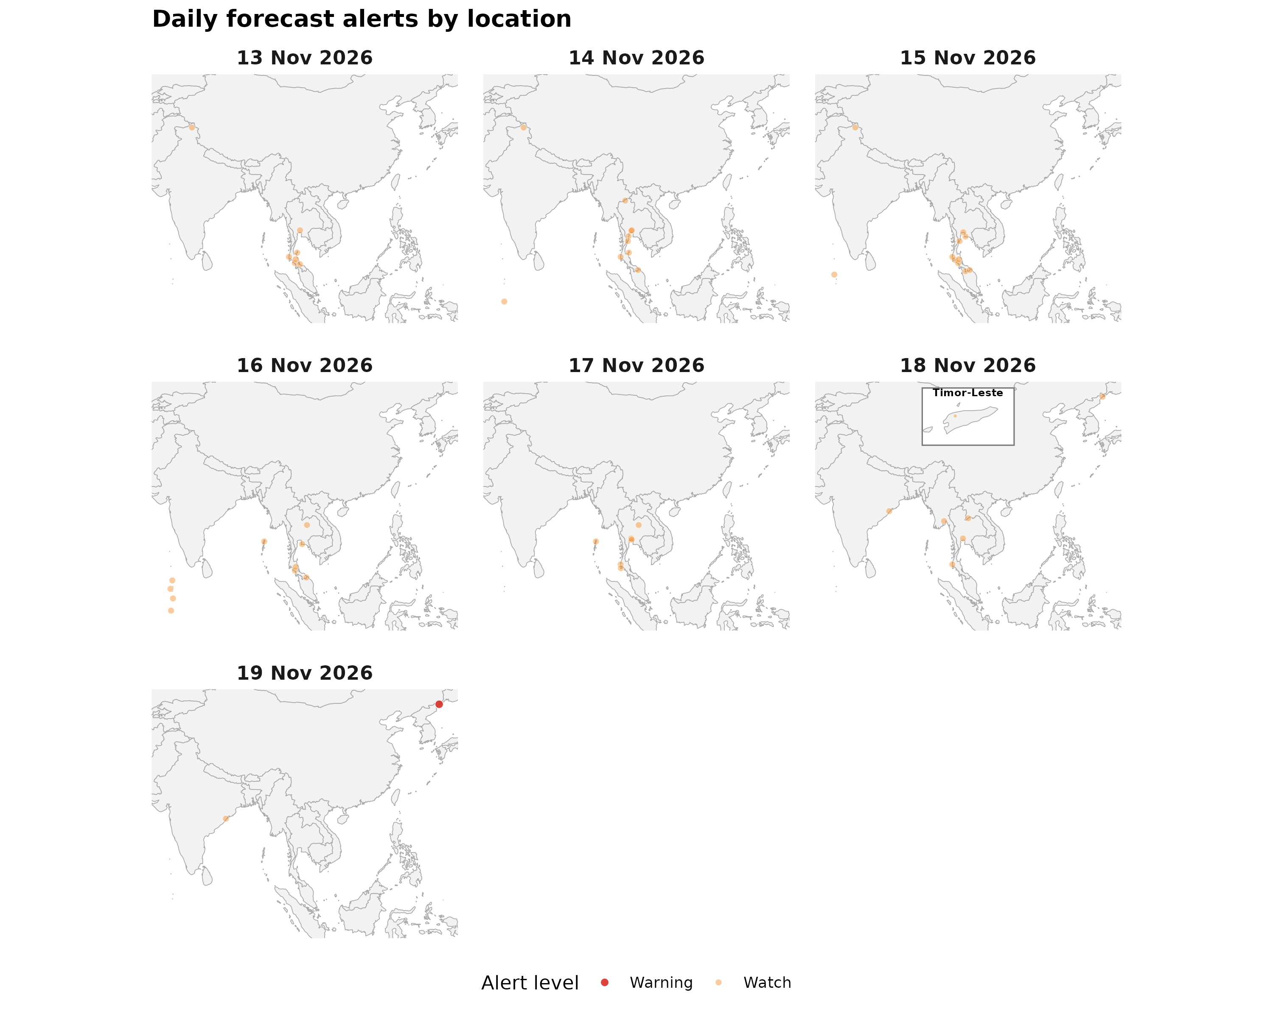

Forecast alerts by country
Country | Warning | Watch | Alert_Reasons
DPR Korea | 1 | 1 | Thunderstorm; Very strong wind
Thailand | 0 | 36 | Cold; Thunderstorm; Very heavy rainfall
India | 0 | 7 | Heavy rain showers; Heavy snow showers; Thunderstorm
Maldives | 0 | 6 | Thunderstorm
Myanmar | 0 | 1 | Thunderstorm
Timor-Leste | 0 | 1 | Thunderstorm
Bangladesh | 0 | 0 | —
Bhutan | 0 | 0 | —
Nepal | 0 | 0 | —
Sri Lanka | 0 | 0 | —

Forecast alerts by state/province
Country | State | Warning | Watch | Total
DPR Korea | Rason Special City | 1 | 1 | 2
Thailand | Phang Nga | 0 | 5 | 5
India | Ladakh | 0 | 3 | 3
Thailand | Nakhon Si Thammarat | 0 | 3 | 3
Thailand | Narathiwat | 0 | 3 | 3
Thailand | Nonthaburi | 0 | 3 | 3
Thailand | Trang | 0 | 3 | 3
India | Andaman and Nicobar Islands | 0 | 2 | 2
India | Odisha | 0 | 2 | 2
Thailand | Khon Kaen | 0 | 2 | 2
Thailand | Pathum Thani | 0 | 2 | 2
Thailand | Prachuap Khiri Khan | 0 | 2 | 2
Thailand | Rayong | 0 | 2 | 2
Thailand | Samut Prakan | 0 | 2 | 2
Thailand | Surat Thani | 0 | 2 | 2
Maldives | Addu Atoll | 0 | 1 | 1
Maldives | Alif Dhaal Atoll | 0 | 1 | 1
Maldives | Baa Atoll | 0 | 1 | 1
Maldives | Gnaviyani Atoll | 0 | 1 | 1
Maldives | Laamu Atoll | 0 | 1 | 1
Maldives | Lhaviyani Atoll | 0 | 1 | 1
Myanmar | Bago Region | 0 | 1 | 1
Thailand | Chiang Mai | 0 | 1 | 1
Thailand | Krabi | 0 | 1 | 1
Thailand | Loei | 0 | 1 | 1
Thailand | Phetchaburi | 0 | 1 | 1
Thailand | Phuket | 0 | 1 | 1
Thailand | Songkhla | 0 | 1 | 1
Thailand | Yala | 0 | 1 | 1
Timor-Leste | Ermera Municipality | 0 | 1 | 1
Source: Open-Meteo. Alert counts represent location–date forecast rows across all forecast dates. Forecast alerts use WMO weather codes and country-specific thresholds for Bangladesh, Bhutan, India, Thailand, Nepal, and Sri Lanka, informed by national meteorological and disaster-management agencies. Custom rules apply where unavailable. The highest triggered severity determines the forecast alert level: Normal, Advisory, Watch, or Warning. These indicators are not official agency warnings.

Met / hydro verification checklist
[ ] Sri Lanka — https://www.meteo.gov.lk/ / https://www.irrigation.gov.lk/
[ ] Thailand — https://www.tmd.go.th/ / https://www.thaiwater.net/

Sources: Google Flood Forecasting API / Flood Hub (gauges, significant events, urban flash floods); GDACS; national NMHS/hydro. Decision support only — not an official WHO warning.

