WHO SEARO Daily Flood Early Warning Brief — 2026-10-27
Generated 2026-10-27 13:41 IST

Verdict (triage)
ALERT: India
WATCH: Sri Lanka, Thailand
STABLE: Bangladesh, Myanmar, Nepal

Flood Hub — country gauge summary
country | tier | total_gauges | Warning | Danger | Extreme | new_danger | new_extreme | cleared_hot
Bangladesh | STABLE | 894 | 0 | 0 | 0 | 0 | 0 | 0
India | ALERT | 16,340 | 199 | 31 | 0 | 0 | 0 | 0
Myanmar | STABLE | 3,177 | 0 | 0 | 0 | 0 | 0 | 0
Nepal | STABLE | 765 | 0 | 0 | 0 | 0 | 0 | 0
Sri Lanka | WATCH | 310 | 92 | 15 | 0 | 0 | 0 | 0
Thailand | WATCH | 2,143 | 0 | 0 | 0 | 0 | 0 | 0
ALERT: ≥1 Extreme gauge; or Danger gauges plus a GDACS orange/red flood/cyclone for that country; or newly elevated hot gauges with ≥3 Danger gauges.
WATCH: ≥1 Danger gauge, a GDACS orange/red hit, urban flash-flood signal (next ~24h), and/or newly elevated hot gauges — without meeting ALERT criteria.
STABLE: No Danger/Extreme gauges, no GDACS orange/red, and no urban flash-flood signal for that country.

Urban flash floods — next ~24 hours (SEARO)
country | iso2 | events | highly_likely_events | likely_events | period_hours | latest_issue
India | IN | 10 | 1 | 10 | 24 | 2026-10-27T00:31:54.512633Z
Sri Lanka | LK | 6 | 1 | 6 | 24 | 2026-10-27T00:31:54.512633Z
Thailand | TH | 6 | 1 | 6 | 24 | 2026-10-27T00:31:54.512633Z
Urban flash floods: Flood Hub model of flash-flood likelihood in urban areas over the next ~24 hours (~20 km). Highly likely = stronger polygon signal. Decision support only — verify with national met/hydro.

GDACS — SEARO floods & cyclones (last 7 days)
alert_level | event_type | country | name | from_date | url
red | TC | India | Tropical Cyclone ARNAB-26 | 2026-10-26T00:00:00 | https://www.gdacs.org/report.aspx?eventid=1001345&episodeid=6&eventtype=TC
green | FL | Thailand | Flood in Thailand | 2026-10-18T01:00:00 | https://www.gdacs.org/report.aspx?eventid=1104241&episodeid=1&eventtype=FL

Flood Hub significant events (SEARO filter)
None touching SEARO right now.

Admin-1 screen (Danger/Extreme gauges only)
country | region_code | ADM1 | Danger | Extreme | hot_gauges
India | IN | Odisha | 16 | 0 | 16
India | IN | Andhra Pradesh | 13 | 0 | 13
Sri Lanka | LK | Kuruṇægala | 8 | 0 | 8
Sri Lanka | LK | Puttalama | 4 | 0 | 4
Sri Lanka | LK | Gampaha | 2 | 0 | 2
India | IN | Rajasthan | 1 | 0 | 1
India | IN | Tamil Nadu | 1 | 0 | 1
Sri Lanka | LK | Kaḷutara | 1 | 0 | 1
Hot gauges: Flood Hub stations currently at Danger (severe) or Extreme severity. Admin-1 units are listed only if they contain ≥1 hot gauge; use as a geographic filter and verify with gauges + national met/hydro before acting.

OpenMeteo Forecasting
Forecast data collected for 1 locations from 27 October 2026 to 02 November 2026. Across this forecast period, 0 Warning and 1 Watch alerts were identified (counts represent location–date forecasts).

Watch reasons: Thunderstorm.

Daily forecast alerts by location
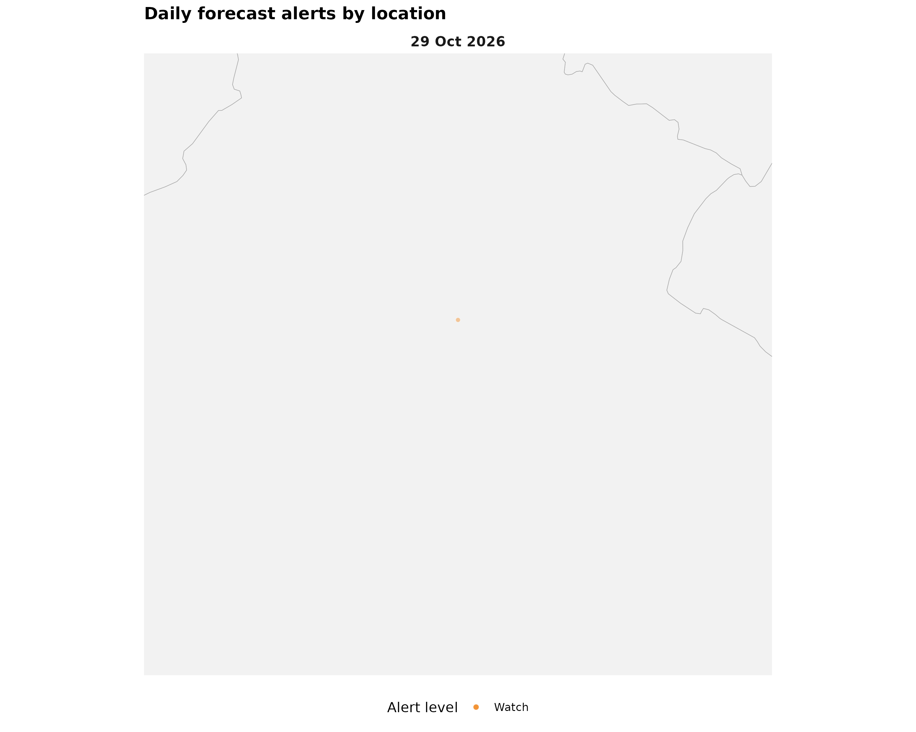

Forecast alerts by country
Country | Warning | Watch | Alert_Reasons
India | 0 | 1 | Thunderstorm

Forecast alerts by state/province
Country | State | Warning | Watch | Total
India | NCT Delhi | 0 | 1 | 1
Source: Open-Meteo. Alert counts represent location–date forecast rows across all forecast dates. Forecast alerts use WMO weather codes and country-specific thresholds for Bangladesh, Bhutan, India, Thailand, Nepal, and Sri Lanka, informed by national meteorological and disaster-management agencies. Custom rules apply where unavailable. The highest triggered severity determines the forecast alert level: Normal, Advisory, Watch, or Warning. These indicators are not official agency warnings.

Met / hydro verification checklist
[ ] India — https://mausam.imd.gov.in/ / https://ffs.india-water.gov.in/
[ ] Sri Lanka — https://www.meteo.gov.lk/ / https://www.irrigation.gov.lk/
[ ] Thailand — https://www.tmd.go.th/ / https://www.thaiwater.net/

Sources: Google Flood Forecasting API / Flood Hub (gauges, significant events, urban flash floods); GDACS; national NMHS/hydro. Decision support only — not an official WHO warning.

