WHO SEARO Daily Flood Early Warning Brief — 2026-10-28
Generated 2026-10-28 12:13 IST

Verdict (triage)
ALERT: India
WATCH: Sri Lanka, Thailand
STABLE: Bangladesh, Myanmar, Nepal

Flood Hub — country gauge summary
country | tier | total_gauges | Warning | Danger | Extreme | new_danger | new_extreme | cleared_hot
Bangladesh | STABLE | 894 | 0 | 0 | 0 | 0 | 0 | 0
India | ALERT | 16,340 | 148 | 60 | 2 | 29 | 2 | 0
Myanmar | STABLE | 3,177 | 0 | 0 | 0 | 0 | 0 | 0
Nepal | STABLE | 765 | 0 | 0 | 0 | 0 | 0 | 0
Sri Lanka | WATCH | 310 | 41 | 1 | 0 | 0 | 0 | 14
Thailand | WATCH | 2,143 | 0 | 0 | 0 | 0 | 0 | 0
ALERT: ≥1 Extreme gauge; or Danger gauges plus a GDACS orange/red flood/cyclone for that country; or newly elevated hot gauges with ≥3 Danger gauges.
WATCH: ≥1 Danger gauge, a GDACS orange/red hit, urban flash-flood signal (next ~24h), and/or newly elevated hot gauges — without meeting ALERT criteria.
STABLE: No Danger/Extreme gauges, no GDACS orange/red, and no urban flash-flood signal for that country.

Urban flash floods — next ~24 hours (SEARO)
country | iso2 | events | highly_likely_events | likely_events | period_hours | latest_issue
Thailand | TH | 13 | 1 | 13 | 24 | 2026-10-28T00:33:59.595422Z
Sri Lanka | LK | 6 | 1 | 6 | 24 | 2026-10-28T00:33:59.595422Z
India | IN | 4 | 1 | 4 | 24 | 2026-10-28T00:33:59.595422Z
Urban flash floods: Flood Hub model of flash-flood likelihood in urban areas over the next ~24 hours (~20 km). Highly likely = stronger polygon signal. Decision support only — verify with national met/hydro.

GDACS — SEARO floods & cyclones (last 7 days)
alert_level | event_type | country | name | from_date | url
red | TC | India | Tropical Cyclone ARNAB-26 | 2026-10-26T00:00:00 | https://www.gdacs.org/report.aspx?eventid=1001345&episodeid=11&eventtype=TC

Flood Hub significant events (SEARO filter)
None touching SEARO right now.

Admin-1 screen (Danger/Extreme gauges only)
country | region_code | ADM1 | Danger | Extreme | hot_gauges
India | IN | Odisha | 29 | 2 | 31
India | IN | Andhra Pradesh | 26 | 0 | 26
India | IN | Rajasthan | 1 | 0 | 1
Sri Lanka | LK | Puttalama | 1 | 0 | 1
Hot gauges: Flood Hub stations currently at Danger (severe) or Extreme severity. Admin-1 units are listed only if they contain ≥1 hot gauge; use as a geographic filter and verify with gauges + national met/hydro before acting.

OpenMeteo Forecasting
Forecast data collected for 229 locations from 28 October 2026 to 03 November 2026. Across this forecast period, 19 Warning and 205 Watch alerts were identified (counts represent location–date forecasts).

Warning reasons: Daily rainfall above 100 mm; Thunderstorm with hail.
Watch reasons: Heavy rain showers; Strong wind; Thunderstorm; Very heavy rainfall.

Daily forecast alerts by location
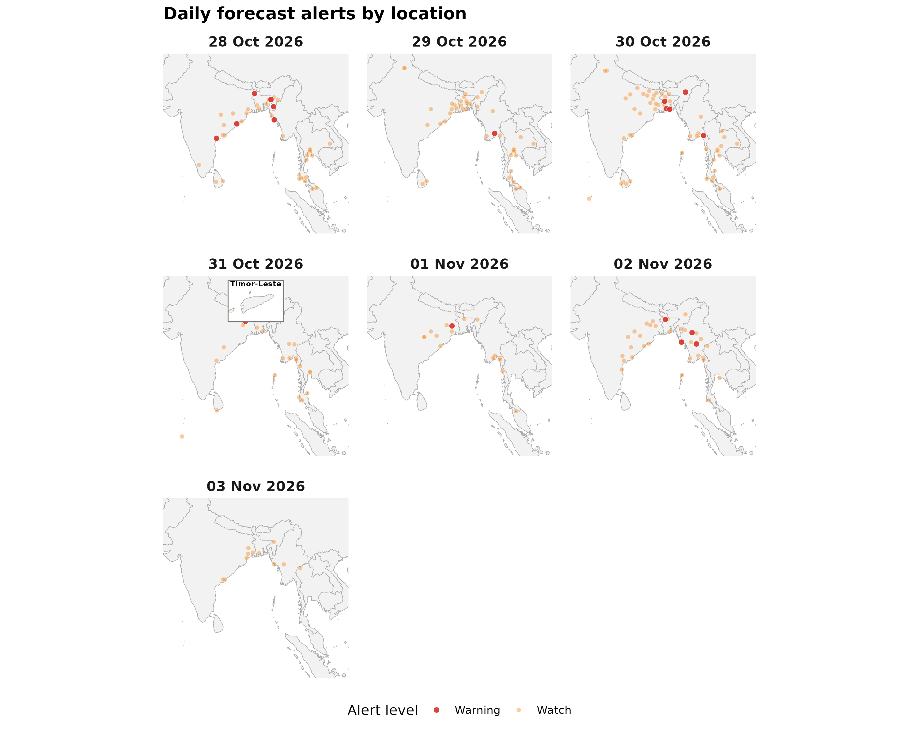

Forecast alerts by country
Country | Warning | Watch | Alert_Reasons
India | 8 | 87 | Daily rainfall above 100 mm; Heavy rain showers; Strong wind; Thunderstorm; Thunderstorm with hail
Myanmar | 6 | 31 | Thunderstorm; Thunderstorm with hail
Bangladesh | 5 | 24 | Thunderstorm; Thunderstorm with hail
Thailand | 0 | 50 | Heavy rain showers; Thunderstorm; Very heavy rainfall
Sri Lanka | 0 | 9 | Thunderstorm
Maldives | 0 | 2 | Thunderstorm
Nepal | 0 | 1 | Thunderstorm; Very heavy rainfall
Timor-Leste | 0 | 1 | Thunderstorm
Bhutan | 0 | 0 | —
DPR Korea | 0 | 0 | —

Forecast alerts by state/province
Country | State | Warning | Watch | Total
Bangladesh | Rajshahi Division | 2 | 3 | 5
India | Nagaland | 2 | 2 | 4
Myanmar | Rakhine State | 2 | 1 | 3
India | Odisha | 1 | 13 | 14
India | West Bengal | 1 | 13 | 14
India | Andhra Pradesh | 1 | 11 | 12
India | Jharkhand | 1 | 8 | 9
Bangladesh | Khulna Division | 1 | 7 | 8
Myanmar | Kayin State | 1 | 4 | 5
Bangladesh | Barisal Division | 1 | 3 | 4
Myanmar | Bago Region | 1 | 3 | 4
India | Mizoram | 1 | 2 | 3
Bangladesh | Rangpur Division | 1 | 1 | 2
Myanmar | Naypyidaw Union Territory | 1 | 1 | 2
India | Tripura | 1 | 0 | 1
Myanmar | Sagaing Region | 1 | 0 | 1
India | Chhattisgarh | 0 | 12 | 12
India | Bihar | 0 | 6 | 6
India | Assam | 0 | 5 | 5
Myanmar | Ayeyarwady Region | 0 | 5 | 5
Myanmar | Mon State | 0 | 4 | 4
Thailand | Pathum Thani | 0 | 4 | 4
Thailand | Rayong | 0 | 4 | 4
Thailand | Yala | 0 | 4 | 4
Bangladesh | Chattogram Division | 0 | 3 | 3
Bangladesh | Dhaka Division | 0 | 3 | 3
Bangladesh | Mymensingh Division | 0 | 3 | 3
India | Andaman and Nicobar Islands | 0 | 3 | 3
Myanmar | Yangon Region | 0 | 3 | 3
Sri Lanka | Eastern Province | 0 | 3 | 3
Thailand | Krabi | 0 | 3 | 3
Thailand | Nakhon Si Thammarat | 0 | 3 | 3
Thailand | Nonthaburi | 0 | 3 | 3
Thailand | Samut Prakan | 0 | 3 | 3
Thailand | Surat Thani | 0 | 3 | 3
Thailand | Ubon Ratchathani | 0 | 3 | 3
India | Himachal Pradesh | 0 | 2 | 2
India | Meghalaya | 0 | 2 | 2
India | Uttar Pradesh | 0 | 2 | 2
Myanmar | Magway Region | 0 | 2 | 2
Myanmar | Mandalay Region | 0 | 2 | 2
Myanmar | Shan State | 0 | 2 | 2
Myanmar | Tanintharyi Region | 0 | 2 | 2
Sri Lanka | Sabaragamuwa Province | 0 | 2 | 2
Sri Lanka | Uva Province | 0 | 2 | 2
Thailand | Khon Kaen | 0 | 2 | 2
Thailand | Mae Hong Son | 0 | 2 | 2
Thailand | Narathiwat | 0 | 2 | 2
Thailand | Phang Nga | 0 | 2 | 2
Thailand | Phetchaburi | 0 | 2 | 2
Thailand | Phuket | 0 | 2 | 2
Thailand | Prachuap Khiri Khan | 0 | 2 | 2
Thailand | Trang | 0 | 2 | 2
Bangladesh | Sylhet Division | 0 | 1 | 1
India | Haryana | 0 | 1 | 1
India | Kerala | 0 | 1 | 1
India | Madhya Pradesh | 0 | 1 | 1
India | Manipur | 0 | 1 | 1
India | Punjab | 0 | 1 | 1
India | Telangana | 0 | 1 | 1
Maldives | Alif Dhaal Atoll | 0 | 1 | 1
Maldives | Gaafu Dhaalu Atoll | 0 | 1 | 1
Myanmar | Chin State | 0 | 1 | 1
Myanmar | Kayah State | 0 | 1 | 1
Nepal | Koshi Province | 0 | 1 | 1
Sri Lanka | Southern Province | 0 | 1 | 1
Sri Lanka | Western Province | 0 | 1 | 1
Thailand | Kanchanaburi | 0 | 1 | 1
Thailand | Loei | 0 | 1 | 1
Thailand | Nakhon Ratchasima | 0 | 1 | 1
Thailand | Songkhla | 0 | 1 | 1
Timor-Leste | Special Administrative Region of Oecusse-Ambeno | 0 | 1 | 1
Source: Open-Meteo. Alert counts represent location–date forecast rows across all forecast dates. Forecast alerts use WMO weather codes and country-specific thresholds for Bangladesh, Bhutan, India, Thailand, Nepal, and Sri Lanka, informed by national meteorological and disaster-management agencies. Custom rules apply where unavailable. The highest triggered severity determines the forecast alert level: Normal, Advisory, Watch, or Warning. These indicators are not official agency warnings.

Met / hydro verification checklist
[ ] India — https://mausam.imd.gov.in/ / https://ffs.india-water.gov.in/
[ ] Sri Lanka — https://www.meteo.gov.lk/ / https://www.irrigation.gov.lk/
[ ] Thailand — https://www.tmd.go.th/ / https://www.thaiwater.net/

Sources: Google Flood Forecasting API / Flood Hub (gauges, significant events, urban flash floods); GDACS; national NMHS/hydro. Decision support only — not an official WHO warning.

